Use to set git user name
git config --global user.name "Abhay Anand"

use to get user name
git config user.name

use to get all the user name
git config --global --get-all user.name

use to unset all the user
git config --global --unset-all user.name

use to set email
git config --global user.email abhayanand3482@gmail.com

use to get email
git config --global user.email

use to get current repository
git status

use to initialize git-repository
git init (it enable the git for the specific project)

use to remove gitrepository
rm -rf .git (it remove the git for the specific project)
Note: Do not initialize a git repository inside a git repository

Commiting
Commit work as a check point to save work after some work
If we add a file in git repository and without committing it if we check the status of the repository then it gives us a message with all the files who are not committed.
Ex:-
Untracked files:
(use "git add <file>..." to include in what will be committed)
outline.txt
in order to commit the changes we have to add the files where we have made the changes using
git add filename (use to stage files which we want to commit)
git add . (use to stage all the files which are changed)

use to commit all the staged file
git commit -m “Message we want to provide while committing”
after committing it gives us list of file which are committed
[master (root-commit) d632bc4] Start working on outline and main character
2 files changed, 2 insertions(+)
create mode 100644 character.txt
create mode 100644 outline.txt

use to return the logs of all the Commit
git log

if we want git to ignore some files or folders then we can create them in following ways
this file may contain the data which we don’t want to share like API key or card details etc.
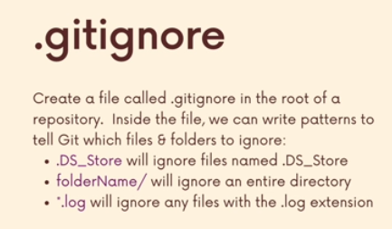
We have to create a filename .gitignore in root directory and mention the name of all the files and folders which we want to get ignored by git.
Ex:-
For file – .file_name
For folder - .folder_name/
Note:- After adding files name to git ignore git will not tract the files

Branching
Master Branch:-
The master branch is the default primary branch that Git used to create when you initialized a new repository.

✅ Key Facts About master:
- It was the default branch name in Git before Git version 2.28.
- When you run git init, Git would automatically create a branch named master.
- It typically represents the main line of development, often containing stable, production-ready code.
Use to return the git Branch
Git branch
Note:- the branch with * is the current branch
Ex:- * master

Creating new branch
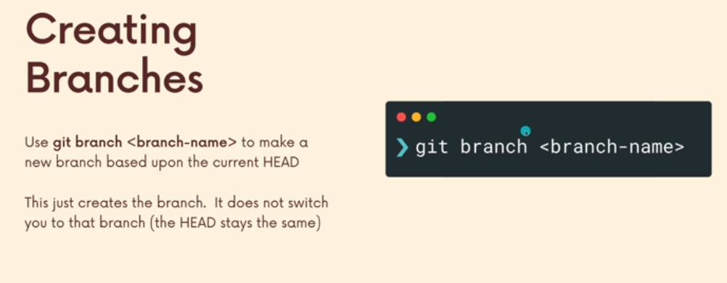

Use to switch the branch
git switch branchName (* will point )

Use to delete branch
git branch -D branch_name
Note:- we cannot delete the branch in which we are currently present, we have to switch to another branch the delete the branch we want to delete

Use to rename the branch
git branch -m renamed_branchname

Use to merge two branches
git merge branch
Note:- we must go to the branch in which we want to merge another branch
Then git merge branch_name_which_wants_to_merge

In case if there is changes in both the branches in same file it will give a conflict message which we have to resolve manually

Stashing

Stashing in Git allows you to temporarily save your uncommitted changes (i.e., your working directory and staged changes) without committing them. This is useful when you need to switch branches or perform other Git operations, but you're not yet ready to commit your current changes.

📘 Example Scenario:
Suppose you're working on a feature in a branch and:
- You have uncommitted changes.
- You suddenly need to switch to another branch (e.g., to review someone else’s work or fix a bug).
There are two possible situations:
- Git allows switching, and your changes come along, which may cause conflicts or confusion.
- Git prevents switching, especially if it causes conflicts in the destination branch.

✅ Solution: Use Git Stash
To temporarily save your changes and get a clean working directory:
git stash
- This saves the changes and reverts your working directory to the last commit.
- You can now safely switch branches:
bash
git checkout other-branch
- When you're ready to resume work, go back to your branch and reapply the stash:
bash
git checkout your-feature-branch
git stash pop

use to go to a specific commit
git checkout 72fc90 (first 7 digits of git commit id)
Or
git checkout HEAD~1 (if want to go 1 commit back and so no )
Note:-

When you use a command like git checkout <commit-id>, Git does two things:
- It moves your files to look exactly like they did at that specific commit.
- It moves the HEAD (which tells Git where you are in history) to point to that commit.
After doing this, if you run git log, Git will show that you're now at that commit in history (not at the latest one).

📦 Example:
Let’s say you have a Git project with 3 commits:

A -- B -- C (main)
- A: First commit – added a file hello.txt
- B: Second commit – changed hello.txt
- C: Third commit – added a new file readme.md
Your current branch main points to commit C.
Now you run:
git checkout B

🔧 What Happens?
- Git will change your files to look like they did in commit B.
  - So, readme.md (added in C) will disappear.
  - hello.txt will look like how it was in commit B.
- Git will move the HEAD to point at commit B.
  - You're now in a "detached HEAD" state.
  - You're not on the main branch anymore—just sitting at commit B.

📜 When You Run git log Now:
It will show commit B at the top and commit A below it. You won’t see commit C (because you checked out before it).

✅ Summary:
git checkout <commit-id>
= Load the files from that point in time
- Move HEAD to that point in the commit history
You’re basically “time traveling” in your project’s history.

Use Case
Let's say your project has this history:
A -- B -- C -- D (main)
- A: Initial commit
- B: Added feature X
- C: Modified feature X
- D: Added feature Y
You're currently on the main branch at commit D.

🔄 Now You Want To:
Go back to commit B and start a new branch from there to try a different version of feature X, without affecting the main branch.

✅ Steps to Do This:
# Step 1: Go to commit B
git checkout B
Now you're in a "detached HEAD" state — you're looking at the project as it was at commit B.
# Step 2: Create a new branch from here
git checkout -b new-feature-x
This creates a new branch called new-feature-x from commit B and switches you to it.

🌿 Now Your History Looks Like:
C -- D (main)
/
A -- B
\
(new-feature-x)
You can now make new commits on the new-feature-x branch and develop your alternative version of feature X without affecting main.

Github
Githbu is a hosting platform got git repository. You can put your own Git repos on Github and access them from anywhere and share them with people around the world.

How to push repo to Github
1. Create a local repository in local system
Create a folder
Initialize a local repo using git init
2. Create a Remote Repository on GitHub
- Go to GitHub and log in.
- Click the + icon at the top right and select New repository.
- Enter a repository name (e.g., my-project), add description if you want.
- Choose Public or Private.
- Click Create repository.

3. Connect Your Local Repo to GitHub
GitHub will show you the commands to push your existing repo. For example:
git remote add origin https://github.com/your-username/my-project.git

4. Push Your Code to GitHub
git push -u origin branch_name
Ex:-
git push -u origin master
What does git push -u origin branch_name mean?
- git push: This sends your local changes (commits) to the remote repository (like GitHub).
- origin: This is the name of the remote repository (usually the default name for your GitHub repo).
- branch_name: The name of the branch you want to push your changes to (e.g., master or main).
- -u: This sets up a tracking relationship between your local branch and the remote branch. It means next time you can just run git push without typing everything.

What happens the first time you push?
- When you push your branch for the first time, GitHub creates a new branch with the same name in the remote repo.
- Your local branch is now connected (tracked) to that remote branch.

What happens the second time (and later)?
- When you push again to the same branch, Git just updates the remote branch with your new changes.
- No new branch is created, only the existing branch gets updated

5. Verify on GitHub
Go to your GitHub repo page. You should see your files uploaded.

Note:-
You can take a local branch from your computer and push its code to any branch on GitHub (the remote), even if the branch names are different.

Syntax:
git push origin local_branch_name:remote_branch_name
- local_branch_name = the branch on your computer
- remote_branch_name = the branch on GitHub you want to send your code to

In simple words:
- You have a branch on your PC, called, say, feature1.
- You want to push it to GitHub but into a branch called dev.
- You run: git push origin feature1:dev
- This sends the code from your local feature1 branch to the remote branch dev.

Why is this useful?
- Your local and remote branch names don’t have to match.
- You can create or update any branch on GitHub from your local branches.
- Good for managing multiple features or different stages (like dev, test, prod).

How to clone an existing repository
Command:
git clone git_url

Example:
git clone https://github.com/7004588224abhay/clone-project.git

What happens when you run this?
- Git copies the whole project from GitHub (or any Git server) to your computer.
- It creates a new folder with the project’s files.
- It also sets up Git in that folder — meaning your local copy is a Git repository now.
- You can start working with the project locally, tracking changes, and pushing updates.

How to check if Git is initialized?
Run this command inside the cloned folder:
git remote -v
- It will show the remote URL(s) linked to your local repo.
- This confirms your local folder is connected to the remote repository.

