Student Management System - Database Systems Project Documentation
Course Name: Database Systems
Project Title: Student Management System
Group Members:
• Salman Ahmed Shah (70145697)
• Zohaib Nisar (70154592)
• Salman Manzoor (70154457)
GitHub Repository:
https://github.com/70145697-lab/Student-Management-System

Project Scenario Description
Student Management System is a database project that manages student records, courses, attendance, marks, fees, and teachers in an educational institute. The system reduces paperwork and provides efficient data management.

Objectives
• Store student records digitally
• Reduce paperwork
• Manage attendance
• Manage marks
• Manage fee records
• Generate reports

Database Design Overview
Tables:
1. Student(Student_ID, Name, Phone, Department)
2. Teacher(Teacher_ID, Name, Subject)
3. Course(Course_ID, Course_Name)
4. Enrollment(Student_ID, Course_ID)
5. Attendance(Attendance_ID, Date, Status, Student_ID)
6. Marks(Marks_ID, Total_Marks, Grade, Student_ID)
7. Fee(Fee_ID, Amount, Status, Student_ID)
The database uses Primary Keys and Foreign Keys and follows normalization principles.

Relationships
Student → Enrollment → Course
Teacher → Teaches → Course
Student → Attendance
Student → Marks
Student → Fee

Features (10 Features)
1. Add Student
2. Update Student
3. Delete Student
4. Search Student
5. Add Course
6. Assign Course to Student
7. Mark Attendance
8. View Attendance Report
9. Enter Student Marks
10. Calculate Student Grade

SQL Implementation

CREATE TABLE Student (

Student_ID INT PRIMARY KEY,

Name VARCHAR(50),

Phone VARCHAR(20),

Department VARCHAR(50)

);

CREATE TABLE Course (

Course_ID INT PRIMARY KEY,

Course_Name VARCHAR(50)

);

CREATE TABLE Enrollment (

Student_ID INT,

Course_ID INT,

PRIMARY KEY (Student_ID, Course_ID),

FOREIGN KEY (Student_ID) REFERENCES Student(Student_ID)

ON DELETE CASCADE,

FOREIGN KEY (Course_ID) REFERENCES Course(Course_ID)

ON DELETE CASCADE

);

INSERT INTO Student VALUES

(1, 'Ali', '03001234567', 'CS'),

(2, 'Ahmed', '03007654321', 'IT');

INSERT INTO Course VALUES

(101, 'Database'),

(102, 'Programming');

INSERT INTO Enrollment VALUES

(1, 101),

(2, 102),

(1, 102);

SELECT * FROM Student;

SELECT S.Name, C.Course_Name

FROM Student S

JOIN Enrollment E ON S.Student_ID = E.Student_ID

JOIN Course C ON E.Course_ID = C.Course_ID;

UPDATE Student

SET Phone = '03111234567'

WHERE Student_ID = 1;

DELETE FROM Student

WHERE Student_ID = 2;
Feature-wise Queries
Feature 1: INSERT Student
Feature 2: UPDATE Student
Feature 3: DELETE Student
Feature 4: SELECT Student
Feature 5: INSERT Course
Feature 6: INSERT Enrollment
Feature 7: INSERT Attendance
Feature 8: SELECT Attendance Report
Feature 9: INSERT Marks
Feature 10: CASE Statement for Grade Calculation

Sample Data
Students:
1 Ali CS
2 Ahmed IT
3 Salman SE
Courses:
101 Database Systems
102 OOP
103 COAL

ER Diagram
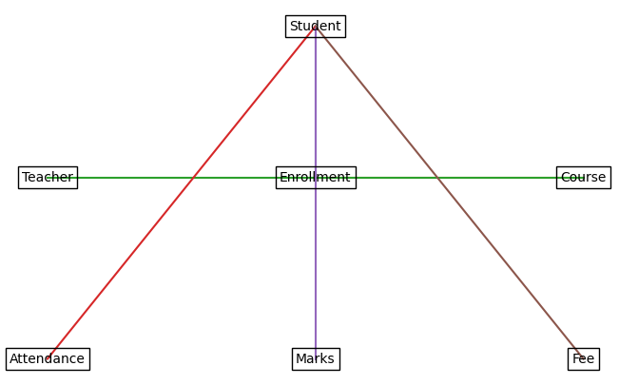

Screenshots

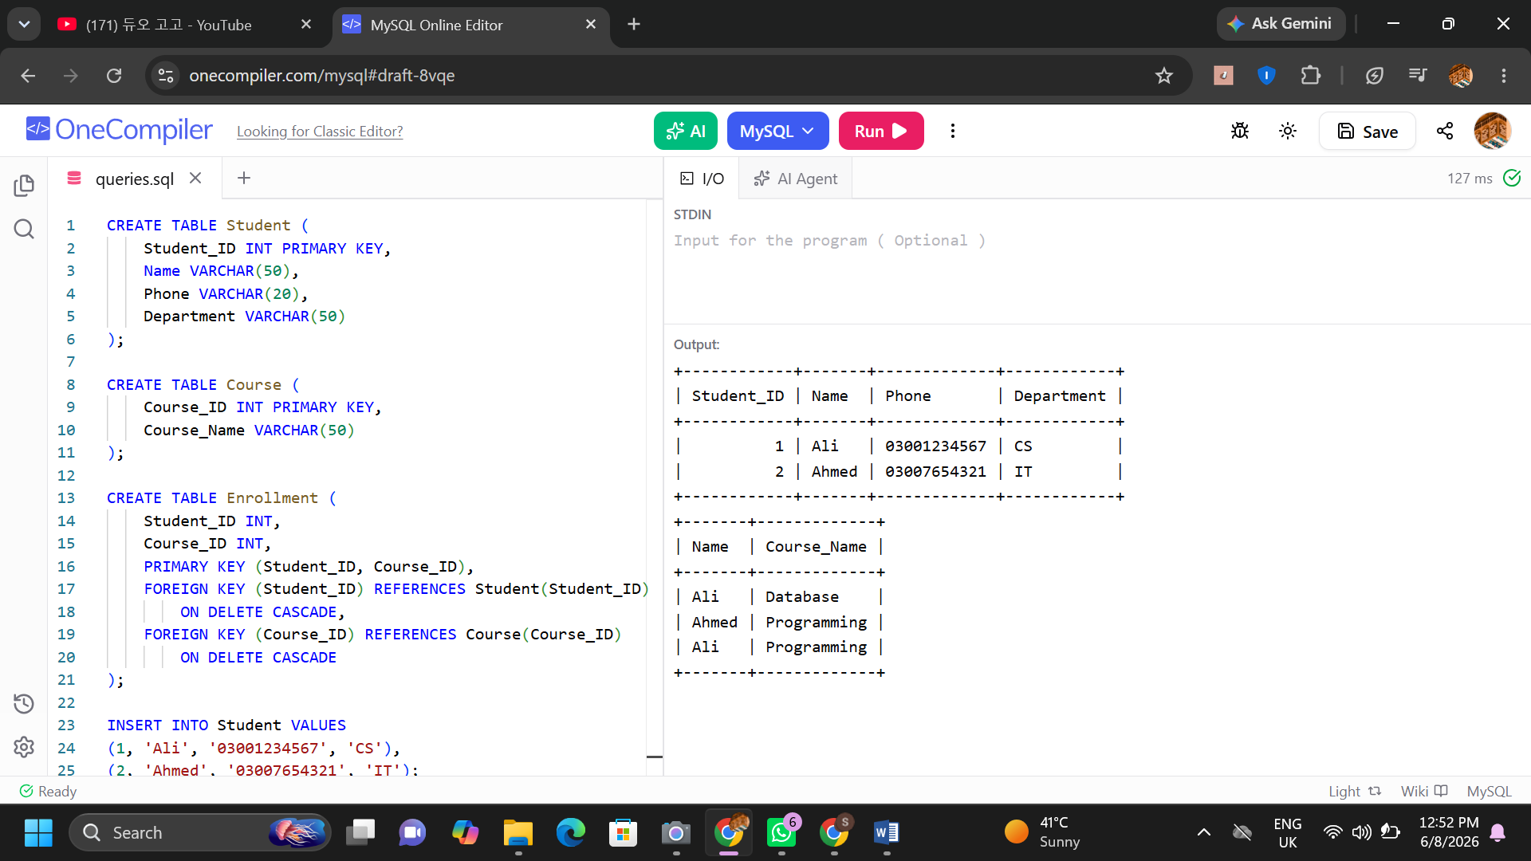Conclusion
Student Management System helps educational institutes manage student data efficiently, reduces manual work, improves accuracy, and provides quick access to records.

