Vehicle Rental Management System
Final Project Documentation - Database Systems
Field | Details
Project Title | Vehicle Rental Management System (VRMS)
Course | Database Systems
Program / Section | BSCS - Section B
Instructor | Ms. Ambreen Akmal
Institution | The University of Lahore
Submission Scope | Phase I and Phase II
Database / Tool | PostgreSQL 15+ / pgAdmin 4

Group Members
Name
Muhammad Usman Tariq
Fazal Shahbaz
Fahad Zubair

Main GitHub Repository: https://github.com/70191-dev/Vehicle-Rental-Management-System/

1. Project Scenario Description
The Vehicle Rental Management System (VRMS) is a relational database project that automates the operations of a vehicle rental agency. It maintains customer records, vehicle inventory, bookings, payments, and return details in a structured PostgreSQL database.
The system replaces manual ledgers and disconnected spreadsheets with a central database that reduces duplicate bookings, protects payment history, tracks vehicle availability, and supports useful business reports such as customer rental history and revenue by vehicle.

2. Problem Statement
- Manual rental records can cause double booking of vehicles for overlapping dates.
- Payment records may be lost or disputed when they are not linked to bookings.
- Vehicle availability is difficult to monitor without a current inventory status.
- Revenue reporting is slow when totals must be calculated by hand.
- Return condition and late fee records need an auditable database trail.

3. Database Design Overview
The database is normalized around five main tables. Each table has a primary key and the transactional tables are connected through foreign keys so the rental lifecycle remains consistent from booking to payment and return.
Table | Primary Key | Purpose
Customer | CustomerID | Stores customer personal and contact details.
Vehicle | VehicleID | Stores the vehicle fleet, rates, plates, and status.
Booking | BookingID | Links a customer with a vehicle for a rental period.
Payment | PaymentID | Records payments against bookings.
Return | ReturnID | Records actual return date, condition, and late fee.

4. Relationships
Relationship | Tables | Cardinality | Business Meaning
Makes | Customer to Booking | 1 : N | One customer can create many bookings.
For | Vehicle to Booking | 1 : N | One vehicle can appear in many bookings over time.
Has Payment | Booking to Payment | 1 : N | A booking can have multiple installment payments.
Ends With | Booking to Return | 1 : 1 | A completed booking has one return record.

Foreign keys used: Booking.CustomerID references Customer.CustomerID, Booking.VehicleID references Vehicle.VehicleID, Payment.BookingID references Booking.BookingID, and Return.BookingID references Booking.BookingID.

5. ERD and EERD
The ERD represents the five core entities and their relationships. The EERD extends the model with specialization: Customer is divided into Individual Customer and Corporate Customer, while Vehicle is divided into Car, Bike, and Truck.
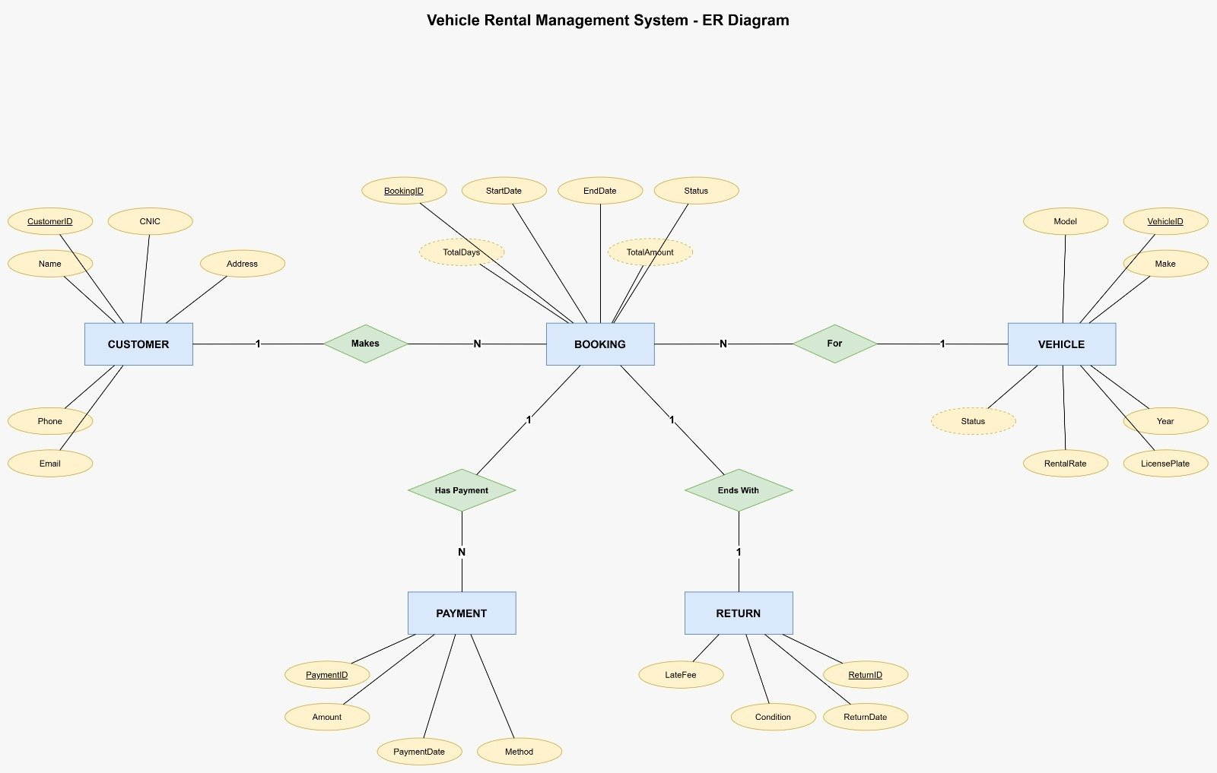
Figure 1: Entity Relationship Diagram (ERD)
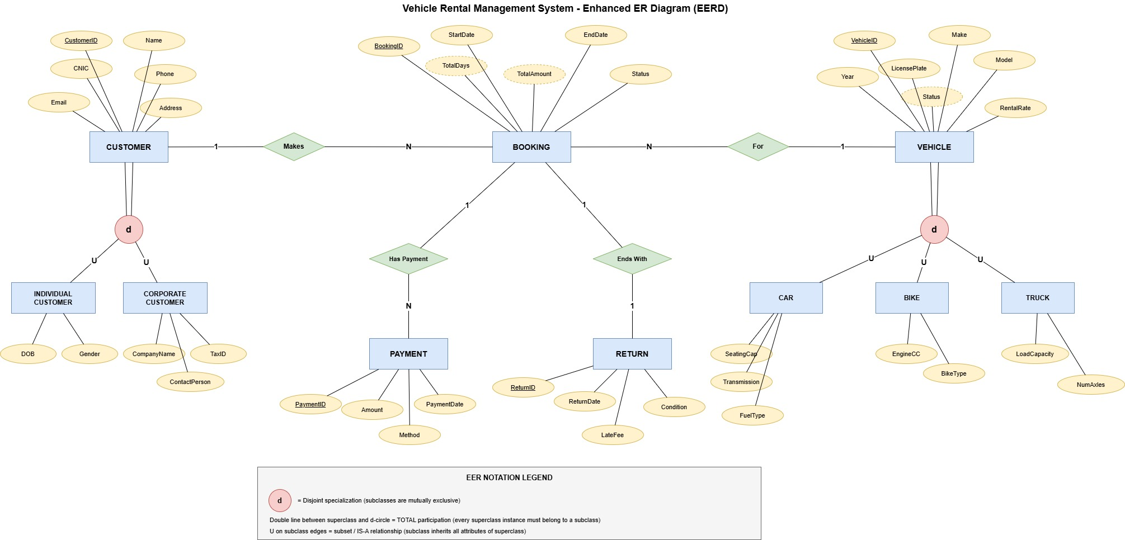
Figure 2: Enhanced Entity Relationship Diagram (EERD)

6. Phase 2 Functional Features
Phase 2 adds ten runnable SQL features in sql/04_features.sql. These features demonstrate real operations in the rental business and cover DML, DDL, and DCL requirements.
# | Feature | SQL Type | Output / Purpose
1 | Register a New Customer | INSERT | Adds a new customer record.
2 | Add a New Vehicle | INSERT | Adds a new rentable vehicle to inventory.
3 | Create a New Booking | INSERT | Creates a rental booking for a customer and vehicle.
4 | Search Available Vehicles | SELECT + WHERE | Filters available vehicles within a rate range.
5 | View Customer Rental History | SELECT + JOIN | Shows a customer's bookings with vehicle details.
6 | Record a Payment | INSERT | Stores payment details for a booking.
7 | Update Vehicle Status | UPDATE | Marks a vehicle as rented, available, or maintenance.
8 | Process Vehicle Return | INSERT + UPDATE | Logs return condition, late fee, and completes booking.
9 | Cancel / Delete a Booking | DELETE | Removes cancelled bookings.
10 | Revenue Report by Vehicle | SELECT + JOIN + GROUP BY | Aggregates total revenue per vehicle.

7. SQL Command Categories Covered

7.1 DDL - Data Definition Language
- CREATE TABLE statements define Customer, Vehicle, Booking, Payment, and Return in sql/01_schema.sql.
- ALTER TABLE adds RegistrationDate to Customer.
- CREATE OR REPLACE VIEW creates ActiveRentals for current active bookings.
- CREATE INDEX creates idx_vehicle_status to speed up vehicle status searches.

7.2 DML - Data Manipulation Language
- INSERT is used for customers, vehicles, bookings, payments, and returns.
- SELECT is used for searches, rental history, active rental views, and revenue reports.
- UPDATE is used to change booking and vehicle statuses.
- DELETE is used to remove cancelled bookings.

7.3 DCL - Data Control Language
- CREATE ROLE creates the rental_clerk database role.
- GRANT gives SELECT permission on project tables and temporarily allows INSERT on Booking.
- REVOKE removes the INSERT permission from Booking to demonstrate permission control.

8. SQL Script Execution Order
- Run sql/01_schema.sql to create the tables and constraints.
- Run sql/02_sample_data.sql to insert the sample records.
- Run sql/03_joins.sql to test Phase 1 join queries.
- Run sql/04_features.sql to execute the ten Phase 2 features and DDL/DCL examples.

9. Key SQL Evidence
The complete SQL is stored in the repository. The representative examples below show the important commands used in Phase 2.
INSERT INTO Customer (Name, CNIC, Phone, Email, Address)
VALUES ('Imran Sheikh', '35202-1112223-9', '0300-1112223',
'imran.sheikh@gmail.com', 'Wapda Town, Lahore');
SELECT c.Name AS Customer, b.BookingID, (v.Make || ' ' || v.Model) AS Vehicle,
b.StartDate, b.EndDate, b.TotalAmount, b.Status
FROM Booking b
JOIN Customer c ON b.CustomerID = c.CustomerID
JOIN Vehicle v ON b.VehicleID = v.VehicleID
WHERE c.CustomerID = 1;
CREATE ROLE rental_clerk LOGIN PASSWORD 'clerk123';
GRANT SELECT ON Customer, Vehicle, Booking, Payment, "Return" TO rental_clerk;
REVOKE INSERT ON Booking FROM rental_clerk;

10. Screenshots of Feature Outputs
The following screenshots were captured from pgAdmin after running each feature in sql/04_features.sql.

Feature 1: Register a New Customer
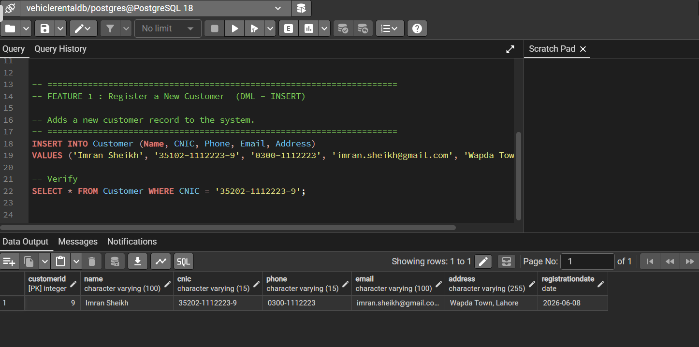
Screenshot 1: Feature 1: Register a New Customer

Feature 2: Add a New Vehicle
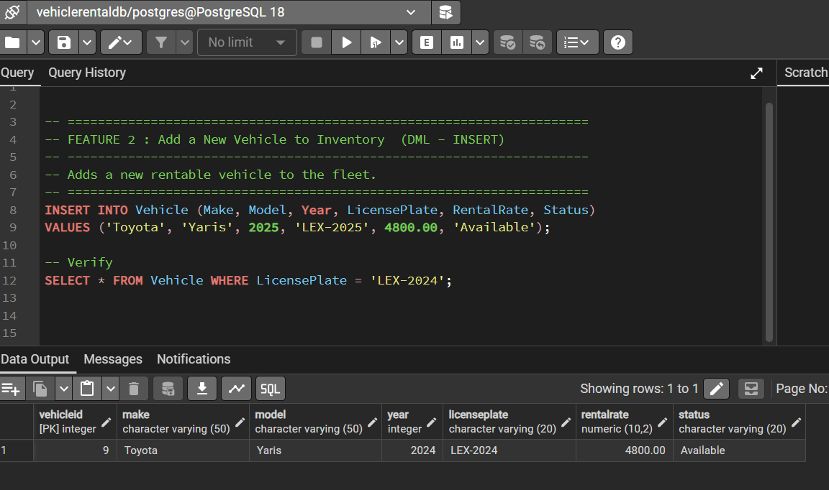
Screenshot 2: Feature 2: Add a New Vehicle

Feature 3: Create a New Booking
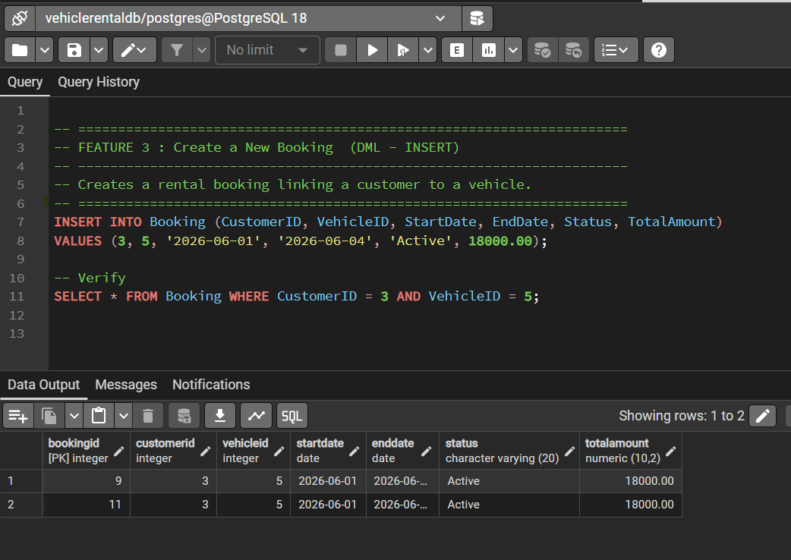
Screenshot 3: Feature 3: Create a New Booking

Feature 4: Search / Filter Available Vehicles
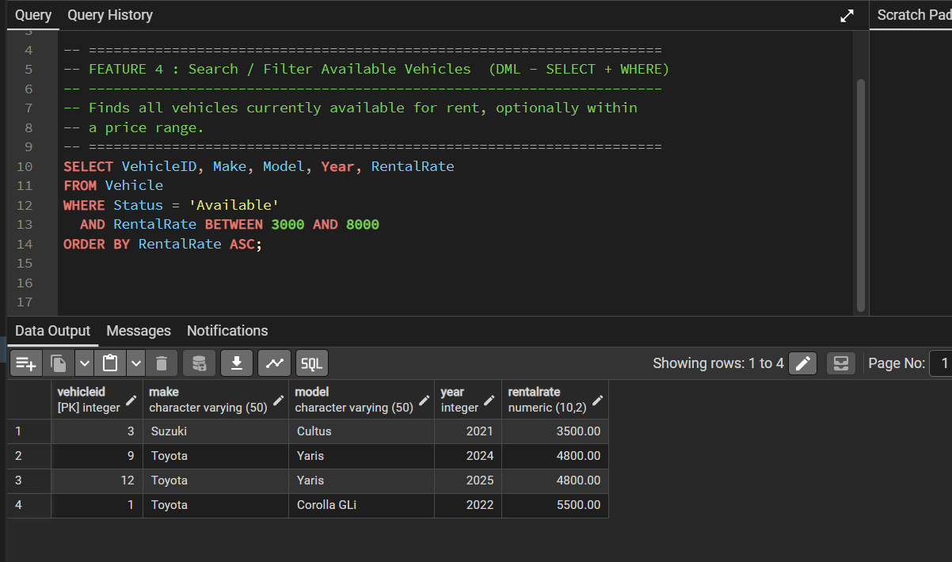
Screenshot 4: Feature 4: Search / Filter Available Vehicles

Feature 5: View Customer Rental History
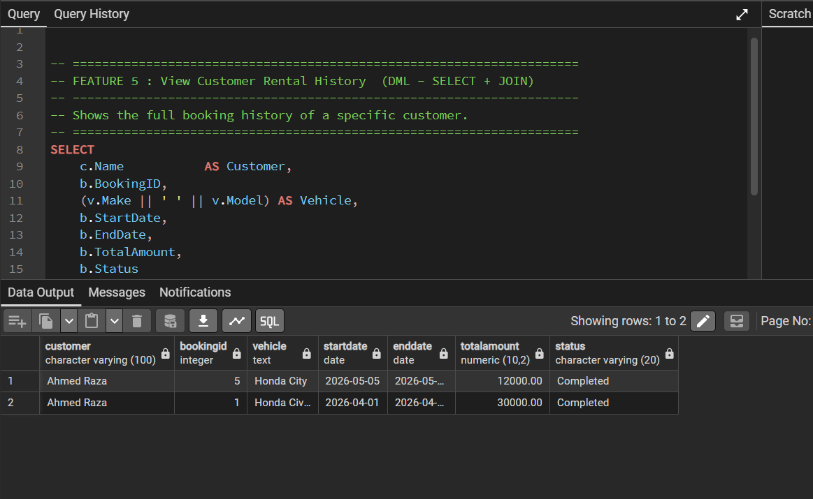
Screenshot 5: Feature 5: View Customer Rental History

Feature 6: Record a Payment
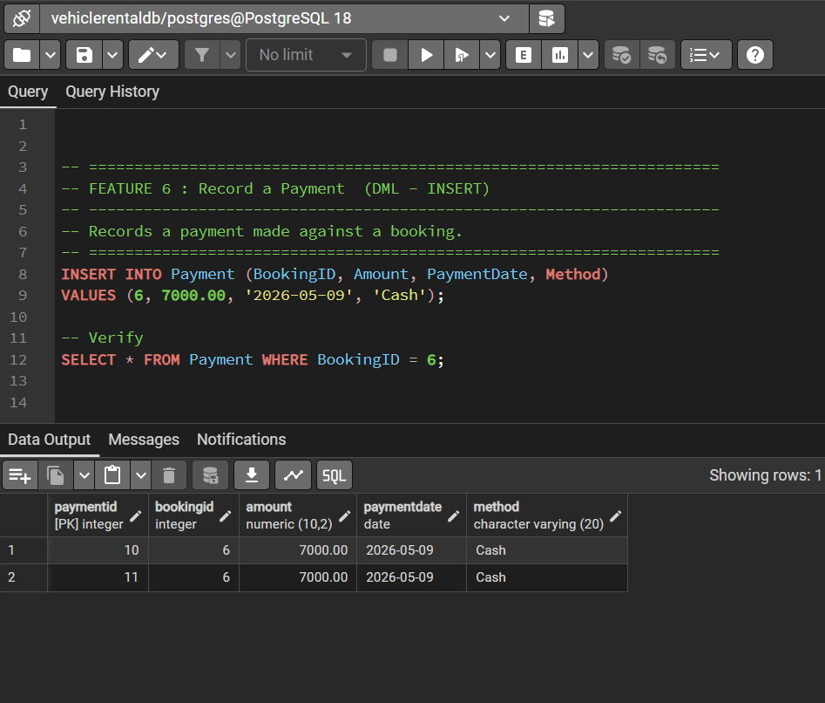
Screenshot 6: Feature 6: Record a Payment

Feature 7: Update Vehicle Status
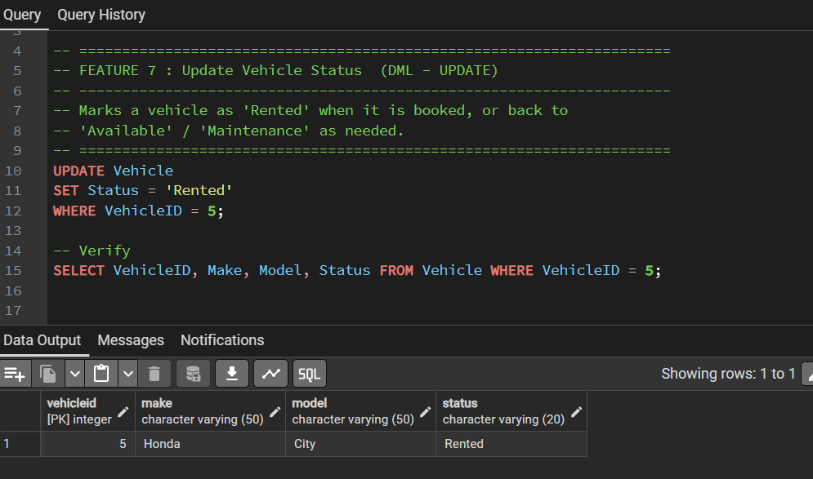
Screenshot 7: Feature 7: Update Vehicle Status

Feature 8: Process a Vehicle Return + Late Fee
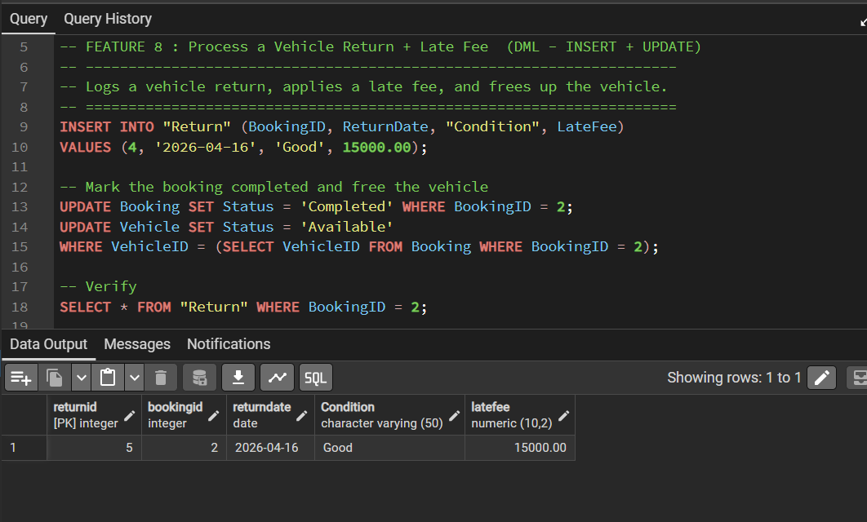
Screenshot 8: Feature 8: Process a Vehicle Return + Late Fee

Feature 9: Cancel / Delete a Booking
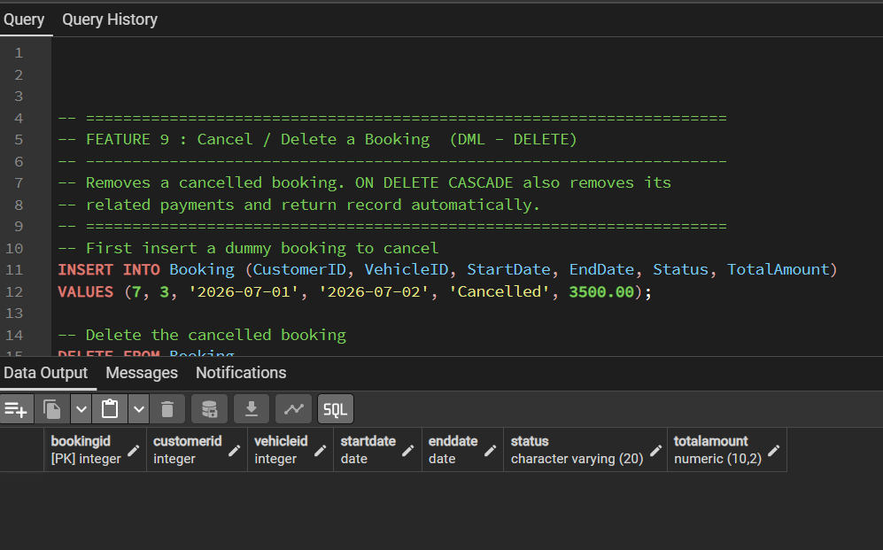
Screenshot 9: Feature 9: Cancel / Delete a Booking

Feature 10: Revenue Report by Vehicle
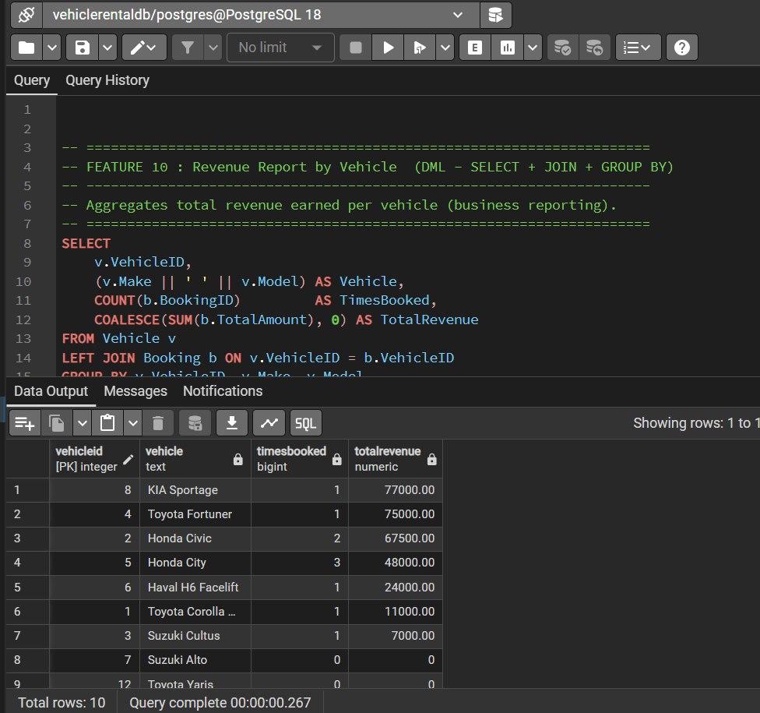
Screenshot 10: Feature 10: Revenue Report by Vehicle

11. DCL Output Evidence
This screenshot verifies the DCL section that creates, grants, and revokes permissions for the rental_clerk role.
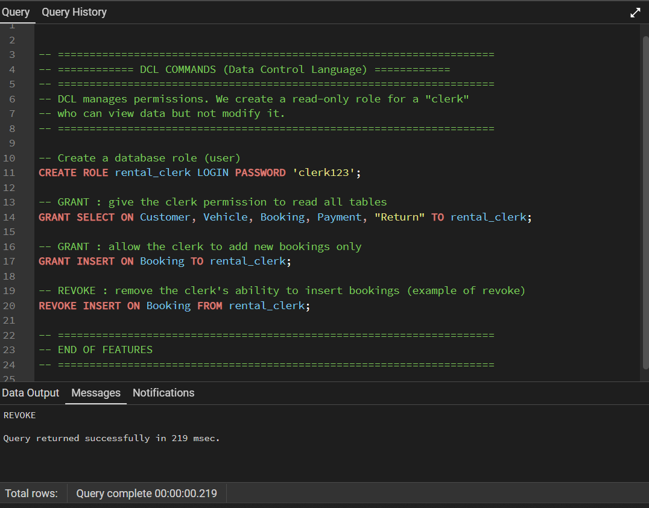
Screenshot 11: DCL role and permission commands

12. Conclusion
The Vehicle Rental Management System demonstrates a complete relational database workflow for a realistic rental business. The project includes normalized schema design, ER/EER modeling, sample data, join queries, ten Phase 2 functional SQL features, DDL/DML/DCL command coverage, and pgAdmin screenshots proving the query outputs.

