**(PART - B)**

|  |  |
| --- | --- |
| Roll.No. : C117 | Name: Aadee Sawarkar |
| Sem/Year : IV/2 | Batch: C2 |
| Date of Experiment : 11/03/2022 | Date of Submission: 11/03/2022 |
| Grade -- |  |

# B.1: Procedure of performed experiment

Flowcharts to be drawn:

* To Find simple interest

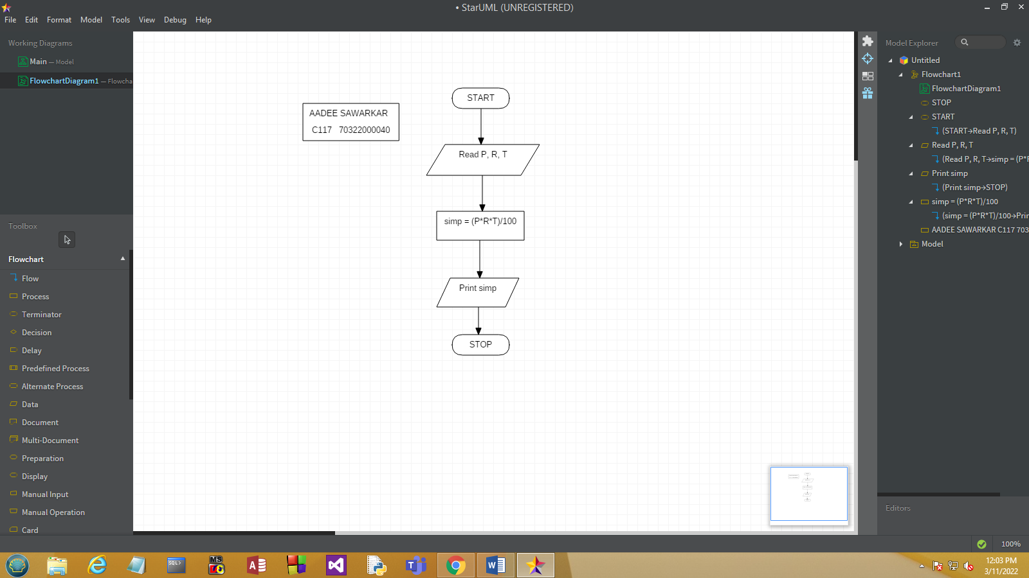

* To Find area of a circle

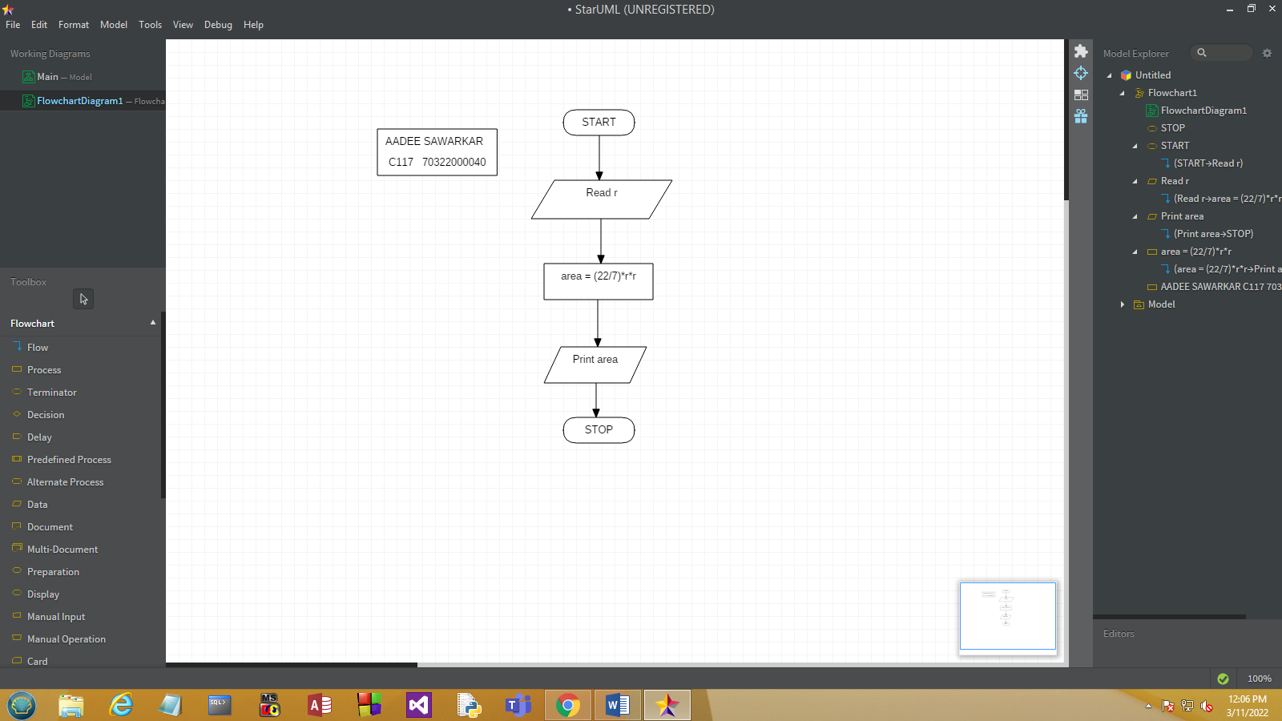

* To Find sum of digits of a given integer number

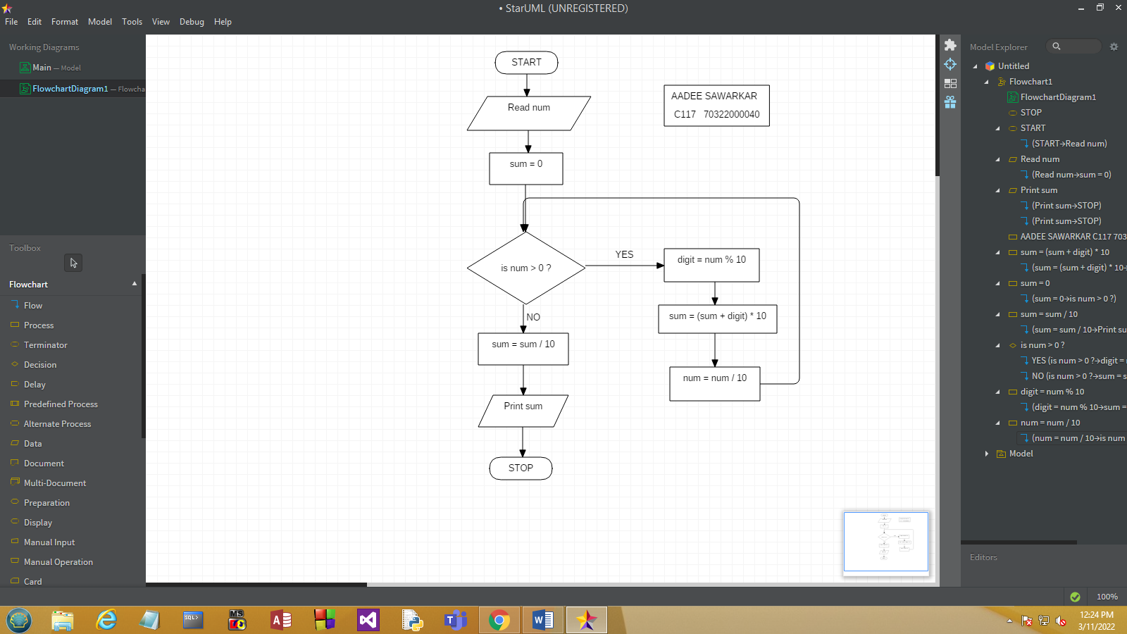

* To check whether a given number is divisible by 3 and 7 or nor

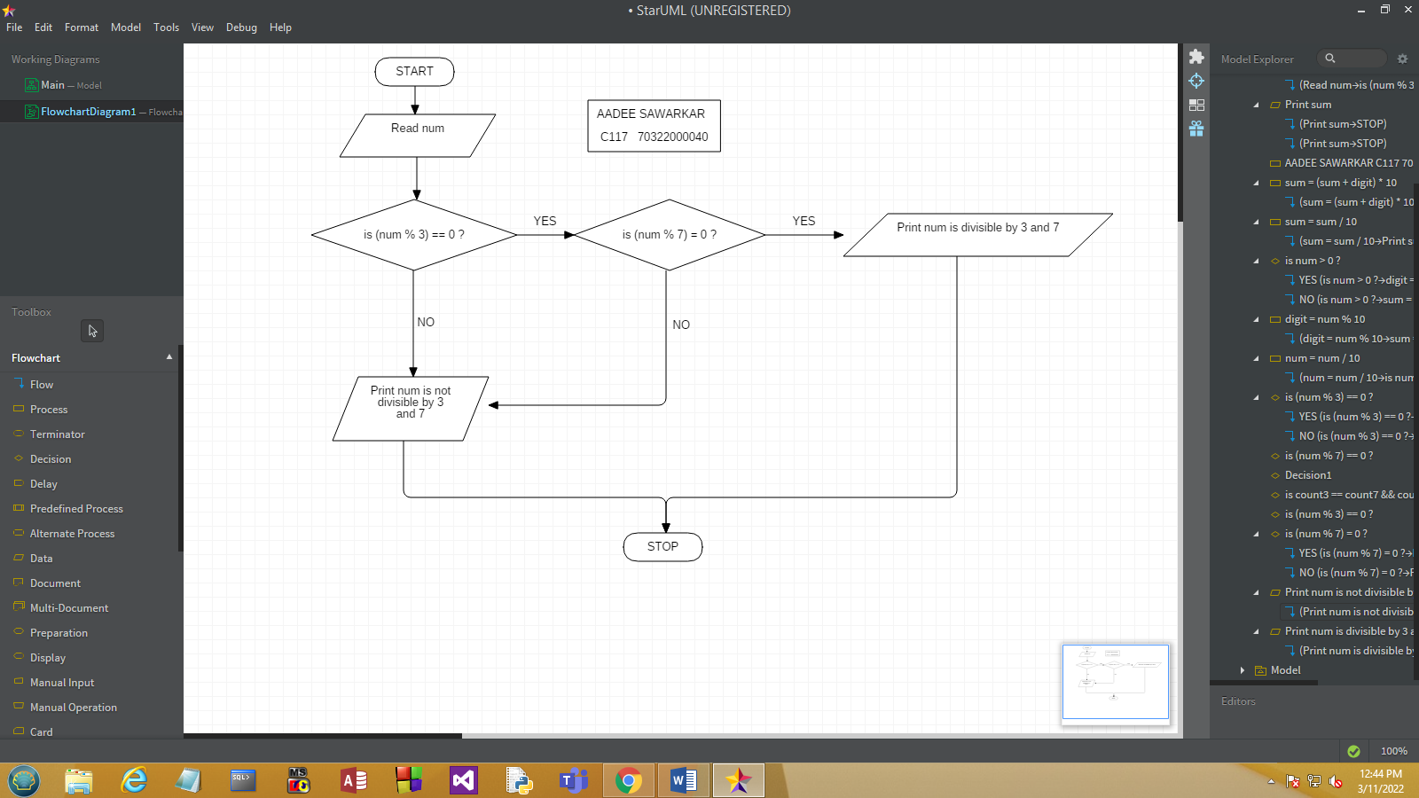

* To check whether the given number is prime number or not

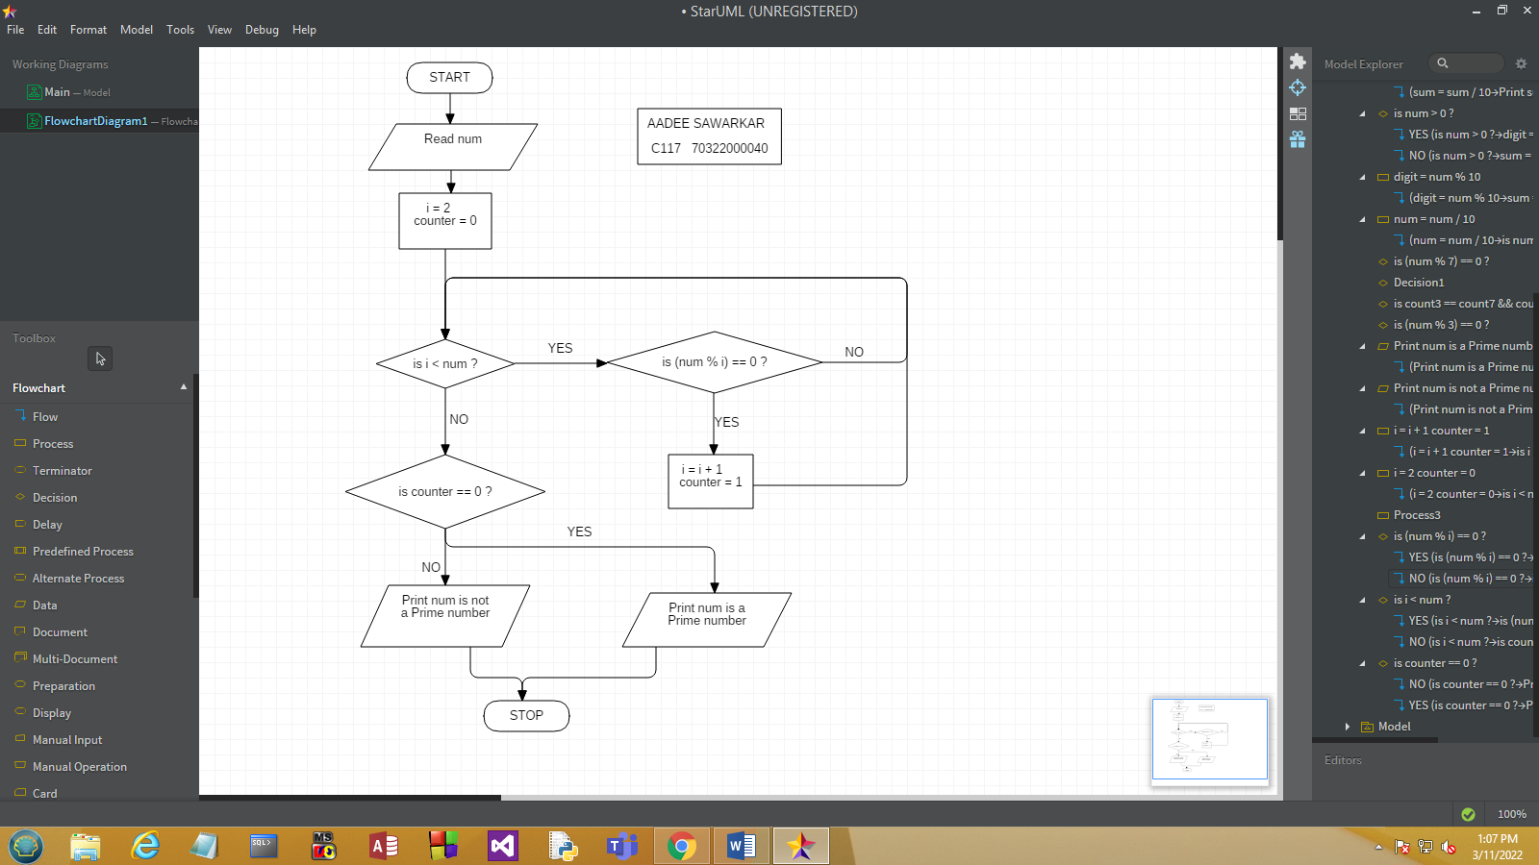

* To print all prime numbers in the given range.

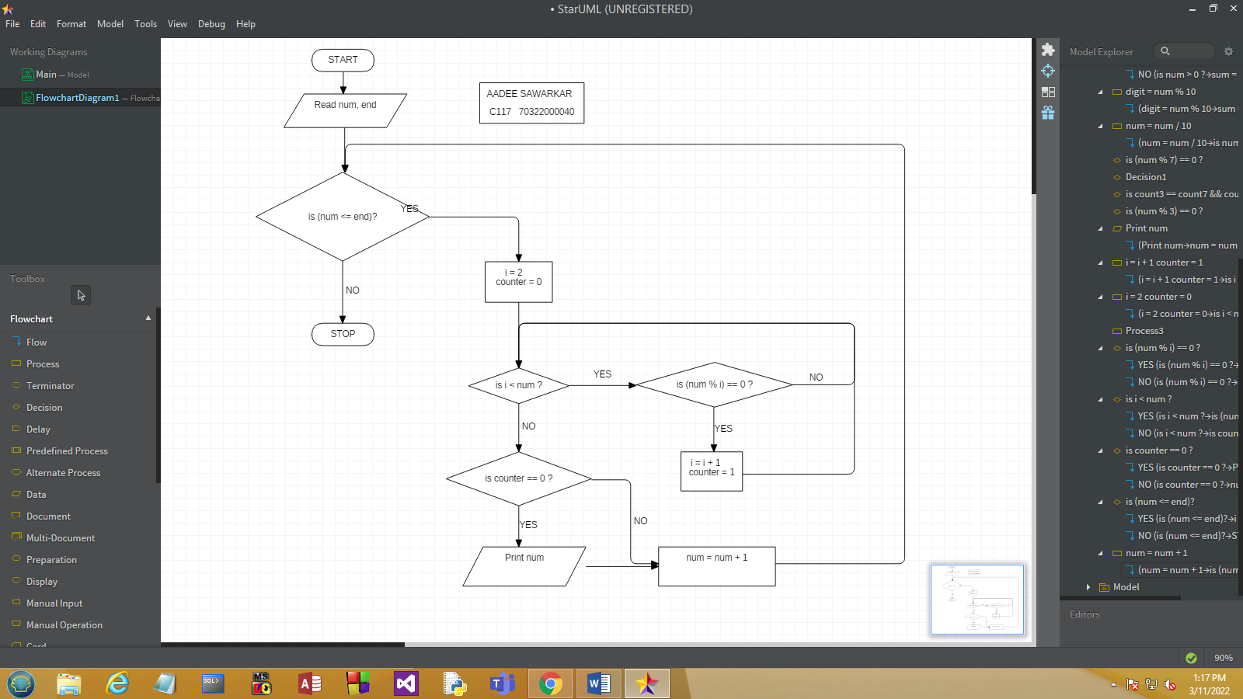

# B.2: Observations and Learning’s:

Drew flowcharts for the following:

* 1. To find simple interest
  2. To find area of a circle
  3. To find sum of digits of a given integer number
  4. To check whether a given number is divisible by 3 and 7 or nor
  5. To check whether the given number is prime number or not
  6. To print all prime numbers in a given range.

# B.3: Conclusion:

Learnt how to draw flowcharts on StarUML software