**Respiration in Organisms**

**<H1> Learning Outcomes**

* To know about respiration and its types
* To understand the steps of respiration
* To understand human respiratory system
* To know about the mechanism of breathing
* To learn about respiration in other animals and plants

**<H1> Let’s Begin**

Have you ever noticed that after every activity the person starts breathing faster? Why is it so? What is the reason behind faster and vigorous breathing after heavy exercise? Is breathing a part of respiration? Let us explore more about this in the chapter.

**<H1> Respiration**

Breathing is a part of respiration. Breathing is the physical process of intake of oxygen and release of carbon dioxide through inhalation and exhalation. Respiration is the chemical process, which involves energy release from the breakdown of food.

We require a continuous supply of energy for life processes. We get this energy through the process of respiration. Oxygen required by the cells for breakdown of food and release of energy, is provided by inhalation of oxygen rich air. The nutrients present in digested food react with oxygen to release energy. This reaction of food with oxygen is called oxidation.

**<H1> Steps of Respiration**

When food is broken down, carbon dioxide and water are released. These waste products are released out from the body through exhalation. Inhalation and exhalation of air to take in oxygen and to eliminate carbon dioxide from the body respectively is breathing or external respiration. The use of oxygen for breakdown of food to release energy is the cellular respiration or internal respiration and it takes place in the body cells.

**<H1> Human Respiratory System**

The respiratory tract consists of nostrils, nasal cavity, trachea and bronchi. These together with lungs form the human respiratory system.

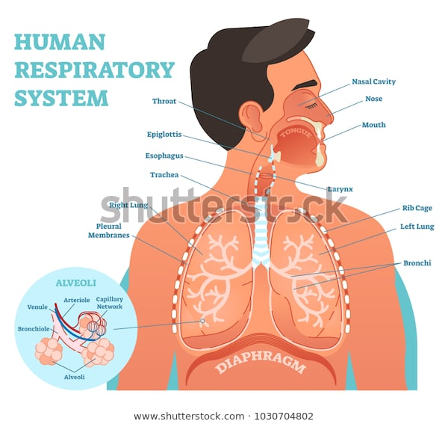Nose is the initial opening for the respiratory system, made of bone, muscle, and cartilage. The nasal passage is lined with mucus-secreting cells and hair, which keep the passage moist and trap dust particles and germs, there by preventing them from entering the respiratory tract. The air breathed in, passes from **nostrils** through the **pharynx** to the windpipe or trachea. **Trachea** is a tube which is made of cartilaginous rings. It branches into two smaller tubes called **bronchi**, each connected to the left and right lung. These bronchi after entering into the

lungs get branched further and become **bronchioles**. Bronchioles again branch to form a network that finally ends into alveolar ducts. Show image of human respiratory system.

Each alveolar duct is connected with thin-walled alveolar sacs. **Alveoli** are the functional units of lungs. Each alveolus is richly supplied with blood capillaries. **Lungs** are the pair of organs which occupy the thoracic region. They are protected by the rib cage and sternum in the front, by the vertebral column at the back and by a **diaphragm** at the bottom. Surrounding each lung is a double-walled sac called a pleural membrane.

|  |
| --- |
| **Let’s Check**  **Fill in the blanks**   1. Breathing is a part of ____________. 2. The use of oxygen for breakdown of food to release energy is the **________** respiration**.** 3. _________ is the initial opening for the respiratory system. 4. **_________** are the functional units of lungs. 5. _________ transports oxygen to all the cells of the body. |

**<H1> Mechanism of breathing**

Breathing is a continuous process and involves inhalation or taking in of oxygen rich air and exhalation or giving out of carbon dioxide rich air. A breath means one inhalation and one exhalation. The number of times a person breathes in a minute is called **breathing rate**.

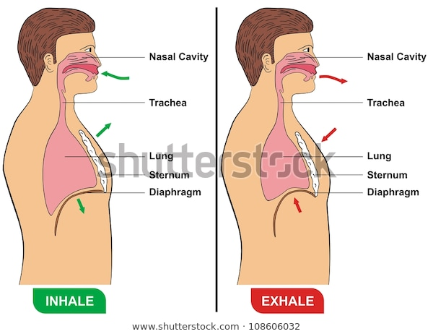Breathing rate of a person varies during different activities. We breathe faster after a run while we breathe slowly when we are at rest. It is so because our body cannot get enough oxygen to produce energy during physical exercise. When we need extra energy after a physical exercise, we breathe faster to supply more oxygen to our cells. This speeds up the breakdown of large amount of food reserves to provide more energy. That is why we generally feel hungry after heavy exercise.

Show image of 'mechanism of breathing' a. inhalation , b. exhalation.

When we inhale air, ribs move up and outwards while diaphragm moves down. Due to this, the space in the chest cavity increases and air enters into the lungs. When we exhale air, ribs move down and inwards while the diaphragm moves up. This movement reduces the space in chest cavity and air is pushed out of the lungs. This facilitates intake of oxygen and exhalation of air rich in carbon dioxide.

|  |
| --- |
| **Facts Corner**  Your sneeze travel up to 100 miles per hour. |

**<H1>Exchange of Gases in Alveoli**Oxygen and carbon dioxide are exchanged by [diffusion](https://en.wikipedia.org/wiki/Diffusion) between the external gaseous environment and the [blood](https://en.wikipedia.org/wiki/Blood). This exchange of gases occurs in the [alveoli](https://en.wikipedia.org/wiki/Pulmonary_alveolus) or air sacs in the lungs. When air rich in oxygen enters the lungs and reaches the alveoli, oxygen moves across from the inhaled air to the blood. It then combines with the red colour pigment called haemoglobin present in the blood. Blood transports oxygen to all the cells of the body. Carbon dioxide, the waste product of respiration, present in the blood diffuses into the air sac or alveoli and is exhaled into the air through the nose.

The walls of the alveoli are extremely thin, to allow for the exchange of oxygen and carbon dioxide in the lungs. There are about three million alveoli present in the lungs.

|  |
| --- |
| **Facts Corner**  Our right lung is bigger than the left lung and both are quite big in size. |

|  |
| --- |
| **Activity**  To understand the mechanism of breathing through lungs  **Materials required**  A balloon  Glass tube  Bell jar  A rubber cork with a single hole  One rubber sheet  **Procedure**  Making Breathing MechanismTake a balloon and fix it to the arm of glass tube. Pass the upper end of the glass tube through the hole of rubber cork. Now take a bell jar and fix the rubber cork along with glass tube. Tie the rubber sheet tightly around the rim of the base of bell jar and pull it down. In this experiment, balloon act as lungs and rubber sheet acts as diaphragm.  You will observe that when the rubber sheet is pulled down, the space in the bell jar increases and the air pressure inside the bell jar reduces. Due to this decrease in pressure, air from the outside enters the balloon. By relaxing the rubber sheet, the space in the bell jar decreases and the air pressure inside increases. So the air from balloon is pushed out and the balloon gets deflated.  **Conclusion**  The inflation and deflation of lungs is caused by the movement of thoracic diaphragm. |

**<H1> Cellular Respiration**

The oxygenated blood goes from lungs to the heart through blood vessels. The heart then pumps this blood to all tissues of the body through arteries. These arteries further subdivide into capillaries, which supply oxygen to the cells of the body for the oxidation of food. In the cell, energy is obtained by breaking down sugars into carbon dioxide and water in the presence of oxygen. This process is called cellular respiration or tissue respiration.

The carbon dioxide is now absorbed by the blood capillaries and is sent back to the lungs where it is expelled out through exhalation.

The path of oxygen in humans during respiration is,

Nostrils→ Nasal cavity→ Pharynx → Trachea → Bronchi → Bronchioles → Alveoli→ Blood→ Cells

**<H1> Types of Respiration**

There are two types of respiration, aerobic and anaerobic.

In a cell, food in the form of glucose reacts with oxygen and is broken down into water and carbon dioxide to release energy. The breakdown of food in the presence of oxygen is called **aerobic respiration**. This chemical reaction is given as,



Food can be broken down in the absence of oxygen also. This type of respiration is called **anaerobic respiration**. In the absence of oxygen, food is broken down into carbon dioxide and ethanol or alcohol. There are some unicellular organisms such as yeast, which live in the absence of oxygen. These organisms are anaerobes and produce energy through anaerobic respiration.

**C:\Users\Administrator\Desktop\Capture.PNG**

Anaerobic respiration also occurs in our muscle cells, when there is temporary deficiency of oxygen resulting from activities such as fast running, brisk walking for hours or cycling. In the course of these heavy exercises energy is used in large amount but the supply of oxygen is limited. Thus, to produce energy, muscle cells carry out anaerobic respiration in which glucose is broken down in the absence of oxygen and lactic acid and energy is produced.

C:\Users\Administrator\Desktop\Capture.PNG

|  |
| --- |
| **Let’s Check**  **Mark the given sentences T for true or F for false.**   1. The number of times a person breathes in a minute is called inhalation. 2. When we inhale air, ribs move down and inwards while diaphragm moves up. 3. The breakdown of food in the presence of oxygen is called aerobicrespiration**.** 4. In anaerobic respiration, lactic acid is released along with energy in anaerobes. 5. Anaerobic respiration also occurs in our muscle cells. |

**<H1> Respiration in Other Animals**

There are different ways of gaseous exchange in different animals.

* **Cell membrane**

In unicellular organisms such as amoeba , exchange of gases occurs through their cell membrane.

Show respiration in amoeba. 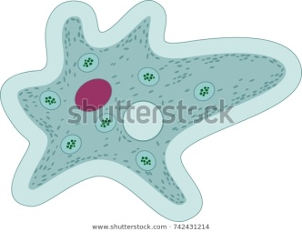

* 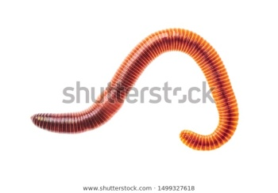**Skin**

Amphibians such as frog, salamander and newts use their skin as a respiratory organ when in water and respire through lungs when on land. Gaseous exchange in earthworms and leeches occurs through the moist and slimy surface of their skin.

Earthworm

* **Air holes**

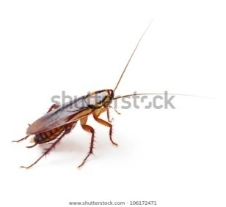Insects such as cockroaches and grasshoppers have openings or spiracles on the side of their bodies. Air entering through these openings reaches all body parts through tubes called tracheal tubes and their branches called tracheoles.

show image of respiration in insects.

* **Gills**

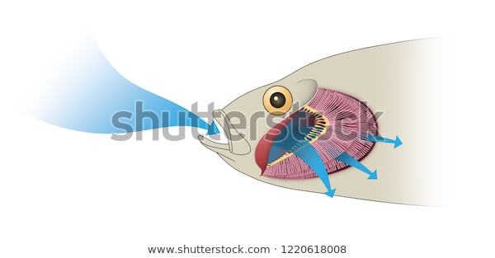The gills in fishes increase the surface area for exchange of gases. Gills have a large number of filaments and are richly supplied with thin capillaries. When water enters through the mouth of fishes, it flows over the gills. The blood in capillaries of the gills absorbs oxygen and gives out carbon dioxide through its walls.

Show image of respiration in fish.

* **Lungs**

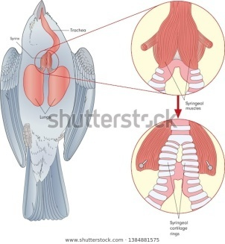Most mammals such as horse, birds, monkey, cat, dog, humans, etc respire through lungs. Tadpoles breathe through gills but when they grow up to become frogs, they breathe through lungs and skin.

Show image of respiration in frog.

**<H1>Respiration in Plants**

Similar to other organisms, plants also take in oxygen and give out carbon dioxide. Gaseous exchange in plants occurs through small pores called stomata present on the stem and leaves of plants. Stomata consist of guard cells. Contraction and expansion of guard cells regulate the closing and opening of stomata for exchange of oxygen and carbon dioxide.

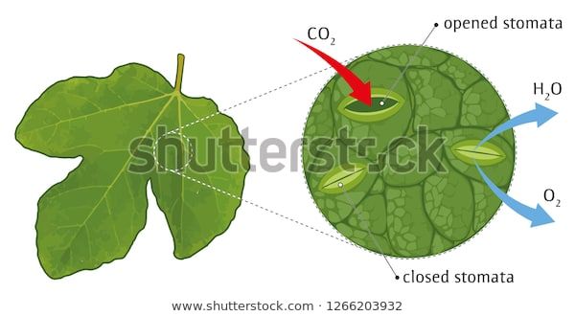

Show image of stomata.

Root cells of plants obtain oxygen from air trapped between soil particles. That is why we should not water plants excessively because water replaces the oxygen present in the soil, as a result of which plants cannot breathe.

Mangrove trees have aerial roots to obtain oxygen as they grow in swampy areas where the roots cannot get air from the waterlogged soil.

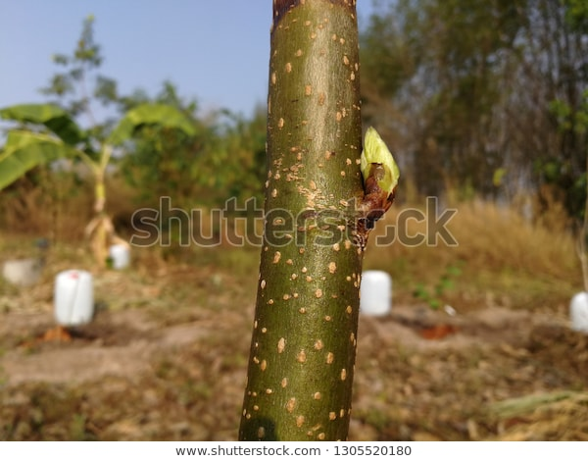Lenticels are small openings or loosely placed cells present on the stems of plants. These cells allow the gaseous exchange of respiratory gases between air and living cells of the woody stem.

Show image of lenticels.

|  |
| --- |
| **Activity**  **To understand that the plants respire through stomata**  **Materials required**  A leafy plant (rose plant)  Petroleum jelly  **Procedure**  Place the plant in a dark room for 5-6 days so that no photosynthesis takes place. Now coat the underside of any two leaves with petroleum jelly. Now, place the plant under the bright sunlight for 5-6 days.  You will observe that the leaves coated with petroleum jelly begin to die.  **Conclusion**  Photosynthesis does not occur in the leaves coated with petroleum jelly because there was no way for air to enter. |

|  |  |  |  |  |  |  |  |  |  |  |
| --- | --- | --- | --- | --- | --- | --- | --- | --- | --- | --- |
| **Let’s Check**    **Match the following.**   |  |  | | --- | --- | | **Column I** | **Column II** | | Frog | Spiracles | | Cockroaches | Cell membrane | | Plants | Lungs and moist skin | | Earthworms | Stomata, lenticels and root | |

**<H1> Let’s Look Back**

**<H1> Let’s Revise**

**A. Choose the correct option**

1. The ribs move __________ during the process of exhalation.

a. Up and inwards

b. Down and inwards

c. Up and outwards

d. Down and outwards

2. Which of the following activity require minimum amount of energy?

a. Running

b. Walking

c. Sleeping

d. Cycling

3. The air that we breathe in passes to the tiny sacs is called

a. Bronchi

b. Alveoli

c. Pharynx

d. Bronchioles

4. Taking of air rich in oxygen inside the body is called

a. Exhalation

b. Inhalation

c. Respiration

d. Excretion

5. Frogs respire through which of the following?

a. Lungs

b. Moist skin

c. Gills

d. Both a. and b.

**B. Very short answer questions**

1. Why our nostrils possess hairs and mucous?

2. Name the pigment in blood that transports oxygen.

3. Give example of organisms which respire through anaerobic mode.

4. Is the rate of breathing same for the entire respiring organism?

5. Name the small opening present on the sides of the body of insects for gaseous exchange.

**C. Short answer questions**

1. How is breathing different from respiration?

2. Why do we breathe faster during heavy exercises?

3. Why is it suggested to cover our nose while we sneeze?

4. What happens when we overwater the plants?

5. Write about the role of gills in fishes?

**D. Long answer questions**

1. Explain the difference between aerobic and anaerobic respiration.

2.Describe the process of gaseous exchange in humans.

3.Draw a well labelled diagram of human respiratory system.

4. Explain the mechanism of breathing including the movement of ribs and diaphragm.

5. Plants respire through stomata. Explain with the help of an activity.

|  |
| --- |
| **Let’s Think**  Why is it impossible to sneeze with your eyes open? |

|  |
| --- |
| **Life Skills**  We know that plants and trees are the lungs of our planet. We must water the plants whenever possible in our house, society and school. |

|  |
| --- |
| **Weblinks**  <https://www.britannica.com/science/respiration>  <https://www.britannica.com/science/stomate> |