Access block
Project title: Reception Baseline — a base-rate locator for expected Steam reception
Student: ____________________
Student identifier: ____________
Phase: Phase 1 — media analytics and product justification
Repository: _(GitHub URL to be entered by the student)_
Collaborator: fffchaobu — invited _(date)_ — status _(pending / accepted)_
Submitted release / tag: phase1-analytics
Full commit identifier: _(to be entered by the student at tag time)_
What Predicts a Steam Title's Positive Review Rate?
Opportunity and Alternatives
Small studios and self-publishers must decide how to position a title with no external reference for how it will be received. Steam publishes a score on every store page but never the distribution behind it, so a developer cannot tell whether expecting a 0.75 positive review rate is ordinary caution or a warning sign. Two products were compared. Concept A, a reception benchmark, would place an expectation inside the market distribution. Concept B, a cross-market reception gap detector, would flag divergence between language communities. Concept B was rejected on measurement grounds: the rate is computed within each community's own voting pool, so a community-to-community difference confounds reception with the composition of reviewers, and no further collection from the same endpoints could separate the two.
Data and Model Rationale
The sample is 159 Steam titles released from 2024-11-14 to 2026-10-09, drawn as a quota sample over 6 genre tags crossed with 9 release quarters. The unit of analysis is one title; each row is a distinct application. Candidates were screened for release date and review count directly from the store search response, so per-title metadata calls were spent only on titles already known to be inside the window. Records come from the documented public review-summary and app-details endpoints, retrieved at one declared timestamp with a fixed request interval and no rate-limit workaround.
The outcome is the title-level positive review rate, total positive divided by total positive plus total negative. Being a proportion bounded in [0,1], it is estimated by fractional logit: a generalised linear model with a binomial family and a logit link, which keeps fitted values inside the permissible range where a linear model would not. The focal predictors are free-to-play status and release age, the latter with a squared term because the mechanism need not be linear. The log review count controls for how precisely each rate is estimated, and the sampling tag controls for genre. Both specifications were declared before execution and both are reported.
Results, Uncertainty and Robustness
The analysis does not support a predictive product. Across 159 titles the mean rate was 0.823 with a standard deviation of 0.124. Paid titles averaged 0.825 on 124 titles against 0.817 on 35 free-to-play titles, and the free-to-play group's median was in fact the higher of the two. Table 1 sets out the principal estimates with their uncertainty and their robustness checks, which is the whole of the evidence this decision rests on:
Table 1. Principal estimates, uncertainty, and robustness checks.
Estimate | Logit coef. | SE | p | Robustness
is_free | -0.095 | 0.522 | 0.856 | -0.439 weighted; -0.332 settled
age_years | +0.434 | 1.318 | 0.742 | -0.268 settled; sign flips
multiplayer_emphasis | -0.486 | 0.549 | 0.376 | n = 28; model 2 only
Pseudo-R² (Cox–Snell) | 0.007 | — | — | attributes explain under 1% of variation
Pearson χ²/dof | 0.103 | — | — | no overdispersion; no influential titles

The interval is the finding rather than an inconvenience. The free-to-play marginal effect is minus 0.014 with a 95% interval from minus 0.161 to plus 0.134, so the sample cannot detect an effect of a size a developer would act on, and cannot rule one out either. Dispersion is low and no title is influential, which shows the residual variance matches the assumed variance rather than showing that the model is informative. Figure 1 shows the same result without a model: the reference distribution the product will use.
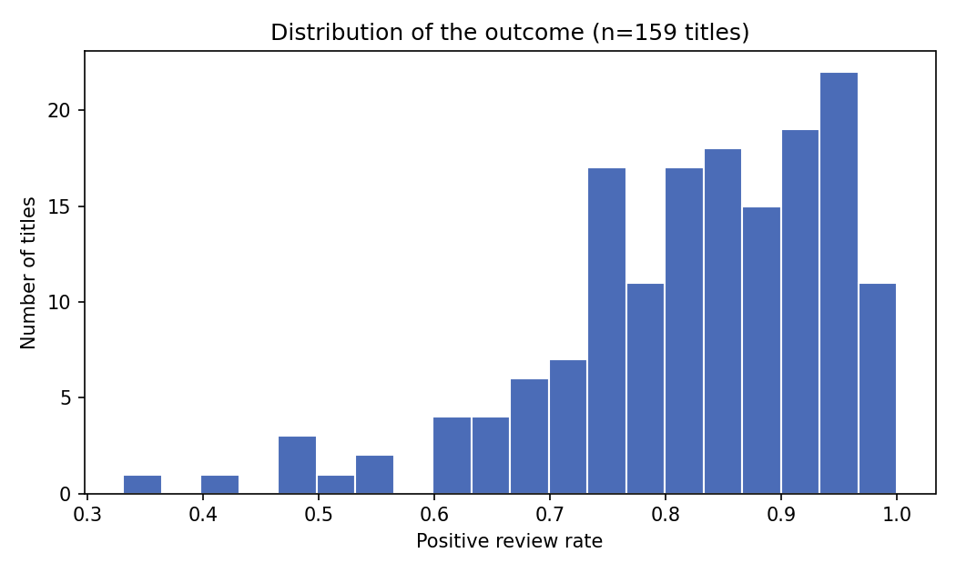
Figure 1. Distribution of the positive review rate across 159 titles. The product reports a user's expected rate as a position in this distribution.
Robustness checks move the focal estimate materially without changing the conclusion: the free-to-play coefficient ranges from -0.095 unweighted to -0.439 when weighted by review count and -0.332 when titles under six months old are excluded, while the age term moves from +0.434 to -0.268 and changes sign. No specification makes either predictor distinguishable from zero.
One pattern deserves follow-up rather than a product claim. Titles whose core loop is social or competitive average 0.769 against 0.835 for single-player-led titles, on 28 titles, a logit coefficient of minus 0.486 (p = 0.376). It is the largest gap anywhere in the analysis and consistent in sign, but it is not significant at this sample size. A power calculation puts the sample needed to detect it at roughly ten times the present size, beyond the range this project was scoped to, so it was not pursued.
Development Decision and Why This Project
The evidence justifies a benchmark rather than a predictor, and a narrower benchmark than first proposed. Because the attributes explain under one per cent of the variation, a tool emitting a predicted score for an unreleased title would restate the sample mean while appearing to say something specific about that title. A conditional benchmark fails too, and on its own terms: the unconditional interquartile range is 0.755 to 0.920, a width of 0.165, while the six genre medians span only 0.825 to 0.867, a width of 0.042. A user selecting a genre would watch the answer stay still, which is a broken interaction rather than a cautious one, so those inputs were removed.
The project to develop is Reception Baseline, a media app for small studios and self-publishers preparing a launch. The user enters the positive review rate they expect and learns its percentile among comparable recent titles, read against the full distribution with its sample size shown. The tool then lists the real titles nearest that position, each linking to its Steam store page, so the task ends in content rather than in a number: a developer can open ten comparable games and judge them directly. Two view controls adjust that list only: how many titles to show, and a minimum review count. The second is not neutral — a 500-review floor raises the listed set's mean from 0.823 to 0.864 — so the interface states it. The percentile always uses the full reference set. The mechanism responds to its input: a rate of 0.70 sits at the 14th percentile and 0.90 at the 67th. It is preferable to Concept B because Concept B's comparison cannot be measured from this data at all, whereas this one is measured directly. The supported features are the percentile position with its distribution, the comparable-title discovery list, and a scope statement naming the attributes that were tested and found not to explain the variation. The model does not run in the interface; it determined which outputs are honest to offer, which is why no predicted value appears anywhere. What remains an assumption is that a developer finds a population position and its nearest neighbours useful without any attribute conditioning. That is untested here, because this study observes titles rather than developer behaviour, and it is the assumption the Phase 2 pilot must test.
Limitations
Power is the main constraint: with 35 free-to-play titles the intervals are wide, so not significant means not detected. The 50-review floor excludes releases that attracted almost no attention, plausibly the worst received, so the reference range is optimistic at the bottom. Rates were retrieved at a single timestamp, leaving drift over time unobserved. Developer reputation, marketing spend and launch quality are unmeasured and plausibly correlated with both business model and reception. The gameplay feature is derived from the provider's category list rather than hand-verified for every title. The design supports association, not causal identification, and an excluded title is unobserved rather than a zero.
References
Byers, T., Gibbs, M., & Nansen, B. (2025). Evaluating time in play and temporal satisfaction: Time-centric language in video game user reviews on Steam. In Proceedings of the 37th Australian Conference on Human-Computer Interaction. Association for Computing Machinery. https://doi.org/10.1145/3764687.3764693
Eberhard, L., Kasper, P., Koncar, P., & Gütl, C. (2018). Investigating helpfulness of video game reviews on the Steam platform. In 2018 Fifth International Conference on Social Networks Analysis, Management and Security (SNAMS). IEEE. https://doi.org/10.1109/SNAMS.2018.8554542
Guzsvinecz, T., & Szűcs, J. (2023). Length and sentiment analysis of reviews about top-level video game genres on the Steam platform. Computers in Human Behavior, 149, 107955. https://doi.org/10.1016/j.chb.2023.107955
Ma, J., & Jenkel, H. B. (2025). Cultural insights in game reception. International Journal of Gaming and Computer-Mediated Simulations, 17(1). https://doi.org/10.4018/IJGCMS.391739
Mai, Y., & Hu, B. (2023). Optimizing free-to-play multiplayer games with premium subscription. Management Science, 69(6). https://doi.org/10.1287/mnsc.2022.4510
Valve Corporation. (n.d.). Steamworks documentation: User reviews. Retrieved 12 October 2026, from https://partner.steamgames.com/doc/store/getreviews

