CSE307

Internet Networking Essentials

Name: Piyush Chand Gupta

Registration Number: 12304700

Roll Number: 20 Section: K23UP



GitHub Repository:

<https://github.com/ayubeh1513/Internet-Networking-CA-1>

An eight-floor office building implements a well-designed hybrid network that provides both efficient communication and scalable and tolerant network functionality. The six computers on each of the first three floors use star topology to connect to a centralized switch which enhances management capabilities. Data transmission through the ring topology design in the following three floors maintains continuous data flow as well as system redundancy. All devices on the two floors benefit from mesh topology which ensures maximum tolerance through their straight device-to-device connections.

The first three floors receive Class A private, public IPv4 addresses and Class A public IPv4 addresses power the remaining floors to connect with external networks.

A dynamic routing approach is implemented for efficient inter-floor communication. All floors experience smooth connectivity according to ping tests that validate both the address scheme and routing design. An organized method provides an organization with secure operations along with scalable and high- performance networking services.

The eight-storied office structure contains organizational networking elements which maximize operational connectivity and administrative expandability. Six computers in each of the first three floors function under a star topology which connects to a central switch to make management simpler while accommodating growth needs. The mesh topology connection between devices throughout the two floors provides complete tolerance and high levels of reliability. A ring topology covers the following three floors through circular computer connections that maintain redundancy for improved data flow efficiency. The combination of topologies provides good performance as well as operational resiliency and extends scalability throughout the building's footprint.

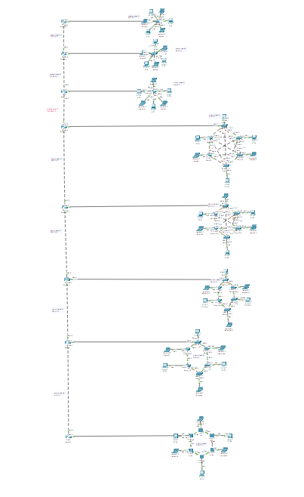

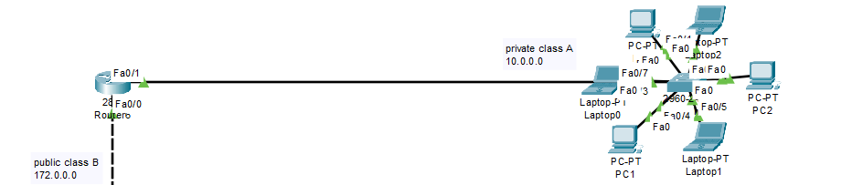

* 2nd Floor (Lan 2)

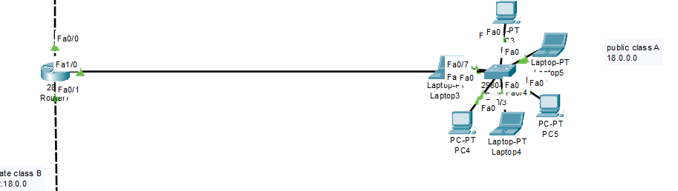

* 3rd Floor (Lan 3)

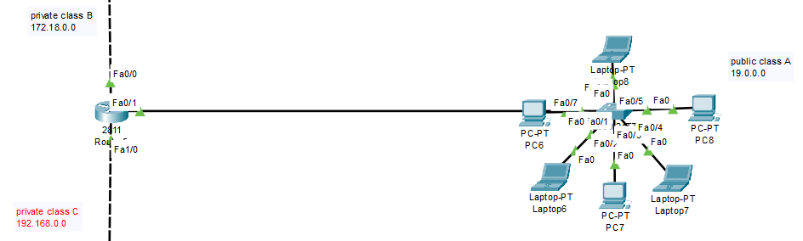

* 4th Floor (Lan 4)

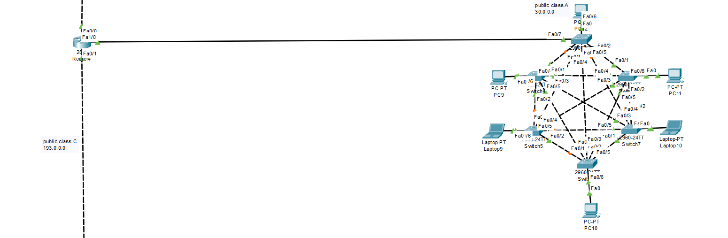

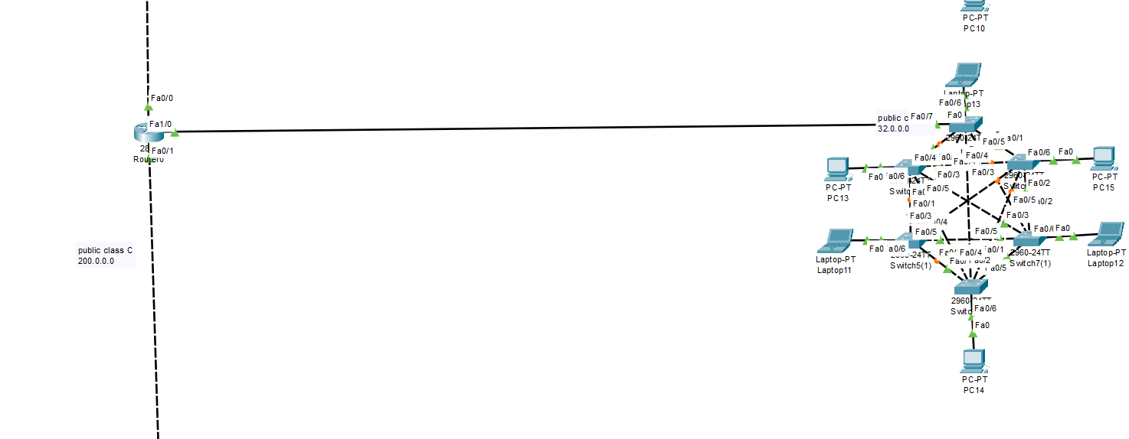

* 6th Floor (Lan 6)

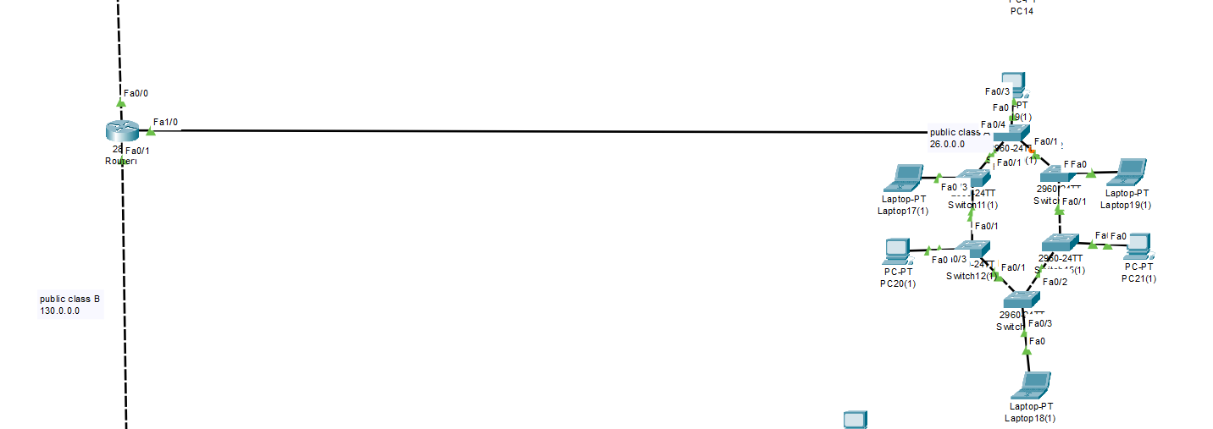

* 7th Floor (Lan 7)

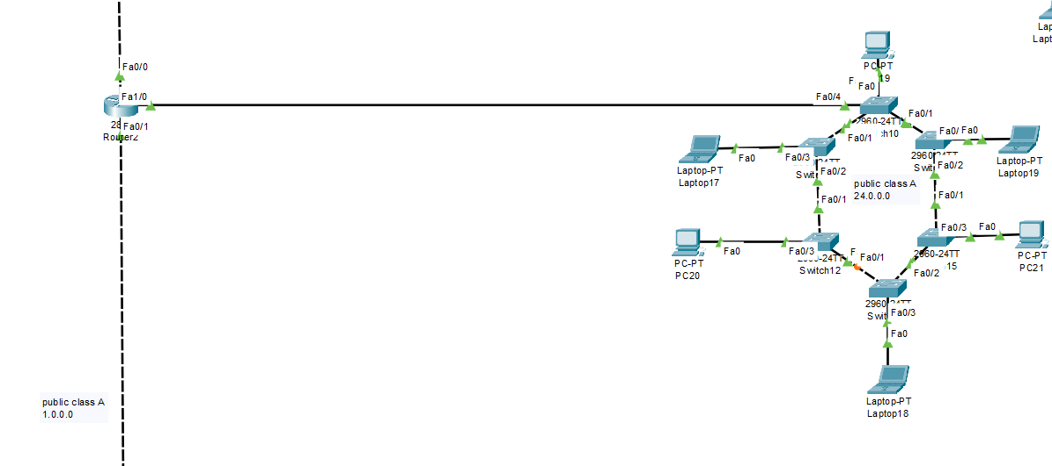

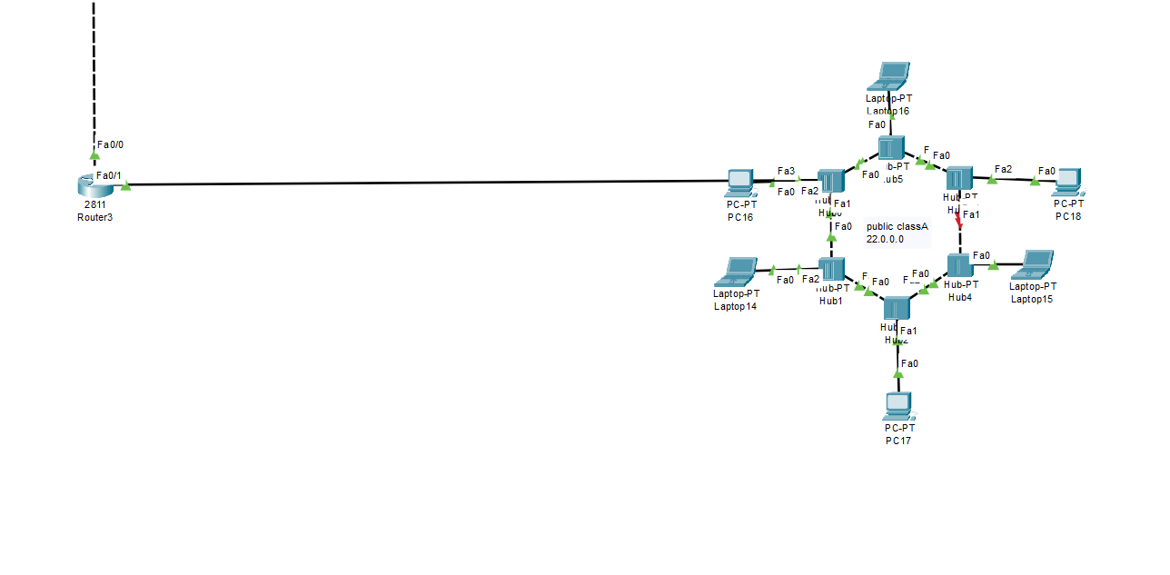

# IP Address Allocation

The organization has established a planned IP addressing format to allow smooth network connectivity among the eight-floor workplace. Each floor of the three initial sections will receive Class A public , private IPv4 addresses which provide exclusive addressings for six computers each floor while maintaining network security. Class A public IPv4 addresses will be assigned to the remaining five floors which enables extensive external connections. The routers utilize a bus topology to link their network segments with each router using Class A public IPv4 addresses for router-to-router communication establishing effortless data transmission between network segments. Network performance shows maximum scalability alongside unique IP allocation while ensuring optimized network connections throughout all different floors of the building.

* LAN 1 (Network Address: 10.0.0.0)

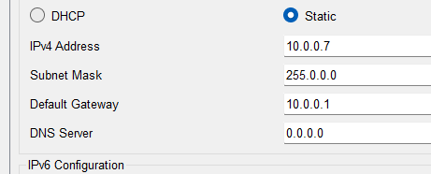

* LAN 2 (Network Address: 18.0.0.0)

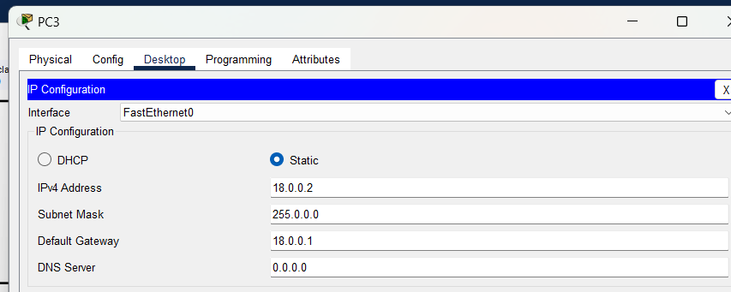

* LAN 3 (Network Address: 19.0.0.0)

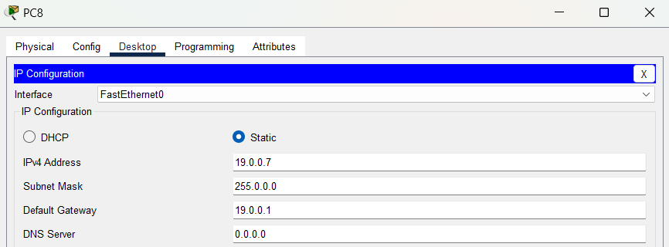

* LAN 4 (Network Address: 30.0.0.0)

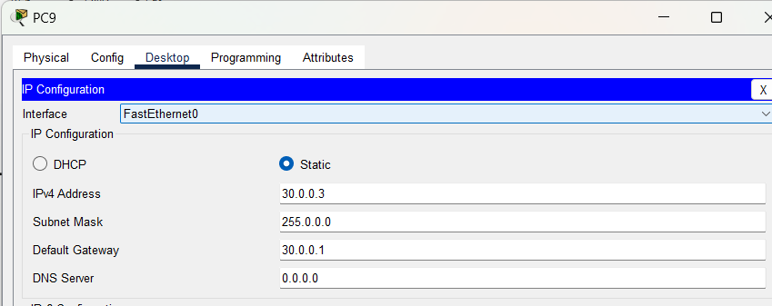

* LAN 5 (Network Address: 32.0.0.0)

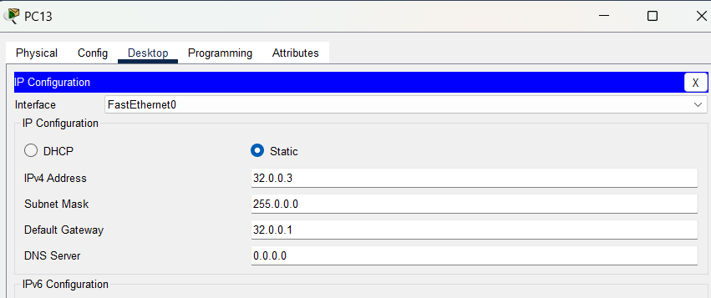

* LAN 6 (Network Address: 26.0.0.0)

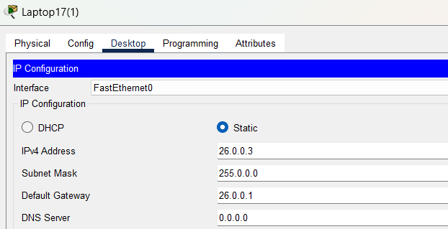

* LAN 7 (Network Address: 24.0.0.0)

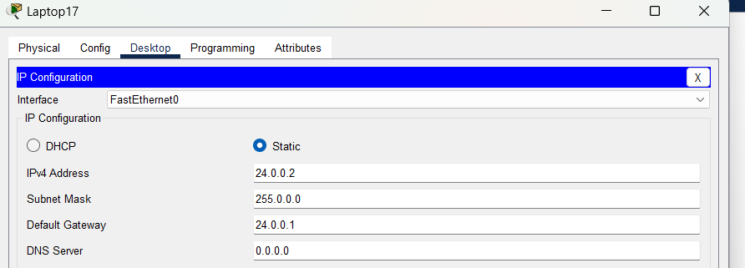

* LAN 8 (Network Address: 22.0.0.0)

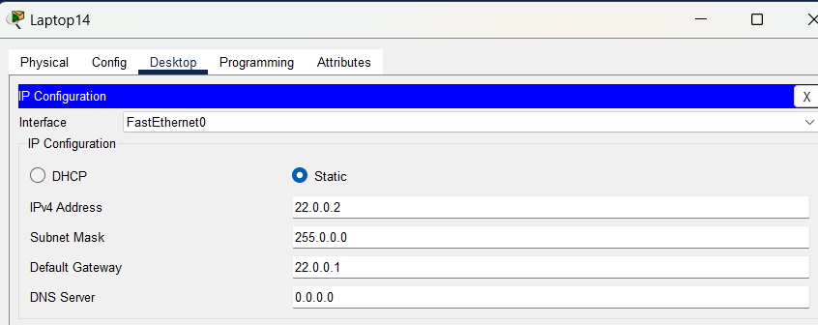

Router 1:

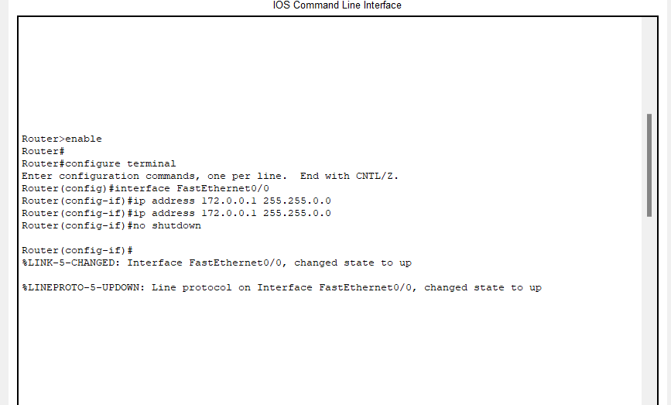

Router 2:

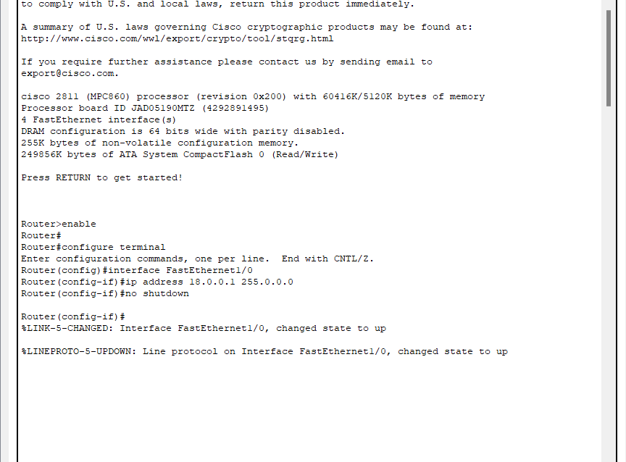

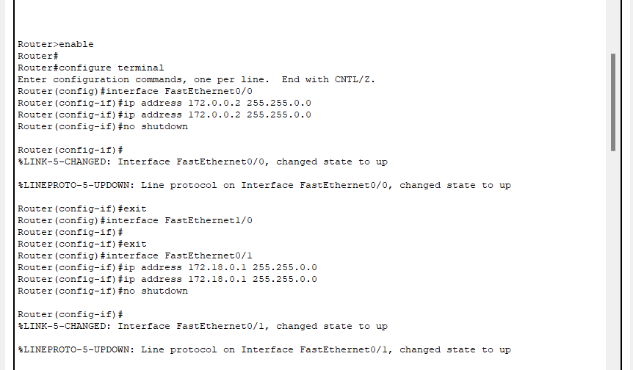

Router 3:

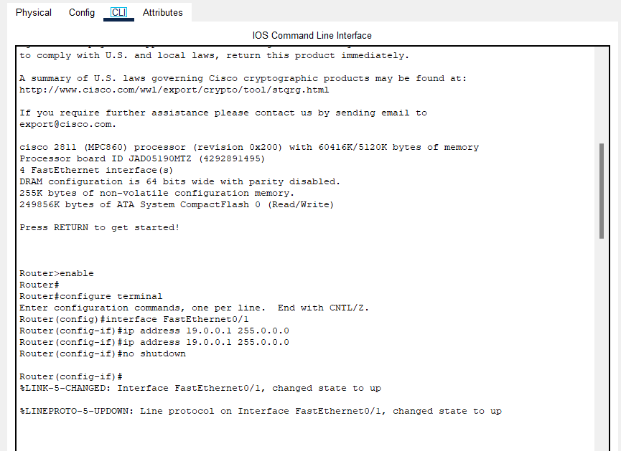

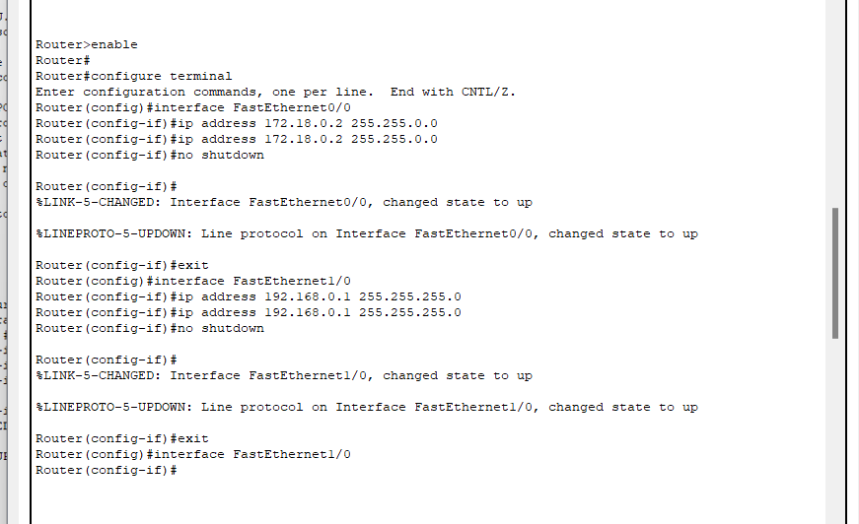

Router 4:

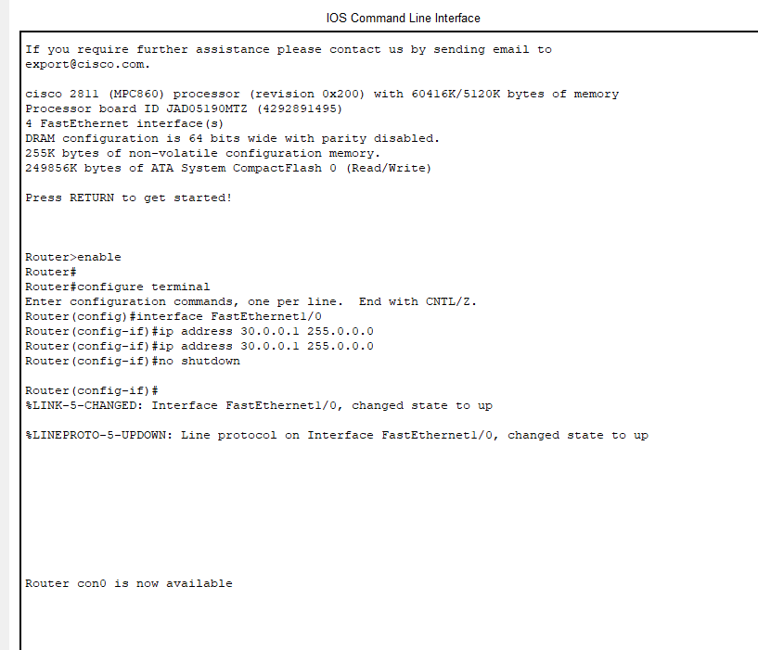

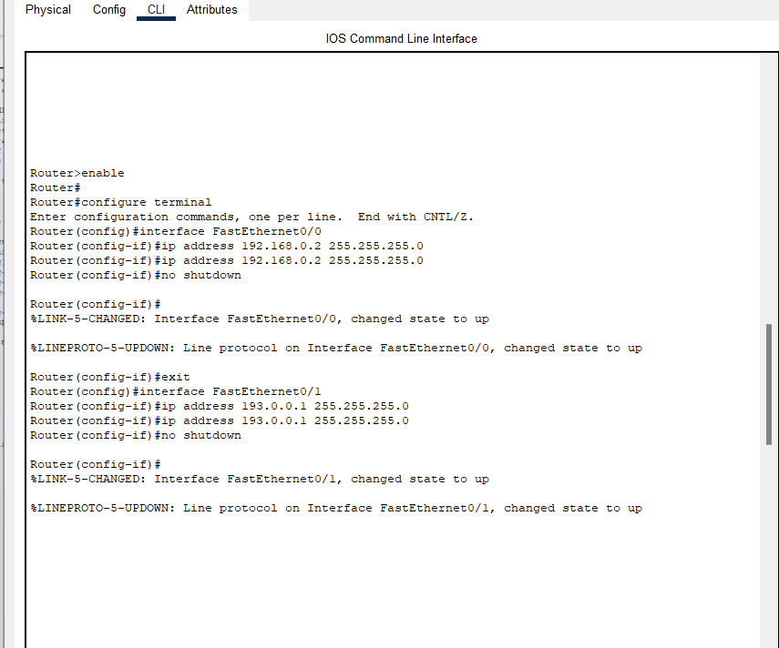

Router 5:

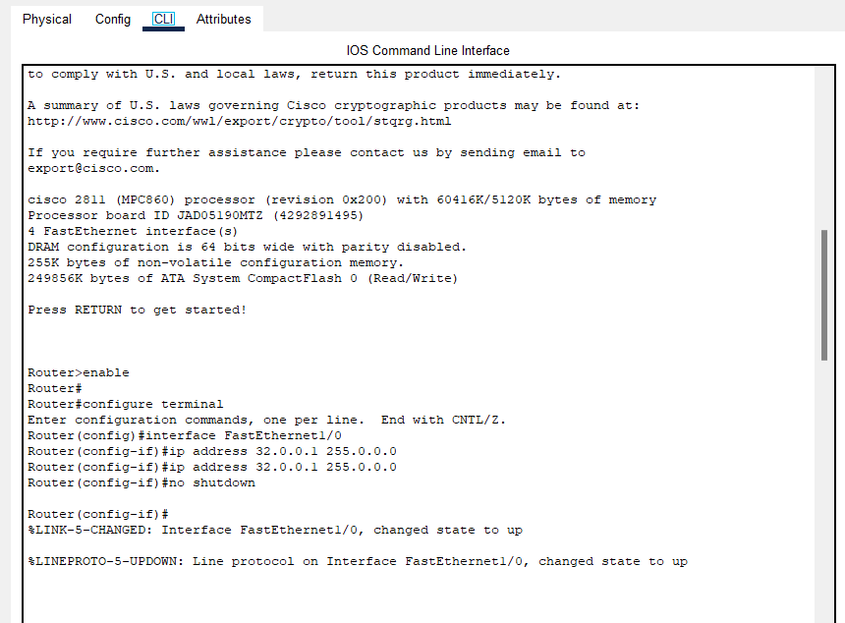

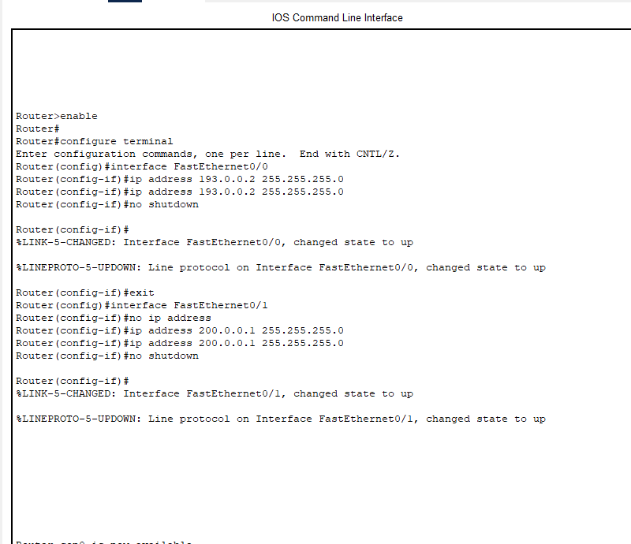

Router 6:

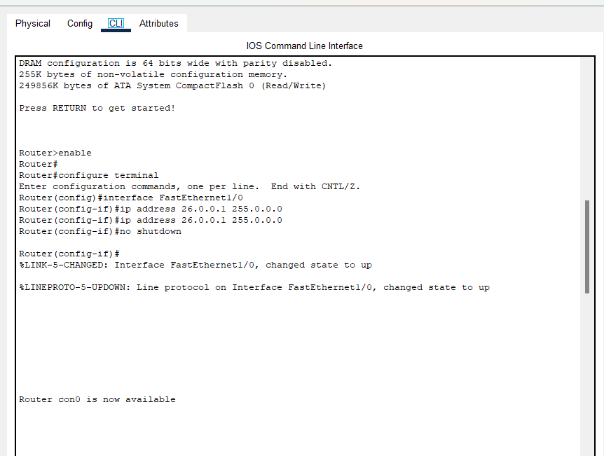

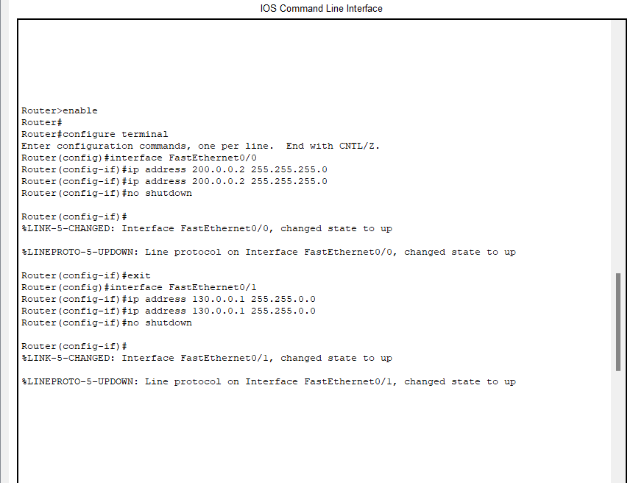

Router 7:

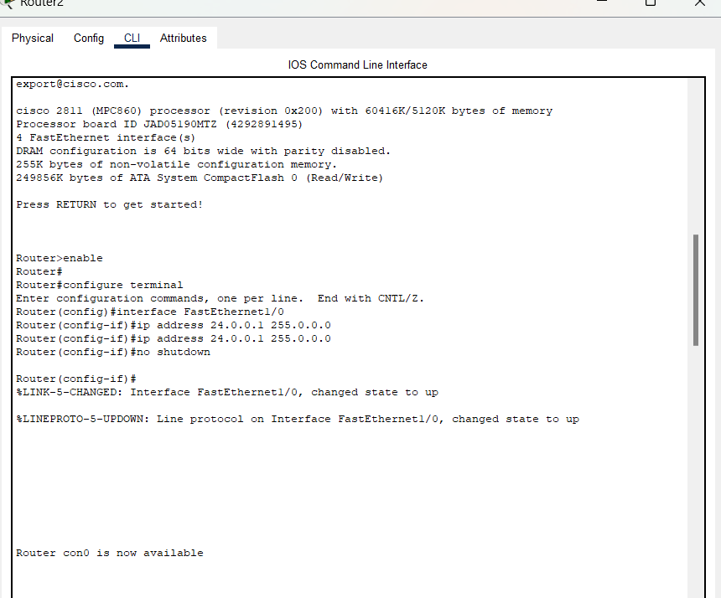

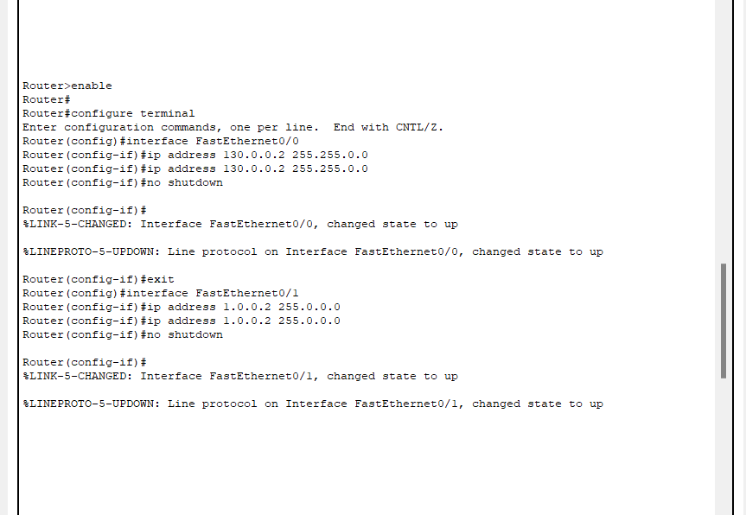

Router 8:

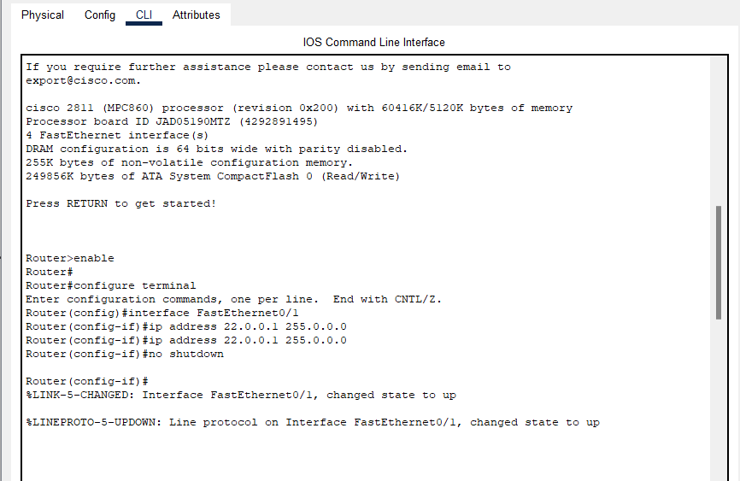

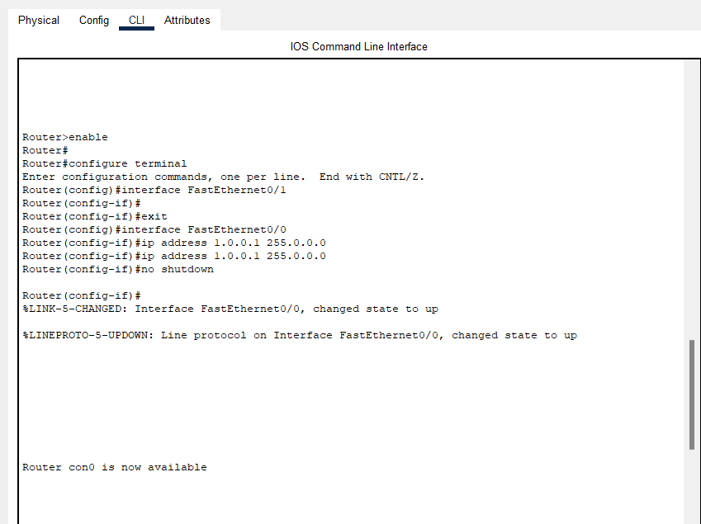

# Dynamic Routing Protocol Selection

# OSPF (Open Shortest Path First) is chosen due to its scalability, fast convergence, and efficient route computation.

# Supports hierarchical design and reduces routing overhead.

# Ensures optimized path selection across multiple topologies.

# Provides seamless network expansion.

* Router 1

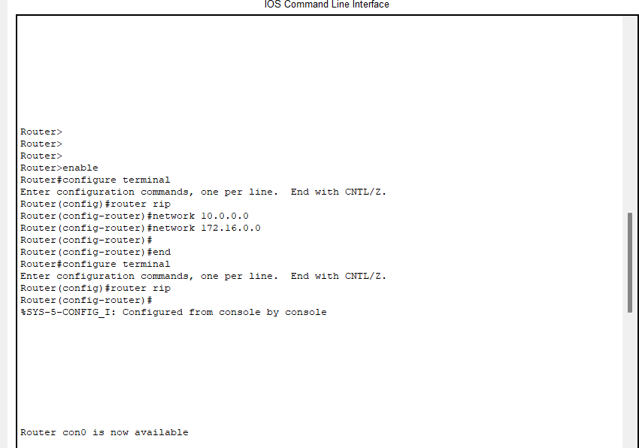

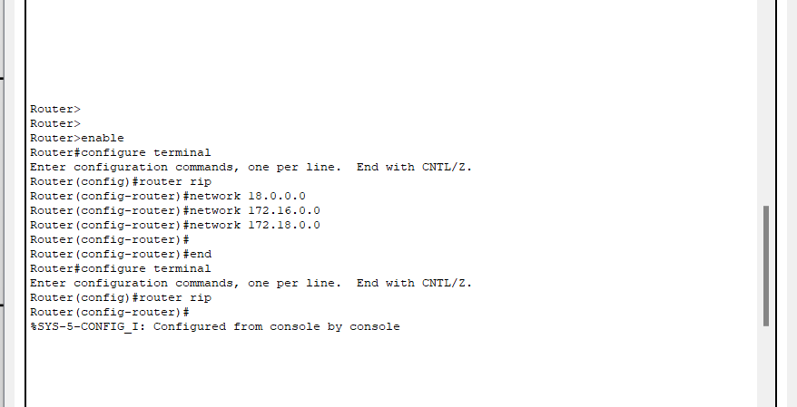

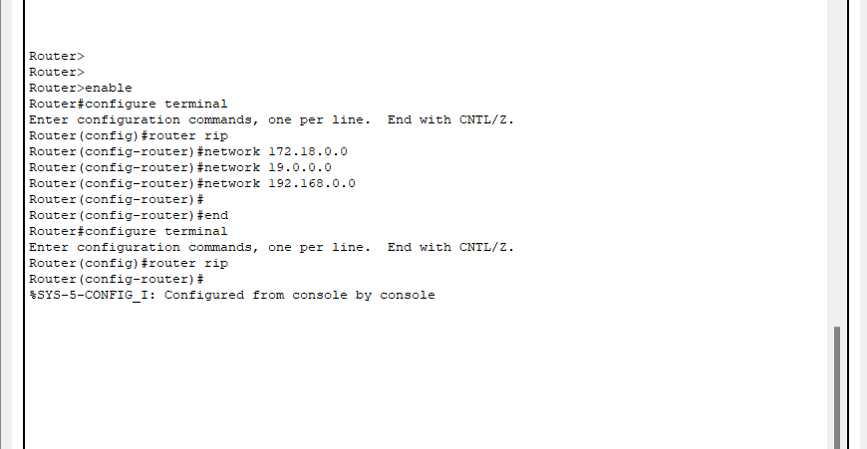

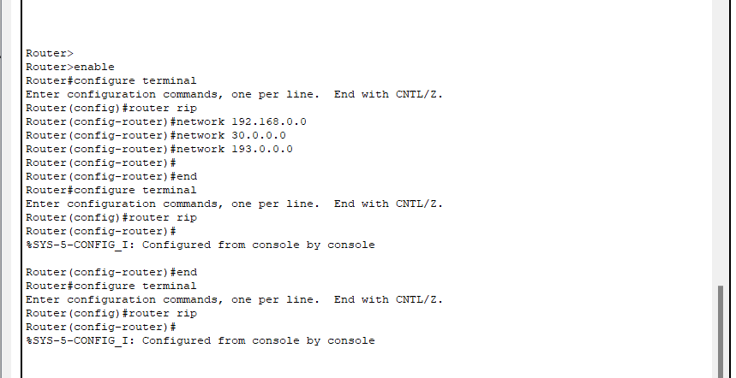

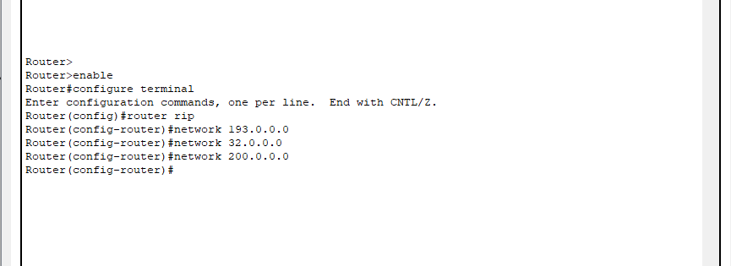

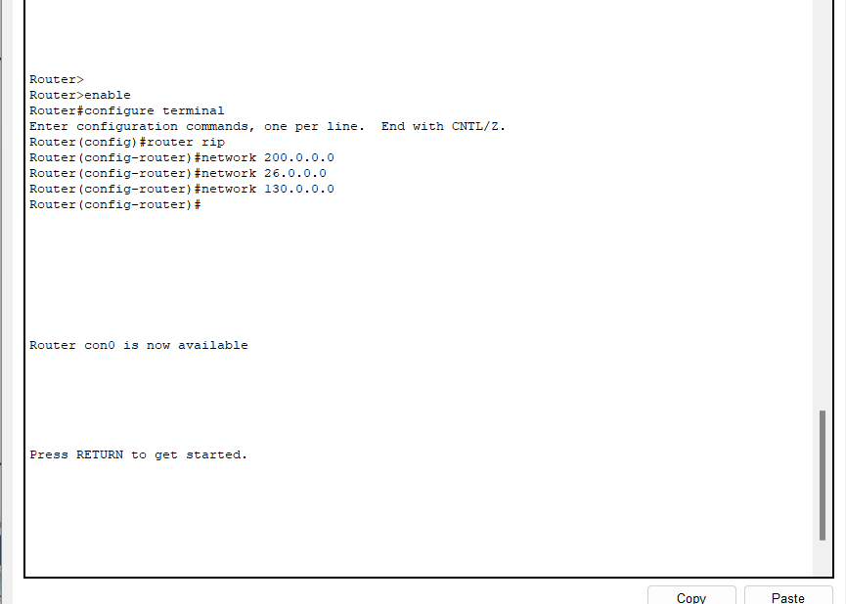

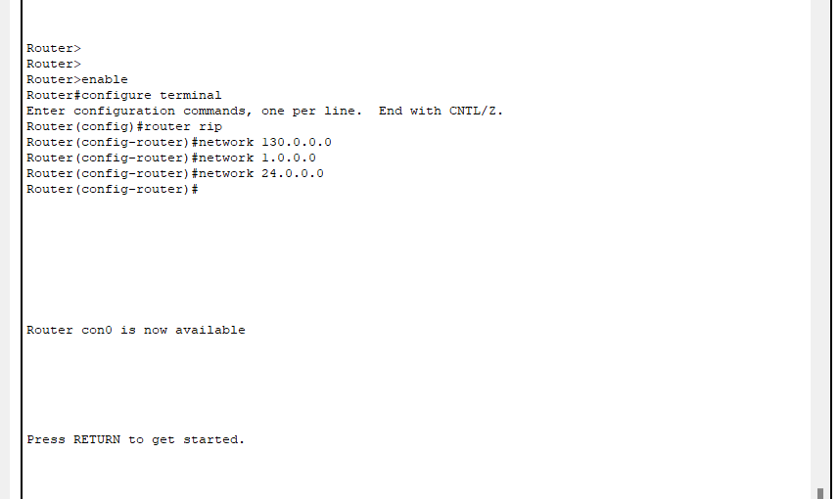

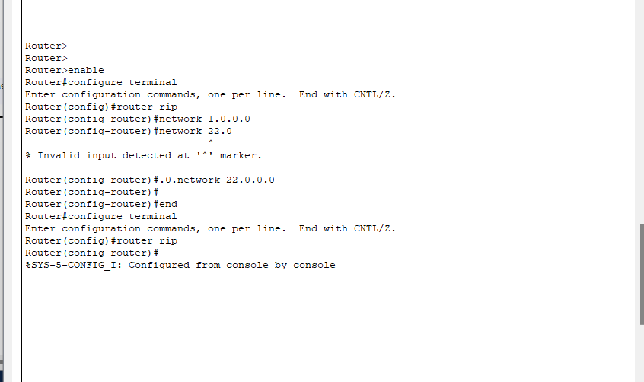

# Communication Between LANs

The successful ping test verifies that every Local Area Network (LAN) located across eight floors communicates without problems. Every Local Area Network which has its designated classful IP range achieves successful ICMP echo communication with all other networks in the building. The established static routing protocol maintains predetermined network routes to enable efficient floor-to-floor data connection. All devices on the Floors 1-3 Class A private, public network possess a dual capability for intra-network communication as well as external connectivity to the Class A public network devices that exist on Floors 4-8 through router configuration. The bus topology successfully links all routers to facilitate constant data transmission which provides swift and dependable network connections. Network design and routing effectiveness is verified when packets sent from various floors reach all intended destinations without suffering any losses according to ping test results.

* 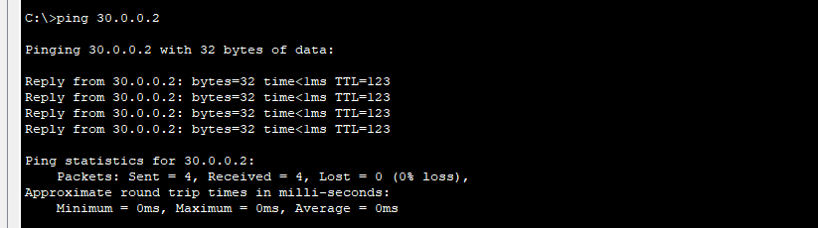From LAN 1
* From LAN 2

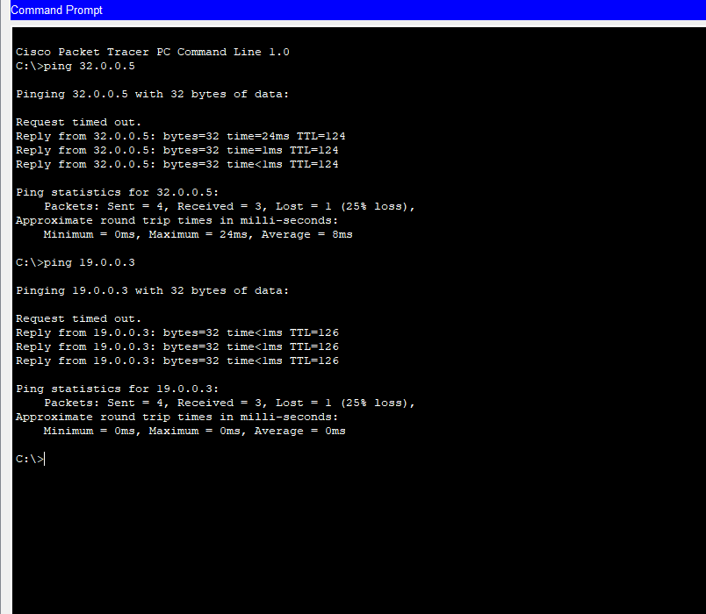

* From LAN 3

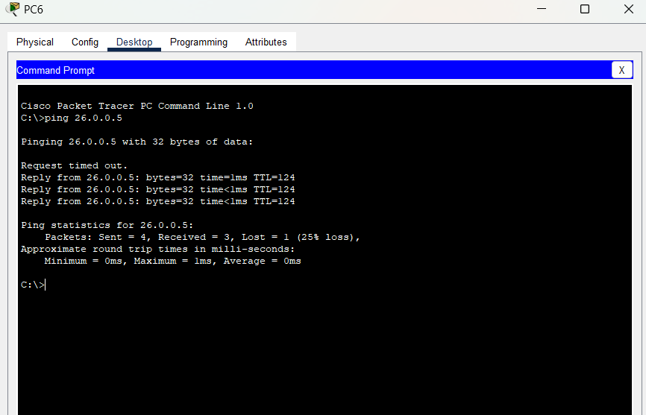

**From LAN 4**

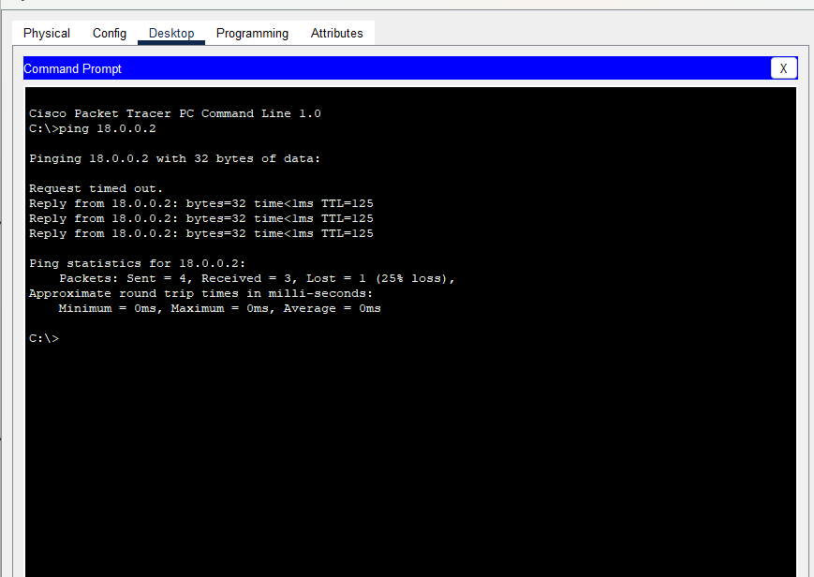

**FROM LAN 5**

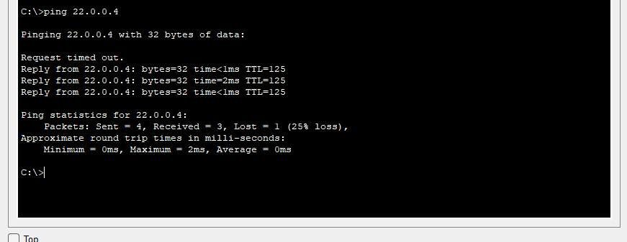

**From LAN 6:**

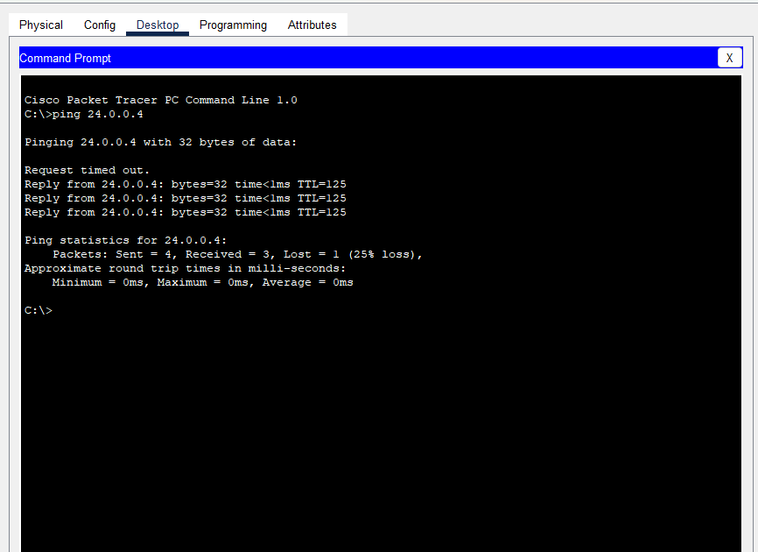

* From LAN 7

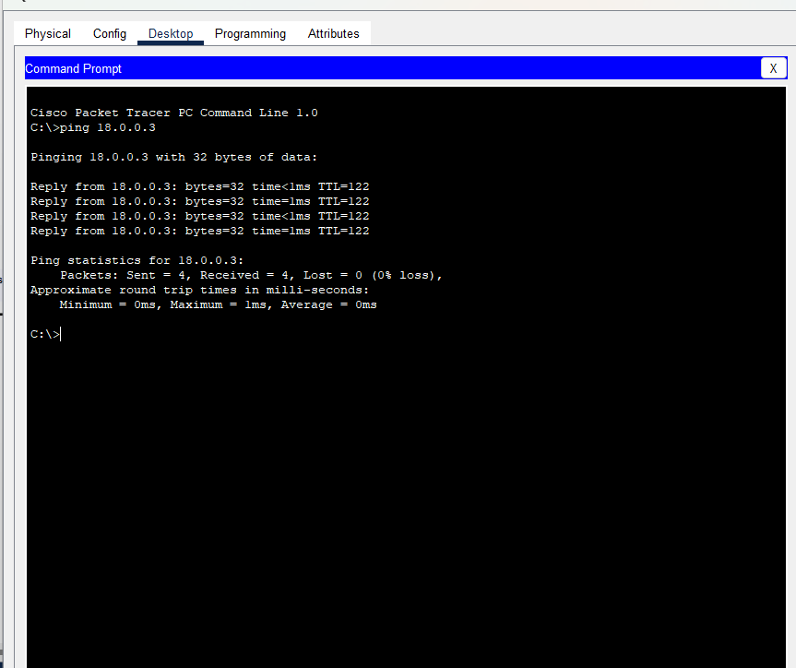

**FROM LAN 8**

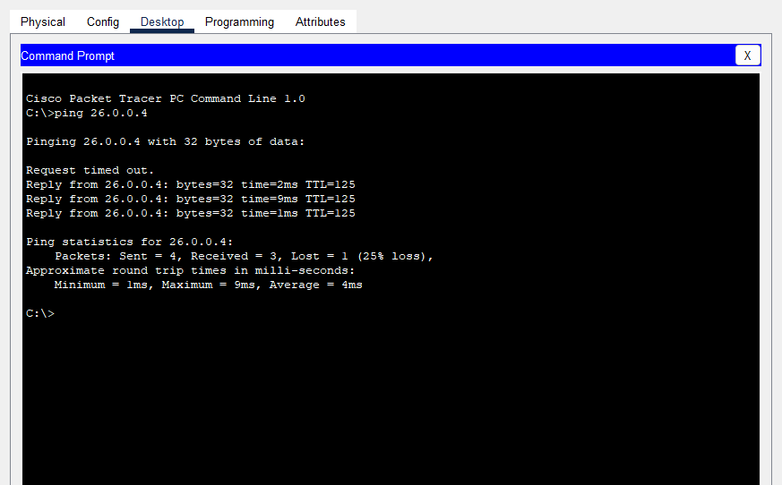

**Ping Table**

|  |  |  |  |
| --- | --- | --- | --- |
| **Test ID** | **From** | **To** | **Result** |
| 101 | LAN 1 | LAN 2 | Successful |
| 102 | LAN 1 | LAN 3 | Successful |
| 103 | LAN 1 | LAN 4 | Successful |
| 104 | LAN 1 | LAN 5 | Successful |
| 105 | LAN 1 | LAN 6 | Successful |
| 106 | LAN 1 | LAN 7 | Successful |
| 107 | LAN 1 | LAN 8 | Successful |
| 108 | LAN 2 | LAN 3 | Successful |
| 109 | LAN 2 | LAN 4 | Successful |
| 110 | LAN 2 | LAN 5 | Successful |
| 111 | LAN 2 | LAN 6 | Successful |
| 112 | LAN 2 | LAN 7 | Successful |
| 113 | LAN 2 | LAN 8 | Successful |
| 114 | LAN 3 | LAN 4 | Successful |
| 115 | LAN 3 | LAN 5 | Successful |
| 116 | LAN 3 | LAN 6 | Successful |
| 117 | LAN 3 | LAN 7 | Successful |
| 118 | LAN 3 | LAN 8 | Successful |
| 119 | LAN 4 | LAN 5 | Successful |
| 120 | LAN 4 | LAN 6 | Successful |
| 121 | LAN 4 | LAN 7 | Successful |
| 122 | LAN 4 | LAN 8 | Successful |
| 123 | LAN 5 | LAN 6 | Successful |
| 124 | LAN 5 | LAN 7 | Successful |
| 125 | LAN 5 | LAN 8 | Successful |
| 126 | LAN 6 | LAN 7 | Successful |
| 127 | LAN 6 | LAN 8 | Successful |
| 128 | LAN 7 | LAN 8 | Successful |