Ryan McKay – Project 2 Report

My API provides a variety of functionality for interacting directly with the GYM_Member, GYM_Workout_Routine and GYM_Trainer relations from my GYM relational database.

For the GYM_Member relation, my API provides the functionality to call the weight_loss function, the give_first_workout procedure and to get all the tuples from the member_1_full_workout_routines view. The weight_loss function returns how much weight has been lost (or gained) over the course of a gym member's time at a gym. A gym trainer could use this to check on a gym member's weight loss progress. The give_first_workout procedure is helpful procedure which gives a gym member their first workout if they don't already have one. A gym member could use this if they don't want to plan out their own first workout and want a generic one to get them started. The member_1_full_workout_routines view, provides an isolated view of member 1's workout routines, which can be helpful for protecting this member, as front end user, from seeing any other member's workout routines, and gives them an environment that they could hypothetically perform tasks in.

For the GYM_Workout_Routine relation, my API provides the functionality to rename a workout, delete a workout, and delete all workouts belonging to a single gym member. Renaming a workout is a helpful feature that a member may want to use, if for example, they want to change the name of their workout from 'Monday Workout' to 'Midweek Workout', thus implying a different use for the workout. Deleting a workout is helpful if a member is done using a workout routine, and wants to get rid of it. And deleting all workouts is helpful if a gym member wants to just clear out all of their workout routines and start fresh.

For the GYM_Trainer relation, my API provides the functionality to be able to update a trainer, add a new trainer and get all the members a trainer is training. Updating a trainer is useful if a trainer wants to update their email address or change the rate they charge. Adding a new trainer is useful for when a new trainer joins the gym and one of the workers wants to add him into the system. Getting all the members a trainer is training is a very helpful feature for a trainer, whether they want to give themselves a refresher on their trainees' names, or get their ids so that other hypothetical tasks could be performed in the system, such as checking or editing the workout routines of one of their trainees.

**Member Router Route Paths**

Path Name: Get Weight Loss

Path: http://blue.cs.sonoma.edu:8116/api/v1/member/:id/weightloss

Description: Call this route to get the weight loss of a member (calculated over all their entire recorded history at the gym)

Image:

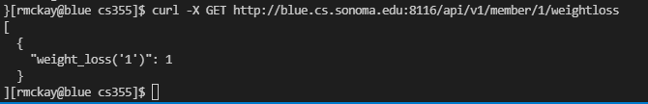

(Value of 1 means they lost 1 pound)

Path Name: Give First Workout Routine

Path: http://blue.cs.sonoma.edu:8116/api/v1/member/:id/giveFirstWorkoutRoutine

Description: Call this route to add a workout routine to the specified member if they don't have any workout routines

Image: 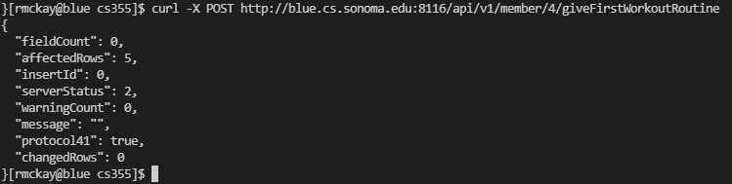

Path: Get Gym Member 1 Full Workout Routines View

Path: http://blue.cs.sonoma.edu:8116/api/v1/member/member1FullWorkoutRoutines

Description: Call this route to get all the tuples from the view member_1_full_workout_routines

Image:

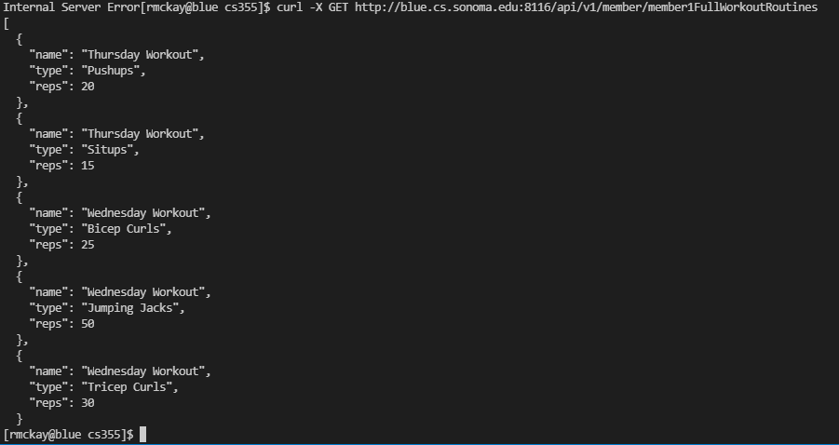

**Workout Routine Router Route Paths**

Path Name: Rename a Workout

Path: http://blue.cs.sonoma.edu:8116/api/v1/workoutRoutine/:member_id

Description: Call this route to rename a workout

Image: 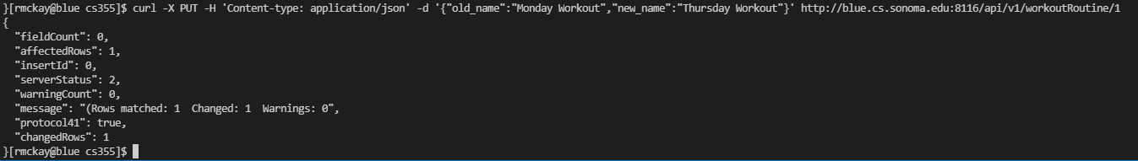

Path Name: Delete a Workout Routine

Path: http://blue.cs.sonoma.edu:8116/api/v1/workoutRoutine/:member_id

Description: Call this route to delete a single workout routine

Image:

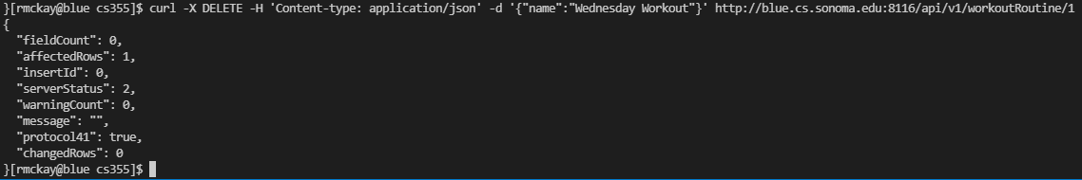

Path Name: Delete All Workout Routines Belonging to a Member

Path: http://blue.cs.sonoma.edu:8116/api/v1/workoutRoutine/:member_id/all

Description: Call this route to delete all workout routines belonging to the specified member

Image: 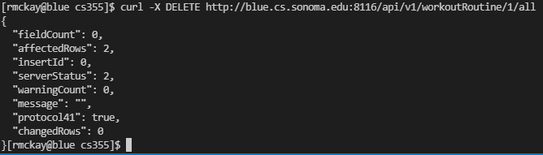

**Trainer Router Route Paths**

Path Name: Update Trainer

Path: http://blue.cs.sonoma.edu:8116/api/v1/trainer/:id

Description: Call this route to update the attributes of a single trainer (excluding the id)

Image:

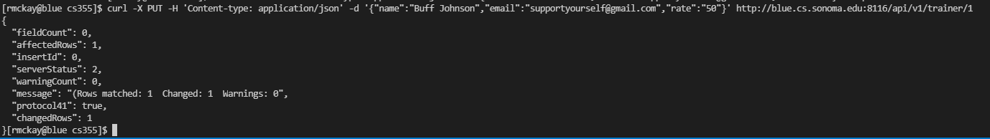

Path Name: Add Trainer

Path: http://blue.cs.sonoma.edu:8116/api/v1/trainer

Description: Call this route to add a new trainer

Image:

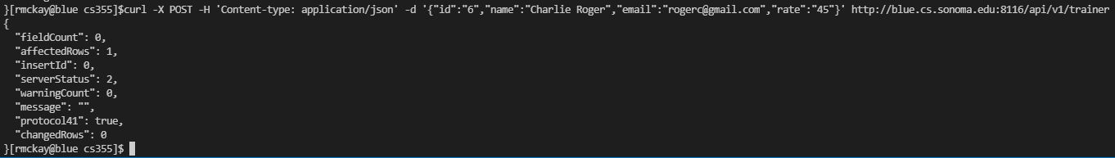

Path Name: Get Training

Path: http://blue.cs.sonoma.edu:8116/api/v1/trainer/:id/training

Description: Call this route to get all the members a trainer is training

Image:

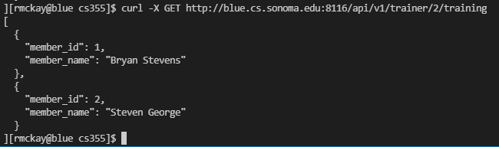

(Note: While running the pictured commands I sometimes refreshed the database with my GYM_DDL_and_Insert_File_Updated.sql file to get a clean slate for running the commands)