Context-Aware Semantic Construction for Multimodal Outfit Recommendation
Context-Aware Semantics for Outfit Recommendation
A Data-Driven Framework with Thermal-Comfort Proxy Variables and LLM-Based Quality Assessment and Diagnosis
Min-Chen Wu
Department of Management Information Systems, National Chung Hsing University, Taichung, Taiwan
arnywu1014@gmail.com
Context-aware outfit recommendation requires more than visual compatibility: outfits should also reflect weather, activity, occasion, and style. We frame this data-centric multimodal recommendation problem by constructing traceable natural-language conditions from outfit images and text. The pipeline estimates outfit-level clothing insulation (CLO), maps plausible activities to Metabolic Equivalent of Task (MET) values, derives a temperature reference through simplified thermal mapping, and rewrites short Polyvore descriptions into context-aware queries. CLO and MET are treated as literature-constrained proxy variables rather than measured comfort labels. Generation quality is diagnosed with checklist-based LLM-as-a-Judge and a stratified manual audit, while recommendation utility is evaluated with a fixed Hybrid Attention text-conditioned recommender. On 35,140 Polyvore Outfits Disjoint samples, context-aware descriptions improve compatibility and conditional item retrieval: AUC increases from 0.9292 to 0.9454, FITB accuracy from 0.6374 to 0.6478, Recall@10 from 0.0780 to 0.0921, and Recall@50 from 0.2303 to 0.2518. Semantic ablations show style contributes most consistently, while weather and occasion add complementary constraints. Simpler Two-Tower validation preserves retrieval gains, and controlled counterfactual replacements alter rankings observably. These results indicate that traceable context-aware semantic construction can improve multimodal outfit retrieval without modifying the primary recommender architecture, while LLM-based assessment remains a diagnostic aid, not human ground truth.
CCS CONCEPTS • Information systems → Recommender systems; Multimedia information systems; Retrieval models and ranking • Computing methodologies → Artificial intelligence; Natural language processing; Computer vision
Additional Keywords and Phrases: multimodal recommendation, outfit recommendation, context-aware recommendation, context-aware semantic construction, thermal-comfort proxy variables, CLO, MET, LLM-as-a-Judge
- Introduction
For fashion recommender systems to move beyond commerce-oriented product recommendation toward decision support for everyday dressing, they must address contextual factors that are more complex than product preference and visual compatibility alone. Prior fashion recommendation research has progressed from item-level preference modeling to multimodal compatibility, image-text retrieval, and generative outfit construction, yet most methods still focus primarily on relationships among products or items and less often address constraints that users encounter in real-life dressing situations. Everyday dressing is not merely a matter of selecting individual items. It is a compound decision influenced by weather, planned activities, usage scenarios, occasion formality, and overall styling requirements. Consequently, an outfit that appears visually coherent may still be unsuitable in practice if it does not match the current setting, climate, or style requirements.
This limitation also affects multimodal recommendation data. Even when a model can jointly use image and text information, if the data lack contextual conditions that the model can learn from, the model may primarily capture visual compatibility among items and fail to respond consistently to users' actual weather, occasion, and style requirements. In other words, whether a recommendation model can respond effectively to outfit context depends not only on the model architecture but also on whether the data provide sufficiently explicit, traceable, and auditable contextual semantics.
Accordingly, we formulate context-aware outfit recommendation as a data-centric multimodal recommendation problem. Because mood, personal preference, and real usage context are difficult to recover comprehensively from existing datasets, we focus on three contextual dimensions that can be explicitly constructed for model learning: weather, occasion, and style. Using CLO, MET, simplified thermal-comfort estimation, and LLM-assisted rewriting, we transform short outfit descriptions that lack contextual information into text conditions enriched with contextual semantics. A fixed Hybrid Attention text-conditioned outfit recommendation model serves as the primary controlled experiment for examining the effect of data-side context-aware semantic construction on offline recommendation performance, while a simpler Two-Tower architecture is used for cross-architecture robustness validation. Rather than introduce a new recommendation backbone, we show how data-side context-aware semantic construction addresses original outfit-data limitations and affects recommendation performance, contextual-factor behavior, and candidate-ranking patterns.
  - Research Questions
This study examines data-side context-aware semantic construction through four research questions:
- RQ1: Do context-aware descriptions improve outfit compatibility and conditional item retrieval when the recommendation model is held fixed?
- RQ2: How do weather, occasion, and style semantics affect outfit compatibility and rankings?
- RQ3: Can clothing insulation, activity MET, and temperature reference values provide a traceable and reasonable basis for constructing contextual conditions?
- RQ4: Are the generated descriptions sufficiently image-text consistent, contextually plausible, and auditable to support downstream recommendation training and evaluation?
  - Contributions
- We propose a data-centric context-aware semantic construction pipeline for multimodal outfit recommendation integrating outfit images, original descriptions, CLO/MET proxies, and simplified thermal mapping into natural-language conditions learnable by a recommendation model.
- We use interpretable CLO and MET scales to constrain weather and activity semantics and treat them as literature-constrained proxies, not measured comfort labels.
- We use fixed Hybrid Attention with FashionCLIP representations so the main comparison isolates the text source. A simpler FashionCLIP Two-Tower model provides cross-architecture validation.
- We design a multi-level evaluation covering recommendation utility, semantic sensitivity, and assessment reliability, combining the main recommendation tasks, semantic ablations, cross-architecture and counterfactual robustness analyses, generation-quality diagnostics, and manual auditing to characterize the effects, mechanisms, and limits of context-aware descriptions.
- Related Work and Research Positioning
  - Multimodal Outfit Recommendation and Text-Conditioned Retrieval
Fashion recommender systems were initially developed largely for e-commerce, where the primary objective is to help users search, rank, and filter apparel items from large catalogs. Because online fashion catalogs are large and rapidly changing while user interaction records are relatively sparse, prior studies have commonly addressed personalized product recommendation, similar-item recommendation, or complementary-item recommendation using interaction histories, product attributes, visual features, or textual descriptions to predict individual items or matching products that a user may prefer. These approaches support product discovery and e-commerce conversion, but when applied to everyday dressing decisions they may still be insufficient for determining whether an entire outfit fits the user's current life context [4, 5].
Unlike item-level product recommendation, outfit recommendation is a compositional decision problem. It must determine not only whether an individual product is worth recommending or whether a candidate is similar or compatible with an existing item, but also whether multiple items from different categories can form a wearable, appropriate, and coherent outfit. Fashion-recommendation reviews note that outfits span multiple categories and, beyond personal preference, require item compatibility and overall coherence. Nevertheless, existing datasets and model settings still tend to emphasize product relationships, visual compatibility, or candidate-item ranking, with less direct treatment of real-world constraints such as warm versus cold weather, planned activities, occasion formality, and style requirements.
Recent work has incorporated natural-language descriptions into outfit recommendation conditions so that models can respond not only to product images or category information but also to dressing requirements expressed in text. Wang and Zhong proposed Text-Conditioned Outfit Recommendation with a Hybrid Attention Layer that jointly models textual conditions and item features to construct outfits that satisfy the description while maintaining internal compatibility [19]. Jang et al. introduced the Text-to-Outfit Retrieval task, which maps a user's textual description directly to a complete outfit and models text-outfit relationships at the item, style, and outfit semantic levels [11].
These text-conditioned approaches, however, remain highly dependent on the quality of the original textual conditions in the data. If outfit descriptions are very short or contain only product names, thematic tags, and style phrases, a model may learn image-text alignment and item compatibility without learning the weather, occasion, and activity constraints needed for everyday dressing. We therefore shift the research question to the data side rather than simply applying existing product recommendation methods to an outfit task: how can commerce-oriented outfit data with limited life-context information be transformed into traceable and auditable context-aware text conditions that a fixed recommendation model can learn?
  - LLM-Assisted Recommendation and Data-Centric Challenges
Large language models (LLMs) are widely studied in recommender systems and support user-intent understanding, text representation, feature engineering, product-description enrichment, preference elicitation, and explanation generation. Their value to recommendation lies not only in directly producing recommendations, but also in transforming sparse or incomplete text into semantically richer auxiliary features that can improve user or item representations [14, 20].
Using LLMs to generate recommendation inputs, rank candidates, or recommend items also introduces limitations. Prior work notes that LLMs often incur substantial inference cost and latency and may generate plausible but unsupported content. If such erroneous attributes or descriptions are incorporated into downstream recommendation models, they may affect both model decisions and explanations [14]. Likewise, when LLMs are used for automated evaluation, their judgments may depend on prompt design, model bias, evaluation criteria, and calibration procedures, motivating standardized procedures, additional validation, and robustness checks [8].
Given these limitations, we adopt a data-centric perspective in which the LLM is not the final recommender but a tool for constructing and diagnosing textual conditions. Specifically, LLMs are used to rewrite context-aware descriptions and assess generation quality, while fixed prompts, structured outputs, checklist rules, and sample-level audits are used to reduce the effects of unstable generation and hallucinated attributes on downstream training. The main recommendation experiments hold the recommendation backbone, data split, and training settings constant so that the core comparison isolates whether the input text provides more useful contextual semantics. Additional recommendation architectures are used only for complementary robustness validation of whether the observed gains depend strongly on a particular model design.
  - Context-Aware Fashion Recommendation and Thermal-Comfort Proxy Variables
Context-aware recommendation assumes that relevance changes with the usage context rather than being determined solely by fixed user preferences, historical interactions, or item similarity. In fashion recommendation, reviews have identified location, season, occasion, culture, and social background as factors that may affect whether a recommendation meets practical dressing needs. Weather, special occasions, location, and scene information have likewise been highlighted as important directions for making fashion recommendation more specific and practically useful [4, 5]. These conditions are often handled separately, however, through weather-aware, occasion-aware, or location-aware recommendation rather than being converted into integrated natural-language conditions that a text-conditioned outfit recommender can learn.
For everyday dressing, we define context-aware outfit recommendation as augmenting item compatibility and styling coherence with information that influences clothing choices, represented as model-learnable text conditions. We operationalize context along three dimensions: weather, occasion, and style. Weather captures external climate and thermal constraints, occasion captures activity and social-context constraints, and style captures the overall visual semantics and aesthetic direction of the outfit. This definition does not restrict context awareness to the physical environment, but includes dressing conditions that users commonly express together in natural-language queries.
Weather refers to external climatic and perceived thermal conditions that affect comfort and clothing choice, including temperature, season, thermal sensation, precipitation, and insulation needs. Prior weather-oriented fashion recommendation work has incorporated weather as an input condition, demonstrating its relevance to clothing recommendation [15]. Research on outdoor clothing choice also shows that air temperature, humidity, and wind speed may affect clothing insulation and garment selection, while consumer research suggests that weather can influence color preferences [3, 12]. In this study, weather therefore represents comfort, insulation needs, and external environmental constraints rather than serving merely as background information.
Occasion covers dressing purpose, social context, formality, time, and setting. It is not limited to geographic locations such as an office, wedding venue, or travel destination, but also covers commuting, dating, gatherings, and evening activities that combine purpose and temporal context. Prior occasion-aware outfit research shows that outfit appropriateness depends not only on visual coordination among items but also on context and occasion requirements [18]. Accordingly, occasion in this study is not a single location label. It describes the activity and social context in which an outfit is worn. A standalone temporal expression such as “evening” is treated as a temporal modifier within occasion semantics, while a more complete occasion is formed when it co-occurs with activity cues such as a party, date, dinner, or formal event.
Style denotes the overall styling semantics formed jointly by visual cues such as garment silhouette, material, color, pattern, item combination, and accessories. Unlike weather and occasion, style is not an external physical condition and is not equivalent to a user's personal taste. Rather, it describes the aesthetic direction and visual tone conveyed by an outfit. Fashion-style research indicates that style can be composed from garment types, colors, materials, details, and multiple style attributes and therefore should not be reduced to a single fixed label [1]. Reviews of fashion recommendation likewise note that aesthetic factors affect clothing choices and may not be fully captured by conventional visual features [13]. We therefore include style as a contextual condition to represent overall outfit semantics not captured by weather or occasion.
To constrain free-form text generation, we introduce clothing insulation (CLO) and Metabolic Equivalent of Task (MET) as thermal-comfort proxy variables in the data-construction process. CLO represents the thermal insulation of clothing, whereas MET represents metabolic intensity. Both are important parameters in human heat exchange and thermal-comfort reasoning [7, 10]. We then use McIntyre's simplified mapping derived from Fanger's thermal-comfort model to convert CLO and MET into a temperature reference value that constrains weather-semantic generation and provides a more traceable connection among clothing insulation, activity intensity, and textual description [16].
The CLO, MET, and temperature reference values used in this study are data-construction proxies rather than measurements from human-subject experiments or true comfort labels. We do not claim to predict an individual's actual thermal comfort. Instead, these physical reference quantities provide a more consistent and traceable basis for linking outfit insulation, activity intensity, and weather semantics. The scope of this work is therefore context-aware semantic construction under physically motivated proxy constraints, together with offline utility evaluation using a fixed primary recommendation model and complementary robustness validation.
  - Research Gap and Positioning
The preceding literature reveals three issues. First, multimodal outfit recommendation can already model outfit compatibility from images, text, and item relations, and recent text-conditioned approaches further incorporate natural-language descriptions. However, when outfit text consists mainly of product names, style tags, or short thematic phrases, models may learn image-text alignment and item relationships without reliably capturing everyday semantics such as weather, activity intensity, occasion formality, and insulation needs. Thus, outfit recommendation performance depends not only on model architecture but also on whether the input text provides sufficiently explicit and traceable contextual information [4, 11, 19].
Second, LLMs can support semantic enrichment and data construction in recommender systems, but without explicit constraints and quality control, generated descriptions may introduce visually unsupported content, semantic drift, or unstable outputs. Prior work similarly notes that LLM-assisted recommendation must address inference cost, hallucination, and reliability, while LLM-based evaluation requires standardized procedures, calibration, and robustness checks [8, 14, 20]. When LLMs are used to rewrite outfit descriptions, the central issue is not text volume but whether generated content is constrained, auditable, and linked to downstream performance under a fair comparison.
Third, context-aware fashion recommendation has recognized the influence of weather, season, location, and occasion, but these factors are often incorporated as external conditions, auxiliary fields, or task-specific variables rather than being transformed into integrated natural-language conditions for text-conditioned outfit recommendation. Everyday dressing needs are rarely expressed as a single label. Instead, weather, occasion, and style jointly form the semantic context. It is therefore important to investigate how these factors can be converted into traceable and auditable text conditions that can train a fixed multimodal recommendation model [1, 4, 15, 18].
Based on this positioning, we treat context-aware description construction itself as a data-centric multimodal outfit recommendation problem. We do not propose a new recommendation backbone. Instead, a fixed text-conditioned outfit recommender is used as the primary controlled setting to compare original outfit descriptions and context-aware descriptions under the same data split and training conditions, with a simpler architecture providing cross-architecture robustness validation. Specifically, clothing insulation, MET, and temperature reference values provide proxy constraints for LLM-based description rewriting. We then combine generation-quality assessment and manual auditing, text-length and target-clue checks, semantic-factor ablation, cross-architecture validation, and counterfactual sensitivity analysis to evaluate the contextual text conditions from the perspectives of data quality, recommendation utility, and ranking behavior. The central contribution is not to demonstrate the superiority of an LLM or a particular recommender architecture, but to examine how traceable and auditable contextual text conditions affect multimodal outfit recommendation and how robust those effects are across analyses and model settings.
- Problem Definition and Methodological Framework
  - Problem Definition
Let an outfit be denoted by $O=i_{1},i_{2},...,i_{n}$, where each item ij contains information such as an image, category, and textual attributes. The original dataset provides an outfit-level description d0, which is typically short and primarily reflects product names, style tags, or brief thematic phrases. Our goal is to construct a context-aware description de without changing outfit composition or semantics while adding weather, occasion, and style information relevant to everyday dressing.
Specifically, we formulate context-aware description construction as a data-transformation problem. The construction function is defined as:
$d_{e}=G(d_{0},I,C,M,R)$ (1)
In Equation (1), I represents the outfit images or item-level visual features, C denotes clothing-insulation information, M denotes activity intensity and activity semantics, and R denotes the temperature reference value from simplified thermal mapping. These proxy variables primarily constrain weather and activity semantics so that insulation, activity intensity, and weather conditions in the generated description remain traceable. Style semantics are preserved and enriched from the original description and outfit visuals rather than inferred directly from the physical proxy variables.
  - Dataset and Experimental Split
We use the Polyvore Outfits Disjoint (PO-D) split as the primary experimental dataset [9]. Compared with the non-disjoint version, the disjoint split prevents items from being shared across training, validation, and test sets, reducing the risk of item-level leakage and providing a stricter generalization setting. We retain the original PO-D split for comparability with prior outfit recommendation work. Without altering that split, we construct a context-aware textual description for every outfit. The construction process incorporates clothing insulation (CLO), Metabolic Equivalent of Task (MET), temperature and thermal-comfort mapping, and occasion and style cues. After parsing and format validation, all 35,140 generated descriptions can be aligned with PO-D samples. The training, validation, and test sets contain 16,995, 3,000, and 15,145 outfits, respectively. The original Polyvore text source contains 68,306 records. This number is reported only as the size of the available original-text source and is not the sample size of the main experiment.
To distinguish source-data size, usable generated samples, and downstream evaluation samples, Table 1 summarizes the dataset scope and major evaluation settings. The dataset-split and alignment rows describe the number of context-aware descriptions available to the main experiment, whereas the compatibility and recommendation rows describe the test samples actually used by the downstream tasks. Compatibility evaluation includes 30,290 test pairs and 15,145 FITB questions. CIR evaluation requires a sufficiently large candidate pool for each target category. Consequently, 9,311 of the 15,145 test questions yield evaluable query-target pairs, while the remaining 5,834 are excluded from recall computation. Detailed task definitions and metrics are provided in Section 4.
Table 1: Dataset scope and evaluation settings
Category | Item | Value / Description
Dataset split | Train / validation / test / total outfits | 16,995 / 3,000 / 15,145 / 35,140
Dataset alignment | Valid generated descriptions aligned with PO-D | 35,140 / 35,140 (100.00%)
Original text records | Original Polyvore title/description records | 68,306 records. Reported only as the number of available original text records, not as the main experimental sample size
Compatibility evaluation | Compatibility test pairs | 30,290
Compatibility evaluation | FITB test questions | 15,145
Recommendation evaluation | Evaluable query-target pairs per seed | 9,311 (9,311 unique pairs)
Recommendation evaluation | Excluded from recall computation | 5,834 test questions. Excluded by the task-specific eligibility filter
  - Limitations of the Original Text Fields and Data-Centric Motivation
Although Polyvore Outfits Disjoint (PO-D) provides outfit-level text, the original text primarily comes from webpage names, titles, or short thematic phrases and was not designed for context-aware outfit recommendation. Under our text-conditioned recommendation setting, the original outfit-level condition is defined as url_name + title. We therefore compare this original text condition with the generated context-aware description rather than using the title field alone as the baseline.
As shown in Table 2, among the 35,140 outfits aligned with the PO-D main experiment, only 34 original url_name + title queries are missing (0.10%), and the average length is 4.82 words. These texts remain mainly short phrases reflecting webpage names, style tags, or brief themes and provide limited information about thermal conditions, occasion requirements, activity intensity, or clothing insulation. By contrast, the generated context-aware descriptions have no missing values, average 10.08 words, and cover weather, occasion, and style.
The data-centric motivation arises not from missing original text but from its limited contextual coverage. The goal of rewriting is therefore not arbitrary text expansion. It is to transform short, commerce-oriented outfit text into traceable and auditable conditions that reflect everyday dressing needs. Because the generated descriptions are longer than the original text, subsequent experiments explicitly control for text length and audit target-clue leakage to reduce the risk of attributing performance gains merely to longer queries or exposed target-item clues.
Table 2: Comparison between original text fields and generated context-aware descriptions
Text field | Missing records | Word length (mean / median / max) | Mean query tokens | <=3 words
Original query | 34 (0.10%) | 4.82 / 5.00 / 25 words | 4.90 | 21.88%
Context-aware description | 0 (0.00%) | 10.08 / 10.00 / 27 words | 11.60 | 0.00%
  - Framework Overview
The overall method consists of three components: context-aware description construction, generation-quality control, and fixed downstream recommendation evaluation. First, outfit images and original text from PO-D are combined with CLO and MET references to estimate outfit-level insulation and plausible activity intensity. Second, McIntyre's simplified thermal mapping converts CLO and MET into a temperature reference value used to constrain weather semantics. Finally, a large language model (LLM) rewrites the original short text into a context-aware description containing weather, occasion, and style semantics based on the original description, CLO/MET proxies, and the temperature reference value.
Figure 1 summarizes the context-aware description-construction pipeline. The process is designed to build learnable contextual text conditions from traceable proxy variables rather than to expand text freely. Each generated description can be traced to the original outfit images and text, estimated CLO, activity/MET, temperature reference value, and prompt configuration, making the construction process easier to inspect and explain than unconstrained rewriting.
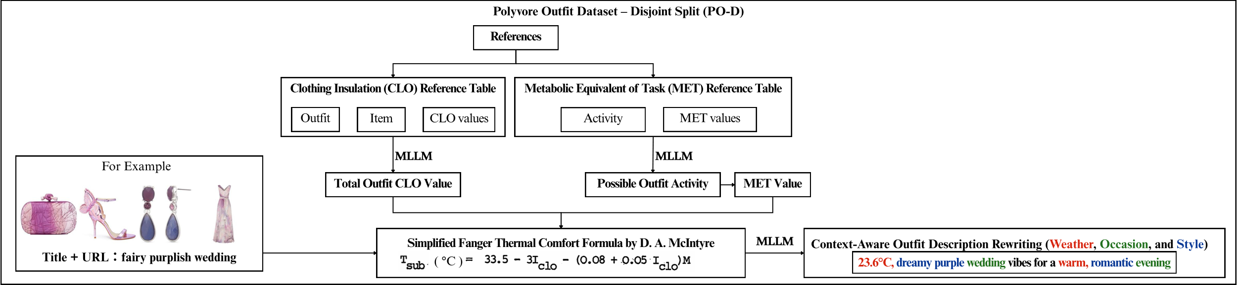
Figure 1: Context-aware outfit description construction pipeline using CLO/MET proxy variables and thermal mapping.
After description construction, checklist-based LLM-as-a-Judge diagnoses generation quality by checking image-text consistency, representation of contextual conditions, and semantic drift. This quality-control process is not used as a direct measure of downstream recommendation utility. It evaluates whether the generated descriptions are usable and auditable. The constructed descriptions are then provided to the Hybrid Attention text-conditioned outfit recommendation model and compared with the original text under identical data splits, visual representations, model architecture, and training settings, isolating the source of the text condition. A simpler Two-Tower architecture also provides cross-architecture robustness validation and serves only as a complementary validation model rather than replacing the primary Hybrid Attention setting.
  - CLO Estimation and Clothing-Insulation Sources
Clothing insulation (CLO) is a standardized measure of the thermal resistance provided by clothing to heat flow from the body. The commonly used conversion is 1 clo = 0.155 m²·K/W. We use CLO's comparable garment-insulation scale as an estimated outfit-level proxy for weather-semantic generation and thermal mapping, not as a measured human-comfort label [6, 7].
To establish a traceable CLO reference basis, we compile three sources of clothing-insulation data: ensemble-level insulation data from ASHRAE RP-1760, modern empirical studies of item- and ensemble-level insulation, and clothing-insulation lookup values associated with ASHRAE Standard 55 [2, 17, 21]. These sources are organized into item-level and ensemble-level CLO reference tables that support LLM-based estimation of outfit-level CLO from outfit images and item information.
Because ensemble CLO is not necessarily a linear sum of item-level values, we retain item- and ensemble-level references. Layering, inter-garment air layers, coverage area, material thickness, garment length, and design details can all influence overall insulation. We therefore treat CLO as an estimated proxy that provides a traceable connection among outfit insulation, weather semantics, and text-condition construction. After estimation, output format and numeric range are checked, and the interquartile range (IQR) rule is used to flag outlying estimates for re-evaluation. Flagged records are re-inferred, not truncated or removed, preserving data-construction traceability.
  - MET Mapping and Activity-Constraint Construction
Metabolic Equivalent of Task (MET) represents metabolic intensity across activities and can serve as an individual parameter in thermal-comfort estimation. In general, 1 MET corresponds to the baseline metabolic level of seated rest. In this study, MET characterizes the plausible activity intensity associated with an outfit and, together with clothing insulation (CLO), serves as an intermediate scale for subsequent weather-semantic generation and thermal mapping [7].
To map activity semantics to MET values, we use the 2024 Adult Compendium of Physical Activities as the primary reference. The compendium associates textual activity descriptions with MET values and covers everyday activities such as walking, commuting, work, leisure, and household tasks, providing a standard reference for converting natural-language activity descriptions into metabolic intensity [10]. The original table contains 1,114 activities. To reduce prompt length and instability caused by redundant candidates, we sort by MET value and remove duplicate entries with identical MET values within major activity categories, yielding 457 representative activity candidates.
During generation, the model does not freely generate a MET value. Instead, it first selects the activity that best matches the outfit context from the curated candidate list and then maps that activity to its corresponding MET value. This design reduces numeric drift from free-form generation and preserves a traceable link among activity semantics, MET values, and the subsequent temperature reference value. MET is therefore not a measured activity level in this study, but a proxy used to constrain activity semantics and thermal mapping.
  - Simplified Thermal Mapping
After obtaining outfit-level clothing insulation (CLO) and Metabolic Equivalent of Task (MET), we use McIntyre's simplified relationship based on Fanger's thermal-comfort model to map clothing insulation and activity intensity to a temperature reference value [6, 16]:
$T_{sub}=33.5-3I_{cl}-(0.08+0.05I_{cl})M$ (2)
In Equation (2), $I_{cl}$ denotes clothing insulation, M denotes metabolic intensity, and $T_{sub}$ denotes the temperature reference value used for data construction. The mapping converts numeric CLO and MET annotations into a weather-semantic reference expressible in natural-language descriptions.
Importantly, we do not use this equation as a complete Predicted Mean Vote (PMV) calculation, nor do we interpret $T_{sub}$ as the actual comfort temperature for every user. A complete thermal-comfort assessment generally also requires air temperature, mean radiant temperature, air velocity, humidity, individual differences, and clothing configuration, none of which are measured in this dataset. Accordingly, $T_{sub}$ is used only as a data-construction variable that establishes a relative mapping among clothing insulation, activity intensity, and weather semantics.
Simplified thermal mapping produces more consistent weather and temperature semantics across CLO/MET combinations. For example, an outfit with greater insulation and lower activity intensity maps to a lower temperature reference, whereas lower insulation or higher activity intensity maps to a higher temperature reference. The objective is not to predict actual human thermal comfort, but to reduce reliance on unconstrained weather generation and preserve a traceable relationship among insulation, activity intensity, and environmental semantics in the context-aware descriptions.
  - Context-Aware Description Rewriting
The rewriting stage transforms short outfit-level text into query-like natural-language conditions that jointly express weather, occasion, and style semantics. We use Google Gemma 3 4B IT (gemma-3-4b-it) for rewriting because it supports multimodal input and large-scale data construction. Model inputs include the original description, outfit images, the outfit-level CLO estimate, the MET-based activity-intensity reference, and the temperature reference value. The MET-linked activity candidate is not the final occasion label; it constrains activity intensity so that generated weather and occasion semantics do not clearly conflict with outfit insulation or metabolic intensity. The semantic content of the final description remains grounded primarily in the original text and outfit images.
For example, the original description “fairy purplish wedding” can be rewritten as “23.6°C, dreamy purple wedding vibes for a warm, romantic evening.” Here, Weather is represented by “23.6°C” and “warm,” Occasion by “wedding” and “evening,” and Style by “dreamy,” “purple,” and “romantic.” This example illustrates that rewriting transforms a short source tag into a text condition containing environmental, occasion, and styling semantics rather than merely expanding it arbitrarily.
The generated output is retained as a single natural-language description rather than being separated into independent Weather, Occasion, and Style fields. This design reflects how users typically express mixed semantics in outfit searches, where temperature, activity or occasion, and overall style often appear in the same query. Weather/Occasion/Style (W/O/S) factors are used later to construct the fair subset, perform semantic-factor ablations and counterfactual sensitivity analysis, and interpret results. Model training still uses the integrated natural-language description as the text condition to match the input form of a text-conditioned outfit recommender.
  - Generation Constraints, Traceability, and Reproducibility
To reduce formatting instability and semantic drift during LLM generation, we fix the input sources, reference data, prompt version, and post-processing rules during data construction. CLO estimation uses fixed clothing-insulation reference tables and outfit information. MET mapping is restricted to a curated activity candidate list. Thermal mapping uses the fixed McIntyre simplification, and context-aware rewriting uses a fixed model and prompt template. These choices constrain free-form generation to a repeatable process rather than arbitrary model-generated contextual conditions.
Generated outputs retain their correspondence with the original outfit data and include intermediate fields for CLO, MET, the temperature reference value, and the final context-aware description. These fields enable later sample-level analysis of relationships among proxy values, textual descriptions, and recommendation results. The traceability claimed here derives primarily from fixed data sources, fixed rules, and sample-level field alignment rather than from a fully automated data-versioning system.
Prompt refinement is part of method development, not a formal ablation. Early prompt versions were used to correct unstable output formats, numeric parsing difficulties, overgeneralized activity semantics, and insufficient representation of contextual conditions. Only the final fixed prompt was used for formal data construction. Because different prompt drafts were not used to retrain and reevaluate downstream models under otherwise identical conditions, we do not claim quantitative superiority among prompt versions. Instead, we report the final construction rules, main downstream recommendation experiments, and complementary robustness analyses.
  - LLM-as-a-Judge Generation-Quality Assessment and Diagnostics
Context-aware description rewriting has no unique reference answer. The same outfit images and original description can support multiple reasonable formulations, so fluency or one holistic score cannot adequately capture differences in image-text consistency, representation of contextual conditions, and semantic reliability. We therefore adopt a checklist-based LLM-as-a-Judge procedure that decomposes description quality into itemized criteria for diagnosing image-text inconsistency, missing contextual conditions, semantic drift, and generated content unsupported by the images.
Figure 2's checklist covers three dimensions: content and context, visual attributes, and text quality. Items include weather or temperature, occasion or usage, overall style, color, visible design features, and hallucination control. We weight checklist items by visual grounding, contextual representation, and text quality, giving higher priority to image-text consistency and hallucination control.
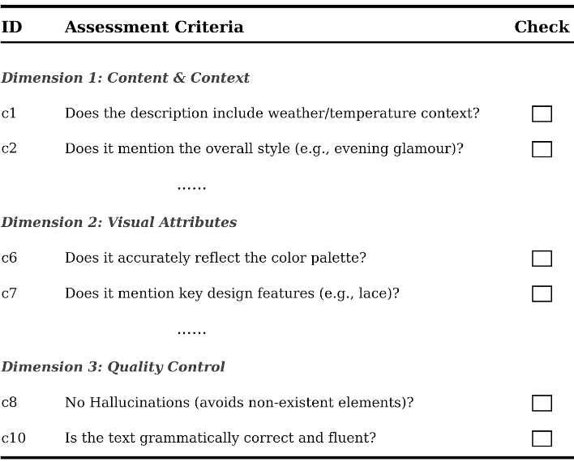 | 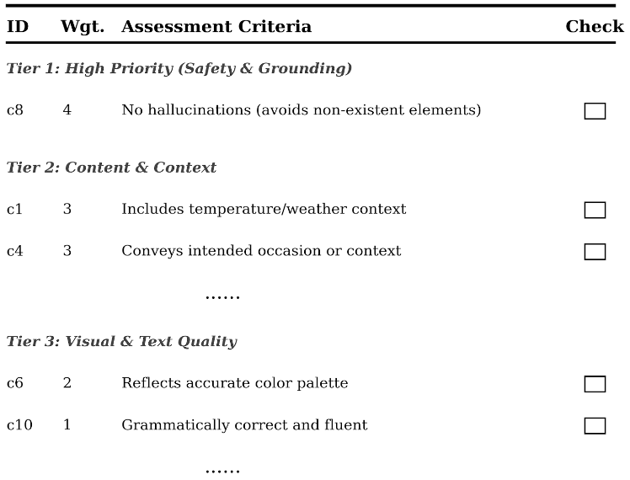
Figure 2: Checklist-based assessment criteria for generated context-aware outfit descriptions.
Algorithm 1 presents the three-stage scoring procedure used in this study. Phase 1 constructs a general checklist. Phase 2 adapts the criteria and weights to the context-aware outfit-description task. Phase 3 then scores each outfit image-description pair item by item and returns a quality score, feedback, and a suggested revision. We use two multimodal judging models, Qwen3-VL-32B-Instruct and Gemma-3-27B-it, to evaluate all 35,140 context-aware descriptions.

ALGORITHM 1: Three-phase LLM-as-a-Judge procedure for generated description assessment
Require:
Image collage set $I=\{i_{n}\}_{n=1}^{N}$
Description set $D=\{d_{n}\}_{n=1}^{N}$
Paired dataset $X$ = {$X_{n}\}_{n=1}^{N}$ with $X_{n}$ = ($i_{n}$, $d_{n}$)
Coverage LLM $M_{\text{cov}}$
Preference LLM $M_{\text{pref}}$
Scoring LLM $M_{\text{score}}$
Ensure:
Scores $S=\{s_{n}\}_{n=1}^{N}$
Feedback $F=\{f_{n}\}_{n=1}^{N}$
Suggested Revision $R=\{r_{n}\}_{n=1}^{N}$
Phase 1: Generate General Guidelines
$$C←GENERATEGUIDELINE(M_{cov}, X)$$
$C$ = {𝐜₁,…,𝐜ₘ}, a universal checklist of yes/no items (criterion-guided, reference-free).
Phase 2: Personalize Guidelines
$$C*←PERSONALIZE(M_{pref},X,C)$$
$C*$ re-ranks and may augment $C$ according to global task conditions; denote C* = $\{c_{1}^{*},…,c_{m*}^{*}\}$(m* may differ from m). All inputs thereafter are evaluated against the same C*.
Phase 3: Score Descriptions
for each $X_{n}$ = ($i_{n}$, $d_{n}$) in $X$do
$$\left(s_{n}, f_{n}, r_{n}\right)←SCORE\left(M_{\text{score}}, { X}_{n}, C*\right)$$
end for
return $S, F, R$
LLM-as-a-Judge scores are used for generation-quality diagnostics rather than as training signals or sample-selection criteria for the downstream recommender. Judge-produced feedback and suggested revisions are retained to analyze failure types and potential corrections for low-scoring samples. To complement the automated scores with human assessment, we conduct a stratified manual audit. Formal quality scores from the two judges are converted to within-model percentile ranks and used to define high-score, low-score, and disagreement strata. Low-score samples have a mean percentile no greater than 0.25 and a percentile difference no greater than 0.35. High-score samples have a mean percentile of at least 0.75 and a percentile difference no greater than 0.35. Disagreement samples have a percentile difference of at least 0.50 or an absolute raw-score difference of at least 0.25. We sample 10 cases from each stratum, yielding 30 manual-audit samples under a fixed random seed. The sample set also covers diverse temperatures, activity intensities, occasions, and styles. Judge scores are not used to delete or revise generated samples directly. Feedback and suggested revisions are retained only for diagnostics, and the formal downstream experiments use the original batch-generated context-aware descriptions so that an additional revision stage does not alter the main data condition.
The manual audit uses the weighted checklist defined for each judging model. Given the same outfit images and description, the researcher makes a binary decision per checklist item and calculates a human score with the automated evaluation weights. Judge A and Judge B contain 10 and 15 checklist items, respectively, producing 750 human item-level decisions across the 30 samples. To compare automated scores with human judgments, we report mean bias, mean absolute error (MAE), root mean square error (RMSE), Pearson correlation, and Spearman rank correlation. The manual audit is used only as complementary validation of LLM-as-a-Judge reliability. It is not treated as a large-scale gold standard and is not used to rescreen or modify downstream training data.
  - Primary Downstream Recommendation Model
The downstream recommender is Wang and Zhong's Hybrid Attention text-conditioned outfit model [19]. The model uses FashionCLIP to extract item image and text representations and integrates textual conditions with candidate-item features through the Hybrid Attention Layer to estimate candidate fit with the existing outfit and textual requirement.
As shown in Figure 3, generated context-aware descriptions are used as textual conditions while item images, item names, feature extraction, model architecture, and data splits are held constant. This design controls downstream-model factors so that experimental differences primarily reflect the source of the textual condition. The comparison therefore focuses on original url_name + title queries versus generated context-aware descriptions within the same text-conditioned recommendation framework.
We do not modify the core Hybrid Attention Layer or claim a new recommendation-model design. The main experiments hold the recommender, multimodal representations, data splits, and training settings fixed so that the comparison isolates text-condition source and tests whether context-aware descriptions improve outfit compatibility and conditional item retrieval. A simpler FashionCLIP-based Two-Tower architecture is additionally used for cross-architecture robustness validation. It is a complementary validation model and does not replace the primary recommendation setting.
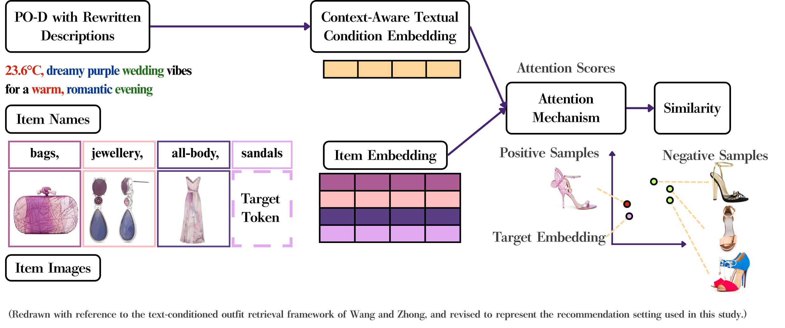
Figure 3: Fixed downstream text-conditioned outfit recommendation framework with generated context-aware descriptions. Adapted from Wang and Zhong [19], with the textual condition revised to the generated context-aware description used in this study.
  - Contextual Semantic-Factor Annotation
Although training uses each context-aware description as one natural-language condition, later analyses identify whether it contains weather, occasion, and style semantics. We therefore annotate generated descriptions with Weather, Occasion, and Style (W/O/S) factors according to the operational definitions in Table 3. These annotations support fair-subset construction, semantic-factor ablation, contextual-subset comparisons, and counterfactual sensitivity analysis. They are not supplied to the downstream recommender as additional structured features.
Table 3: Operational definitions of W/O/S semantic factors
Factor | Operational definition | Examples
Weather (W) | Describing external climate, temperature, season, or thermal-feeling context. Hard indicators include temperature values, weather phenomena, and seasonal terms. Soft indicators include weather-related feeling terms such as warm, cool, and chilly. | 23.6°C, warm, chilly, summer
Occasion (O) | Text spans that independently express an activity, place, time context, or usage scenario. Only explicit context phrases are counted. If a phrase only implies a possible context through style but does not contain an identifiable occasion cue, it is not counted as Occasion. | date, travel, party, walk, evening
Style (S) | Text spans describing fashion style, aesthetic direction, garment type, material, pattern, or visible styling cues. These terms indicate the visual or stylistic expression of the outfit rather than a user’s personal identity or long-term preference. | casual, formal, heels, floral prints
This annotation establishes an analyzable semantic layer; it does not decompose the description and re-enter its factors separately into the model. The downstream recommender still receives the complete natural-language description, while W/O/S annotations are used to characterize semantic coverage and support the fair-subset, ablation, contextual-subset, and counterfactual analyses.
- Experimental Design
  - Tasks and Evaluation Metrics
We evaluate the effect of context-aware textual conditions on downstream multimodal outfit recommendation using compatibility and conditional recommendation tasks. Outfit compatibility includes Compatibility Prediction (CP) and Fill-in-the-Blank (FITB). CP evaluates the model's ability to distinguish compatible from incompatible outfits and is measured primarily by area under the receiver operating characteristic curve (AUC). FITB evaluates whether the model can select the correct missing item from a candidate set and is reported as accuracy.
Conditional recommendation is evaluated with Conditional Item Retrieval (CIR). Given a text condition and a partial outfit, CIR measures whether the correct target item is ranked near the top of the candidate list. Let N be the number of queries eligible for CIR evaluation and ri the rank of the correct target item for query i. Recall@K is defined in Equation 3:
$Recall@K=\frac{1}{N}\sum_{i=1}^{N}{I}\left(r_{i}≤K\right)$ (3)
where$I\left(·\right)$ is the indicator function and equals 1 when the correct target item appears within the top K candidates and 0 otherwise. We report Recall@1, Recall@3, Recall@5, Recall@10, Recall@30, and Recall@50 to characterize retrieval performance at different ranking depths.
The main experiments are repeated with five fixed random seeds, and we report the mean, standard deviation, and 95% confidence interval (CI). Because original text and context-aware descriptions are compared under the same random seeds and experimental settings, the observations are paired. We use paired t-tests and Wilcoxon signed-rank tests to assess differences between the two text conditions, and paired-sample Cohen's dz to quantify the standardized effect size. Let Di denote the metric difference (context-aware description minus original text) for random seed i, and let D-bar and sD denote the mean and standard deviation of these differences. Cohen's d_{z} is defined in Equation 4:
$d_{z}=\frac{\overset{‾}{D}}{s_{D}}$ (4)
A positive difference indicates that the context-aware description outperforms the original text on the corresponding metric. When multiple primary metrics are tested simultaneously, p-values from the paired t-tests are additionally adjusted using the Benjamini-Hochberg procedure. Because only five random seeds are available, the Wilcoxon signed-rank test has limited statistical resolution. Results are therefore interpreted jointly using the direction of the mean difference, 95% CI, effect size, and significance tests rather than a single p-value.
  - Comparison Conditions and Control Analyses
The primary comparison contrasts original outfit-level text (url_name + title) with generated context-aware descriptions. Both conditions use the same data splits, item images, item names, feature extraction, recommender architecture, and training settings. Thus, the main experiment isolates the text-condition source's influence on downstream recommendation performance.
To examine whether performance differences could be explained by other factors, we include three control analyses. First, a text-length check analyzes the relationship between query-length differences and retrieval improvement to determine whether gains are attributable only to longer generated descriptions. Second, a Target-Clue Leakage Audit examines whether generated descriptions systematically expose target categories or target-item cues. Third, we inspect the distributions and plausibility of CLO, MET, and temperature reference values to verify that the proxy variables remain within interpretable ranges during data construction.
  - Experimental Settings
Data preprocessing and early rewriting validation used a Google Colab A100 GPU. Subsequent LLM validation and recommender training used an NVIDIA RTX PRO 6000 Blackwell Workstation Edition GPU with 96 GB VRAM. All primary comparisons use the same data splits and FashionCLIP representations to minimize confounding from preprocessing or feature extraction.
The CP task trains the fixed Hybrid Attention recommender using FashionCLIP item representations. The model is trained for 100 epochs with a batch size of 50 and a learning rate of 5 × 10⁻⁵. Hard negative sampling starts after epoch 40 to better distinguish difficult negative examples.
For CIR, CP-stage model weights initialize further conditional complementary-item retrieval training. This setup follows the text-conditioned outfit recommendation pipeline in which the model first learns outfit compatibility and is then adapted for target-item ranking. We compare Recall@K under original outfit-level text and context-aware descriptions to quantify the contribution of contextual text conditions to conditional outfit recommendation.
  - Contextual Semantic-Factor Ablation
In addition to the main experiment, we use the W/O/S annotations from Section 3.12 to design contextual semantic-factor ablations that assess the effects of weather, occasion, and style semantics on downstream recommendation. The main experiment compares Original text with Context-aware description using all valid samples. The ablation uses a fair subset in which Weather, Occasion, and Style are all present, preventing differences in semantic coverage from confounding interpretation. Four text conditions are constructed: Full/Context-aware description, No-Weather (No-W), No-Occasion (No-O), and No-Style (No-S). Full retains the complete context-aware description, whereas No-W, No-O, and No-S remove weather-, occasion-, and style-related spans, respectively. All ablations use identical data splits, feature extraction, and recommender settings so that differences are concentrated in the contextual semantics retained in the text.
  - Robustness Validation Design
    - Cross-Architecture Validation
To assess whether the benefits observed in the main experiment depend strongly on Hybrid Attention, we additionally evaluate a simpler FashionCLIP-based Two-Tower model. The validation uses the same Polyvore Outfits Disjoint split as the main experiment and independently trains the model with original outfit text and context-aware descriptions, keeping text source as the principal difference between conditions. The Two-Tower model serves only as a complementary robustness architecture and does not replace the Hybrid Attention model used in the main experiment.
FashionCLIP first produces separate 512-dimensional image and text representations for each item. These are concatenated into a 1,024-dimensional item representation and transformed by a shared projection layer into a 256-dimensional feature. For CP, pooled item representations and the outfit-level text representation are jointly used for compatibility prediction. For conditional retrieval, the partial outfit, text condition, and target category form the query representation, which is compared with candidate-item representations to produce rankings. The retrieval stage reuses CP-trained item and text encoders, preserving the sequence from compatibility learning to candidate ranking.
Original text and context-aware descriptions are each trained under five fixed random seeds. The CP and retrieval models are trained for 100 epochs with a batch size of 256, learning rate of 1 × 10⁻³, AdamW optimizer, weight decay of 1 × 10⁻⁴, and dropout of 0.15. The model checkpoint with the best validation FITB accuracy is selected.
    - Counterfactual Context Sensitivity Analysis
To further assess whether recommendation rankings respond to changes in contextual semantics, we design a single-factor counterfactual context sensitivity analysis. Rather than regenerating the entire description or changing multiple contextual conditions simultaneously, we replace only one semantic factor—Weather, Occasion, or Style—while holding all other inputs and retrieval settings fixed, and observe the sensitivity of candidate rankings to that controlled semantic change.
Let the original context-aware text condition for sample i be denoted in Equation 5:
$q_{i}=\left(W_{i},O_{i},S_{i}\right)$ (5)
where Wi, Oi, and Si denote the Weather, Occasion, and Style semantics in the text condition. We construct the single-factor counterfactual conditions defined in Equations 6–8:
$q_{i}^{\left(W\right)}=\left(W_{i}',O_{i},S_{i}\right)$ (6)
$q_{i}^{\left(O\right)}=\left(W_{i},O_{i}',S_{i}\right)$ (7)
$q_{i}^{\left(S\right)}=\left(W_{i},O_{i},S_{i}'\right)$ (8)
where Wi', Oi', and Si' denote the counterfactual semantics after factor replacement. Each counterfactual operation modifies only the target factor while preserving the other two contextual components, reducing interference from simultaneous multidimensional changes.
Counterfactual cases are sampled from the 9,311 query-target pairs in the formal CIR test for which a complete candidate pool can be constructed. Each case retains the same partial outfit, target item, target category, and candidate pool. As in formal CIR evaluation, the pool contains 3,000 candidate items from the same fine-grained category as the target. Sampling uses random seed 42 and avoids selecting the same outfit more than once. We construct eight cases each for Weather, Occasion, and Style. Each factor has two opposing perturbation directions, with four cases sampled per direction, yielding 24 controlled counterfactual pairs. We also balance target types as closely as possible between clothing-led and accessory-led items, resulting in 12 cases of each type.
Weather perturbations use the evaluable samples' median temperature reference of 22.9°C. Samples at least 2°C above or below the median represent warmer or colder conditions, respectively, producing warm-to-cold and cold-to-warm perturbations. Occasion perturbations use the formal/casual semantics in the existing descriptions to construct formal-to-casual and casual-to-formal replacements. Style perturbations use richness: high means at least two style terms and low no more than one, producing high-to-low and low-to-high replacements. Table 4 summarizes these settings.
Table 4: Counterfactual perturbation settings for contextual semantic factors
Factor | Perturbation direction | Operational setting | n
Weather | warm → cold | Replace the warmer condition with a colder-weather description emphasizing insulation and layered dressing. | 4
Weather | cold → warm | Replace the colder condition with a warmer-weather description emphasizing lightweight and breathable dressing. | 4
Occasion | formal → casual | Replace formal-occasion semantics with everyday casual-activity semantics. | 4
Occasion | casual → formal | Replace casual-occasion semantics with formal work-context semantics. | 4
Style | high → low style richness | Replace the richer style description with simpler styling semantics of lower style density. | 4
Style | low → high style richness | Replace the simpler style description with richer, more layered styling semantics. | 4
Total |  |  | 24
During retrieval, only the modified text description is re-encoded. The partial outfit, target item, target category, candidate pool, and recommender remain fixed. We use the fixed weights of the existing context-aware CIR model and do not retrain it on counterfactual text, so that ranking differences between the original context-aware and counterfactual conditions are concentrated as much as possible on the changed textual context.
To quantify ranking responses after counterfactual replacement, we first calculate the target-item rank change. Let ri be the target rank under the original context-aware condition and ri' the rank under the counterfactual condition. The rank difference is defined in Equation 9:
$ΔRank_{i}=r_{i}'-r_{i}$ (9)
A positive ΔRanki indicates that the target moves down after counterfactual replacement; a negative value indicates that it moves up. Because the counterfactual text has no new human-annotated recommendation ground truth, rank difference is used only to describe the direction and magnitude of ranking response. Its sign does not directly indicate improved or degraded recommendation quality.
In addition to target-item rank, we calculate the Top-1 changed rate to determine whether replacing a contextual factor changes the highest-ranked candidate. Let T1(q_{i}) and T1(q_{i}') denote the top-ranked candidate under the original context-aware and counterfactual conditions, respectively. The Top-1 change for a single case is defined in Equation 10:
${Change@1}_{i}=I\left[T_{1}\left(q_{i}\right)≠T_{1}\left(q_{i}'\right)\right]$ (10)
where I(·) is the indicator function and equals 1 when the top candidate differs before and after counterfactual replacement and 0 otherwise. The average across all cases is the Top-1 changed rate, representing the proportion of counterfactual perturbations that change the first recommendation.
To measure broader changes among high-ranked candidates, we also compute the Jaccard overlap between the Top-5 candidate sets under the original and counterfactual conditions. Let T5(q_{i}) and T5(q_{i}') denote the two Top-5 candidate sets. The overlap is defined in Equation 11:
$J_{i}^{\left(5\right)}=\frac{\left|T_{5}\left(q_{i}\right)∩T_{5}\left(q_{i}'\right)\right|}{\left|T_{5}\left(q_{i}\right)∪T_{5}\left(q_{i}'\right)\right|}$ (11)
The resulting J_{i}⁵ lies between 0 and 1. Values closer to 1 indicate more similar Top-5 candidate sets after replacement and thus greater stability to contextual change. Lower values indicate greater reorganization of the high-ranked candidate set caused by the single-factor perturbation.
This analysis measures candidate-ranking sensitivity to a controlled change in one contextual semantic factor, not whether the original or counterfactual condition yields better recommendation quality. Because no corresponding human recommendation ground truth exists after the counterfactual change, we do not assume that the target rank should improve or decline, and we do not interpret rank differences as causal effects of contextual factors on recommendation performance. The analysis complements the W/O/S ablation by testing whether candidate rankings respond observably when other retrieval conditions are held fixed and one textual contextual factor is changed.
- Experimental Results
This section reports the constructed descriptions' quality and downstream recommendation results. We first examine the validity and quality of generated data and intermediate proxy variables to establish an interpretable basis for downstream results. We then compare original text with context-aware descriptions on outfit compatibility and conditional item retrieval, and use the fair subset, semantic-factor ablations, cross-architecture validation, and counterfactual sensitivity analysis to assess robustness and potential sources of the gains. Finally, category-level, contextual-subset, and qualitative analyses identify the benefits and limits of context-aware descriptions.
  - Validity and Quality of the Generated Data
Because the main experiments use generated descriptions as text conditions, we first assess whether the data are reasonable and usable. We examine four aspects: proxy-variable distributions, text-length confounding, target-clue leakage, and generation quality. These checks determine whether CLO, MET, and temperature reference values remain interpretable and whether text length, potential answer clues, or generation quality could confound the downstream recommendation results.
    - Proxy-Value Sanity Checks
CLO, MET, and temperature reference values serve as intermediate proxy variables during weather-semantic generation and description rewriting. We examine their main distributions and boundary cases to verify that their data characteristics remain reasonable. This analysis is not intended to validate actual human thermal comfort. It assesses whether the proxies occupy analyzable and interpretable ranges. Table 5 summarizes these distributions and boundary cases.
Table 5: Sanity check of CLO, MET, and temperature proxy variables
Proxy variable | Main distribution | Tail / flag | Interpretation
CLO | Median = 0.93. Q1–Q3 = 0.63–1.21. P5–P95 = 0.25–2.07 | Max = 5.20. CLO > 4: 20 records | Most values fall within a plausible outfit-level insulation range, with a small high-insulation tail.
MET | Median = 1.00. Q1–Q3 = 1.00–1.30. P5–P95 = 1.00–1.50 | MET = 1.0: 25,786 records (73.4%). MET > 10: 8 records | The activity proxy is concentrated in low-intensity activities, consistent with conservative daily-wear assumptions.
Temperature reference | Median = 22.9°C. Q1–Q3 = 19.9–24.5°C. P5–P95 = 13.5–27.1°C | Temperature < 0°C: 257 records (0.73%). Temperature < −20°C: 51 records (0.15%) | The main distribution is interpretable, but extreme low values indicate boundary cases in the simplified thermal mapping.
As shown in Table , CLO has a median of 0.93 and an interquartile range of 0.63–1.21, with P5–P95 spanning 0.25–2.07, indicating that most outfit-level insulation estimates lie within the main distribution. A small number of high-CLO samples remain, including 20 records with CLO > 4. We do not directly delete or truncate these observations, but retain the original estimates to expose the full distribution and boundary behavior of the proxy variable. The temperature reference value has a median of 22.9°C, an interquartile range of 19.9–24.5°C, and a P5–P95 range of 13.5–27.1°C, placing the main distribution within a range usable for constructing weather semantics. Nevertheless, 257 samples fall below 0°C (0.73% of all samples), including 51 below −20°C (0.15%). Consistent with the intended direction of the mapping, higher CLO or MET yields a lower temperature reference value, reflecting the use of garment insulation and activity intensity as constraints on weather semantics.5
The median temperature reference is 22.9°C, and the central distribution lies mainly between 13.5°C and 27.1°C, making it a useful reference scale for weather-semantic generation. The 257 values below 0°C, including 51 below −20°C, should not be interpreted as actual ambient temperatures. They are boundary cases from simplified thermal mapping under high insulation or activity intensity. We retain these records as diagnostic evidence and consistently treat the temperature value as a data-construction reference rather than as an observed comfort temperature or weather label.
Overall, the main distributions of CLO, MET, and the temperature reference value are interpretable, while the small number of extreme cases also reveal the boundaries of simplified thermal mapping and proxy estimation. We therefore use these quantities as intermediate proxy scales for context-aware semantic construction, establishing a traceable relationship among clothing insulation, activity intensity, and weather semantics rather than claiming precise measurements of garment insulation, human metabolism, or thermal comfort.
    - Text-Length Confounding Check
As Table 2 shows, context-aware descriptions are longer on average than the original outfit-level text (url_name + title). We therefore examine whether retrieval gains can be explained primarily by longer queries. Let ΔL denote the token-length difference between the generated and original descriptions. Using the 9,311 CIR query-target pairs as the unit of analysis, we measure the association between ΔL and retrieval improvement. Because each CIR query has a single correct target item in our setting, Hit@10 and Recall@10 are numerically equivalent. Table 6 reports the corresponding correlation results.
Table 6: Correlation between text-length difference and retrieval improvement
X | Y | N | Pearson r | p | Effect-size interpretation
ΔL | Hit@10 improvement | 9,311 | 0.027647 | 0.007632 | negligible
ΔL | Rank improvement | 9,311 | 0.043384 | 0.000028 | negligible
As shown in Table 6, the Pearson correlation between ΔL and Hit@10 improvement is only 0.0276, and the correlation with rank improvement is 0.0434. Although these coefficients can reach statistical significance with 9,311 observations, their magnitudes are negligible, suggesting that text-length differences do not explain the primary retrieval gains. We also compare Hit@10 in subsets with similarly long original and context-aware descriptions. If the improvement were driven mainly by longer text, the advantage of context-aware descriptions should substantially diminish or disappear in these matched-length subsets. Table 7 reports the matched-length subset results.
Table 7: Hit@10 comparison under matched-length subsets
Matched-length subset | Query-target pairs | Original description | Context-aware description | Difference | Mean rank improvement
Same token length | 63 | 0.0698 | 0.0762 | +0.0063 | 22.62
Within 1 token | 223 | 0.0646 | 0.0753 | +0.0108 | 10.00
Within 2 tokens | 573 | 0.0667 | 0.0729 | +0.0063 | 12.84
Within 3 tokens | 1,158 | 0.0772 | 0.0879 | +0.0107 | 11.21
Within 5 tokens | 3,014 | 0.0790 | 0.0896 | +0.0106 | 21.47
Table 7 shows that among 63 samples with identical token lengths, Hit@10 still increases from 0.0698 under original text to 0.0762 under context-aware descriptions. Among 1,158 samples with a length difference of at most three tokens, Hit@10 increases from 0.0772 to 0.0879. Thus, the context-aware condition retains higher retrieval performance even at lengths comparable to original descriptions.
Overall, text-length difference has negligible association with retrieval improvement, which remains positive in matched-length subsets. The current evidence therefore does not support attributing the primary performance gains to longer query text.
    - Target-Clue Leakage Audit
In conditional item retrieval, text conditions may naturally include garment categories or dressing requirements such as “dress,” “coat,” “sneaker,” or “wedding outfit.” Such words are not necessarily answer leakage in realistic recommendation because a user query may explicitly specify the desired item type. Our audit therefore does not attempt to remove all item words. Instead, it tests whether generated descriptions systematically reveal the target item's category, item name, or highly identifying clues more often than the original text condition.
We perform a static lexical audit on the 9,311 CIR query-target pairs. The checks include whether the generated description directly contains the target fine-grained category, whether it contains either the fine-grained or main category, and whether it overlaps with discriminative tokens in the target-item name. To distinguish category-level requirements from more answer-specific item clues, we report both a permissive token-level overlap and a stricter bigram-level overlap and compare them with the original url_name + title condition. Table 8 summarizes the lexical-audit results.
Table 8: Target-clue leakage audit for generated and original text conditions
Audit item | Count | Ratio | Interpretation
Audited CIR query-target pairs | 9,311 | 100.00% | Main CIR query-target pairs
Generated fine-category lexical match | 419 | 4.50% | Direct fine-category mention in generated descriptions
Generated any-category lexical match | 454 | 4.88% | Fine- or major-category mention in generated descriptions
Generated target-item token overlap | 1,030 | 11.06% | Loose token-level clue check
Generated target-item bigram overlap | 81 | 0.87% | Stricter phrase-level clue check
Original target-item token overlap | 1,155 | 12.40% | The original text condition also contains item-like token overlap
As shown in Table 8, generated descriptions directly contain the target fine-grained category in 4.50% of cases and either the fine-grained or main category in 4.88%, indicating limited explicit category exposure. For discriminative target-item name tokens, generated descriptions have an 11.06% token-level overlap, compared with 12.40% for the original url_name + title condition, showing that such lexical overlap is not unique to contextual rewriting. Under the stricter bigram criterion, only 0.87% of generated descriptions contain a phrase-level overlap with the target-item name.
Overall, generated descriptions contain a small amount of target-category or item-name overlap, but the proportions are limited and do not show a clear increase over the original text condition. Because realistic text-conditioned recommendation queries may explicitly include garment categories or desired item types, the presence of a category term alone should not be treated as answer leakage. The audit therefore supports using the generated descriptions in subsequent recommendation evaluation and reduces concern that the observed gains arise from systematic exposure of target clues.
    - Generation-Quality Assessment
After checking proxy values, text length, and target clues, we assess generation quality. Because context-aware rewriting is open-ended and outfits may admit multiple reasonable formulations, we do not rely on a single score. Instead, we combine the overall score distribution, overlap among low-scoring samples, prompt robustness, and a 30-sample manual audit to determine whether the generated descriptions meet basic downstream-experiment quality requirements.
The two multimodal judging models are denoted Judge A and Judge B. Judge A is Qwen3-VL-32B-Instruct and Judge B is Gemma-3-27B-it. Each model evaluates all 35,140 generated descriptions using its own weighted checklist. Judge A has a mean quality score of 0.828 (SD = 0.142), while Judge B has a mean of 0.960 (SD = 0.089). Most generated descriptions therefore satisfy the major checklist criteria, but the two judges operate on different score scales and Judge B is strongly concentrated near the upper end. Subsequent analyses consequently examine not only aggregate scores but also overlap in low-scoring samples and prompt robustness.
For example, the high-scoring case 223051514, “23.6°C, Effortless Summer Days in a Floral Midi Dress,” is judged relatively consistent because it preserves visible outfit features and enriches the summer-dressing semantics with a temperature cue and query-like phrasing. By contrast, the low-scoring case 186249502, “25.1°C, Cozy Winter Vibes: Layered Comfort for a Festive Ice Skating Day,” is judged less consistent because 25.1°C conflicts with the winter/ice-skating semantics and because the description introduces a specific occasion that is not supported by the image. This example illustrates how LLM-as-a-Judge can diagnose image-text inconsistency and contextual-semantic drift. Table 9 summarizes the overlap between the two judges.
Table 9: Low-score overlap between two LLM judges
Bottom p | Shared low-score samples | Random expectation | Lift | Jaccard | F1
0.05 | 668 | 87.9 | 7.604 | 0.2347 | 0.3802
0.10 | 1,323 | 351.4 | 3.765 | 0.2319 | 0.3765
0.20 | 2,833 | 1,405.6 | 2.016 | 0.2524 | 0.4031
As shown in Table 9, under the bottom-5% threshold the judges share 668 low-scoring samples, compared with 87.9 expected by chance, yielding a lift of 7.604. When the threshold is relaxed to the bottom 10% and bottom 20%, the lifts remain 3.765 and 2.016, respectively. Thus, despite different score scales, the two judges show meaningful agreement in identifying low-quality samples.
To assess sensitivity to judge-prompt wording, we additionally sample 75 descriptions from the high-score region and 75 from the low-score region, yielding 150 descriptions for a prompt-robustness check. P0 denotes the formal evaluation prompt. P0-R2 repeats the same P0 configuration to measure rerun stability. P1 changes the presentation order of checklist items to test order sensitivity, while P2 adopts more conservative evaluation wording to test sensitivity to prompt tone. All versions use the same samples, judging models, and output format, and are compared by their absolute score difference from the formal P0 evaluation. Table 10 reports the prompt-robustness results.
Table 10: Prompt robustness analysis on 150 sampled descriptions
Judge | Version | Mean absolute difference | Median absolute difference | Maximum difference | ≤ 0.05 | ≤ 0.10
Judge A | P0-R2 | 0.0048 | 0.0000 | 0.2727 | 97.3% | 98.7%
Judge B | P0-R2 | 0.0461 | 0.0000 | 0.3939 | 62.0% | 89.3%
Judge A | P1 | 0.0709 | 0.0455 | 0.6818 | 64.0% | 72.0%
Judge B | P1 | 0.0713 | 0.0455 | 0.4242 | 50.0% | 75.3%
Judge A | P2 | 0.0506 | 0.0455 | 0.4545 | 80.0% | 85.3%
Judge B | P2 | 0.0521 | 0.0000 | 0.6061 | 71.3% | 84.0%
Table 10 shows that P0-R2, which repeats the prompt, generally produces smaller score differences, whereas P1, with reordered checklist items, and P2, with more conservative wording, induce larger changes. LLM-as-a-Judge is therefore somewhat sensitive to prompt design, supporting the use of a fixed judge prompt, checklist, weighting scheme, and output format in the formal quality assessment.
For the manual audit, we select 10 high-scoring, 10 low-scoring, and 10 disagreement cases according to the stratified sampling procedure described above, yielding 30 descriptions for manual audit. Using the same outfit images and generated text, the researcher evaluates each description with both weighted checklists, makes binary item decisions, and converts them to a human quality score using the same weights. The two checklists contain 10 and 15 items, respectively, producing 750 human item-level decisions across the 30 samples.
Table 11 compares human and model scores. For Judge A, the mean human score is 0.7242 and the mean model score is 0.6667. For Judge B, the corresponding means are 0.6818 and 0.6566. Both judges score slightly lower on average than the corresponding human-weighted evaluation, with biases of -0.0576 and -0.0253. Judge B has slightly lower MAE and RMSE (0.2212 and 0.3085), whereas Judge A shows stronger Pearson (r = 0.5988) and Spearman (ρ = 0.6729) correlations. Overall, both judges are positively associated with human judgments, but differences remain in absolute score error and sample ordering. Because the 30 samples were deliberately selected across quality strata and disagreement cases for diagnostic purposes, they are not intended to estimate the population distribution of all 35,140 generated descriptions. We therefore do not perform small-sample significance inference on this audit.
Table 11: Auxiliary manual audit on 30 sampled descriptions
Judge | Human mean | Model mean | Bias | MAE | RMSE | Pearson r | Spearman ρ
Judge A | 0.7242 | 0.6667 | −0.0576 | 0.2273 | 0.3369 | 0.5988 | 0.6729
Judge B | 0.6818 | 0.6566 | −0.0253 | 0.2212 | 0.3085 | 0.5537 | 0.4909
At the checklist-item level, the clearest human-model disagreements concern overall image-text consistency, details unsupported by the image, and visual or contextual judgments involving style, occasion, and color. This pattern suggests that the main uncertainty in generation-quality assessment lies not in linguistic fluency but in whether fine-grained visual attributes and contextual semantics are sufficiently aligned with the outfit image.
Overall, both judges assign relatively high mean quality scores across the 35,140 generated descriptions, and their overlap among low-scoring samples is substantially higher than chance. Repeated scoring is also comparatively stable when the prompt is held fixed. The stratified 30-sample manual audit further shows positive associations between both judges and human assessment, although disagreements remain for individual samples and some checklist items. Within the diagnostic scope of this study, these checks do not reveal a systematic problem requiring large-scale replacement or revision of the generated data. The formal downstream experiments therefore retain the batch-generated context-aware descriptions as text inputs. Judge feedback and suggested revisions are used primarily for low-score and failure-case analysis, not for sample filtering or rewriting.
  - Main Recommendation Results
After validating the generated data, we evaluate the effect of context-aware descriptions on downstream recommendation. All experiments use the same data split, FashionCLIP representations, Hybrid Attention recommender, and training settings. The only comparison is the source of the text condition: original outfit-level text (url_name + title) versus generated context-aware descriptions.
Figure 4 and Figure 5 summarize the overall results for outfit compatibility and conditional item retrieval, respectively. Percentage labels in the figures show relative improvement over the original text condition, whereas Table 12 reports the primary metrics with mean ± standard deviation, absolute difference, 95% CI, and adjusted p-value. The figures therefore emphasize overall trends and relative gains, while the table provides the corresponding statistical comparisons.
As shown in Figure 4 and Table 12, context-aware descriptions improve both compatibility metrics. CP AUC increases from 0.9292 to 0.9454, an absolute mean gain of +0.0162, while FITB accuracy increases from 0.6374 to 0.6478, an absolute mean gain of +0.0103. These results indicate that, with the recommendation model fixed, context-aware text conditions improve outfit-compatibility judgments.
Figure 5 further shows that context-aware descriptions outperform the original text condition across multiple CIR Recall@K values. To keep the table concise, Table 12 reports the primary ranking depths Recall@10, Recall@30, and Recall@50, while Figure 5 shows the full Recall@K trend. Specifically, Recall@10 increases from 0.0780 to 0.0921, Recall@30 from 0.1677 to 0.1874, and Recall@50 from 0.2303 to 0.2518.
The statistical tests support these trends. Paired t-tests remain significant for the primary metrics after Benjamini-Hochberg adjustment, and the 95% confidence intervals for the differences do not cross zero. Because the experiments use only five random seeds, the Wilcoxon signed-rank test has limited resolution. We therefore interpret the results jointly from mean differences, confidence intervals, and the direction of effects rather than relying solely on a single nonparametric p-value.
Table 12: Main results on compatibility prediction and conditional item retrieval
Task | Metric | Original text | Context-aware description | Mean difference | 95% CI | Adjusted p
CP | AUC | 0.9292 ± 0.0013 | 0.9454 ± 0.0013 | +0.0162 | [0.0157, 0.0167] | < .001
CP | FITB Accuracy | 0.6374 ± 0.0037 | 0.6478 ± 0.0021 | +0.0103 | [0.0054, 0.0153] | .0045
CIR | Recall@10 | 0.0780 ± 0.0010 | 0.0921 ± 0.0035 | +0.0141 | [0.0101, 0.0182] | < .001
CIR | Recall@30 | 0.1677 ± 0.0045 | 0.1874 ± 0.0038 | +0.0197 | [0.0153, 0.0241] | < .001
CIR | Recall@50 | 0.2303 ± 0.0035 | 0.2518 ± 0.0038 | +0.0215 | [0.0161, 0.0269] | < .001
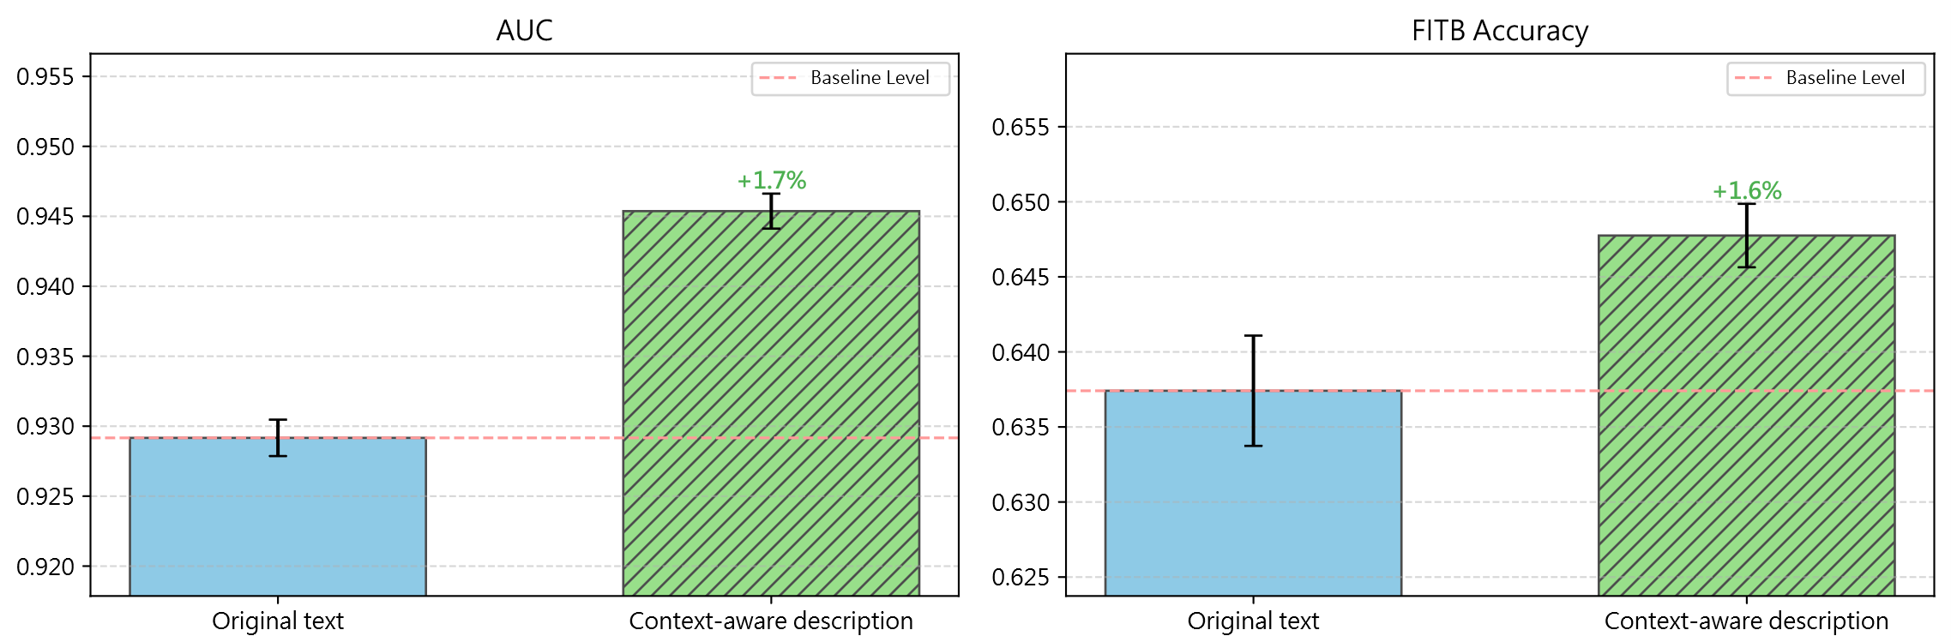
Figure 4: Compatibility prediction performance under original and context-aware text conditions.
Percent labels show improvement over original text; error bars show five-run standard deviations.
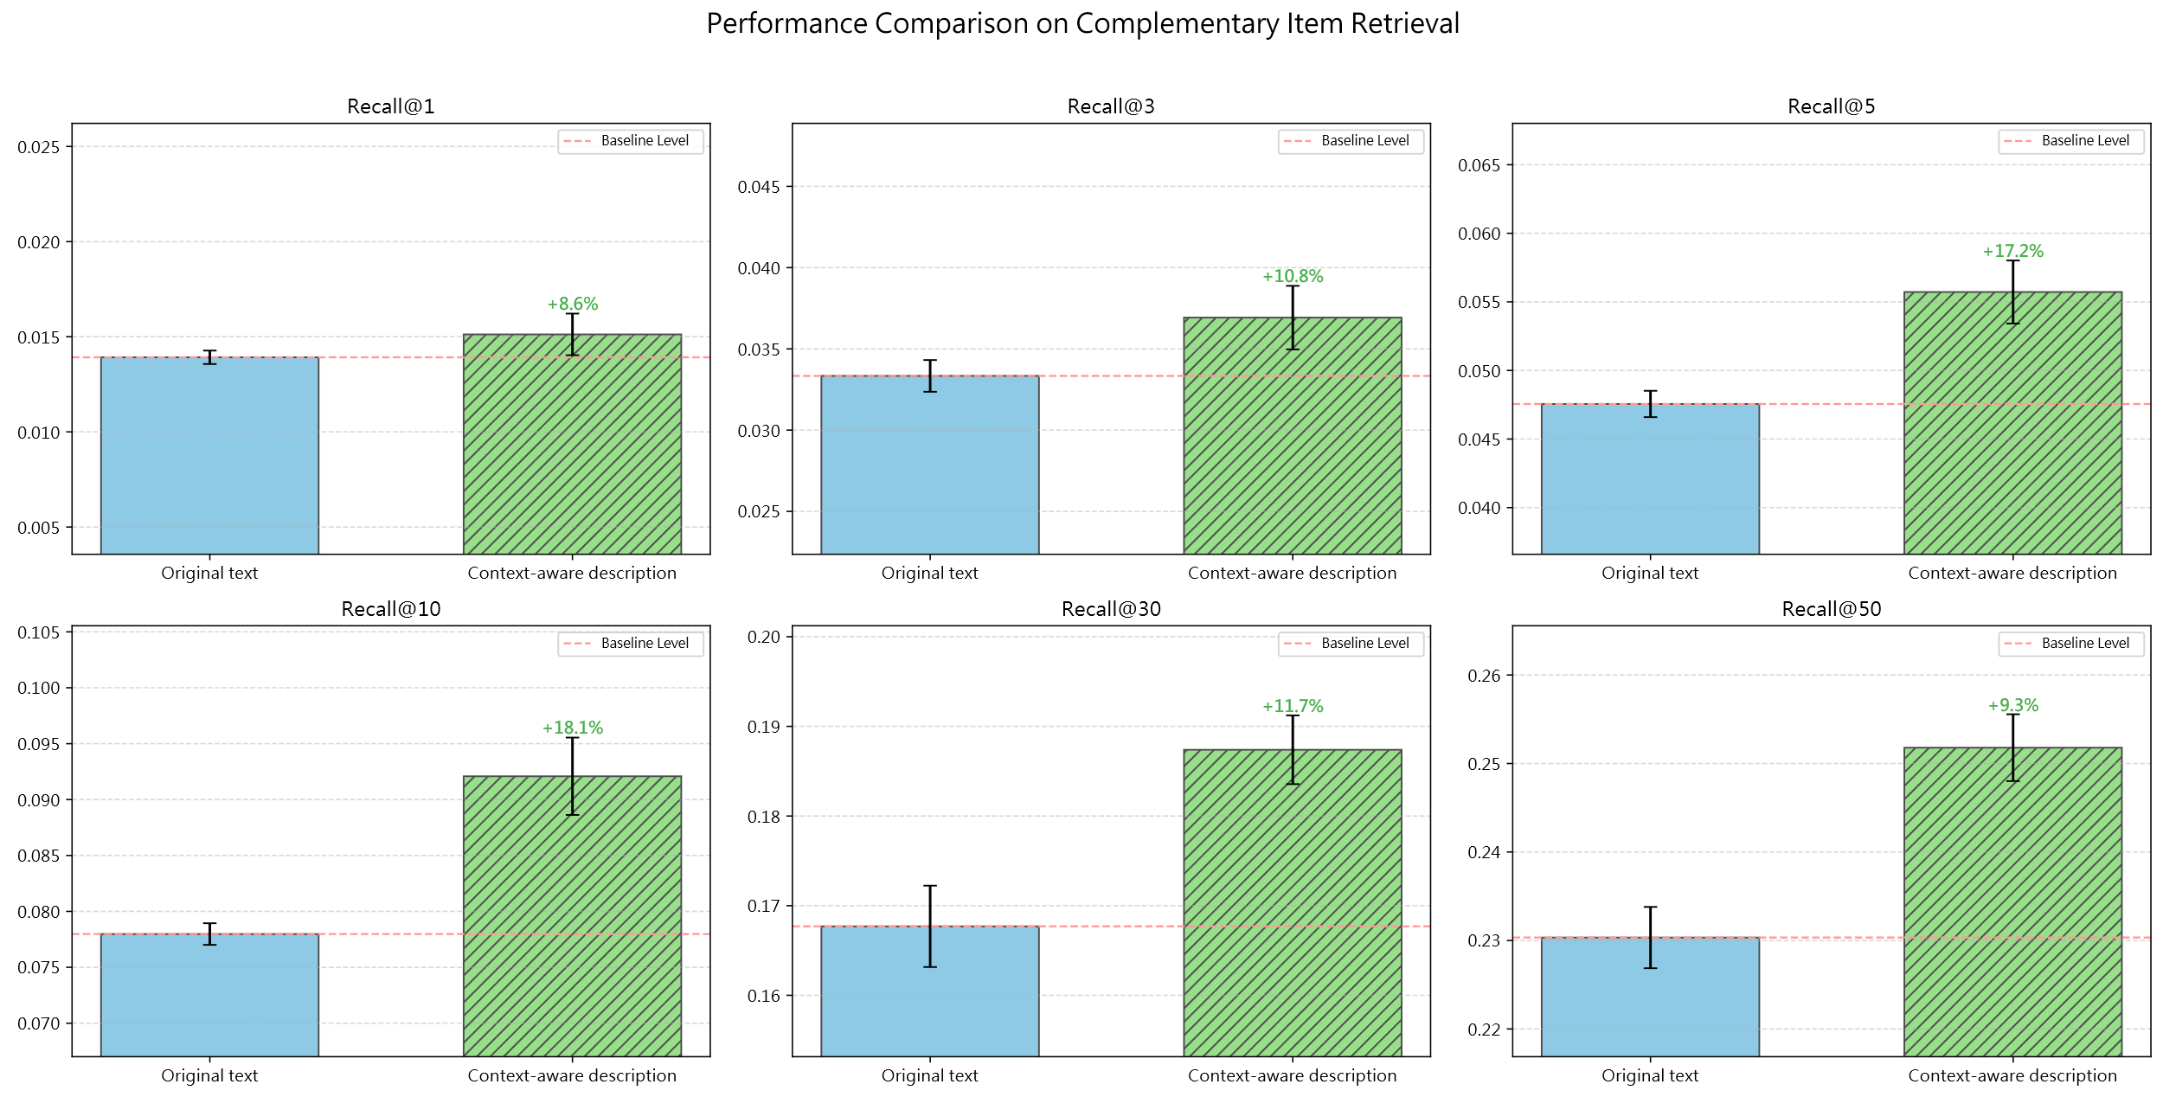
Figure 5: Conditional item retrieval performance under original and context-aware text conditions.
Percent labels show improvement over original text; error bars show five-run standard deviations.
  - Fair-Subset Validation
Using the operational definitions in Section 3.12 and Table 3, we annotate W/O/S semantic factors in the generated descriptions and construct a fair subset to assess whether the main results are driven by differences in semantic-factor coverage. The fair subset contains only samples in which Weather, Occasion, and Style are all present. Of the 35,140 valid generated descriptions, 21,903 (62.33%) satisfy this criterion.
Semantic-factor coverage is 100.00% for Weather, 99.87% for Style, and 62.45% for Occasion. This reflects the operational definitions. Weather can be identified from temperature values, weather phenomena, seasonal terms, or thermal-sensation words. Style can be identified from fashion style, aesthetic direction, garment type, material, or pattern cues. Occasion is annotated only when the text contains a span that independently expresses an activity, place, or usage context. A style tendency merely compatible with a possible context is not counted as Occasion unless that context is explicit. The lower Occasion coverage therefore determines much of the final fair-subset size.
Within the fair subset, we repeat the comparison between original text and the full context-aware description. Table 13 and Table 14 show that Full remains superior on both CP and CIR. CP AUC increases from 0.9112 to 0.9265 and FITB accuracy from 0.6109 to 0.6228. CIR Recall@10, Recall@30, and Recall@50 improve by +0.0096, +0.0203, and +0.0241, respectively. Thus, the improvement persists when all three W/O/S factors are explicitly present, reducing the likelihood that the main result is an artifact of semantic coverage or sample-composition differences.
Table 13: Fair-subset results on compatibility prediction
Metric | Original text | Context-aware description | Difference | p-value | Cohen’s d
AUC | 0.9112 ± 0.0015 | 0.9265 ± 0.0015 | +0.0153 | *** | 8.601
FITB Accuracy | 0.6109 ± 0.0035 | 0.6228 ± 0.0034 | +0.0119 | * | 2.059
Table 14: Fair-subset results on conditional item retrieval
Metric | Original text | Context-aware description | Difference | p-value | Cohen’s d
Recall@10 | 0.0686 ± 0.0043 | 0.0781 ± 0.0023 | +0.0096 | * | 1.479
Recall@30 | 0.1517 ± 0.0077 | 0.1720 ± 0.0034 | +0.0203 | ** | 2.617
Recall@50 | 0.2111 ± 0.0046 | 0.2351 ± 0.0045 | +0.0241 | *** | 4.774
  - Semantic-Factor Ablation
After fair-subset validation, we examine the relative effects of Weather, Occasion, and Style. Following the ablation design in Section 4.4, Full retains the complete context-aware description, while No-W, No-O, and No-S remove weather-, occasion-, and style-related spans, respectively. Because all ablations are conducted within the fair subset in which all three factors are present, differences in factor coverage are minimized. Figure 6 shows the relative impact of each semantic factor across metrics. The proportions are normalized from the performance drop caused by removing each factor and are intended only to compare relative changes within a metric. They should not be interpreted as additive causal contributions. Style accounts for the largest relative impact across both CP and CIR, while Weather and Occasion have smaller effects.
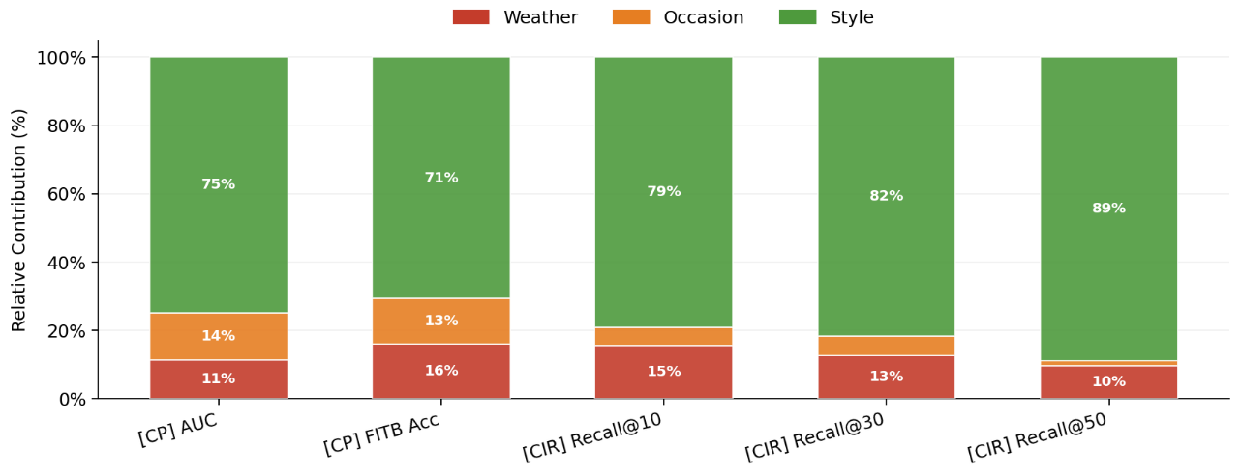
Figure 6: Relative impact of W/O/S ablations across evaluation metrics.
Stacked proportions show normalized performance drops after each factor's removal.
As shown in Table 15, removing Style produces the largest decrease in CP. AUC falls from 0.9265 for the full context-aware description to 0.9110 for No-S, a change of -0.0154. FITB accuracy falls from 0.6228 to 0.6064, a change of -0.0164. By comparison, removing Weather and Occasion reduces AUC by -0.0023 and -0.0029 and FITB accuracy by -0.0037 and -0.0031, respectively.
Table 15: W/O/S ablation results on compatibility prediction in the fair subset
Metric | Context-aware description | No-W | No-O | No-S
AUC | 0.9265 ± 0.0015 | 0.9241 ± 0.0034 | 0.9236 ± 0.0015 | 0.9110 ± 0.0041
FITB Accuracy | 0.6228 ± 0.0034 | 0.6191 ± 0.0060 | 0.6197 ± 0.0024 | 0.6064 ± 0.0051
CIR shows a similar pattern. Table 16 shows that No-S decreases Recall@10, Recall@30, and Recall@50 by -0.0110, -0.0196, and -0.0241, respectively, the largest drops among the three ablations. The effects of No-W and No-O are smaller, with Occasion having especially limited impact on CIR metrics. These results indicate that style-related semantics have the most consistent influence on target-item ranking in the text-conditioned outfit recommendation setting.
Table 16: W/O/S ablation results on conditional item retrieval in the fair subset
Metric | Context-aware description | No-W | No-O | No-S
Recall@10 | 0.0781 ± 0.0023 | 0.0760 ± 0.0013 | 0.0774 ± 0.0009 | 0.0671 ± 0.0035
Recall@30 | 0.1720 ± 0.0034 | 0.1690 ± 0.0047 | 0.1706 ± 0.0030 | 0.1524 ± 0.0042
Recall@50 | 0.2351 ± 0.0045 | 0.2325 ± 0.0068 | 0.2347 ± 0.0014 | 0.2110 ± 0.0014
Overall, the ablation results show that the three contextual semantic dimensions do not contribute equally. Removing Style causes the largest degradation in both CP and CIR, suggesting that fashion style, aesthetic direction, garment type, and visible styling cues constitute the most effective information in the text condition. Weather and Occasion have smaller effects but still provide environmental and usage-context constraints. The benefit of the proposed descriptions therefore does not arise from weather alone. It reflects a richer contextual condition that jointly conveys style, weather, and occasion, with style and visual semantics providing the most stable contribution to recommendation utility.
  - Robustness Analysis
Because the main experiment and semantic ablations center on Hybrid Attention, we further test architecture dependence and ranking responses to controlled textual-context changes. We therefore report cross-architecture validation and counterfactual context sensitivity analysis. The former tests utility trends under another architecture; the latter fixes the model and other retrieval conditions while measuring ranking responses to one changed contextual factor.
    - Cross-Architecture Validation Results
Table 17 reports the cross-architecture validation. The simpler FashionCLIP-based Two-Tower model shows a similar but not identical pattern to the main Hybrid Attention architecture. On CP, context-aware descriptions increase test AUC from 0.8796 to 0.9174, a mean gain of +0.0378 with a 95% CI of [0.0337, 0.0420]. In contrast, CP FITB accuracy decreases from 0.5460 to 0.5382, a mean difference of -0.0077, and the 95% CI [-0.0180, 0.0025] crosses zero. Thus, context-aware descriptions improve compatibility AUC under the alternative architecture, but the effect does not consistently improve CP FITB and thus does not indicate universal improvement across all compatibility metrics.
Retrieval results are consistently positive. Recall@10, Recall@30, and Recall@50 increase from 0.0378, 0.0950, and 0.1419 to 0.0479, 0.1103, and 0.1589, respectively. Mean rank decreases from 601.36 to 572.47, and median rank from 361.20 to 329.80, indicating that the target generally moves forward in the candidate list. The confidence intervals for these retrieval-related differences do not cross zero.
Table 17: Cross-architecture validation with a simplified FashionCLIP-based Two-Tower model
Metric | Original text | Context-aware description | Mean difference | 95% CI
CP Test AUC | 0.8796 ± 0.0029 | 0.9174 ± 0.0033 | +0.0378 | [0.0337, 0.0420]
CP FITB Accuracy | 0.5460 ± 0.0051 | 0.5382 ± 0.0050 | −0.0077 | [−0.0180, 0.0025]
Recall@10 | 0.0378 ± 0.0008 | 0.0479 ± 0.0017 | +0.0102 | [0.0087, 0.0117]
Recall@30 | 0.0950 ± 0.0017 | 0.1103 ± 0.0030 | +0.0153 | [0.0127, 0.0179]
Recall@50 | 0.1419 ± 0.0026 | 0.1589 ± 0.0046 | +0.0170 | [0.0139, 0.0200]
Mean rank ↓ | 601.3589 ± 7.0359 | 572.4678 ± 10.5809 | −28.8911 | [−44.8960, −12.8863]
Median rank ↓ | 361.2000 ± 6.2209 | 329.8000 ± 9.7826 | −31.4000 | [−44.0808, −18.7192]
Overall, the cross-architecture validation does not show uniform improvement on every metric, but the conditional-retrieval metrics largely preserve the direction observed in the main experiment. This suggests that the retrieval benefit of context-aware descriptions is not unique to Hybrid Attention: Recall@K improves and target ranks move forward even with the simpler Two-Tower architecture. The lack of consistent improvement in CP FITB also shows that the effect of textual enrichment depends on architecture and task formulation. These results are therefore treated as evidence of cross-architecture robustness rather than as a comparison of the intrinsic quality of the two recommenders.
    - Counterfactual Context Sensitivity Results
The controlled counterfactual analysis contains 24 cases: eight each for Weather, Occasion, and Style. For each case, the partial outfit, target item, target category, candidate pool, and recommendation model are fixed, while only one contextual semantic factor is replaced. As shown in Table 18, the mean target rank across all 24 cases is 586.0 under the original context-aware condition and 603.0 after single-factor replacement, yielding a mean ΔRank of +17.0 and a mean Top-5 Jaccard overlap of 0.351. Thus, even when all other retrieval conditions are held fixed, modifying a single textual contextual factor produces observable changes in candidate rankings and the high-ranked candidate set.
Table 18: Overall counterfactual retrieval response on 24 controlled pairs
Condition | Mean rank
Context-aware | 586.0
Counterfactual | 603.0
Mean ΔRank | +17.0
Mean Top-5 Jaccard overlap | 0.351
Table 19 further separates responses by contextual factor. Style replacement produces a Top-1 changed rate of 1.00, meaning that the first-ranked candidate changes in all eight Style cases, and its mean Top-5 Jaccard overlap is 0.130, the lowest among the three factors. Occasion has a Top-1 changed rate of 0.38 and mean Top-5 Jaccard overlap of 0.416, while Weather yields 0.12 and 0.508, respectively. Mean ΔRank is -146.4 for Weather, -11.9 for Occasion, and +209.1 for Style, showing that the direction and magnitude of target-rank movement differ by factor. Overall, Style induces the most pronounced reorganization of the leading candidate set, a pattern consistent in direction with the stronger Style effect observed in the W/O/S ablation.
Table 19: Counterfactual retrieval response by context factor
Scope / factor | n | Mean ΔRank | Top-1 changed rate | Mean Top-5 Jaccard overlap
Weather | 8 | −146.4 | 0.12 | 0.508
Occasion | 8 | −11.9 | 0.38 | 0.416
Style | 8 | +209.1 | 1.00 | 0.130
Beyond the aggregate statistics, Figure 7 and Figure 8 illustrate cases with different magnitudes of ranking response. Both use the same partial outfit per case and compare Top-5 retrieval under original context-aware and counterfactual descriptions, showing ranking changes from replacing one contextual factor while others remain fixed.
Figure 7 presents a Weather warm-to-cold perturbation. The original context-aware description is “25.3°C, Effortless Coastal Chic – Perfect for a sun-kissed evening stroll,” and the counterfactual description changes only the weather condition to “10°C, cool layered weather” while preserving the remaining contextual semantics. The high-ranked candidates are substantially reorganized, and the target-item rank moves from 1,606 to 785, with a Top-5 Jaccard overlap of 0.11. This case illustrates an observable ranking response when weather semantics change from a warm to a colder condition.
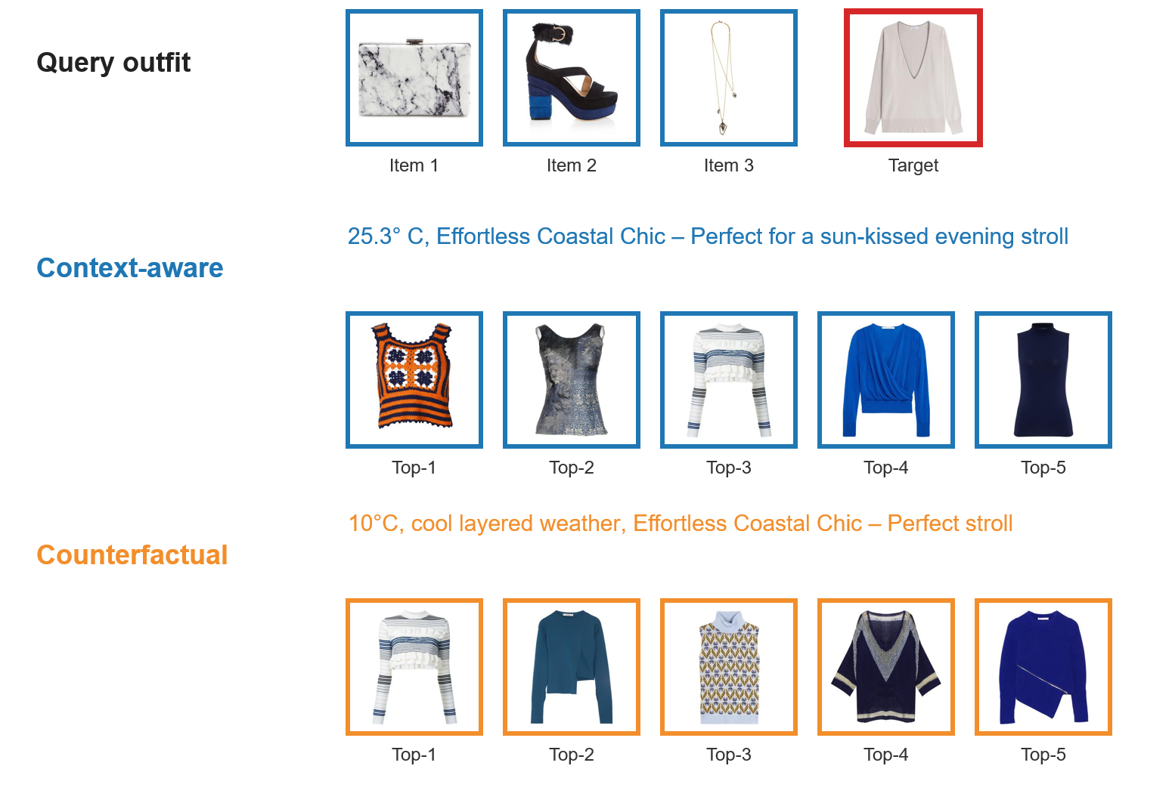
Figure 7: Weather counterfactual example with a larger retrieval response.
Figure 8 presents an Occasion formal-to-casual perturbation. The original context-aware description, “22.9°C, Luxurious Indian Wedding Evening Ensemble,” contains explicit wedding semantics. The counterfactual version replaces the occasion with “for a casual daily outing.” The target bracelet remains at rank 1 before and after replacement, but other top candidates change, yielding a Top-5 Jaccard overlap of 0.25. Importantly, only Occasion is replaced. The strong “Luxurious” style cue and other outfit semantics remain. The overall styling direction therefore changes less than it would under a broader rewrite, which may explain why the target rank remains unchanged. The example shows that occasion replacement can reorganize some leading candidates while producing a relatively limited ranking response when strong style semantics are preserved.
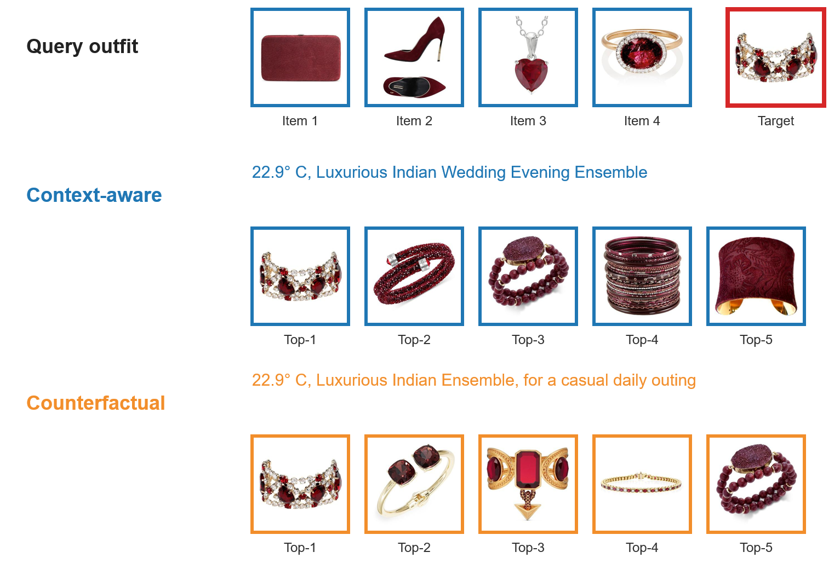
Figure 8: Occasion counterfactual example with a limited retrieval response.
No new human recommendation ground truth exists after the counterfactual replacement. Accordingly, mean ΔRank's sign only indicates the existing target's movement direction and does not directly imply improved or degraded recommendation quality. Taken together, Tables 18 and 19 and Figures 7 and 8 show that candidate rankings respond to controlled replacement of a single contextual semantic factor to varying degrees. Style produces the strongest aggregate response, while individual Weather and Occasion cases show different levels of candidate-set reorganization. These results support observable sensitivity of model rankings to contextual text conditions, but they do not establish causal understanding of contextual semantics.
  - Category-Level and Contextual-Subset Analysis
Beyond aggregate metrics, we examine performance differences across fashion item categories and contextual subsets. Following the original Polyvore taxonomy, the data contain 11 main categories and 141 subcategories. In Figure 9, labels are presented as subcategory (main category). For example, dress (all-body) denotes the dress subcategory within the all-body main category. The figure reports absolute changes in Hit@10, where ΔHit@10 is the difference between context-aware and original text conditions. Larger gains tend to occur for categories associated with outfit-level semantics. Dress (all-body) has the largest ΔHit@10 at +0.023. Purse (bags) and heels (shoes) each improve by +0.013, and pump (shoes) by +0.010. Changes are smaller for jewellery and accessories, with sunglasses (accessories) decreasing by -0.004.
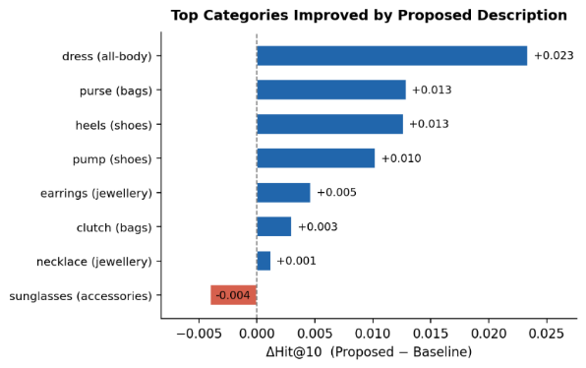
Figure 9: Hit@10 differences by item category.
Each label is shown as subcategory (main category), following the original Polyvore category taxonomy. Bars indicate absolute ΔHit@10 between context-aware and original text conditions.
These results suggest that context-aware descriptions help categories tied to overall styling, formality, occasion, or season more than accessory categories dependent on local visual details. The benefit of the proposed method is therefore not uniform across all categories. It is more pronounced for target items that can exploit outfit-level semantic context.
To determine whether the improvement is restricted to particular contextual conditions, we further analyze 3,432 eligible query-target pairs. Because each text condition is evaluated under five fixed random seeds, this yields 17,160 seed-level observations. Figure 10 compares Hit@10 across cold versus warm, formal versus casual, high versus low style richness, and clothing-led versus accessory-led subsets. The weather split uses the median temperature reference value of 22.9°C. Context-aware descriptions achieve higher Hit@10 than original text in every reported subset, indicating that the overall improvement is not confined to a single contextual condition or target type.
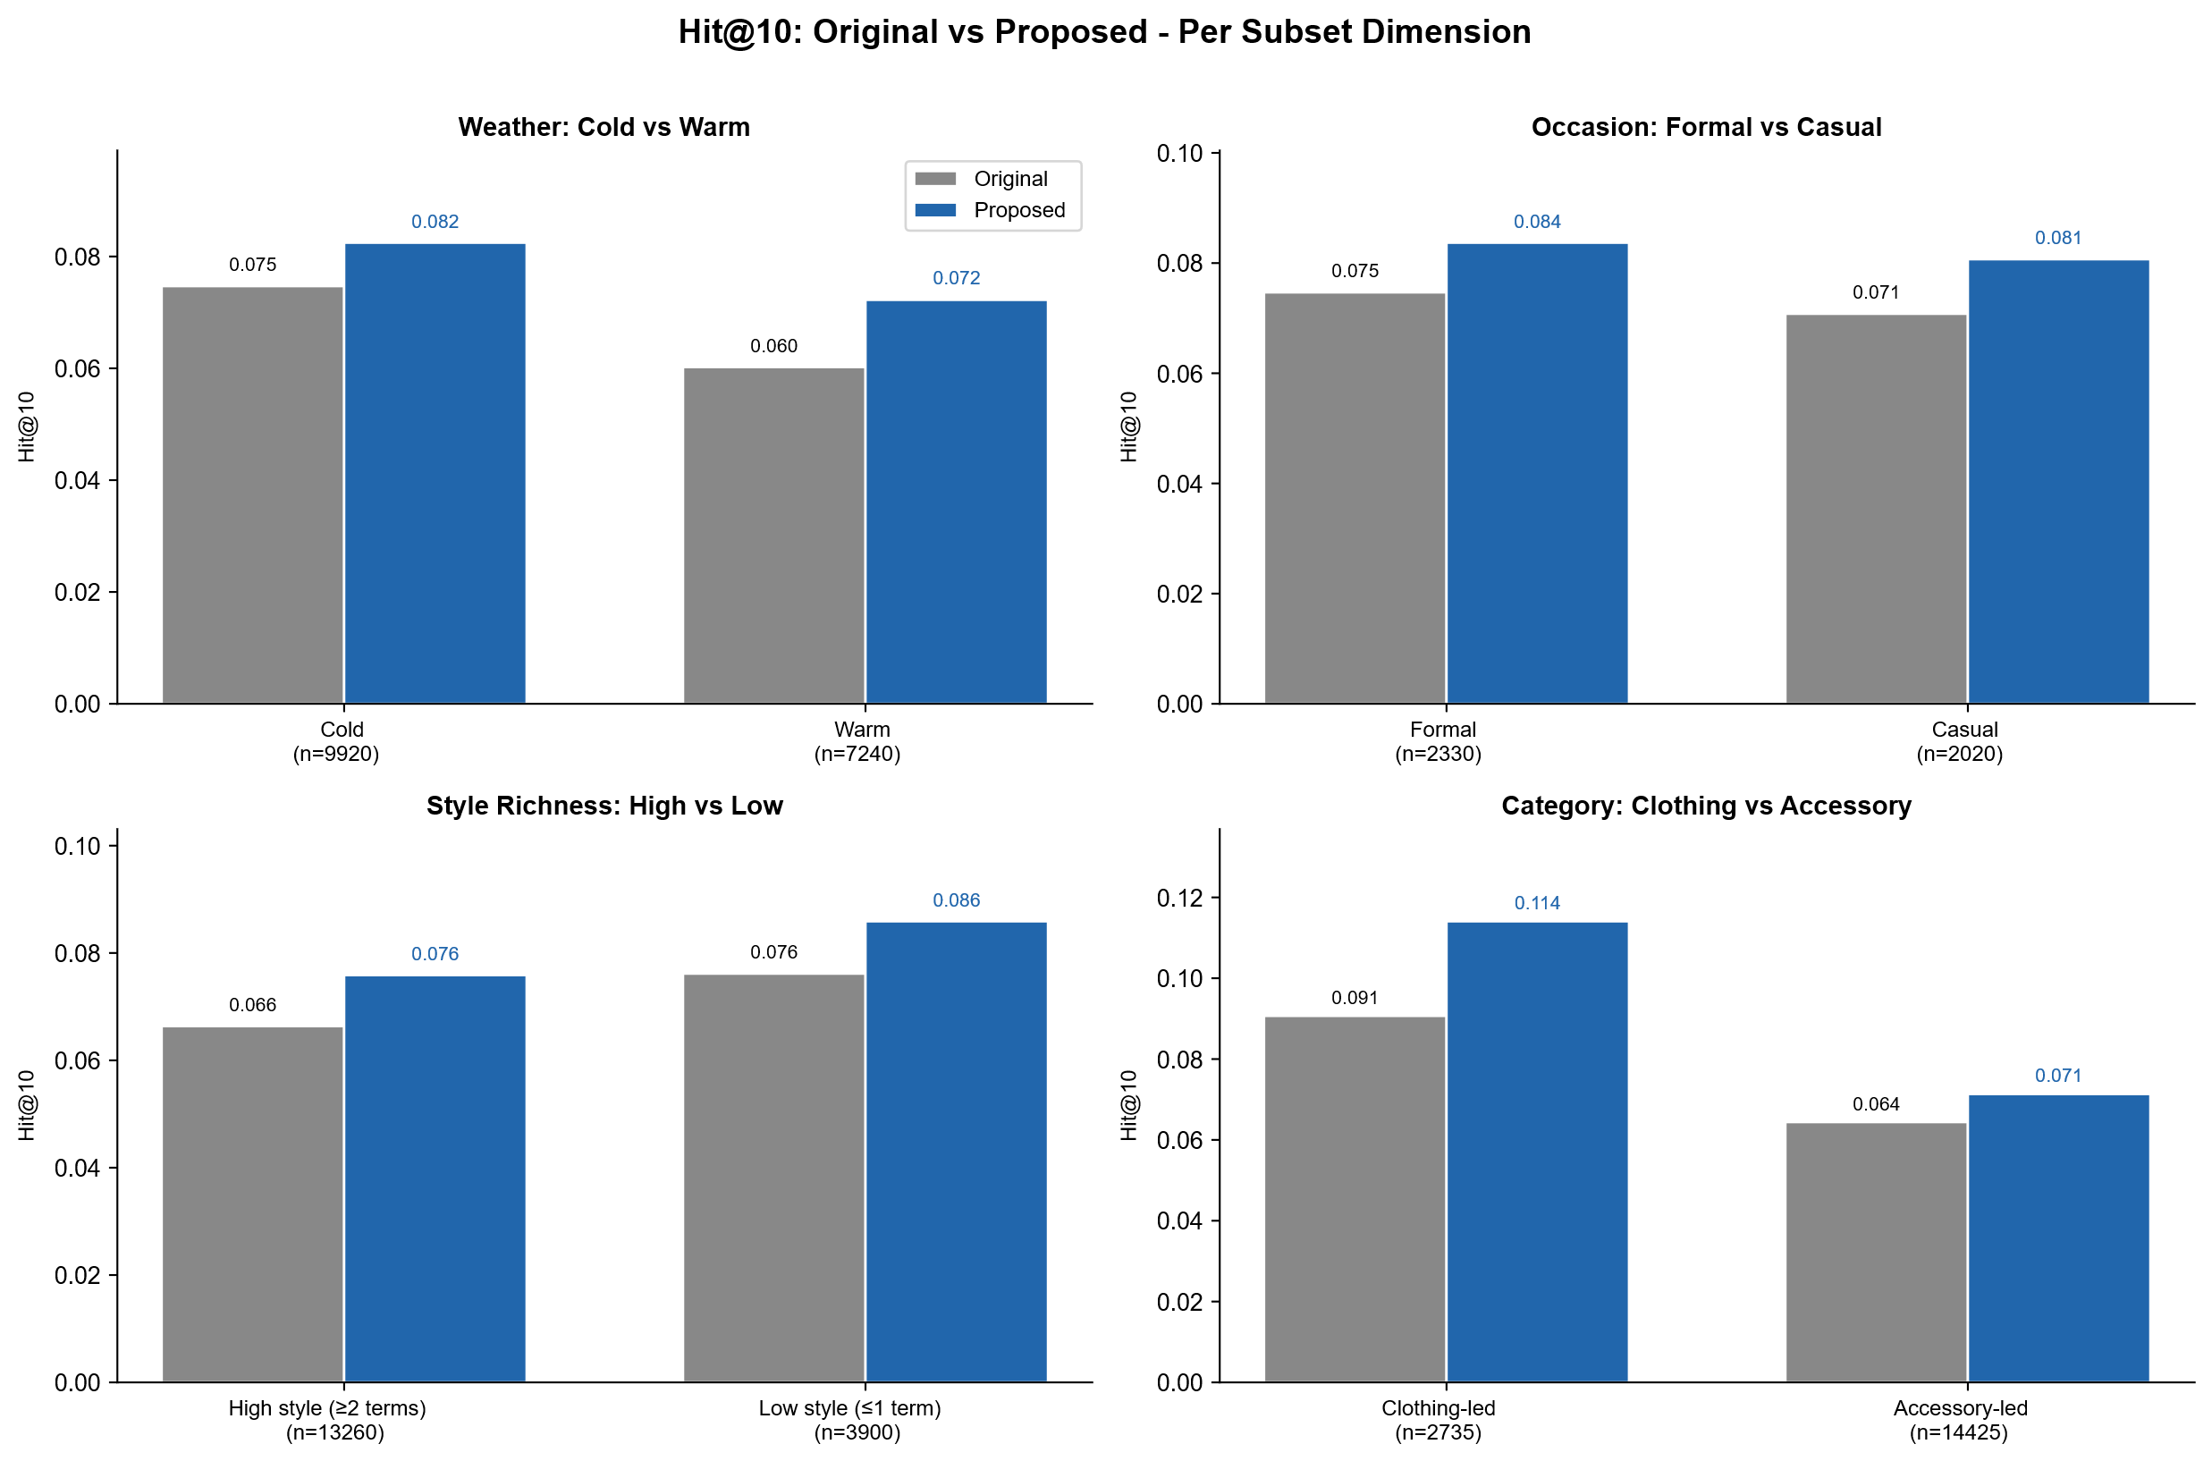
Figure 10: Hit@10 comparison across semantic subsets.
Bars compare both conditions across weather, occasion, style-richness, and target-category subsets.
Together, category-level and contextual-subset analyses show consistently directed improvement across semantic conditions, with magnitude varying by target category. Gains concentrate in dress, shoes, and bags, which closely reflect overall outfit semantics, and are smaller in jewellery and accessories, where retrieval relies on fine-grained visual discrimination.
  - Qualitative Rank-Shift Cases
To inspect how context-aware descriptions affect individual retrieval outcomes, we select two representative cases and analyze target-item rank changes across text conditions. Each case reports both a representative-seed rank and the mean rank across five repeated runs. Mean rank is the primary basis for interpretation, and a smaller value indicates a higher target-item position. Table 20 reports the corresponding rank shifts across the evaluated text conditions.
The first case targets a purse. The original description, “shein xv,” provides almost no useful outfit semantics, whereas the context-aware description, “19.2°C, breezy beach vibes in a dreamy blue swimsuit and linen dress,” adds a beach context, styling tone, and temperature cue. The target item's mean rank improves from 23.4 under Original text to 1.8 under the full Context-aware description. No-Weather remains close to Full, whereas No-Occasion and No-Style rank the target substantially lower, suggesting that the improvement in this case is driven mainly by occasion and style semantics.
The second case targets a dress. The original text condition, “salsa dance Salsa Lessons,” contains an activity cue but little overall styling semantics. The context-aware description, “23.6°C, Effortless Red Romance for Salsa Nights,” preserves the salsa context while adding an evening occasion and romantic styling semantics. The mean target rank improves from 122.6 under Original to 3.0 under Full. No-Style shows the largest degradation among the ablations, with the mean rank rising to 60.2, indicating that style semantics are particularly important in this case.
Table 20: Rank shifts in representative retrieval cases
Text condition | Purse case: representative / mean rank | Dress case: representative / mean rank
Original text | 25 / 23.4 | 18 / 122.6
No-Weather | 2 / 2.8 | 3 / 6.4
No-Occasion | 9 / 6.4 | 8 / 24.4
No-Style | 9 / 4.4 | 68 / 60.2
Context-aware description | 2 / 1.8 | 5 / 3.0
Overall, both cases show that context-aware descriptions can move the target item forward in the ranking, but the responsible semantic cues differ by case. The purse case is influenced more by occasion and style, whereas the dress case is especially sensitive to style. This pattern is consistent with the preceding ablation analysis and supports interpreting the benefit as the joint contribution of multiple semantic cues rather than a single temperature or weather term.
  - Color-Attribute Alignment and Color-Shift Analysis
The fixed downstream recommender used in this study has previously been reported to generate internally compatible outfits while still differing from the original outfits in visual attributes such as color and pattern. The same study noted a tendency to choose similar colors and analyzed the trade-off between compatibility and variation using color diversity [19]. We therefore include color shift as a complementary analysis of whether context-aware descriptions can influence retrieval direction and attribute alignment when the text contains an explicit color condition.
Consider a gray-outfit example. Under the original text condition, “gray Gray Outfits,” early retrieval results are biased toward black items, suggesting that the model can preserve broad outfit compatibility without fully reflecting the gray condition. Under the context-aware description, “24.3°C, Effortless Gray Evening Look with a Classic Twist,” the early candidates align more closely with gray semantics. This qualitative difference suggests that semantic enrichment of the text condition can influence the color-alignment direction of retrieval.
To avoid relying on a single example, we align retrieval outputs from the Original text and Context-aware description conditions and retain queries with a shared single-color constraint, yielding 745 comparable records. We report both row-level and case-level statistics. Row-level analysis treats each comparison row as an observation. If a retrieval case produces multiple records because of different target rows or candidate rankings, each is counted separately. Case-level analysis deduplicates records belonging to the same retrieval case and evaluates improvement per case, producing a smaller and more conservative sample. We define a color-shift problem as a case in which, among early retrieval results, the most common incorrect color appears at least two more times than the query color and the target item itself matches the query color. Table 21 summarizes color-shift mitigation at both levels. Under this definition, 89 row-level color-shift problems are observed and 39 improve with context-aware descriptions, for an improvement rate of 43.82%. At the case level, 15 problematic cases are observed and 5 improve, for a rate of 33.33%.
Table 21: Color-shift mitigation analysis
Level | Problem cases | Improved cases | Improvement ratio
Row-level | 89 | 39 | 43.82%
Case-level | 15 | 5 | 33.33%
As shown in Table 21, context-aware descriptions reduce color shift for some samples and bring early retrieval results closer to explicit color constraints. However, the row-level improvement rate is 43.82% and the case-level rate is 33.33%, indicating that the effect is not stable. Semantic construction can therefore influence retrieval direction and reduce color-condition mismatch in some cases, but color shift remains a limitation that should be addressed by future model designs.
  - Failure-Case Analysis
Finally, a representative failure case shows when context-aware descriptions can degrade retrieval. The target item is sunglasses. The original text condition, “burgundy babe Burgundy Clutches,” preserves an explicit color cue, whereas the context-aware description, “27.2°C, Effortless Sunset Vibes with a Beachy Edge,” shifts the semantic focus toward temperature, sunset atmosphere, a beach context, and abstract style. Although enriching outfit-level context, this description may dilute the original text's direct color or item cues. Table 22 summarizes this representative failure case.
Table 22: Rank comparison in a representative failure case
Text condition | Representative rank | Mean rank
Original text | 28 | 22.4
No-Weather | 644 | 532.4
No-Occasion | 333 | 505.2
No-Style | 106 | 84.4
Context-aware description | 530 | 505.0
As shown in Table 22, the context-aware description degrades the mean target rank from 22.4 under Original text to 505.0, and most ablation conditions also fail to outperform the original text. When the source text already contains a direct visual cue such as an explicit color, adding broader contextual semantics may therefore fail to improve retrieval and can redirect the model toward candidates that match the contextual atmosphere but not the fine-grained target-item details.
This failure case is also consistent with the category-level analysis. Context-aware descriptions produce clearer gains for dress, shoes, and bags, which are more closely tied to overall outfit semantics, while improvements are smaller for jewellery and accessories that depend more heavily on fine-grained visual recognition. The case was not selected specifically because it is an accessory example, but its sunglasses target illustrates the potential instability of context-aware descriptions when local visual attributes are critical to retrieval.
Overall, the failure analysis shows that context-aware descriptions do not benefit every retrieval setting. They are more likely to help when the target item is strongly related to overall styling, formality, season, or occasion semantics. When retrieval depends heavily on color, shape, or local design details, outfit-level contextual semantics may be insufficient to deliver consistent ranking improvements.
- Discussion
  - Implications of Data-Centric Context-Aware Semantic Construction
The results show that, with FashionCLIP representations, the Hybrid Attention recommender, data splits, and training settings held fixed, improving text-condition construction can enhance multimodal outfit recommendation. The main implications are as follows.
- Text-condition quality affects the performance of a fixed recommender. Under the primary Hybrid Attention architecture, context-aware descriptions outperform original outfit-level text on CP, FITB, and CIR. Cross-architecture validation further shows that, with the simpler Two-Tower architecture, test AUC and retrieval-related metrics (Recall@K and rank) preserve a positive improvement direction, although CP FITB does not improve consistently. The retrieval benefit of context-aware descriptions is therefore observable beyond a single architecture, but the effect of textual enrichment still depends on task formulation and model architecture.
- Context-aware descriptions are not generic free-form expansion. CLO, MET, and temperature-reference proxies trace relationships among weather, activity intensity, and clothing insulation. The contribution is thus not longer text but inspectable, traceable contextual semantic conditions.
- Style semantics show the strongest effect. Removing Style produces the largest degradation in both CP and CIR, and the counterfactual analysis likewise shows that Style replacement has the highest Top-1 changed rate and the lowest Top-5 Jaccard overlap. These analyses converge in showing a close relationship between style semantics, outfit compatibility, and candidate ranking. The counterfactual analysis, however, measures ranking sensitivity only and does not support a claim that the model has causal understanding of style.
- Weather and Occasion provide auxiliary contextual constraints. Their aggregate effects are smaller than that of Style, but they add environmental and usage context that makes the descriptions more representative of everyday dressing needs. Counterfactual examples also show that changing a single occasion condition does not necessarily produce a large rank shift because its effect can interact with existing semantic cues such as style. The benefit of context-aware descriptions is therefore best interpreted as joint enrichment from multiple contextual semantics rather than as an effect produced solely by weather or occasion.
  - Benefits and Applicability Boundaries
The experiments also show that the benefit of context-aware descriptions is not uniformly distributed across retrieval settings. The main applicability boundaries are summarized below.
- The method better suits target items with clear outfit-level semantics. Category-level analysis shows larger gains for dress, shoes, and bags. These categories relate more closely to overall styling, formality, occasion, or seasonal semantics and can therefore benefit more from context-aware descriptions.
- Performance is less stable for items that depend strongly on local visual details. Improvements are more limited for jewellery and accessories. When the retrieval target is determined primarily by color, shape, material texture, or fine design details, an outfit-level contextual description may not provide sufficiently precise item cues. This observation is consistent with the manual audit of generation quality: the clearest disagreements between human and model judgments involve overall image-text consistency, visually unsupported details, and judgments of style, occasion, and color. The major risk in generated descriptions is therefore not fluency, but insufficient alignment between fine-grained visual attributes and contextual semantics.
- Contextual semantics can dilute direct source-text cues. The failure case shows that when source text contains an explicit visual cue such as color, adding broader contextual descriptions may steer retrieval toward candidates matching the overall atmosphere but not the target's details.
- Color shift is not fully resolved. The color analysis shows that context-aware descriptions reduce mismatch between color conditions and retrieved results in some cases, but the improvement rates remain limited. Color shift therefore remains a limitation for future model design.
  - Scope of Interpretation and Study Limitations
The findings concern offline recommendation tasks and data-construction effects, not direct user preferences or actual wearing comfort. The main limitations are as follows.
- No user study is included. CP, FITB, and CIR measure compatibility and conditional retrieval, but not user satisfaction, willingness to wear an outfit, or aesthetic preference.
- CLO, MET, and temperature reference are proxies. They connect clothing insulation, activity intensity, and weather semantics during data construction. They are not human-subject measurements and do not represent individual thermal comfort.
- LLM-as-a-Judge is not a human gold standard. We use two multimodal judges, low-score overlap, prompt-robustness analysis, and a 30-sample manual audit. Human scores are positively associated with judge scores, but disagreements remain for individual samples and some checklist items. The procedure cannot replace large-scale human annotation or real-user evaluation.
- Cross-architecture validation does not represent all recommendation models or datasets. The primary experiments center on Hybrid Attention with FashionCLIP representations, and only one simpler Two-Tower model is added as complementary validation. Although retrieval metrics show a similar improvement direction across architectures, all experiments use Polyvore Outfits Disjoint and should not be generalized to all recommendation architectures or outfit datasets.
- Counterfactual analysis measures only ranking sensitivity across 24 controlled cases, with no new human recommendation ground truth for perturbed conditions. The analysis therefore only tests whether candidate rankings respond to a change in one contextual semantic factor. It does not determine which condition is better and cannot establish causal understanding of context.
  - Robustness Safeguards and Residual Evaluation Risks
We perform multiple checks on factors that could affect interpretation and explicitly retain evaluation risks that are not fully eliminated:
- Text-length effects. Query-length differences have only negligible correlations with Hit@10 or rank improvement, and the gain persists in matched-length subsets. The current results therefore do not support longer query text as the primary explanation for the performance improvement.
- Target-clue leakage. The leakage audit identifies a small amount of category or item-word overlap in generated descriptions, but the rate is limited and does not exceed that of original text. This reduces the likelihood that the gains arise mainly from systematic exposure of answer clues.
- Proxy-value plausibility. The main distributions of CLO, MET, and temperature reference values lie largely within interpretable ranges, while a small number of extreme temperature references remain. These findings support their use as intermediate proxy scales while also revealing boundary limitations of the simplified thermal mapping.
- Residual evaluation risks. We do not include generic free-form rewriting as an independent baseline because doing so would shift the study toward the effects of general text expansion or stylistic polishing rather than proxy-constrained context-aware semantic construction. Free-form rewriting could simultaneously alter text length, sentence completeness, image inference, and description quality, introducing additional confounders better suited to a separate study. We also do not perform a masked-query CIR rerun. Instead, the current work uses a lexical audit to test for systematic target clues and therefore does not fully isolate residual lexical information by rerunning retrieval with masked queries. Future work can use generic free-form rewriting and masked-query CIR reruns as sensitivity checks to distinguish proxy-constrained contextual descriptions, general text expansion, and masked text conditions more precisely.
- Threats to Validity
Internal validity may be affected by LLM rewriting, prompt sensitivity, text length, and lexical cues. The primary experiments control the data split, FashionCLIP representation, recommendation architecture, and training settings, plus text-length checks, target-clue audits, and W/O/S ablations that reduce interference from non-contextual factors. The target-clue audit does not indicate large-scale or systematic answer exposure in generated descriptions. However, it is lexical only, and without a masked-query CIR rerun, residual lexical effects cannot be fully excluded.
Construct validity is limited mainly by the proxy nature of CLO, MET, and temperature reference. These variables link clothing insulation, activity intensity, and weather semantics during data construction; they are not measured human-comfort labels. McIntyre's simplified thermal mapping likewise produces an intermediate proxy scale for semantic construction, not a complete thermal-comfort prediction.
LLM-as-a-Judge itself limits evaluation validity. Although both multimodal judges are evaluated through full score distributions, low-score overlap, prompt robustness, and a stratified 30-sample manual audit and correlate positively with human judgments, disagreements remain for individual cases and checklist items. LLM scores may also be affected by prompt structure, model priors, and visual-language capabilities. LLM-as-a-Judge should therefore be treated as an automated quality-assessment and sample-level diagnostic tool, not as the final authority on semantic correctness.
The counterfactual context sensitivity analysis also has a limited interpretive scope. It covers only 24 controlled cases and observes ranking responses to single-factor changes under a fixed model and candidate setting. Because the counterfactual conditions have no new human recommendation ground truth, the analysis can show only that rankings respond observably to contextual text changes. It cannot establish that the perturbed condition produces better recommendation quality, nor can it demonstrate causal understanding of context. The analysis is intentionally positioned as a complementary sensitivity check rather than a primary performance measure.
External validity is constrained by the Polyvore Outfits Disjoint dataset, category distribution, original text quality, temporal fashion bias, and the offline candidate-pool setting. Cross-architecture validation shows retrieval improvements with a simpler Two-Tower model, but only one additional architecture is evaluated and all experiments remain on the same dataset. Further validation is therefore required before generalizing the findings to other outfit datasets, recommendation architectures, real wardrobes, or interactive recommender systems.
- Ethics, Rights, and Transparency
This study uses an existing public benchmark dataset for offline data construction and recommendation-model evaluation. It does not involve human participants, surveys, interviews, user tracking, preference collection, or measurement of actual wearing comfort. We therefore do not claim to evaluate real user preferences or human thermal-comfort responses. The scope is limited to offline multimodal recommendation tasks and analysis of a data-construction method.
Regarding data rights, Polyvore Outfits Disjoint provides outfit images and metadata as a research benchmark, but research use of a public dataset does not imply unrestricted redistribution rights for the original images. Following a conservative approach to rights, the paper primarily communicates results through workflow diagrams, statistical tables, ranking tables, and necessary qualitative examples rather than treating source images as freely redistributable data.
AI tools are used primarily for context-aware description generation and generation-quality diagnostics. Gemma-3-4B-IT generates contextual text conditions from the original description, outfit images, CLO, MET, and temperature reference values. Qwen3-VL-32B-Instruct and Gemma-3-27B-IT are then used for checklist-based LLM-as-a-Judge evaluation. Model-produced quality scores, feedback, and suggested revisions are used only for generation-quality analysis and failure-case diagnostics. They are not direct training signals for the downstream recommender, and formal experimental samples are neither deleted nor rewritten based on judge scores. Downstream recommendation experiments use the fixed batch-generated context-aware descriptions to maintain consistency across conditions.
- Conclusion
We present a context-aware semantic construction framework for multimodal outfit recommendation that integrates outfit images, original descriptions, CLO/MET proxies, simplified thermal mapping, fixed-prompt LLM description generation, and LLM-assisted quality diagnostics. It transforms short original text into contextual natural-language conditions learnable by a text-conditioned recommender.
With the primary Hybrid Attention recommender and FashionCLIP representations held fixed, context-aware descriptions achieve better offline performance than original outfit-level text on CP, FITB, and CIR. Fair-subset validation, W/O/S ablation, text-length checks, target-clue auditing, proxy-value sanity checks, contextual-subset analysis, qualitative ranking cases, color-shift analysis, and failure-case analysis further characterize improvement sources and applicability boundaries. For generation quality, two judging models, prompt-robustness checks, and a stratified 30-sample manual audit indicate that LLM-as-a-Judge is useful as an auxiliary tool for large-scale generation diagnostics but cannot replace human judgment. The manual audit complements automated quality assessment; it is not a large-scale human gold standard.
With the simpler FashionCLIP-based Two-Tower architecture, cross-architecture validation shows test AUC and retrieval metrics (Recall@K and rank) improving broadly consistently with the main experiment, indicating that retrieval benefits are not exclusive to Hybrid Attention. However, Two-Tower CP FITB does not improve consistently, so the benefit still depends on recommender architecture and task formulation. Counterfactual context sensitivity analysis shows that, when other retrieval conditions are fixed, replacing a single Weather, Occasion, or Style factor causes candidate rankings to change to different degrees, with Style producing the strongest aggregate response. This pattern is consistent with the semantic-factor ablation, but it is interpreted only as observable sensitivity to contextual text conditions rather than evidence of causal understanding.
Across the experiments, the benefit of context-aware descriptions is not uniformly distributed across semantic factors or item categories. Style semantics show the clearest and most consistent effects, while Weather and Occasion mainly provide auxiliary contextual constraints. Categories such as dress, shoes, and bags, which depend more strongly on outfit-level semantics, benefit more readily, whereas accessory categories that rely heavily on color, shape, or local details are less stable. These findings show that data-side context-aware semantic construction can improve offline performance of a fixed multimodal recommender without modifying its primary architecture, but the gains remain constrained by target-item category, fine-grained visual attributes, and the type of semantic cue.
The principal contribution is a traceable, auditable contextual-semantic data pipeline and multi-level evaluation of its effects on outfit recommendation through quality diagnostics, main tasks, semantic ablation, cross-architecture validation, and counterfactual sensitivity analysis. Future work should add user evaluation, cross-dataset validation, other recommendation architectures, fine-grained visual-attribute control, and sensitivity checks with generic free-form rewriting and masked-query CIR reruns to assess stability and generalizability across datasets and practical settings.
References
- Hyosun An, Kyo Young Lee, Yerim Choi, and Minjung Park. 2023. Conceptual framework of hybrid style in fashion image datasets for machine learning. Fash Text 10, 1 (May 2023), 18. https://doi.org/10.1186/s40691-023-00338-8
- ASHRAE. 2013. ANSI/ASHRAE Addendum h to ANSI/ASHRAE Standard 55-2010: Thermal Environmental Conditions for Human Occupancy. American Society of Heating, Refrigerating and Air-Conditioning Engineers, Atlanta, GA.
- Yongjie Chu, Hongguo Wang, and Cengceng Liu. 2025. Beneath the colorness skies: Does weather influence consumer color preference? Journal of Retailing and Consumer Services 82, (January 2025), 104154. https://doi.org/10.1016/j.jretconser.2024.104154
- Yashar Deldjoo, Fatemeh Nazary, Arnau Ramisa, Julian McAuley, Giovanni Pellegrini, Alejandro Bellogin, and Tommaso Di Noia. 2024. A Review of Modern Fashion Recommender Systems. ACM Comput. Surv. 56, 4 (April 2024), 1–37. https://doi.org/10.1145/3624733
- Yujuan Ding, Zhihui Lai, P. Y. Mok, and Tat-Seng Chua. 2023. Computational Technologies for Fashion Recommendation: A Survey. https://doi.org/10.48550/arXiv.2306.03395
- P. O. Fanger. 1972. Thermal comfort: analysis and applications in environmental engineering. McGraw-Hill, New York.
- A. P. Gagge, A. C. Burton, and H. C. Bazett. 1941. A Practical System of Units for the Description of the Heat Exchange of Man with His Environment. Science 94, 2445 (1941), 428–430.
- Jiawei Gu, Xuhui Jiang, Zhichao Shi, Hexiang Tan, Xuehao Zhai, Chengjin Xu, Wei Li, Yinghan Shen, Shengjie Ma, Honghao Liu, Saizhuo Wang, Kun Zhang, Zhouchi Lin, Bowen Zhang, Lionel Ni, Wen Gao, Yuanzhuo Wang, and Jian Guo. 2026. A survey on LLM-as-a-judge. The Innovation (January 2026), 101253. https://doi.org/10.1016/j.xinn.2025.101253
- Xintong Han, Zuxuan Wu, Yu-Gang Jiang, and Larry S. Davis. 2017. Learning Fashion Compatibility with Bidirectional LSTMs. In Proceedings of the 25th ACM international conference on Multimedia, October 19, 2017. 1078–1086. https://doi.org/10.1145/3123266.3123394
- Stephen D. Herrmann, Erik A. Willis, Barbara E. Ainsworth, Tiago V. Barreira, Mary Hastert, Chelsea L. Kracht, John M. Schuna, Zhenghui Cai, Minghui Quan, Catrine Tudor-Locke, Melicia C. Whitt-Glover, and David R. Jacobs. 2024. 2024 Adult Compendium of Physical Activities: A third update of the energy costs of human activities. J Sport Health Sci 13, 1 (January 2024), 6–12. https://doi.org/10.1016/j.jshs.2023.10.010
- Junkyu Jang, Eugene Hwang, and Sung-Hyuk Park. 2024. Lost Your Style? Navigating with Semantic-Level Approach for Text-to-Outfit Retrieval. In 2024 IEEE/CVF Winter Conference on Applications of Computer Vision (WACV), January 03, 2024. IEEE, Waikoloa, HI, USA, 8051–8060. https://doi.org/10.1109/WACV57701.2024.00788
- Wenqiang Jing, Yingdi Yin, Wei Luo, Jin Zhang, Zeming Qin, Xinyi Liu, and Meng Zhen. 2023. Outdoor clothing choice for different populations in cold regions: A clothing choice prediction model based on machine learning. Energy and Buildings 289, (June 2023), 113069. https://doi.org/10.1016/j.enbuild.2023.113069
- Laila Khalid and Wei Gong. 2026. Exploring AI in Fashion: A Review of Aesthetics, Personalization, Virtual Try-On, and Forecasting. Multimedia Systems 32, 3 (June 2026), 167. https://doi.org/10.1007/s00530-026-02232-x
- Jianghao Lin, Xinyi Dai, Yunjia Xi, Weiwen Liu, Bo Chen, Hao Zhang, Yong Liu, Chuhan Wu, Xiangyang Li, Chenxu Zhu, Huifeng Guo, Yong Yu, Ruiming Tang, and Weinan Zhang. 2025. How Can Recommender Systems Benefit from Large Language Models: A Survey. ACM Trans. Inf. Syst. 43, 2 (March 2025), 1–47. https://doi.org/10.1145/3678004
- Yujie Liu, Yongbiao Gao, Shihe Feng, and Zongmin Li. 2017. Weather-to-garment: Weather-oriented clothing recommendation. In 2017 IEEE International Conference on Multimedia and Expo (ICME), July 2017. 181–186. https://doi.org/10.1109/ICME.2017.8019476
- D. A. McIntyre. 1978. Design Requirements for a Comfortable Environment. The Electricity Council Research Centre.
- James Smallcombe, Simon Hodder, Kalev Kuklane, Magdalena Młynarczyk, Dennis Loveday, Jakob Eggeling, Amitava Halder, and George Havenith. 2021. Updated Database of Clothing Thermal Insulation and Vapor Permeability Values of Western Ensembles for Use in ASHRAE Standard 55, ISO 7730, and ISO 9920. ASHRAE Transactions VC-21–011, (January 2021), 773–799.
- Anh H. Vo, Tung B. T. Le, Huy V. Pham, and Bao T. Nguyen. 2023. An efficient framework for outfit compatibility prediction towards occasion. Neural Computing & Applications 35, 19 (July 2023), 14213–14226. https://doi.org/10.1007/s00521-023-08431-1
- Xin Wang and Yueqi Zhong. 2024. Text-Conditioned Outfit Recommendation With Hybrid Attention Layer. IEEE Access 12, (2024), 281–293. https://doi.org/10.1109/ACCESS.2023.3346933
- Likang Wu, Zhi Zheng, Zhaopeng Qiu, Hao Wang, Hongchao Gu, Tingjia Shen, Chuan Qin, Chen Zhu, Hengshu Zhu, Qi Liu, Hui Xiong, and Enhong Chen. 2024. A survey on large language models for recommendation. World Wide Web 27, 5 (September 2024), 60. https://doi.org/10.1007/s11280-024-01291-2
- Shengkai Zhao, Liu Yang, Haiyan Yan, Yong Liu, Siru Gao, and Yongchao Zhai. 2025. Reliability of lookup table methods for estimating clothing insulation: Experimental verification using typical garments. Energy and Buildings 348, (December 2025), 116500. https://doi.org/10.1016/j.enbuild.2025.116500
A APPENDICES
A.1 Qualitative Retrieval Examples
Figure A1, Figure A2, and Figure A3 provide additional qualitative examples for the CIR task. Each example compares the top retrieved candidates under Original text, No-Weather, No-Occasion, No-Style, and Context-aware description conditions. The green box marks the ground-truth target item when it appears in the displayed ranking. These examples are used only as qualitative references for interpreting the ranking behavior discussed in Section 5.6 and Section 5.8.
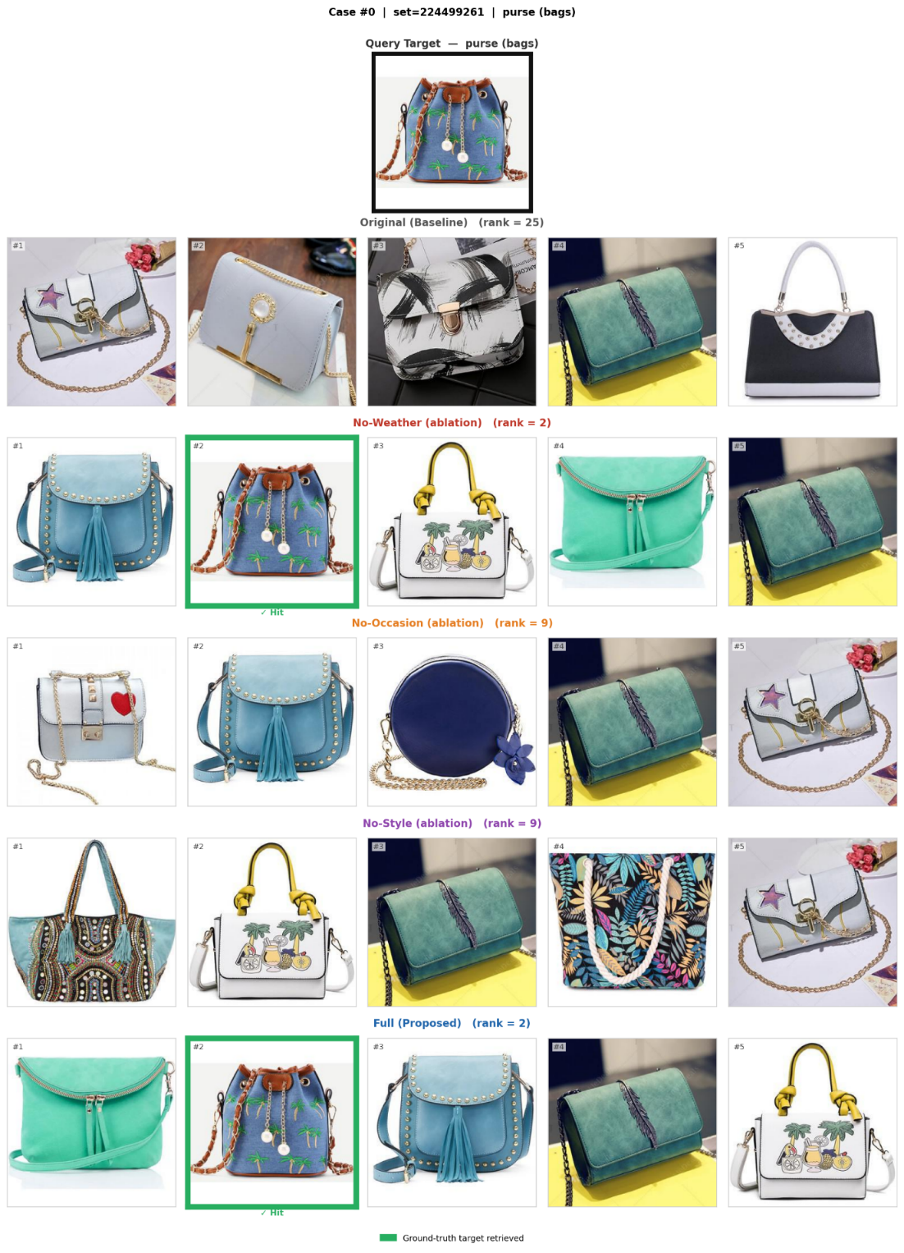
Figure A1: Qualitative retrieval example for a purse target item. The context-aware description retrieves the ground-truth purse at rank 2, whereas the original text condition ranks the target item at rank 25. The ablation results show that removing occasion or style information weakens the ranking compared with the full context-aware description.
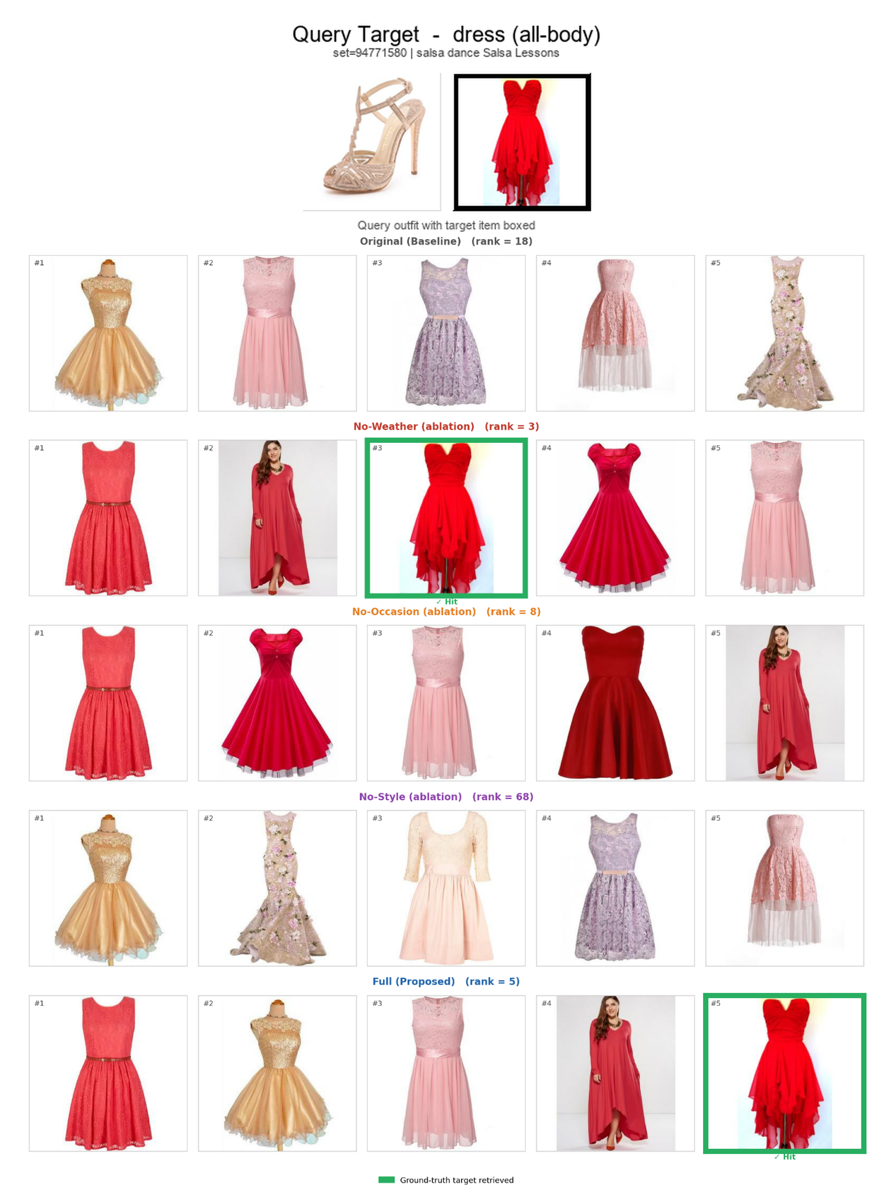
Figure A2: Qualitative retrieval example for a dress target item. The context-aware description improves the target dress ranking from the original condition and retrieves visually related red dress candidates in the top results. The No-Style condition shows a larger ranking degradation, consistent with the role of style semantics in dress-oriented retrieval.
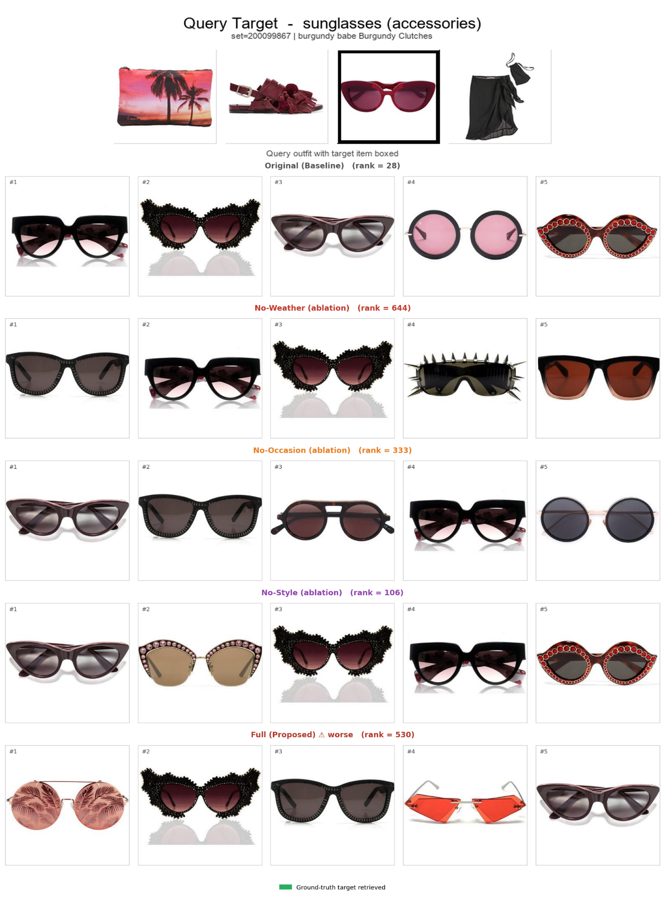
Figure A3: Representative failure case for a sunglasses target item. In this case, the original text condition ranks the target sunglasses higher than the context-aware description. The context-aware description shifts the retrieval direction toward broader sunset or beach-related visual cues, while failing to preserve the fine-grained color and shape attributes needed for the sunglasses target.

