# Error

### 错误组件

// 'errorHandler' => [  
 'errorAction' => 'error/error',],

### 获取错误信息

$error=Yii::*$app*->errorHandler->exception;

# 日志

$log=new FileTarget();  
$log->logFile=Yii::*$app*->getRuntimePath()."/logs/err.log";  
$log->messages[]=[  
 $err_msg,  
 1,  
 'application',  
 *microtime*(true)  
];  
$log->export();

# 版本控制

if(*file_exists*("../version")){  
 *define*("VERSION",*trim*(*file_get_contents*("../version")));  
}else{  
 *define*("VERSION",*date*("Y-M-D H:i:s"));  
}

# Gii

if (*YII_ENV_DEV*) {  
 // configuration adjustments for 'dev' environment  
 $config['bootstrap'][] = 'gii';  
 $config['modules']['gii'] = [  
 'class' => 'yii\gii\Module',  
 ];  
}

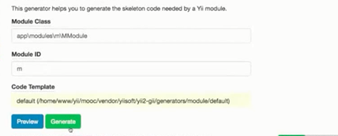

// 模块注册  
 'modules' => [  
 'web' => [  
 'class' => 'app\modules\web\WebModule',  
 ],  
 'm' => [  
 'class' => 'app\modules\m\MModule',  
 ],  
 'weixin' => [  
 'class' => 'app\modules\weixin\WeixinModule',  
 ]

# 路由

// 路由组件  
 'urlManager' => [  
 'enablePrettyUrl' => true,  
 'enableStrictParsing' => false,  
 'showScriptName' => false,  
 'rules' => [  
 "/"=>"/web/user/login"  
 ],  
 ],

Body headerzhurudian