是什么
Prometheus是系统监控和告警工具包

架构
Server：拉取监控数据 存储监控数据 执行规则生成报警
Pushgateway：是外网的汇总设备
Job/exporters：是监控设备的监视器
Alertmanager：是进行报警的设备
Grafana：是展示的设备
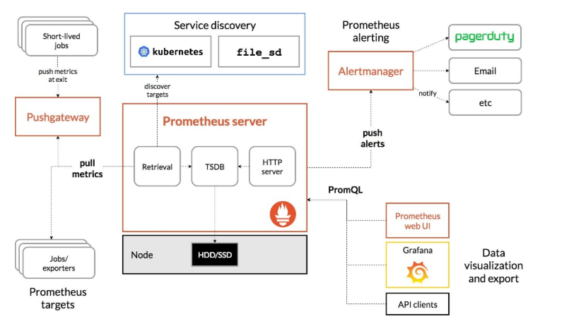

结构

prometheus.yml
//全局的：配置抓取间隔
global:
scrape_interval: 15s # By default, scrape targets every 15 seconds.
evaluation_interval: 15s # Evaluate rules every 15 seconds.评价
//# Attach these extra labels to all timeseries collected by this Prometheus instance.
external_labels:
monitor: 'codelab-monitor'
//规则文件
rule_files:
- 'prometheus.rules.yml'
//抓取的配置
scrape_configs:
- job_name: 'prometheus'
//# Override the global default and scrape targets from this job every 5 seconds.
scrape_interval: 5s
static_configs:
- targets: ['localhost:9090']
- job_name: 'example-random'
//# Override the global default and scrape targets from this job every 5 seconds.
scrape_interval: 5s
static_configs:
- targets: ['localhost:8080', 'localhost:8081']
labels:
group: 'production'
- targets: ['localhost:8082']
labels:
group: 'canary'

数据类型
Count是只增不减
Gauge是也增也减
Histogram是分组直方图 Histogram自定义分隔值，需要计算
Summary分隔值已经设定好了，直接取出值来即可，

scalar标量
vector向量

内置函数
https://prometheus.fuckcloudnative.io/di-san-zhang-prometheus/di-4-jie-cha-xun/functions

