上 海 交 通 大 学 试 卷（ A 卷）
（ 2022 至 2023 学年 第 1 学期 ）

班级号_______________________ 学号______________ 姓名
课程名称 编译原理与技术 成绩

Problem 1: Instruction Selection (24 points)
1.
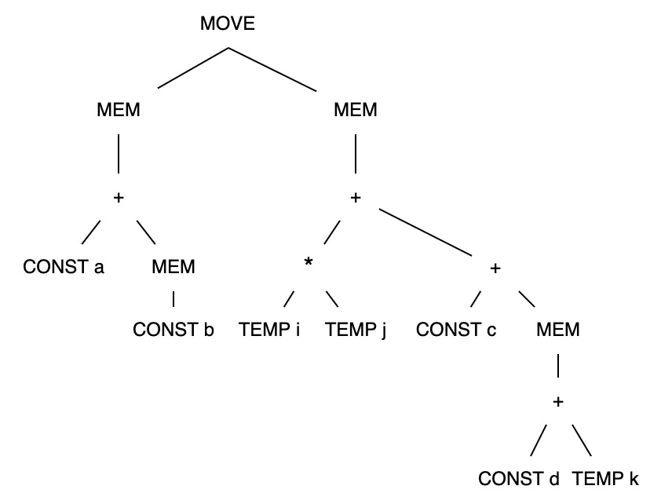

题号得分批阅人(流水阅
卷教师签名处)

我承诺，我将严格遵守考试纪律。

承诺人：

2.

Problem 2: Garbage Collection (24 points)

1.

2.

3.

4.

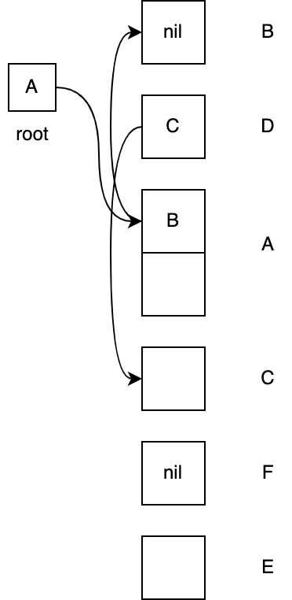

Problem 3: Functional Programming (20 points)
1.
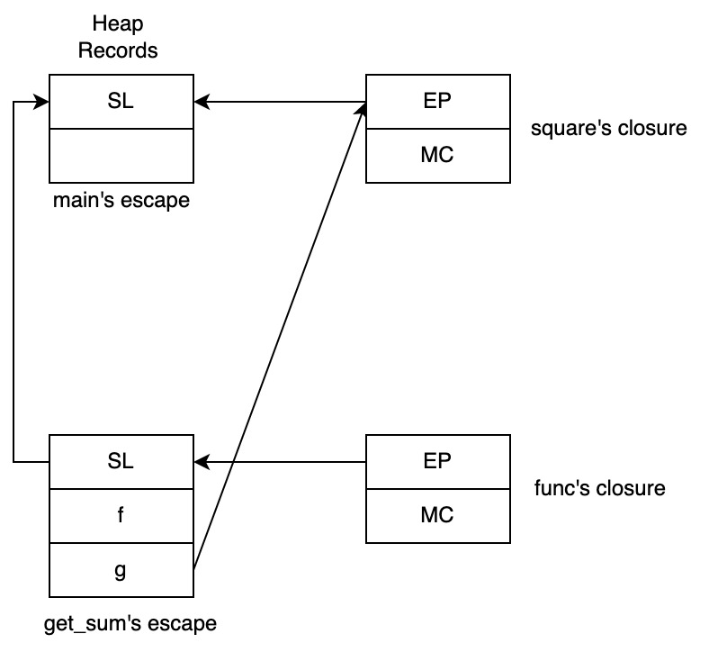

2.

3.

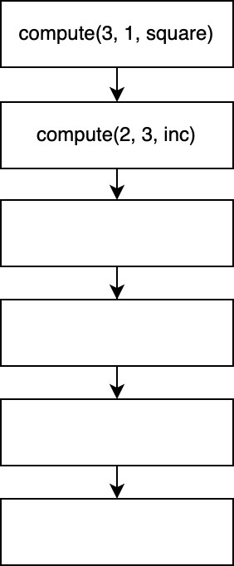
Problem 4: Register Allocation (32 points)
1.

2.
instr | def | use | in | out
t1 <- r1
t2 <- r2
i <- r3
j <- 1
jmp L3
r3,r4 <- i / j
cmp r4, 0
jne L2
r3 <- j
call print
j <- j + 1
cmp j, i
jl L1
r2 <- t2
r1 <- t1
ret

3.

4.

Problem 1: Instruction Selection (24 points)
Name | Effect | Trees | Cost
- | ri | .TEMP | 1
ADD | ri ← rj + rk | ..+....-  ./.\../.\ | 2
SUB | ri ← rj – rk | ..+....-  ./.\../.\ | 2
MUL | ri ← rj * rk | ..*..../  ./.\../.\ | 2
DIV | ri ← rj / rk | ..*..../  ./.\../.\ | 2
ADDI | ri ← rj + c | ....+....+....CONST  .../.\../.\  .CONST...CONST | 3
LOAD | ri ← M[rj + c] | .MEM..MEM..MEM..MEM  ..|....|....|....|  ..+.........+..CONST  ./.\......./.\  ..CONST..CONST | 4
STORE | M[rj + c] ← ri | ....MOVE...MOVE...MOVE...MOVE  ..../..\.../..\.../..\.../..\  ...MEM....MEM....MEM....MEM  ....|......|......|......|  ....+......+....CONST  .../.\..../.\  .CONST.....CONST | 4
MOVEM | M[rj] ← M[ri] | ...MOVE  .../..\  .MEM..MEM  ..|....| | 4

Note:
- The notation M[x] denotes the memory word at address x.
- The third column in the table above is the set of tiles corresponding to the machine instruction in the first column of the table
- The fourth column in the table above is the cost corresponding to the machine instruction in the first column of the table
- On this architecture, a register r₀ always contains zero

Consider the following IR tree and answer the questions below.

1. In the course, we have learnt maximal munch algorithm to tile the
IR tree. Please use this algorithm to tile the IR tree above. Draw your tiles, write the corresponding instruction sequences after tiling, and calculate the cost of your instruction sequences. (12’)

2. We also have learnt a dynamic programming algorithm to find the optimum tiling to the IR tree. Please use the dynamic-programming algorithm to tile the IR tree above. Draw your tiles, write the corresponding instruction sequences after tiling, and calculate the cost of your instruction sequences. (12’)

Problem 2: Garbage Collection (24 points)
- Reference counting may not be able to identify all garbages on heap. Why? (4’)

- In generational collection, if we want to do garbage collection in generation G1, what should we do to handle pointers from roots in G0 (younger than G1) and G2 (older than G1)? (5’)

- When using mark-and-sweep collection or copying collection, we need to find the roots (program variables that are pointers) in the program before starting DFS or BFS. How can garbage collectors know which program variables are pointers? (5’)

- In the mark-and-sweep collection, we can use pointer reversal to avoid large auxiliary stack memory due to DFS (depth-first search). The left diagram shows the initial state of the heap, and the right diagram and table show an intermediate state in a DFS. Please complete the right diagram according to the algorithm of pointer reversal. You need to fill in fields and draw arrows to make it correct. You can refer to Algorithm 13-4 in the Chinese textbook or Algorithm 13.6 in the English textbook. (10’)

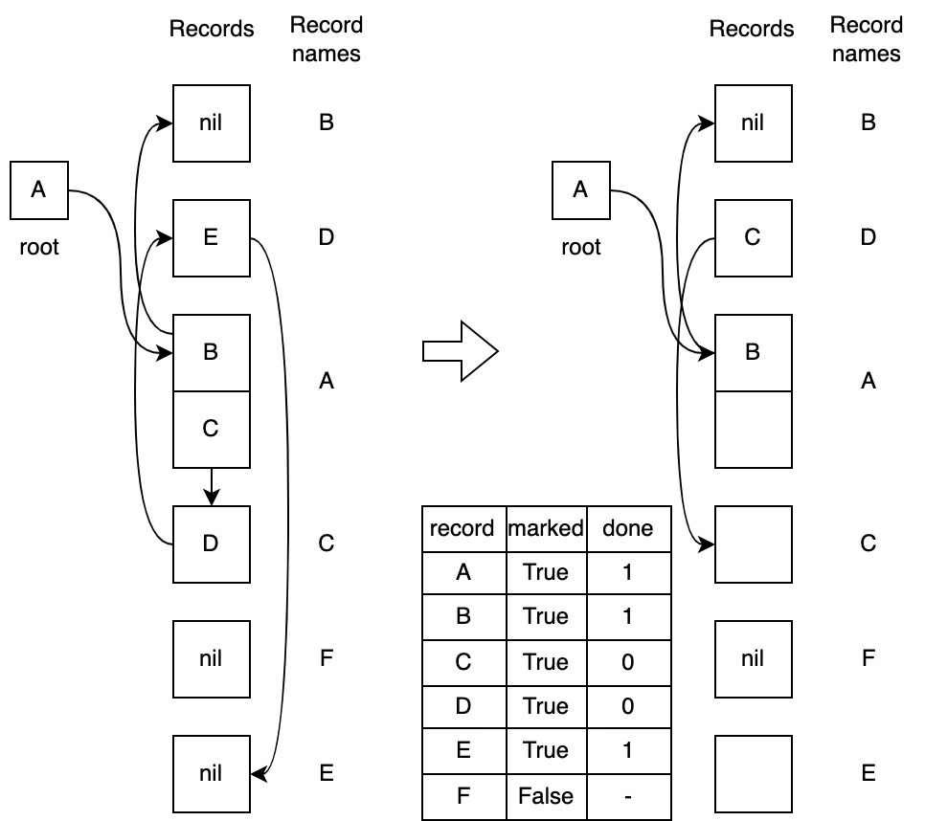

Problem 3: Functional Programming (20 points)
1  2  3  4  5  6  7  8  9  10  11  12  13  14  15  16  17  18  19  20  21  22  23  24  25  26  27  28  29 | let  type intfun = int -> int  function multiply(n: int) : intfun =  let function h(m: int) : int = m * n  in h  end  function square(a: int) : int = a * a  function get_sum(f: intfun, g: intfun) : intfun =  let function func(x: int, y: int) : int = f(x) + g(y)  in func  end  var x := multiply(2)  function compute(i: int, res: int, c: intfun) =  if i=1 then c(res)  else let function inc(b: int) = c(b + 1)  in compute(i-1, res * i, inc)  end  in  var eval = get_sum(x, square)  var sum = eval(-3, 3)  print(sum)  compute(3, 1, square)  end

- When function get_sum is returned in line 25, part of the allocated activation records is shown in the following figure. Please draw the missing activation record(s) and closure(s), and add arrows to indicate the relation of them. (8’)
- What’s the actual value of sum in line 26? (4’)
- Please complete the following control flow graph for all the function calls invoked within line 28. Every blank should be filled with the current function call with the actual value of its arguments. (8’)

Problem 4: Register Allocation (32 points)
Suppose a compiler has compiled the following function find_factor into instructions on the right:
void find_factor(int i) {  int j = 1;  while (j < i) {  if (i % j == 0)  print(j);  j++;  }  } | find_factor:  t1 <- r1  t2 <- r2  i <- r3  j <- 1  jmp L3  L1:  r3,r4 <- i / j  cmp r4, 0  jne L2  r3 <- j  call print  L2:  j <- j + 1  L3:  cmp j, i  jl L1  r2 <- t2  r1 <- t1  ret

Several things are worth noting in the instructions:
- There are four hardware registers in all.
- The compiler passes parameters using registers. (The first parameter goes to r3)
- r1,r2 is callee-saved while r3,r4 are caller-saved.
- The architecture handles integer divisions by fetching the two operands from arbitrary registers. After calculation, it stores the quotient and remainder to r3 and r4 respectively.
- t1, t2, i, j are temporary registers.

Please answer the following questions according to the instructions.
- Draw a control flow graph instruction-by-instruction. (4’)

- Fill up the following def/use/in/out chart. (8’)
instr | def | use | in | out
t1 <- r1
t2 <- r2
i <- r3
j <- 1
jmp L3
r3,r4 <- i / j
cmp r4, 0
jne L2
r3 <- j
call print
j <- j + 1
cmp j, i
jl L1
r2 <- t2
r1 <- t1
ret

- Draw the interference graph for the program. Please use dashed lines for move edges and solid line for real interference edges. (4’)

4. The heuristic to decide which temporary to spill is the same as that in the Tiger book. i.e. The spill priority is calculated as:
Spill Priority =
(Uses+Defs-outside-loop + Uses+Defs-within-loop * 10) / Degree

Adopt the graph-coloring algorithm to allocate registers for temporaries. Write down the instructions after register allocation. (16’)
NOTE: You must write down every decision you make such as simplifying, spilling, coalescing. And you also need to write down new instructions and draw new interference graph after each spilling. If you answer is too simple, you will get a part of score.

