Sensor software simulation update
BMP180 | BMI160 | ADXL345
I ran the processing checks in Python using generated data before connecting the sensors. Calibration, Allan and Hadamard variance, a tilt EKF and the logging format have been tested in software. hardware testing is still pending.

Calibration
I generated six stationary orientations for each accelerometer with known offsets, scale errors and random noise. Each face had 300 samples. I fitted the offsets and scales, then checked them on a separate 600 sample stationary recording.
The maximum recovered offset error was 0.00008 g for the BMI160 model and 0.00016 g for the ADXL345 model. The corrected mean acceleration norms were 1.0001 g and 1.0004 g. For the gyro model, subtracting a separately estimated bias left a maximum stationary axis mean of 0.0024 degrees/s.
The BMP180 compensation code also reproduced the datasheet example: raw temperature 27898 and pressure 23843 gave 15 degrees C and 69964 Pa. This checks the calculation, not the actual sensor accuracy.

Allan and Hadamard variance
I used 18,000 generated samples at 10 Hz, equivalent to 30 minutes. The noise standard deviation was 0.2 degrees/s. A second signal used the same noise plus a linear drift of 0.001 degrees/s per second. Both estimators use overlapping averages.
At 0.1 s, Allan variance was 0.04049 and Hadamard variance was 0.04048 (degrees/s) squared, close to the input noise variance of 0.04000. Constant input gave zero for both. A pure linear ramp gave near-zero Hadamard variance while Allan variance increased with averaging time.

EKF
I tested roll and pitch separately with a 20 degree sinusoidal reference over 60 seconds at 10 Hz. I added acceleration noise of 0.01 g and gyro noise of 0.2 degrees/s. The roll RMSE was 0.208 degrees and pitch RMSE was 0.168 degrees. Covariance stayed positive in both runs.
The EKF uses gyro prediction and gravity correction from the BMI160 model. Gyro bias is removed beforehand. ADXL345 is an independent acceleration check; BMP180 is not fused into tilt. Yaw and position are not estimated.

simulation plots
All plots below use generated inputs. They are not readings from the boards.
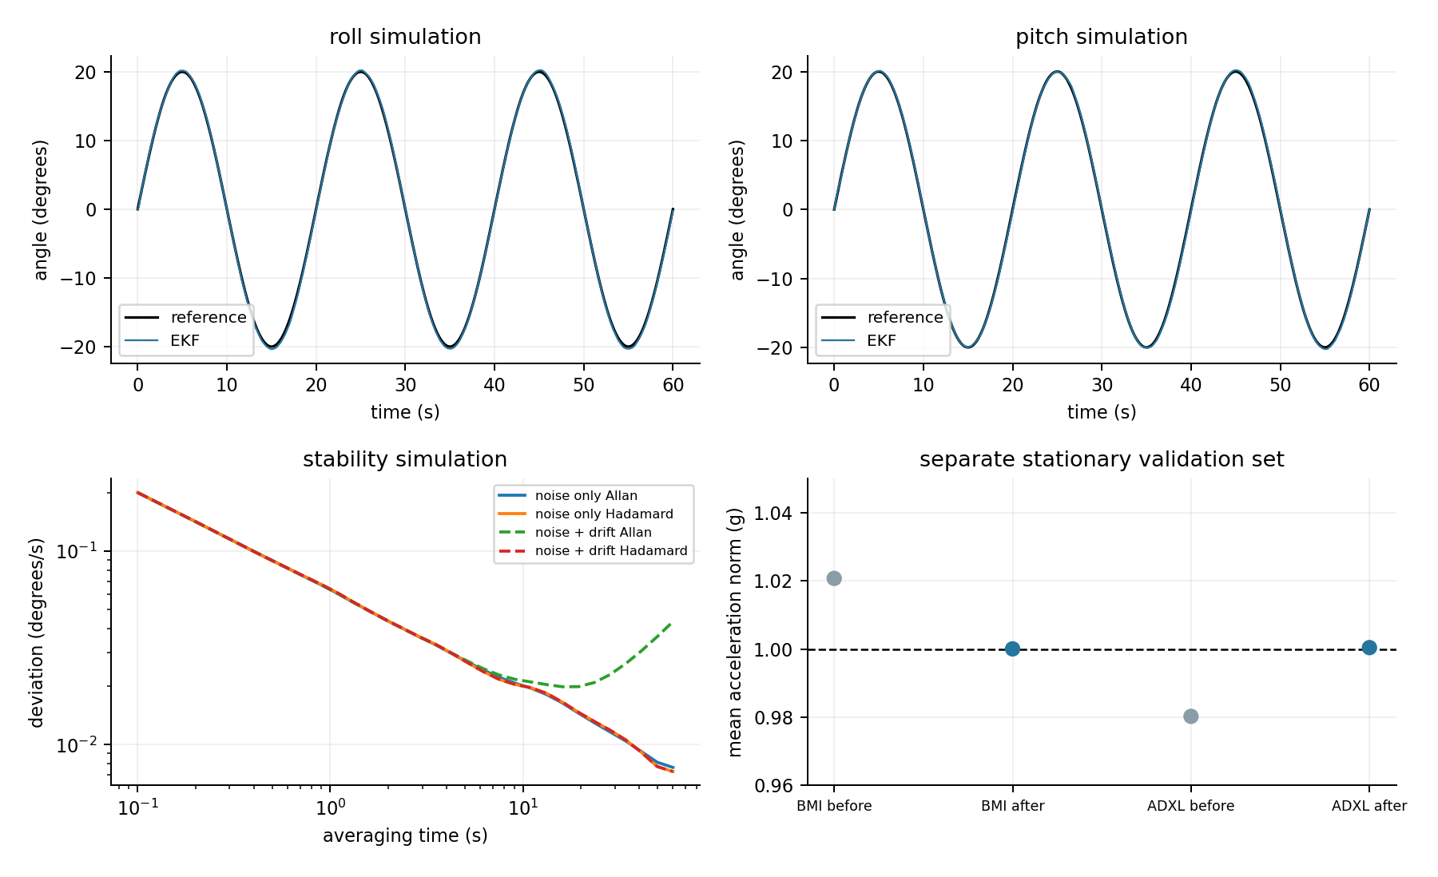

Logging and recovery checks
I tested a 72 byte binary record containing a boot ID, sequence number, timestamp, raw values, compensated pressure and temperature, and CRC32. All 72 single-byte corruption cases were rejected. The Pico and PC record decoders returned the same values.
For local retention, I used a 32 KB FRAM memory model with 80 byte slots. I interrupted the second record write after each possible byte count, then simulated a restart. Across 74 cases, the earlier committed record stayed unchanged. Incomplete records were ignored, and restart did not overwrite the first record. A full store stopped without erasing data.
These checks cover the software write sequence only. They do not prove survival of real brownouts, bus faults or storage damage. The 32 KB model holds 409 records, about 41 seconds at 10 Hz, so longer standalone recording needs more storage.

still to do on hardware
- Get MicroPython connected over USB and confirm the Pico runs a basic command.
- Check sensor addresses and IDs, then verify each sensor responds to movement or height changes.
- Record real data, measure timing gaps and repeat calibration using the actual boards.
- Choose enough local storage, then test power cuts and compare recovered records against the saved baseline.
The simulation results check the implementation. actual noise, EKF tuning and data retention still need to be measured on the hardware.

