

Final Year Project Proposal

Teaching AI to Park

Vaclav Vincent Hornak – G00366783

Project Engineering

Supervisor: Paul Lennon

Bachelor of Software & Electronic Engineering

Galway-Mayo Institute of Technology

2021/2022

Project Description

For my final year project, I decided to look into developing a game and within that game, teach AI to reverse a trailer. The idea came from my hobby in truck simulation and the recent shortage of HGV drivers around Europe. I think this project can be used to teach future drivers how to reverse a trailer as it’s a skill that people struggle with.

I thought I’d challenge myself with creating a game which implements reinforcement learning. Both these topics aren’t taught in college, and I’ve found a real interest in while researching project ideas. I will be using the ML-Agents package in Unity to teach the agents how to park. The challenge will be

Software Programming Languages to be Used

The software I will be using in my project will be C# for my unity project and basic Python for the ML-Agents package. I decided to use these two languages as I’ve worked with C# during my work placement in Avaya and Python is needed for the ML Package.

Architecture Diagram

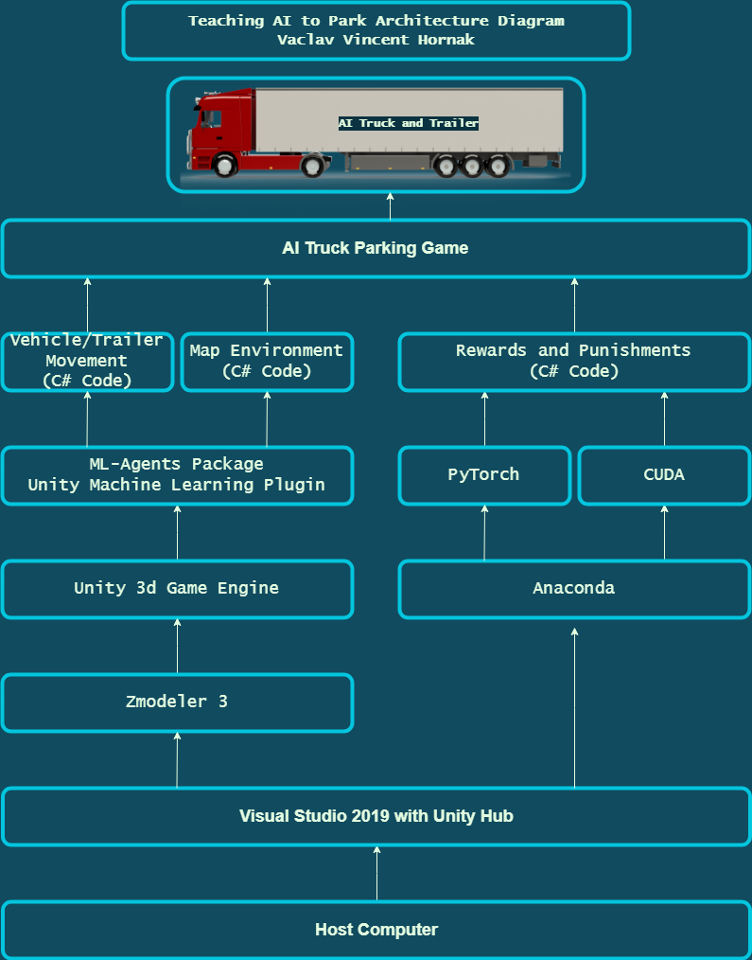

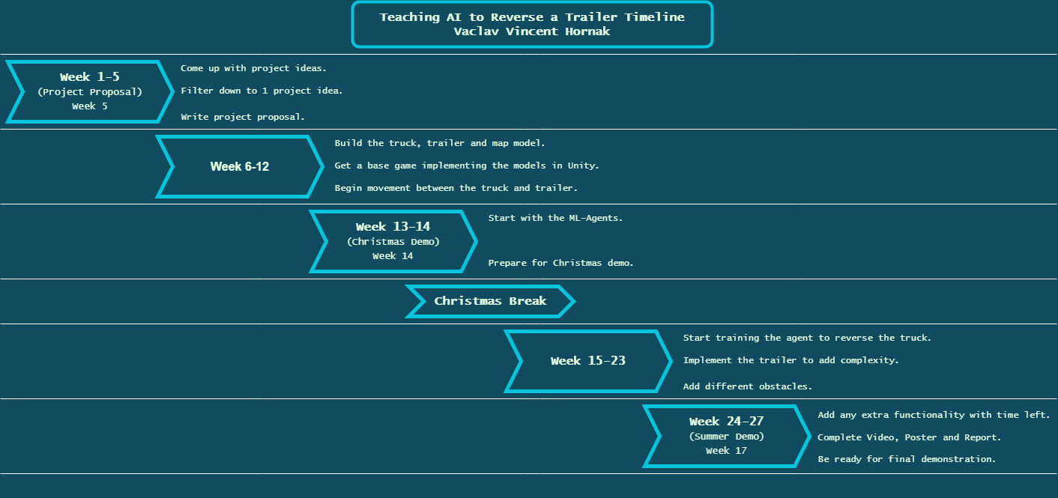Timeline for Deliverables