Screenshots

Scanning and enumerating a local network using Nmap

Step 1
Network discovery
Commad : nmap –sn 192.168.228.129/24

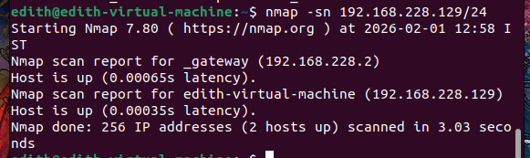

Result :

The Nmap ping scan on the CRT target network 192.168.228.0/24 identified 2 live hosts, including the default gateway and the Ubuntu virtual machine. No unknown or unauthorized devices were detected.

Step 2
Port Scanning
Command : sudo nmap –sS 192.168.228.129

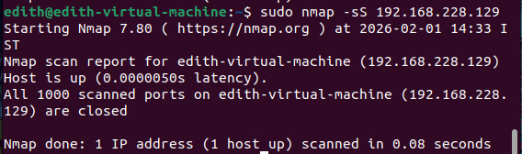

Result :

A TCP SYN scan was conducted on the target host (192.168.228.129) to identify open TCP ports. The scan revealed that all 1000 commonly used ports were closed, indicating that no network services are currently exposed on the system.

Step 3
Service and Version Detection
Command : sudo nmap –sV –sC 192.168.228.129

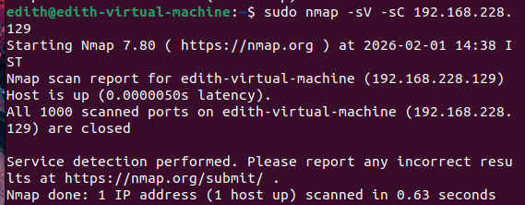

Result :

Service detection was performed using Nmap on the target host. No active services or version information were identified, as all scanned ports were closed. This confirms that the system does not expose network services to the LAN.

Step 4
Vulnerability Assessment :
Command : sudo nmap –script vuln 192.168.288.129

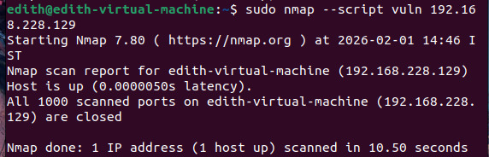

Result :

A vulnerability assessment was conducted using Nmap NSE scripts on the target host. The scan did not identify any known vulnerabilities, as no open ports or exposed services were detected. The system demonstrates a hardened security posture.

