Screenshots

Screenshot 1 – Log file exists

Command:
ls /var/log

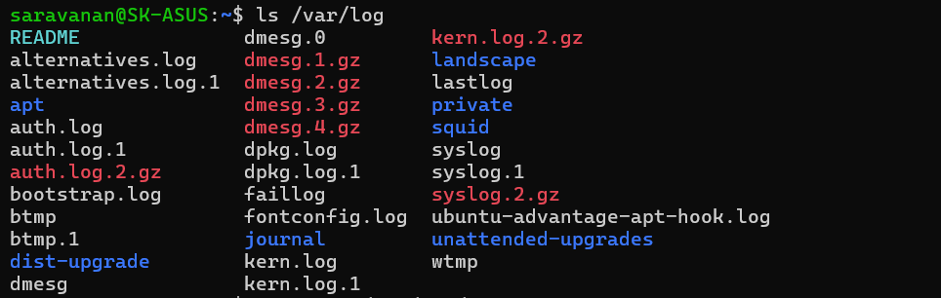

Screenshot 2 – View log file

Command:
sudo less /var/log/auth.log
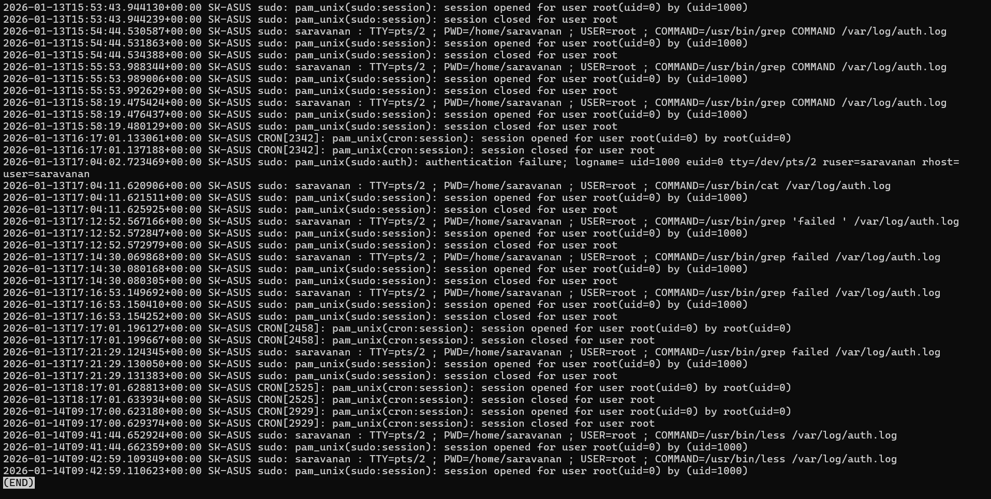

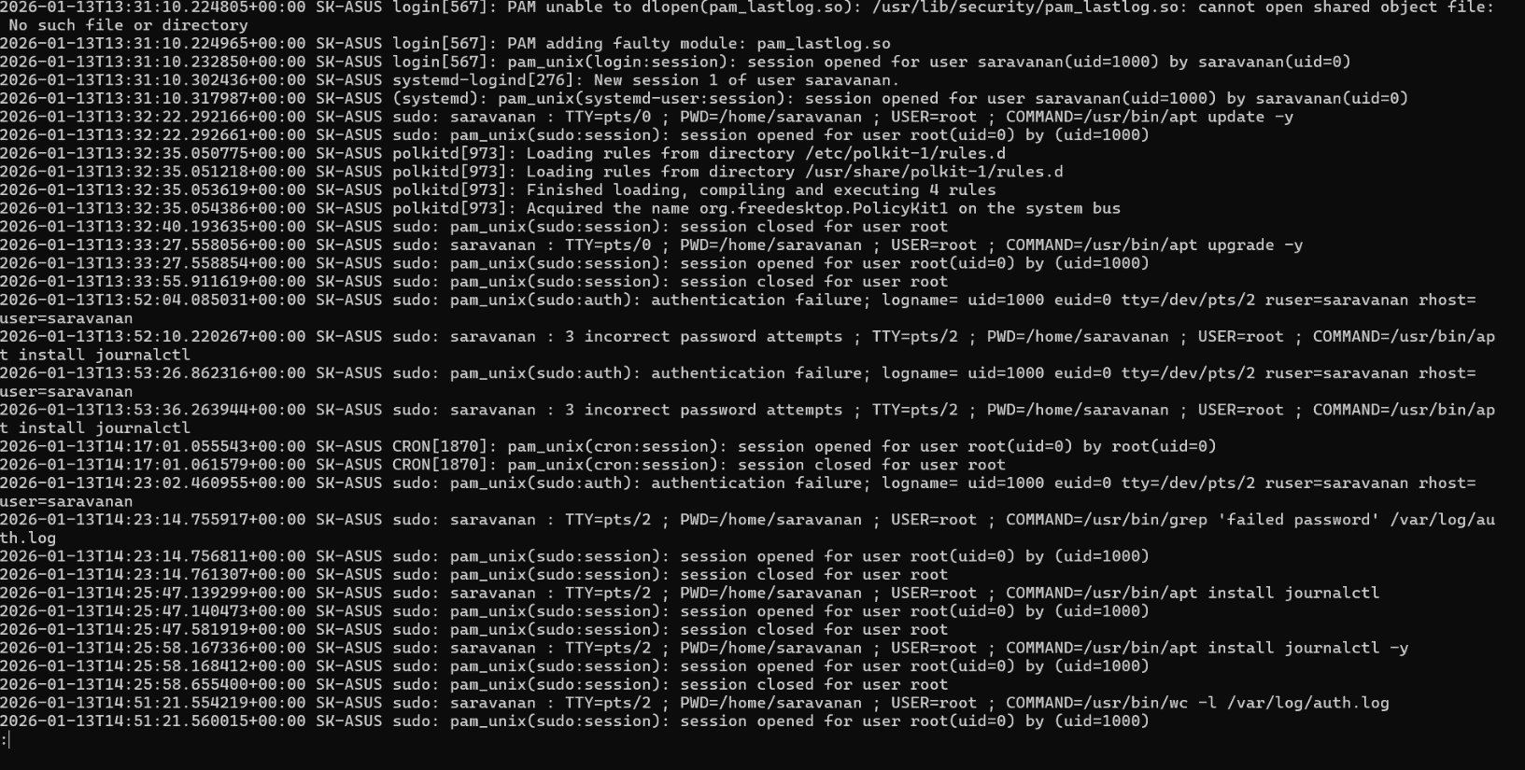

Screenshot 3 – Search failed logins

Command:
sudo grep "Failed" /var/log/auth.log

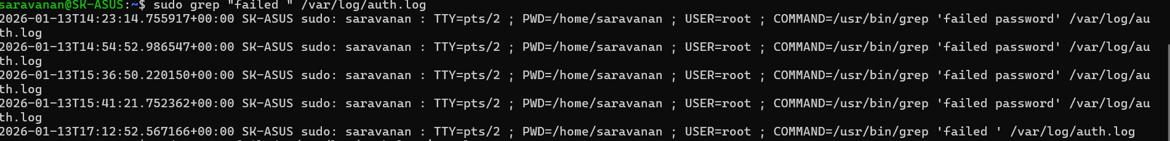

Screenshot 4 – Count failed attempts

Command:
sudo grep "Failed" /var/log/auth.log | wc -l

Screenshot 5 – Analysis command

Command:
sudo grep "Failed" /var/log/auth.log | awk '{print $(NF-3)}' | sort | uniq -c | sort

No major brute-force activity detected.

Screenshot 6 – Final report file

Command :
cat report.txt

