PROJECT TITLE: SMART PUBLIC RESTROOM

TEAM MEMBER : au723721104087 : RAMALAKSHMI.J

In this part you will continue building your project.

* Continue building the project by developing the restroom information platform and mobile app.
* Use web development technologies (e.g., HTML, CSS, JavaScript) to create a platform that displays real-time restroom availability and cleanliness data.
* Design mobile apps for iOS and Android platforms that provide users with access to realtime restroom information .

# Html code : index.html

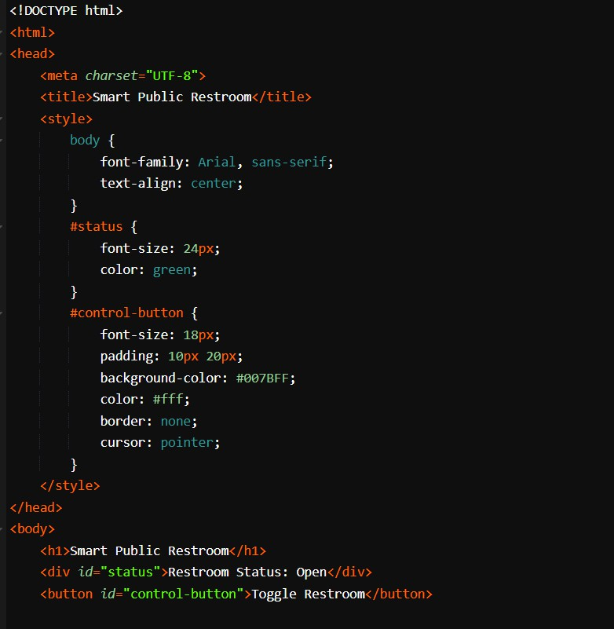

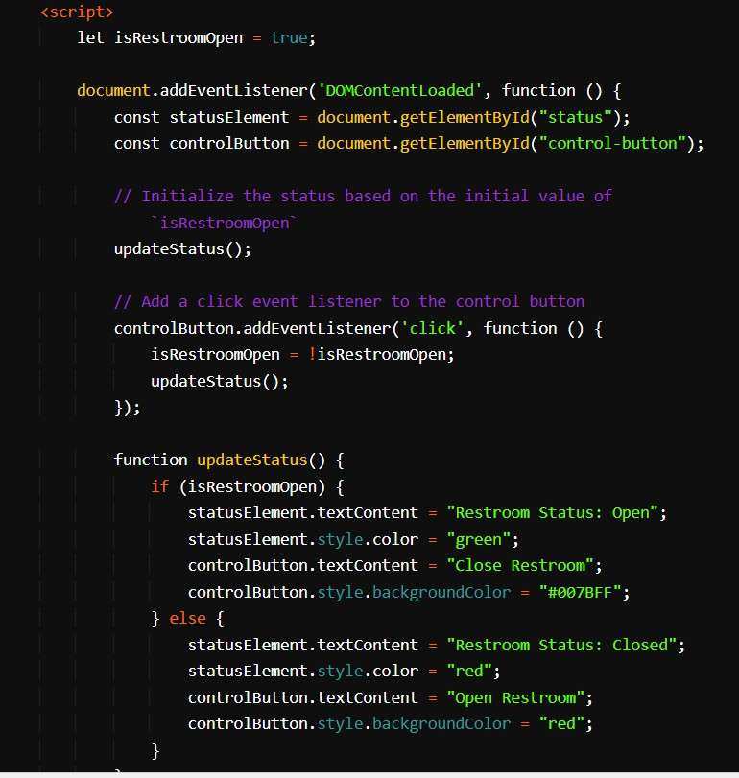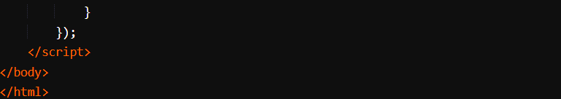

**<!DOCTYPE html>:** This declaration specifies that the document follows HTML5 standards**.**

**<html lang="en">:** The root element of the HTML document, and it indicates that the document is in English.

**<head>:** This section contains metadata about the document, including character encoding, viewport settings, external stylesheet references, and a title for the page.

**<link rel="stylesheet" href="nn.css">:** This line links an external CSS file named "nn.css" to style the web page.

**<title>Smart Public Restroom Status</title>:** Sets the title of the web page, which appears in the browser's title bar or tab.

**<link href="**[**https://cdn.jsdelivr.net/npm/bootstrap@5.3.2/dist/css/bootstrap.min.css"**](https://cdn.jsdelivr.net/npm/bootstrap%405.3.2/dist/css/bootstrap.min.css) **rel="stylesheet">:** This line includes a link to the Bootstrap CSS framework to utilize Bootstrap styles for your web page. It enhances the styling and provides responsive design features.

# <script

**src=**[**"htt**](https://cdn.jsdelivr.net/npm/bootstrap%405.3.2/dist/js/bootstrap.bundle.min.js)**p**[**s://cdn.jsdelivr.net/npm/bootstrap@5.3.2/dist/js/bootstrap.bundle.min.js"**](https://cdn.jsdelivr.net/npm/bootstrap%405.3.2/dist/js/bootstrap.bundle.min.js)**></sc ript>:** This script includes Bootstrap's JavaScript bundle, which is used for certain Bootstrap components and features. Bootstrap is a popular front-end framework for web

development.

**<header>:** This section represents the header of the web page. It includes the title, "Water Fountain Status," and a navigation menu. The navigation menu is styled using Bootstrap's navbar component.

**<h1 align="center">Smart Public Restroom Status</h1>:** This is the main heading of the page, centered within the header.

**<nav class="navbar navbar-expand-sm navbar-dark bg-dark">:** This is a Bootstrap navbar that provides a responsive navigation bar with a dark background.

Inside the navigation bar, there's a button for toggling the navigation links, a <div> for the navigation links, and a search form with an input field and a search button.

**<div class="status-container">:** This <div> represents the container for the water fountain status information and additional content.

**<section class="status">:** This section displays the smart public restroom status (e.g., "Opened").

**<footer>:** The footer section contains copyright information, indicating that the content is copyrighted by "Smart Public Restroom" in the year 2023.

**<script src="nn.js"></script>:** This line includes an external JavaScript file named "nn.js." The JavaScript file is used to add functionality to the web page, such as handling user interactions or updating the water fountain status dynamically.

# CSS (NN.CSS)

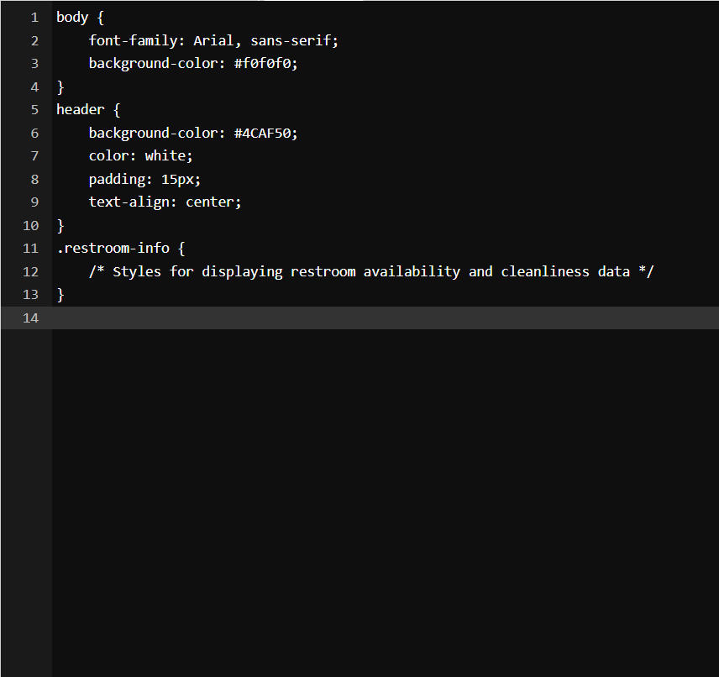

**Java script: (nn.js)**

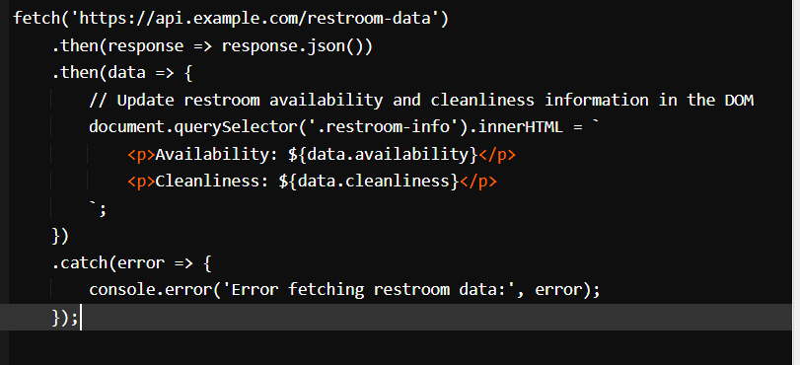

This code includes the HTML structure for the webpage, the associated CSS for styling, and the JavaScript for toggling the restroom's status and updating the display. When you open this HTML file in a web browser, you'll see a basic smart public restroom webpage with a control button to toggle the restroom's status between "Open" and "Closed."

**Result:**

