SMART PUBLIC RESTROOM

TEAM MEMBER:

723721104087 : Ramalakshmi.J

Phase-2:Submission Document

Project Innovation Proposal:

Project Title: Innovative Iot-Based Smart Public Restroom

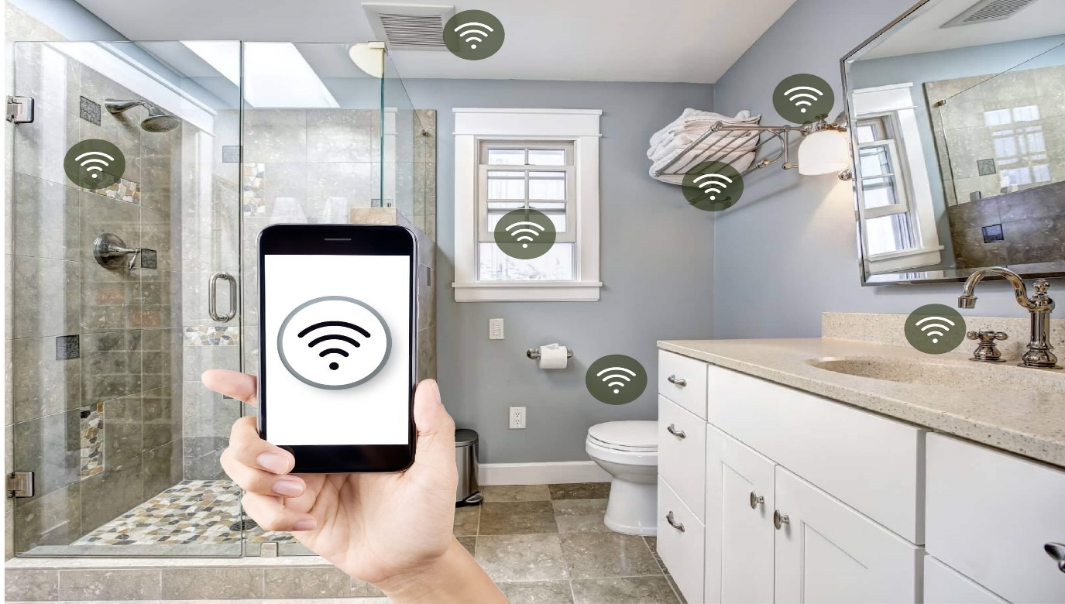

Project Description : This proposal outlines an innovative approach to enhance Smart Toilet Management, also known as Smart Washroom Management is a big part of Facilities Management. By deploying simple IoT solutions such as sensors, facility managers can improve operational processes and washroom experience for its tenants. This is especially important as poor toilet hygiene, sanitation and waste disposal spread germs and affects public health.

SOLUTION: Hand Hygiene Compliance Monitoring is a great example of a well-deployed IoT solution. Its concept implies monitoring the number of people entering a restroom and the number of people using soap to wash hands when leaving the room. Count is anonymous and is done with the help of sensors located at the entrance and under the soap dispenser. Received data are then analyzed and processed into statistics report which presents the handwash compliance percentage on the Hygiene Display Monitor to remind restroom users to wash hands every time they leave the room and improve their hand hygiene behaviour in such a way.

1.Problem Definition:

• Clogged drains, wet towels and dry gunk accumulated on the shower cubicle or the shower curtains can lead to bathroom odours.

• The smells especially , it is essential to ventilate the it, remove trash and deep clean the bathroom at least once a week.

• Broken doors or toilet seats, dim lighting, graffiti, dirty fixtures, soiled toilet seats, and water or urine on the floors also contributed to users perceiving a restroom as unclean, according to the survey.

SOURCE CODE:

* import java.util.Scanner;

// Simulated occupancy sensor class MotionSensor { private boolean occupied; public MotionSensor() {

this.occupied = false;

}

public boolean detectMotion() {

Scanner scanner = new Scanner(System.in);

System.out.print("Is there motion? (y/n): ");

String input = scanner.nextLine().trim().toLowerCase(); return input.equals("y");

}

public boolean isOccupied() {

return occupied;

}

public void setOccupied(boolean occupied) {

this.occupied = occupied;

}

}

public class SmartRestroomSimulation { public static void main(String[] args) {

MotionSensor motionSensor = new MotionSensor(); try {

while (true) {

if (motionSensor.detectMotion()) { if (!motionSensor.isOccupied()) {

System.out.println("Restroom is now occupied."); motionSensor.setOccupied(true);

}

} else{

if (motionSensor.isOccupied()) {

System.out.println("Restroom is now vacant."); motionSensor.setOccupied(false);

}

}

Thread.sleep(1000); // Simulate periodic checking (adjust as needed)

}

} catch (InterruptedException e) {

System.out.println("Exiting...");

}

}

}

FUTURE SELECTION:

* Selecting smart public restrooms for the future involves careful consideration of various factors to ensure they meet the needs of users, facility managers, and sustainability goals. Here's a guide to help with the selection process:
* 1. User Needs and Experience: Identify the specific needs of users, including accessibility requirements, preferences for touchless fixtures, and overall comfort. - Consider user feedback and surveys to understand expectations and preferences.
* 2. Hygiene and Safety: Prioritize hygiene and safety features, such as touchless fixtures, UV-C disinfection, and easy-to-clean surfaces. - Ensure compliance with health and safety regulations, especially in post-pandemic environments.
* 3. Sustainability Goals: Choose restrooms with green solutions like waterefficient fixtures, energy-efficient lighting, and sustainable materials. -

Evaluate options for renewable energy sources and water recycling systems.

* 4. Technology Integration: Assess the integration of IoT (Internet of Things) technology for real-time monitoring, data analytics, and predictive maintenance
* Things) technology for real-time monitoring, data analytics, and predictive maintenance.Ensure compatibility with existing building management systems.
* 5. Maintenance and Durability: Select fixtures and materials that are durable, easy to maintain, and have a long lifespan. - Consider the availability of spare parts and support services
* 6. Cost Considerations: Evaluate the initial installation costs and long-term operational expenses. - Calculate potential cost savings from resourceefficient features.
* 7. Environmental Impact: Assess the overall environmental impact of the restroom, including water and energy use, emissions, and waste generation. - Aim for a restroom that minimizes its carbon footprint.
* 8. Compliance and Accessibility: Ensure that the restroom complies with accessibility standards, such as ADA (Americans with Disabilities Act) requirements. - Review local building codes and regulations.
* 9. Vendor Reputation: Research and choose reputable vendors with a track record of delivering quality smart restroom solutions. - Read customer reviews and seek recommendations.

Description:

The Goal of the system is to monitor and evaluates Toilet Condition In Real-Time, enabling city governments to improve the toilet cleaning & upkeep through:

* Monitoring capabilities
* Actionable intelligence
* Engagement & behavior change
* Standardization of toilet hygiene

To achieve this goal, We have to monitor

1. Number of Male/ Female using toilets
2. Water Usage and Level monitoring
3. The smell in the toilet.
4. Light/ Darkness in the Toilet
5. User Feedback from the Toilet.

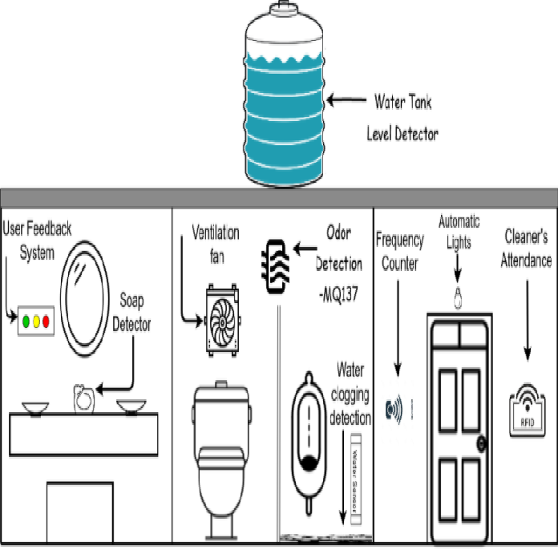

User Counter:

The requirement is that sensor that can be mount on the head (top) of the door/ gate to count the user, with reasonable accuracy. Also, it should be rigid enough to protect from vandalism.

There are multiple ways to do user counting, considering the public toilet and environment, we decided to use a PIR sensor, with some customization.

When a person passes beneath the PIR sensor which will be mounted on the head (top) of the Toilet, it detects the motion of the person. This gives a High pulse at the output.

This pulse will remain High for a specific timeout and then become low for a certain time and become ready again to detect another motion.

It can detect motion within 18 feet.

Smell Sensor:

A smell sensor Node is a wi-fi-based sensor that will detect the level of gases that causes the bad smell in the Toilet.

1. **Selection of Sensor**

* Need to detect gas H2S (Hydrogen Sulphide) which is produced from Human waste.
* Need to detect NH3 (Ammonia) which is produced in Urine.
* It should not consume more power.
* It should get less affected by ambient environment factors like temperature, humidity, etc.
* It should have a long life.

To fulfill all the above requirement, we found two sensors

* **TGS2602**
* **MQ135**
* Water Level Sensor:
* The water level sensor node is a wi-fi-based device that is used to detect four levels i.e. 25%, 50%, 75%, and 100% (full) in the tank.
* There are many water level sensors are present in the market. But, we need to use cost-effective water level sensor, so we have selected Conductivity based water level sensor which is as follows:
* 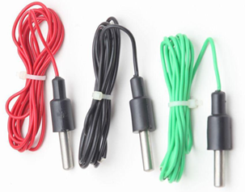Normal Conductor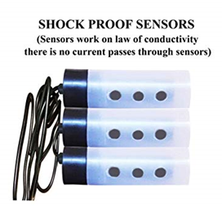Carbon Plated Conductor
* we used carbon plated water level sensor to avoid rusting because of water.
* To detect 4 different levels, we have to insert 5 carbon-plated conductors. Out of which one is connected to the ground placed at the bottom of the tank.
* And the other 4 conductors placed at different detecting levels which are connected to different inverting terminals of comparator LM324
* 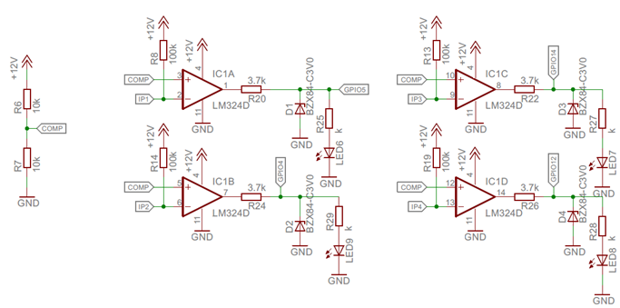Circuit connection of water level sensor with LM324
* 4 conductors are placed at 25%, 50%, 75%, and 100% level in the tank, and the conductor which is connected to the ground is placed at the bottom of the tank.
* 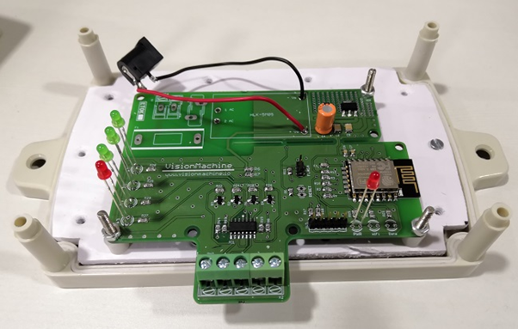Water Level Sensor
* at the time of assembly, we don't have 12v on PCB SMPS, So we used an external adapter here.

# **User Feedback Machine**

The user feedback system is a wireless-based device that takes user feedback in terms of Toilet cleaning. There are three switches for Clean, average, and Dirty feedback.