**Experiment 07**

**Aim:** Socket programming using TCP or UDP.

**TCP Socket Connection :**

TCP server:

**(server.py)**

import socket

def server_program():

host = socket.gethostname()

port = 5000

server_socket = socket.socket()

server_socket.bind((host, port))

server_socket.listen(2)

conn, address = server_socket.accept()

print("Connection from: " + str(address))

while True:

data = conn.recv(1024).decode()

if not data:

break

print("from connected user: " + str(data))

data = input(' -> ')

conn.send(data.encode())

conn.close()

if __name__ == '__main__':

server_program()

**(client.py)**

import socket

def client_program():

host = socket.gethostname()

port = 5000

client_socket = socket.socket()

client_socket.connect((host, port))

message = input(" -> ")

while message.lower().strip() != 'bye':

client_socket.send(message.encode())

data = client_socket.recv(1024).decode()

print('Received from server: ' + data)

message = input(" -> ")

client_socket.close()

if __name__ == '__main__':

client_program()

**Output:**

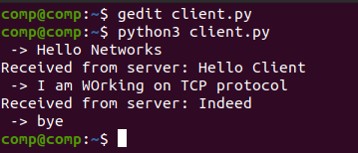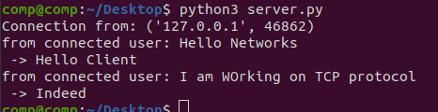

**UDP Socket Connection :**

UDP server :

**(server.py)**

import socket

sock = socket.socket(socket.AF_INET,socket.SOCK_DGRAM)

udp_host = socket.gethostname()

udp_port = 5000

print ("UDP target IP:", udp_host)

print ("UDP target Port:", udp_port)

sock.bind((udp_host,udp_port))

while True:

data,addr = sock.recvfrom(1024)

print ("Received Messages:",data," from",addr)

if not data:

Break

data = input(" -> ")

sock.sendto(data.encode(),addr)

sock.close()

UDP client :

**(client.py)**

import socket

sock = socket.socket(socket.AF_INET,socket.SOCK_DGRAM)

udp_host = socket.gethostname()

udp_port = 5000

print ("UDP target IP:", udp_host)

print ("UDP target Port:", udp_port)

message = input(" -> ")

while message.lower().strip() != 'bye':

sock.sendto(message.encode(),(udp_host,udp_port))

data,addr = sock.recvfrom(1024)

print ("Received Messages:",data," from",addr)

message = input(" -> ")

sock.close()

**Output:**

