**Experiment 10**

**Output**

**Installing nmap**

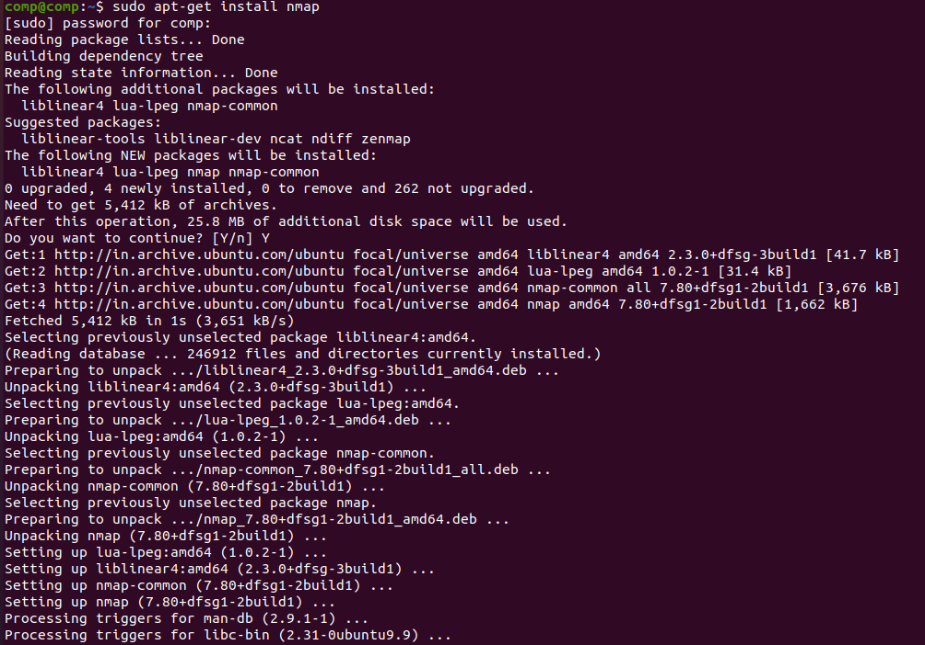

**Scan Single IP:**

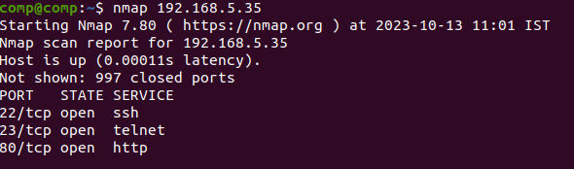

**Scan a Host:**

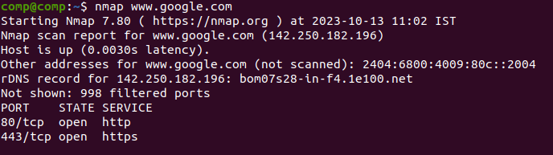

**Scan range of IP:**

comp@comp:~$ nmap 192.168.5.0-255

Starting Nmap 7.80 ( https://nmap.org ) at 2023-10-13 11:08 IST

Nmap scan report for _gateway (192.168.5.1)

Host is up (0.0038s latency).

Not shown: 998 closed ports

PORT STATE SERVICE

22/tcp open ssh

80/tcp open http

Nmap scan report for 192.168.5.26

Host is up (0.00028s latency).

Not shown: 996 closed ports

PORT STATE SERVICE

21/tcp open ftp

22/tcp open ssh

23/tcp open telnet

80/tcp open http

Nmap scan report for 192.168.5.28

Host is up (0.00026s latency).

Not shown: 998 closed ports

PORT STATE SERVICE

22/tcp open ssh

80/tcp open http

Nmap scan report for 192.168.5.32

Host is up (0.00027s latency).

Not shown: 995 closed ports

PORT STATE SERVICE

135/tcp open msrpc

139/tcp open netbios-ssn

445/tcp open microsoft-ds

2701/tcp open sms-rcinfo

5432/tcp open postgresql

Nmap scan report for comp (192.168.5.35)

Host is up (0.00011s latency).

Not shown: 997 closed ports

PORT STATE SERVICE

22/tcp open ssh

23/tcp open telnet

80/tcp open http

Nmap scan report for 192.168.5.36

Host is up (0.00024s latency).

Not shown: 997 closed ports

PORT STATE SERVICE

22/tcp open ssh

80/tcp open http

3306/tcp open mysql

Nmap scan report for 192.168.5.37

Host is up (0.00037s latency).

Not shown: 990 closed ports

PORT STATE SERVICE

80/tcp open http

135/tcp open msrpc

139/tcp open netbios-ssn

445/tcp open microsoft-ds

1801/tcp open msmq

2103/tcp open zephyr-clt

2105/tcp open eklogin

2107/tcp open msmq-mgmt

2701/tcp open sms-rcinfo

5432/tcp open postgresql

Nmap scan report for 192.168.5.40

Host is up (0.00058s latency).

Not shown: 994 closed ports

PORT STATE SERVICE

135/tcp filtered msrpc

139/tcp filtered netbios-ssn

445/tcp filtered microsoft-ds

1110/tcp filtered nfsd-status

2869/tcp filtered icslap

19780/tcp filtered unknown

Nmap scan report for 192.168.5.43

Host is up (0.00022s latency).

Not shown: 998 closed ports

PORT STATE SERVICE

22/tcp open ssh

80/tcp open http

Nmap scan report for 192.168.5.45

Host is up (0.00026s latency).

Not shown: 999 closed ports

PORT STATE SERVICE

80/tcp open http

Nmap scan report for 192.168.5.48

Host is up (0.00025s latency).

Not shown: 998 closed ports

PORT STATE SERVICE

22/tcp open ssh

80/tcp open http

Nmap scan report for 192.168.5.49

Host is up (0.00024s latency).

Not shown: 998 closed ports

PORT STATE SERVICE

22/tcp open ssh

80/tcp open http

Nmap scan report for 192.168.5.51

Host is up (0.0036s latency).

Not shown: 993 closed ports

PORT STATE SERVICE

135/tcp open msrpc

139/tcp open netbios-ssn

445/tcp open microsoft-ds

902/tcp open iss-realsecure

912/tcp open apex-mesh

3306/tcp open mysql

5432/tcp open postgresql

Nmap scan report for 192.168.5.52

Host is up (0.00021s latency).

Not shown: 998 closed ports

PORT STATE SERVICE

22/tcp open ssh

80/tcp open http

Nmap scan report for 192.168.5.53

Host is up (0.00024s latency).

Not shown: 998 closed ports

PORT STATE SERVICE

22/tcp open ssh

80/tcp open http

Nmap scan report for 192.168.5.55

Host is up (0.00055s latency).

Not shown: 998 closed ports

PORT STATE SERVICE

22/tcp open ssh

80/tcp open http

Nmap scan report for 192.168.5.57

Host is up (0.00020s latency).

Not shown: 999 closed ports

PORT STATE SERVICE

80/tcp open http

Nmap scan report for 192.168.5.59

Host is up (0.00022s latency).

Not shown: 998 closed ports

PORT STATE SERVICE

22/tcp open ssh

80/tcp open http

Nmap scan report for 192.168.5.62

Host is up (0.00027s latency).

Not shown: 998 closed ports

PORT STATE SERVICE

23/tcp open telnet

80/tcp open http

Nmap scan report for 192.168.5.64

Host is up (0.00022s latency).

Not shown: 999 closed ports

PORT STATE SERVICE

80/tcp open http

Nmap scan report for 192.168.5.67

Host is up (0.00043s latency).

Not shown: 999 closed ports

PORT STATE SERVICE

80/tcp open http

Nmap scan report for 192.168.5.68

Host is up (0.00024s latency).

Not shown: 998 closed ports

PORT STATE SERVICE

22/tcp open ssh

80/tcp open http

Nmap scan report for 192.168.5.70

Host is up (0.00030s latency).

Not shown: 996 closed ports

PORT STATE SERVICE

135/tcp open msrpc

139/tcp open netbios-ssn

445/tcp open microsoft-ds

2701/tcp open sms-rcinfo

Nmap scan report for 192.168.5.73

Host is up (0.00052s latency).

Not shown: 998 closed ports

PORT STATE SERVICE

22/tcp open ssh

80/tcp open http

Nmap scan report for 192.168.5.75

Host is up (0.00026s latency).

Not shown: 998 closed ports

PORT STATE SERVICE

23/tcp open telnet

80/tcp open http

Nmap scan report for 192.168.5.76

Host is up (0.00027s latency).

Not shown: 997 closed ports

PORT STATE SERVICE

135/tcp open msrpc

139/tcp open netbios-ssn

445/tcp open microsoft-ds

Nmap scan report for 192.168.5.79

Host is up (0.00028s latency).

Not shown: 999 closed ports

PORT STATE SERVICE

80/tcp open http

Nmap scan report for 192.168.5.80

Host is up (0.00074s latency).

Not shown: 994 closed ports

PORT STATE SERVICE

135/tcp filtered msrpc

139/tcp filtered netbios-ssn

445/tcp filtered microsoft-ds

1110/tcp filtered nfsd-status

2869/tcp filtered icslap

19780/tcp filtered unknown

Nmap scan report for 192.168.5.81

Host is up (0.00041s latency).

Not shown: 996 closed ports

PORT STATE SERVICE

21/tcp open ftp

22/tcp open ssh

23/tcp open telnet

80/tcp open http

Nmap scan report for 192.168.5.85

Host is up (0.00023s latency).

Not shown: 998 closed ports

PORT STATE SERVICE

23/tcp open telnet

80/tcp open http

Nmap scan report for 192.168.5.93

Host is up (0.00027s latency).

Not shown: 996 closed ports

PORT STATE SERVICE

21/tcp open ftp

22/tcp open ssh

23/tcp open telnet

80/tcp open http

Nmap scan report for 192.168.5.95

Host is up (0.00018s latency).

Not shown: 999 closed ports

PORT STATE SERVICE

80/tcp open http

Nmap scan report for 192.168.5.96

Host is up (0.00027s latency).

Not shown: 997 closed ports

PORT STATE SERVICE

22/tcp open ssh

80/tcp open http

3306/tcp open mysql

Nmap scan report for 192.168.5.97

Host is up (0.00030s latency).

Not shown: 996 closed ports

PORT STATE SERVICE

21/tcp open ftp

22/tcp open ssh

23/tcp open telnet

80/tcp open http

Nmap scan report for 192.168.5.99

Host is up (0.00026s latency).

Not shown: 998 closed ports

PORT STATE SERVICE

22/tcp open ssh

80/tcp open http

Nmap scan report for 192.168.5.100

Host is up (0.00026s latency).

Not shown: 998 closed ports

PORT STATE SERVICE

21/tcp open ftp

80/tcp open http

Nmap scan report for 192.168.5.107

Host is up (0.00026s latency).

Not shown: 994 closed ports

PORT STATE SERVICE

21/tcp open ftp

22/tcp open ssh

23/tcp open telnet

80/tcp open http

3000/tcp open ppp

3001/tcp open nessus

Nmap scan report for 192.168.5.109

Host is up (0.00024s latency).

Not shown: 999 closed ports

PORT STATE SERVICE

80/tcp open http

Nmap scan report for 192.168.5.113

Host is up (0.00045s latency).

Not shown: 999 closed ports

PORT STATE SERVICE

22/tcp open ssh

Nmap scan report for 192.168.5.115

Host is up (0.00025s latency).

Not shown: 997 closed ports

PORT STATE SERVICE

22/tcp open ssh

80/tcp open http

111/tcp open rpcbind

Nmap scan report for 192.168.5.120

Host is up (0.00024s latency).

Not shown: 998 closed ports

PORT STATE SERVICE

23/tcp open telnet

80/tcp open http

Nmap scan report for 192.168.5.121

Host is up (0.00026s latency).

Not shown: 997 closed ports

PORT STATE SERVICE

21/tcp open ftp

22/tcp open ssh

80/tcp open http

Nmap scan report for 192.168.5.122

Host is up (0.00027s latency).

Not shown: 997 closed ports

PORT STATE SERVICE

21/tcp open ftp

22/tcp open ssh

80/tcp open http

Nmap scan report for 192.168.5.124

Host is up (0.00042s latency).

Not shown: 999 closed ports

PORT STATE SERVICE

80/tcp open http

Nmap scan report for 192.168.5.127

Host is up (0.00024s latency).

Not shown: 998 closed ports

PORT STATE SERVICE

23/tcp open telnet

80/tcp open http

Nmap scan report for 192.168.5.128

Host is up (0.00030s latency).

Not shown: 996 closed ports

PORT STATE SERVICE

22/tcp open ssh

23/tcp open telnet

80/tcp open http

3306/tcp open mysql

Nmap scan report for 192.168.5.130

Host is up (0.00023s latency).

Not shown: 994 closed ports

PORT STATE SERVICE

21/tcp open ftp

22/tcp open ssh

23/tcp open telnet

80/tcp open http

3000/tcp open ppp

3001/tcp open nessus

Nmap scan report for 192.168.5.133

Host is up (0.00029s latency).

Not shown: 999 closed ports

PORT STATE SERVICE

80/tcp open http

Nmap scan report for 192.168.5.136

Host is up (0.00019s latency).

Not shown: 998 closed ports

PORT STATE SERVICE

23/tcp open telnet

80/tcp open http

Nmap scan report for 192.168.5.137

Host is up (0.00028s latency).

Not shown: 997 closed ports

PORT STATE SERVICE

21/tcp open ftp

22/tcp open ssh

80/tcp open http

Nmap scan report for 192.168.5.139

Host is up (0.00024s latency).

Not shown: 999 closed ports

PORT STATE SERVICE

80/tcp open http

Nmap scan report for 192.168.5.143

Host is up (0.00024s latency).

Not shown: 997 closed ports

PORT STATE SERVICE

21/tcp open ftp

23/tcp open telnet

80/tcp open http

Nmap scan report for 192.168.5.147

Host is up (0.00021s latency).

Not shown: 998 closed ports

PORT STATE SERVICE

22/tcp open ssh

80/tcp open http

Nmap scan report for 192.168.5.166

Host is up (0.00046s latency).

Not shown: 998 closed ports

PORT STATE SERVICE

23/tcp open telnet

80/tcp open http

Nmap done: 256 IP addresses (54 hosts up) scanned in 10.75 seconds

**Detect OS and Services:**

