<https://github.com/actorapp/actor-platform/commit/00408d14b2397f66a37cb3c4f556c41ad19f8d20>

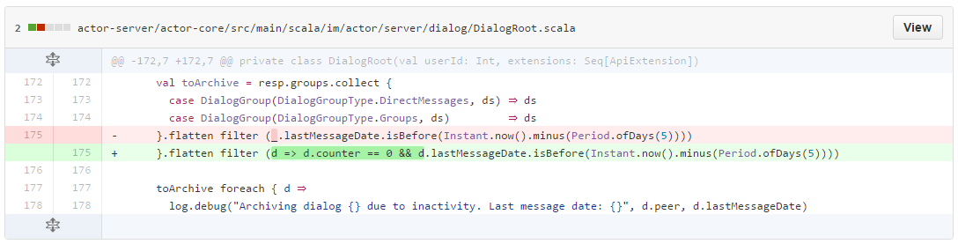

<https://github.com/actorapp/actor-platform/commit/d1c841da3a92dc787e01f824bbde07aa0bba0471>

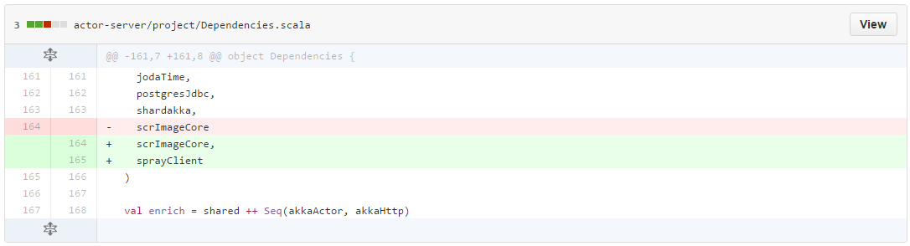

<https://github.com/actorapp/actor-platform/commit/539bf920c46e7c22fae71ac3cd373f3cd09d4dcf>

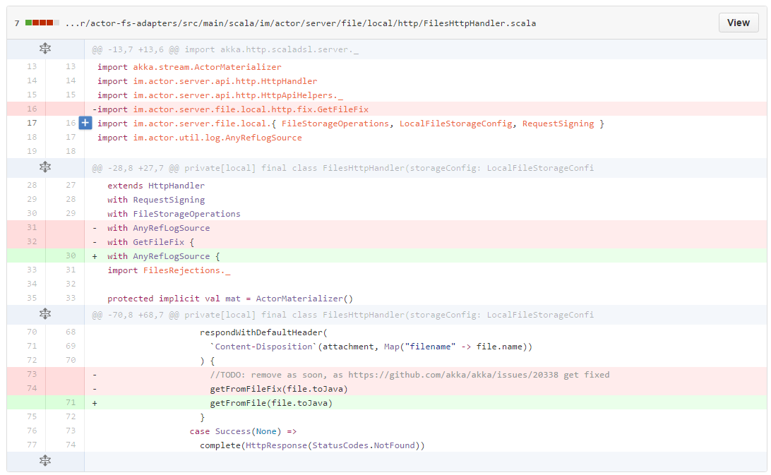

删除 actor-fs-adapters/src/main/scala/im/actor/server/file/local/http/fix/GetFileFix.scala、actor-fs-adapters/src/main/scala/im/actor/server/file/local/http/fix/RangeDirectivesFix.scala、actor-fs-adapters/src/main/scala/im/actor/server/file/local/http/fix/StreamUtilsFix.scala

<https://github.com/actorapp/actor-platform/commit/41c295ebb80981cb35b8968d36d4cfc68ab95b76>

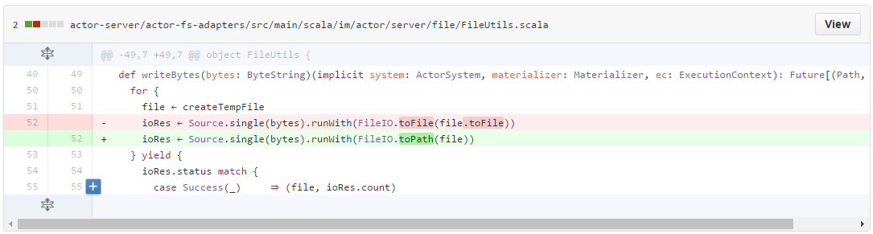

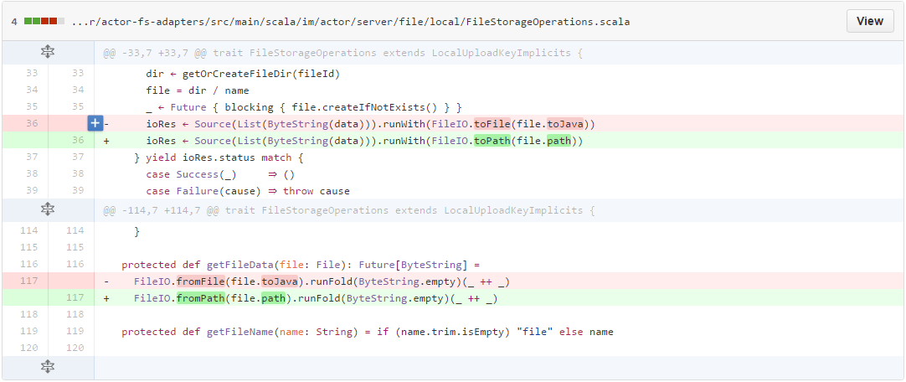

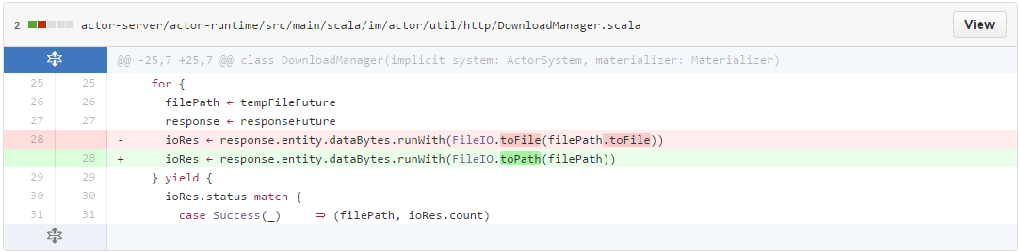

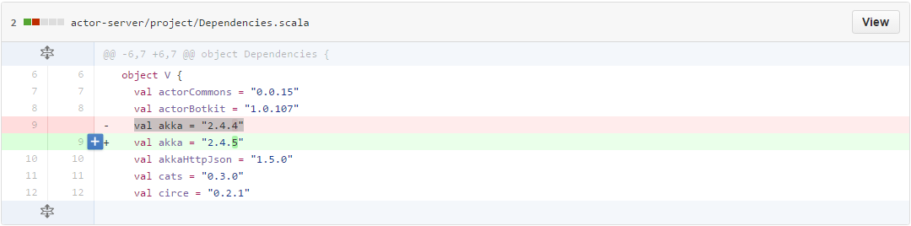

<https://github.com/actorapp/actor-platform/commit/dbe4e2b77590b5a1785a7a988a8f40fb53400a07>

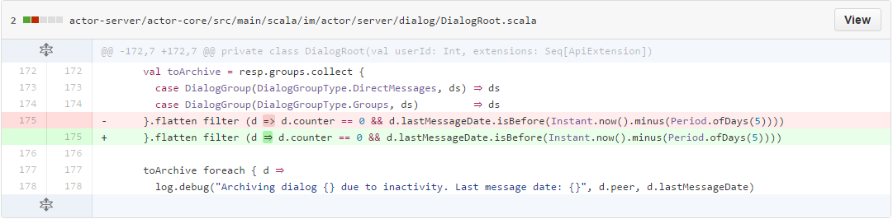

<https://github.com/actorapp/actor-platform/commit/e6518def57c4e9e30aef1df7cf5929a65074c9ce>

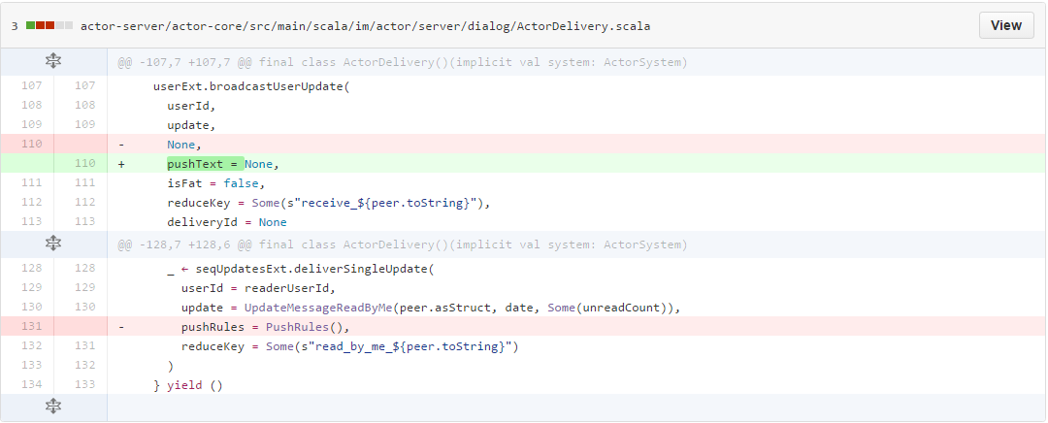

<https://github.com/actorapp/actor-platform/commit/edaa3b8cac21460208c5130fc20725d3ca0eff33>

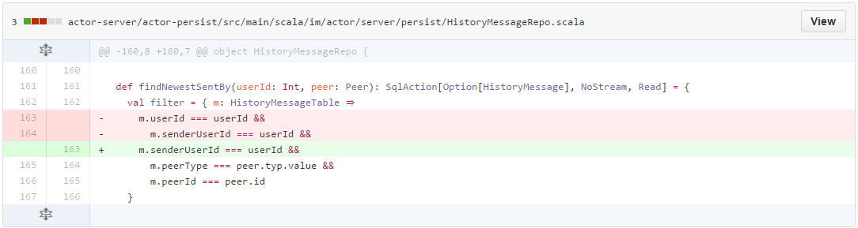

<https://github.com/actorapp/actor-platform/commit/095ce6b7109035410f752fd4a9e9e1baaf989724>

全部更改

<https://github.com/actorapp/actor-platform/commit/eb628c5870aad1f7988dd752f4f48c9ab6138394>

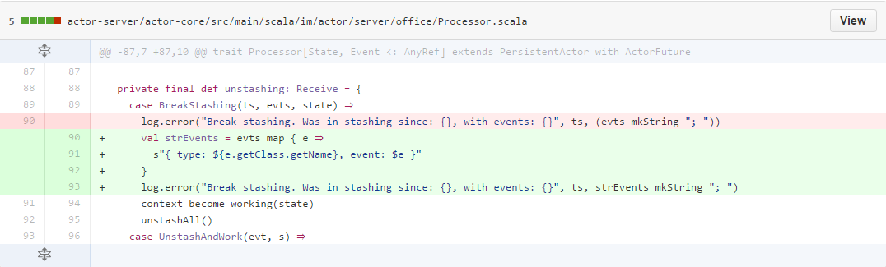

<https://github.com/actorapp/actor-platform/commit/54217e44e0c21caad5d0223c9fd15c7f4959a7d3>

除去tests的全部

<https://github.com/actorapp/actor-platform/commit/148176c4d5ebe3711dccd6182eeb51943acd262e>

除去tests的全部

<https://github.com/actorapp/actor-platform/commit/12d33b897fcfac37981f3989610fd87ac26b9993>

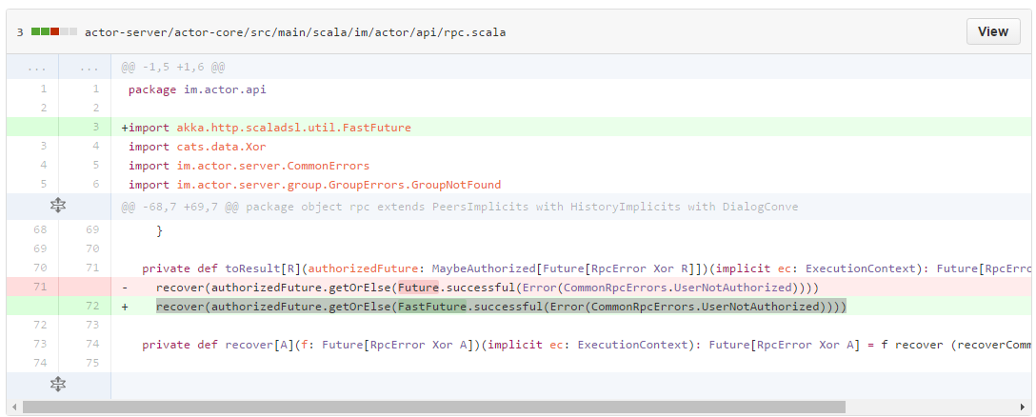

<https://github.com/actorapp/actor-platform/commit/0d31ad68533217399dac4488b62c6b35f4b00621>

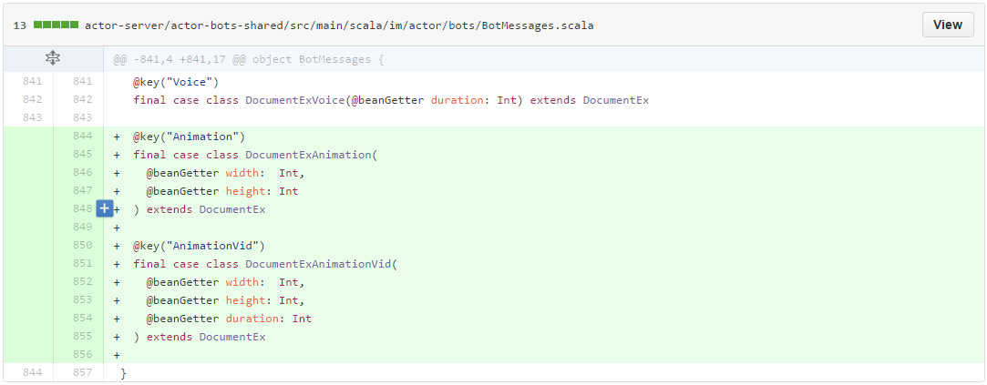

<https://github.com/actorapp/actor-platform/commit/6931b3fe1f8edb62ab3d264a402a21dab02d02b2>

全部内容

<https://github.com/actorapp/actor-platform/commit/67a6752ca044c86fdf6bc884698f30c1a6480ea0>

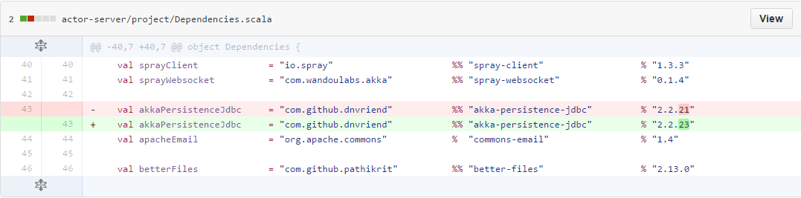

<https://github.com/actorapp/actor-platform/commit/62f7e421c3cbe3c5011da57f0a6ed48facfe9a74>

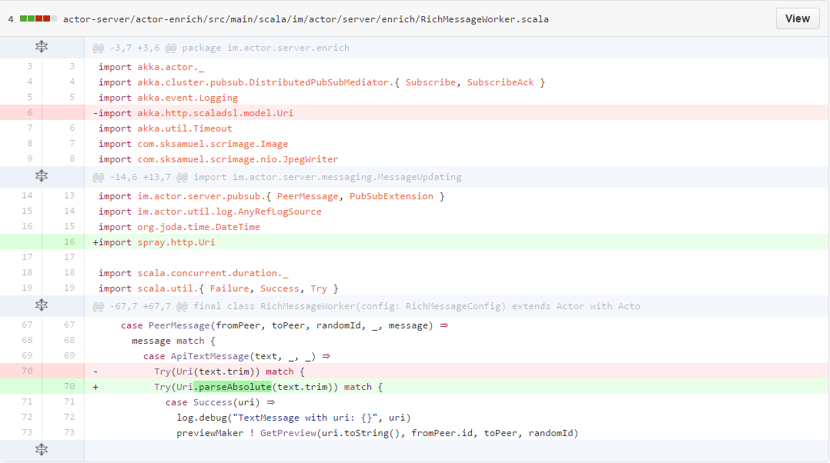

<https://github.com/actorapp/actor-platform/commit/d10fd9402c99d57a05aa257830055bb948d84999>

除去tests

<https://github.com/actorapp/actor-platform/commit/7c6924f122b7cb10696bdcb6c58f37f37a3c22dc>

除去apple push外的全部

<https://github.com/actorapp/actor-platform/commit/5218a121c2333f59d4cc59013862f9d82eab4159>

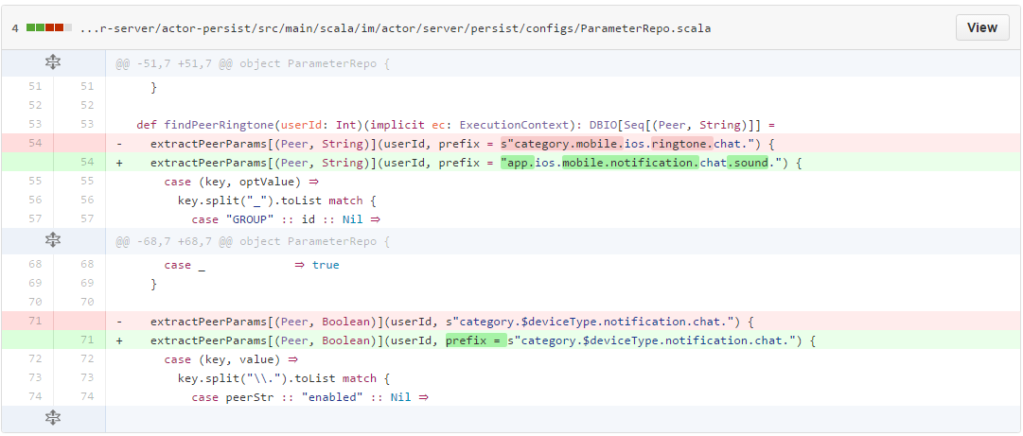

<https://github.com/actorapp/actor-platform/commit/3731bce5bdd7748902ede2728c8bb7e5b1f7ccbd>

添加1.0.153.markdown