AUTOMATION SELENIUM IDE

LAB EXERCISE

CLASSEXERCISE- 01:

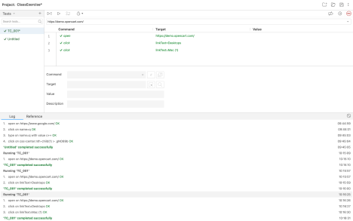

CLASSEXERCISE- 02:

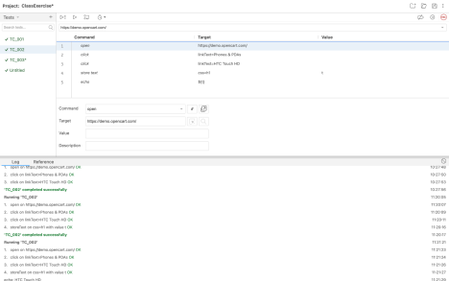

CLASSEXERCISE- 03:

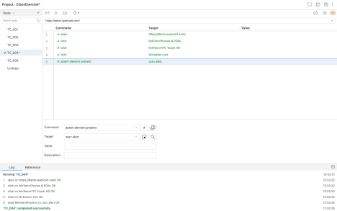

CLASSEXERCISE- 04:

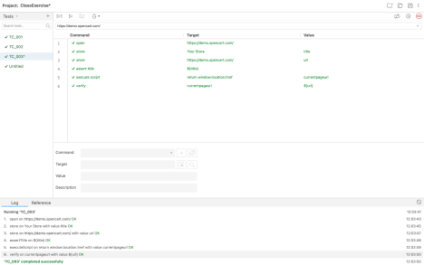

CLASSEXERCISE- 05:

