AUTOMATION SELENIUM IDE

LAB EXERCISE

Day-5

CLASSEXERCISE-1

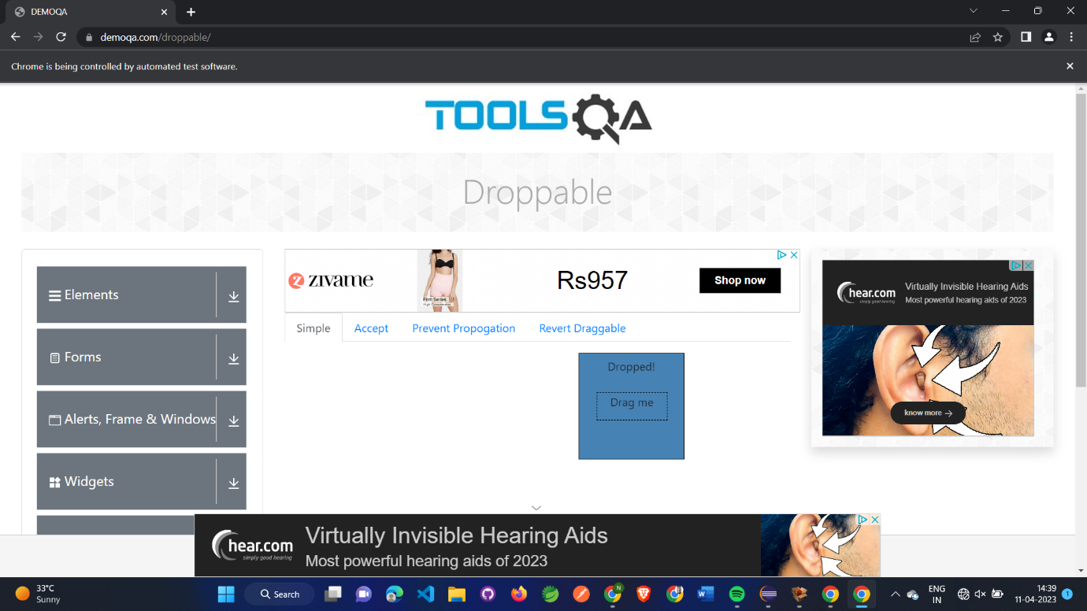

package com.Test.test;

import org.openqa.selenium.By;

import org.openqa.selenium.WebDriver;

import org.openqa.selenium.WebElement;

import org.openqa.selenium.chrome.ChromeDriver;

import org.openqa.selenium.chrome.ChromeOptions;

import org.openqa.selenium.interactions.Actions;

import io.github.bonigarcia.wdm.WebDriverManager;

public class C {

public static void main(String[] args) throws InterruptedException {

ChromeOptions co=new ChromeOptions();

co.addArguments("--remote-allow-origins=*");

WebDriverManager.*chromedriver*().setup();

WebDriver driver=new ChromeDriver(co);

driver.get("https://demoqa.com/droppable/");

driver.manage().window().maximize();

WebElement drag=driver.findElement(By.*id*("draggable"));

WebElement drop=driver.findElement(By.*id*("droppable"));

Actions a=new Actions(driver);

a.dragAndDrop(drag,drop).build().perform();

}

}

CLASSEXERCISE-2

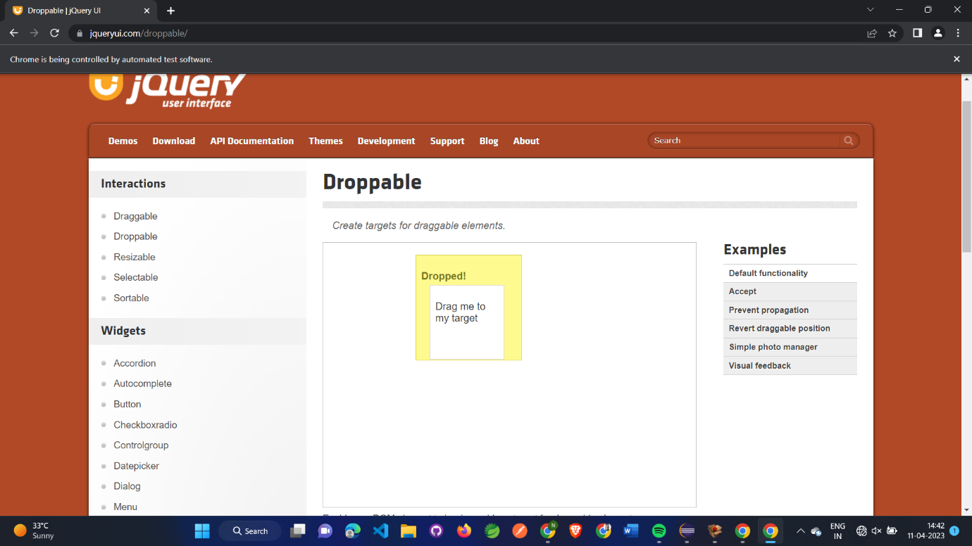

package com.Test.test;

import org.openqa.selenium.By;

import org.openqa.selenium.WebDriver;

import org.openqa.selenium.WebElement;

import org.openqa.selenium.chrome.ChromeDriver;

import org.openqa.selenium.chrome.ChromeOptions;

import org.openqa.selenium.interactions.Actions;

import io.github.bonigarcia.wdm.WebDriverManager;

public class CD52 {

public static void main(String[] args) {

ChromeOptions co=new ChromeOptions();

co.addArguments("--remote-allow-origins=*");

WebDriverManager.*chromedriver*().setup();

WebDriver driver=new ChromeDriver(co);

driver.get("https://jqueryui.com/droppable/");

driver.manage().window().maximize();

driver.switchTo().frame(0);

driver.manage().window().maximize();

WebElement drag=driver.findElement(By.*id*("draggable"));

WebElement drop =driver.findElement(By.*id*("droppable"));

Actions a=new Actions(driver);

a.dragAndDrop(drag, drop).build().perform();

}

}

CLASSEXERCISE-3

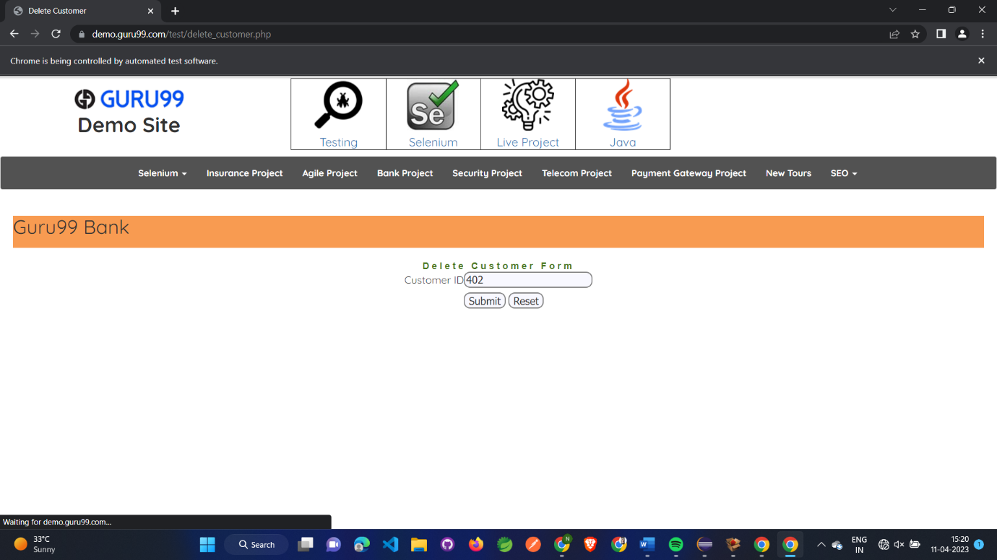

package com.Test.test;

import org.openqa.selenium.Alert;

import org.openqa.selenium.By;

import org.openqa.selenium.WebDriver;

import org.openqa.selenium.WebElement;

import org.openqa.selenium.chrome.ChromeDriver;

import org.openqa.selenium.chrome.ChromeOptions;

import io.github.bonigarcia.wdm.WebDriverManager;

public class D5E3 {

public static void main(String[] args)throws InterruptedException {

// **TODO** Auto-generated method stub

ChromeOptions co=new ChromeOptions();

co.addArguments("--remote-allow-origins=*");

WebDriverManager.*chromedriver*().setup();

WebDriver driver=new ChromeDriver(co);

driver.get("https://demo.guru99.com/test/delete_customer.php");

driver.manage().window().maximize();

WebElement txtBox1=driver.findElement(By.*xpath*("/html/body/form/table/tbody/tr[2]/td[2]/input"));

txtBox1.sendKeys("401");

WebElement submitBtn=driver.findElement(By.*name*("submit"));

submitBtn.click();

Alert alert1=driver.switchTo().alert();

Thread.*sleep*(3000);

alert1.dismiss();

txtBox1.clear();

txtBox1.sendKeys("402");

submitBtn.click();

Alert alert2=driver.switchTo().alert();

alert2.accept();

Alert alert3=driver.switchTo().alert();

String txt=alert3.getText();

alert3.accept();

System.***out***.println(txt);

}

}

CLASSEXERCISE-4

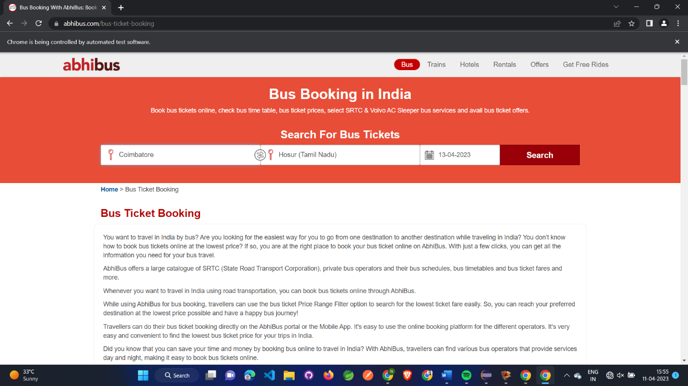

package com.Test.test;

import org.openqa.selenium.By;

import org.openqa.selenium.WebDriver;

import org.openqa.selenium.chrome.ChromeDriver;

import org.openqa.selenium.chrome.ChromeOptions;

import io.github.bonigarcia.wdm.WebDriverManager;

public class Day5 {

public static void main(String args[]) {

ChromeOptions co=new ChromeOptions();

co.addArguments("--remote-allow-origins=*");

WebDriverManager.*chromedriver*().setup();

WebDriver driver=new ChromeDriver(co);

driver.get("https://www.abhibus.com/bus-ticket-booking");

driver.manage().window().maximize();

driver.findElement(By.*xpath*("//*[@id=\"datepicker1\"]")).click();

driver.findElement(By.*xpath*("//*[@id=\"ui-datepicker-div\"]/div[1]/table/tbody/tr[3]/td[7]/a")).click();

driver.findElement(By.*xpath*("//*[@id=\"source\"]")).sendKeys("Coimbatore");

driver.findElement(By.*xpath*("//*[@id=\"destination\"]")).sendKeys("Chennai");

}

}

CLASSEXERCISE-5

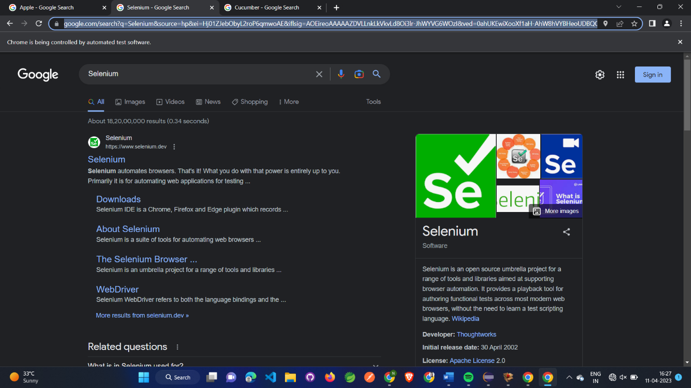

package com.Test.test;

import org.openqa.selenium.By;

import org.openqa.selenium.Keys;

import org.openqa.selenium.WebDriver;

import org.openqa.selenium.WindowType;

import org.openqa.selenium.chrome.ChromeDriver;

import org.openqa.selenium.chrome.ChromeOptions;

import io.github.bonigarcia.wdm.WebDriverManager;

public class D5E4 {

public static void main(String[] args) {

// **TODO** Auto-generated method stub

ChromeOptions co=new ChromeOptions();

co.addArguments("--remote-allow-origins=*");

WebDriverManager.*chromedriver*().setup();

WebDriver driver=new ChromeDriver(co);

driver.get("https://www.google.com");

driver.manage().window().maximize();

driver.findElement(By.*name*("q")).sendKeys("Apple");

driver.findElement(By.*name*("q")).sendKeys(*Keys*.***ENTER***);

System.***out***.println(driver.getWindowHandle());

System.***out***.println(driver.getTitle());

driver.switchTo().newWindow(*WindowType*.***TAB***);

driver.get("https://www.google.com");

driver.manage().window().maximize();

driver.findElement(By.*name*("q")).sendKeys("Selenium");

driver.findElement(By.*name*("q")).sendKeys(*Keys*.***ENTER***);

System.***out***.println(driver.getWindowHandle());

System.***out***.println(driver.getTitle());

driver.switchTo().newWindow(*WindowType*.***TAB***);

driver.get("https://www.google.com");

driver.manage().window().maximize();

driver.findElement(By.*name*("q")).sendKeys("Cucumber");

driver.findElement(By.*name*("q")).sendKeys(*Keys*.***ENTER***);

System.***out***.println(driver.getWindowHandle());

System.***out***.println(driver.getTitle());

}

}