CA1

NAME : S.NISHANI

REG NO : 727722EUIT513

DEPT : B.TECH.IT

QUESTION NO : 1

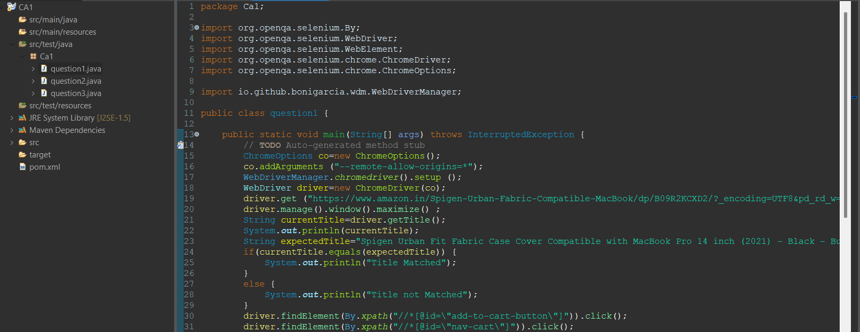

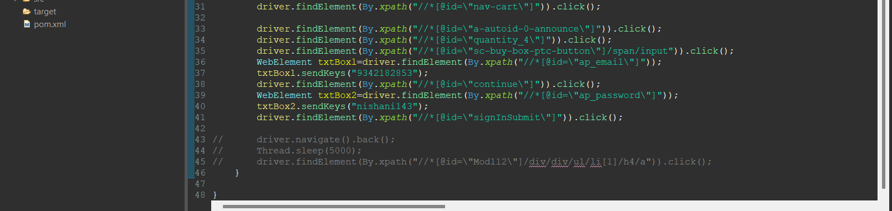

OUTPUT:

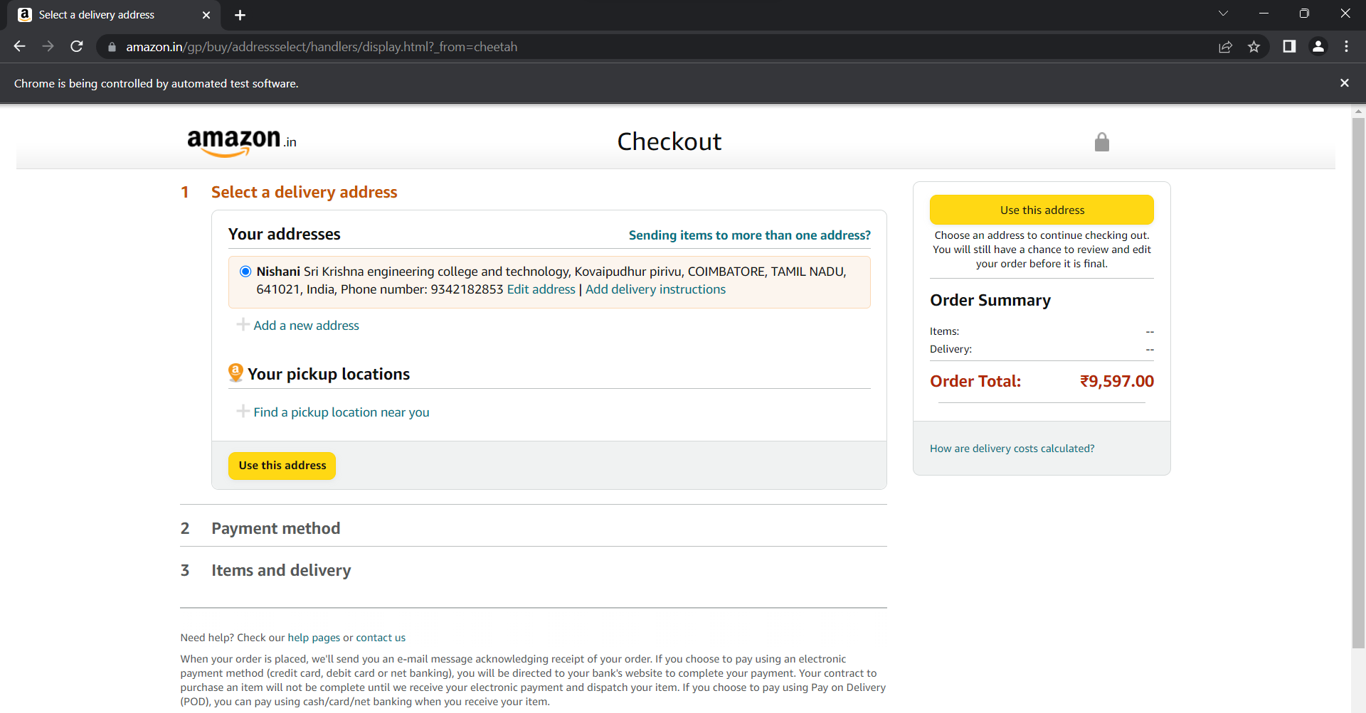

QUESTION NO : 2

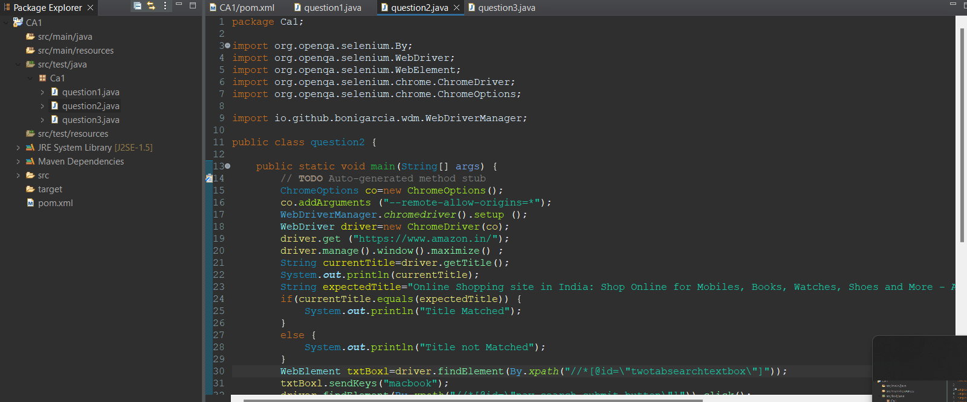

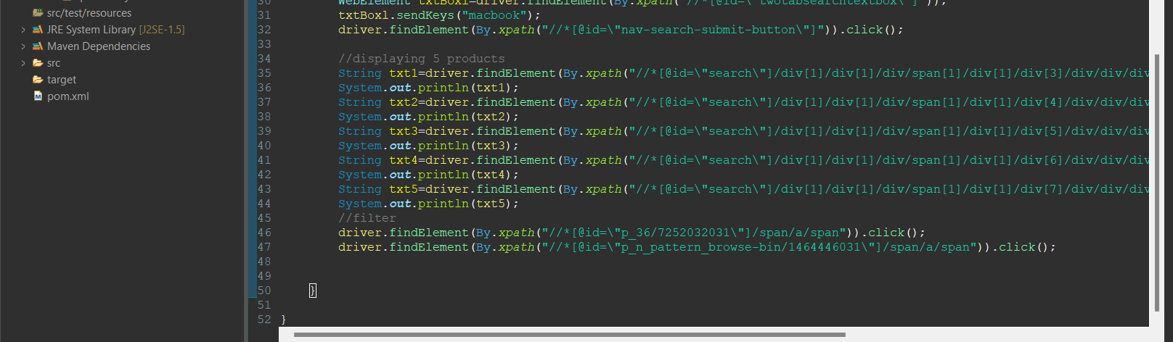

OUTPUT:

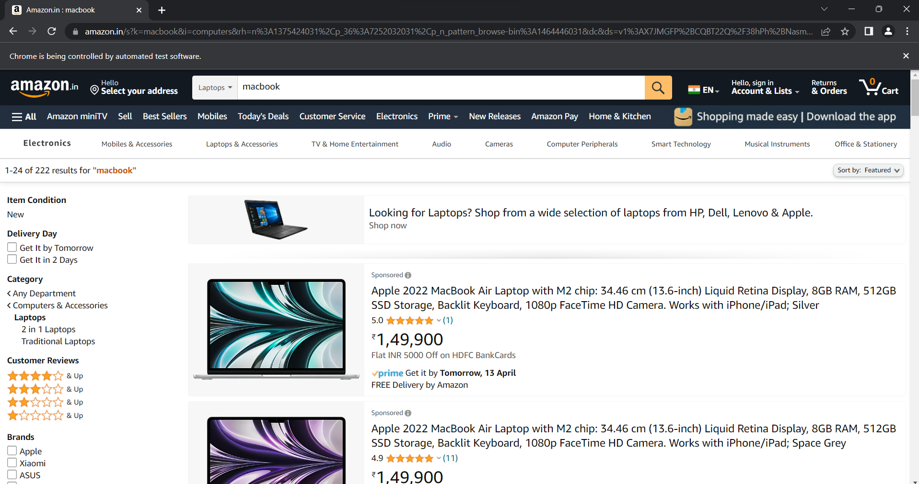

QUESTION NO : 3

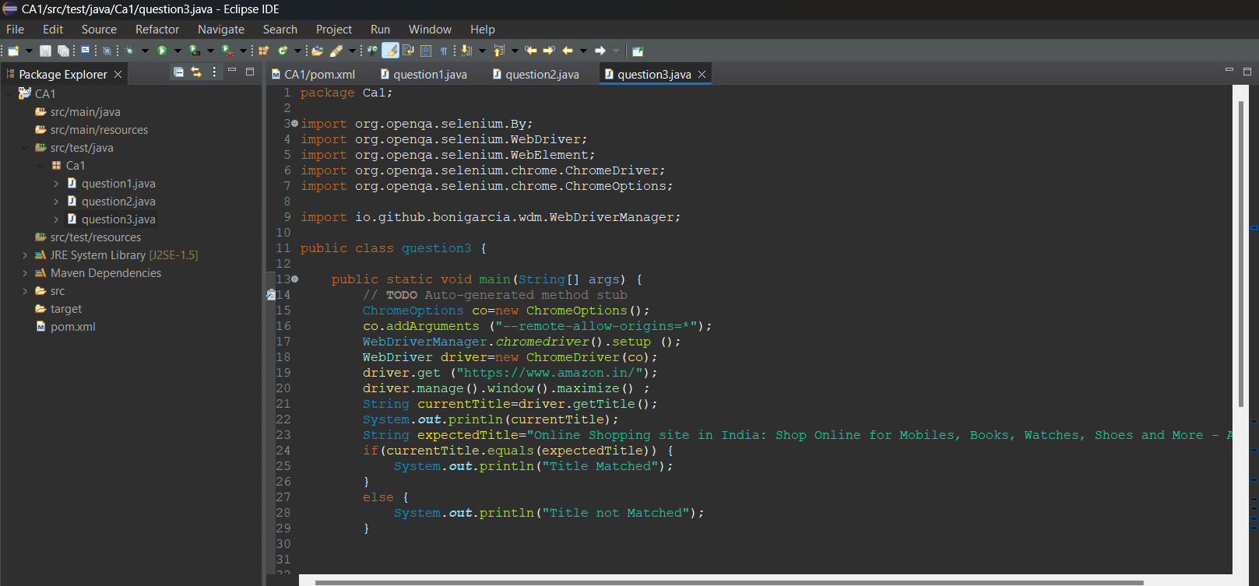

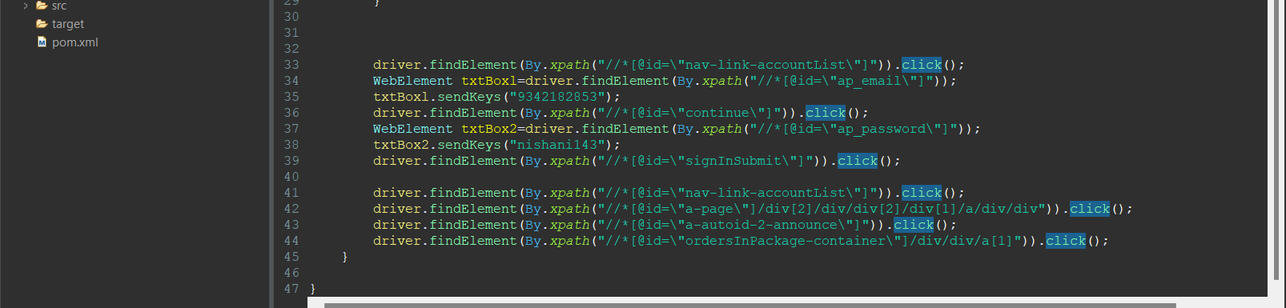

OUTPUT:

