**SOFTWARE REQUIREMENTS SPECIFICATIONS**

**Project Title:**  Online Donation System

**PROBLEM STATEMENT:**

In today’s digital world, charitable organizations and social causes need a streamlined and secure way to collect donations from a broad range of donors. Traditional donation systems often rely on manual processes, limited payment options, and lack transparency and donor engagement features. This creates inefficiencies in fundraising and discourages repeat contributions.

There is a need for a web-based Online Donation System that:

* Enables individuals to contribute quickly and securely to various campaigns.
* Offers modern features like recurring donations, anonymous giving, and progress tracking.
* Provides a robust backend for campaign management and reporting.

This system will bridge the gap between donors and organizations by making fundraising more accessible, transparent, and automated.

**1.Introduction:**

**1.1 Purpose:**

The purpose of this document is to define the software requirements for the Online Donation System. This document will serve as a guideline for the design, development, testing, and maintenance of the system. It is intended for developers, testers, project managers, and stakeholders.

**1.2 Scope:**

The Online Donation System is a web-based platform that enables users to donate to various charitable causes online. It includes functionalities for donor registration, campaign browsing, secure payment processing, recurring donations, and anonymous donations. Admin users can create and manage campaigns and view reports on donations.

**1.3 Definitions and Abbreviations:**

1. Donor – A person who makes a financial contribution.

2. Admin – An authorized user who manages campaigns and system settings.

3. Campaign – A fundraising event for a specific cause.

4. Recurring Donation – A donation that is automatically repeated over regular intervals (e.g., monthly).

5. Anonymous Donation – A donation made without revealing the identity of the donor.

**2.Functional Requirement:**

* The system shall allow users to register and log in.
* The system shall allow users to view a list of all active donation campaigns.
* The system shall allow users to view campaign details, including goal and current amount raised.
* The system shall allow users to make one-time donations via a secure payment gateway.
* The system shall allow users to set up recurring donations (e.g., monthly).
* The system shall allow users to donate anonymously.
* The system shall send email confirmations/receipts after a successful donation.
* The system shall allow administrators to create, edit, and delete donation campaigns.
* The system shall allow admins to generate reports and view analytics on donations.
* The system shall allow users to view their donation history.

**3.Non-Functional Requirement:**

1. The system must ensure 99.9% uptime.

2. All user data and payment information must be encrypted using HTTPS (SSL).

3. The response time for all user actions must not exceed 2 seconds.

4. The system must be accessible from mobile, tablet, and desktop devices (responsive design).

5. Passwords must be stored using industry-standard hashing (e.g., bcrypt).

6. The system should scale to handle at least 500 concurrent users.

7. Backup of data must be performed automatically every 24 hours.

8. The system must comply with relevant privacy and data protection laws.

**3. Overall Description:**

**3.1 Product Perspective:**

This product is a standalone web-based system that interacts with a payment gateway (e.g., Razorpay, Stripe) and a database system (e.g., MySQL). It does not depend on other systems but can be extended with APIs or integrations in the future.

**3.2 Product Function:**

The system will:

* Allow users to register and log in.
* Display active donation campaigns.
* Accept one-time and recurring donations.
* Provide an option for anonymous donations.
* Enable admins to manage campaigns.
* Send email confirmations and receipts.
* Provide analytics and reports to admins.

**4.Use Case Diagram:**

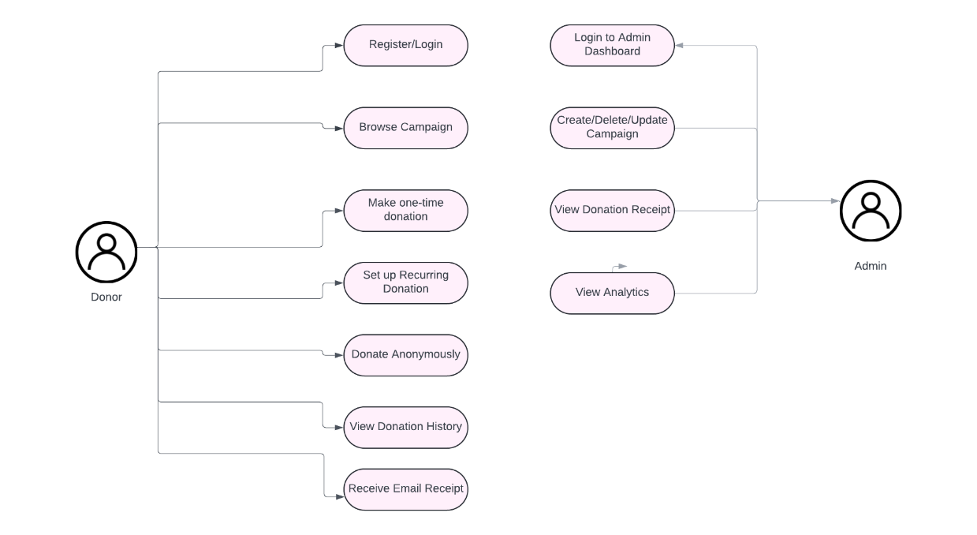

**5. E-R Model Diagram**

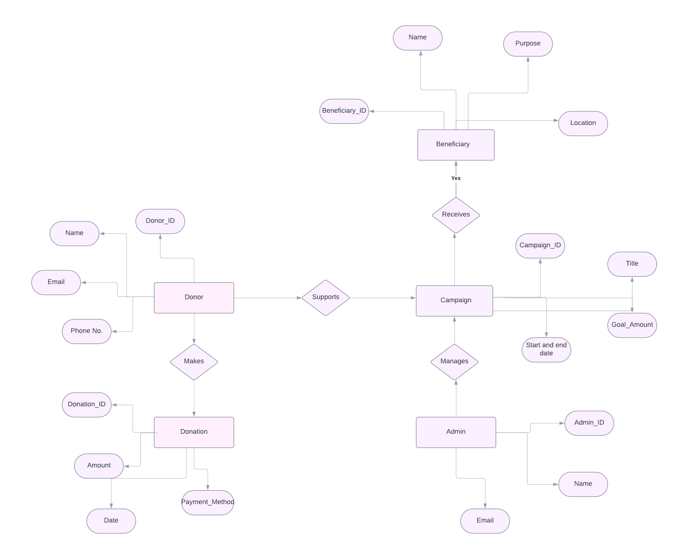

**6. System Overview:**

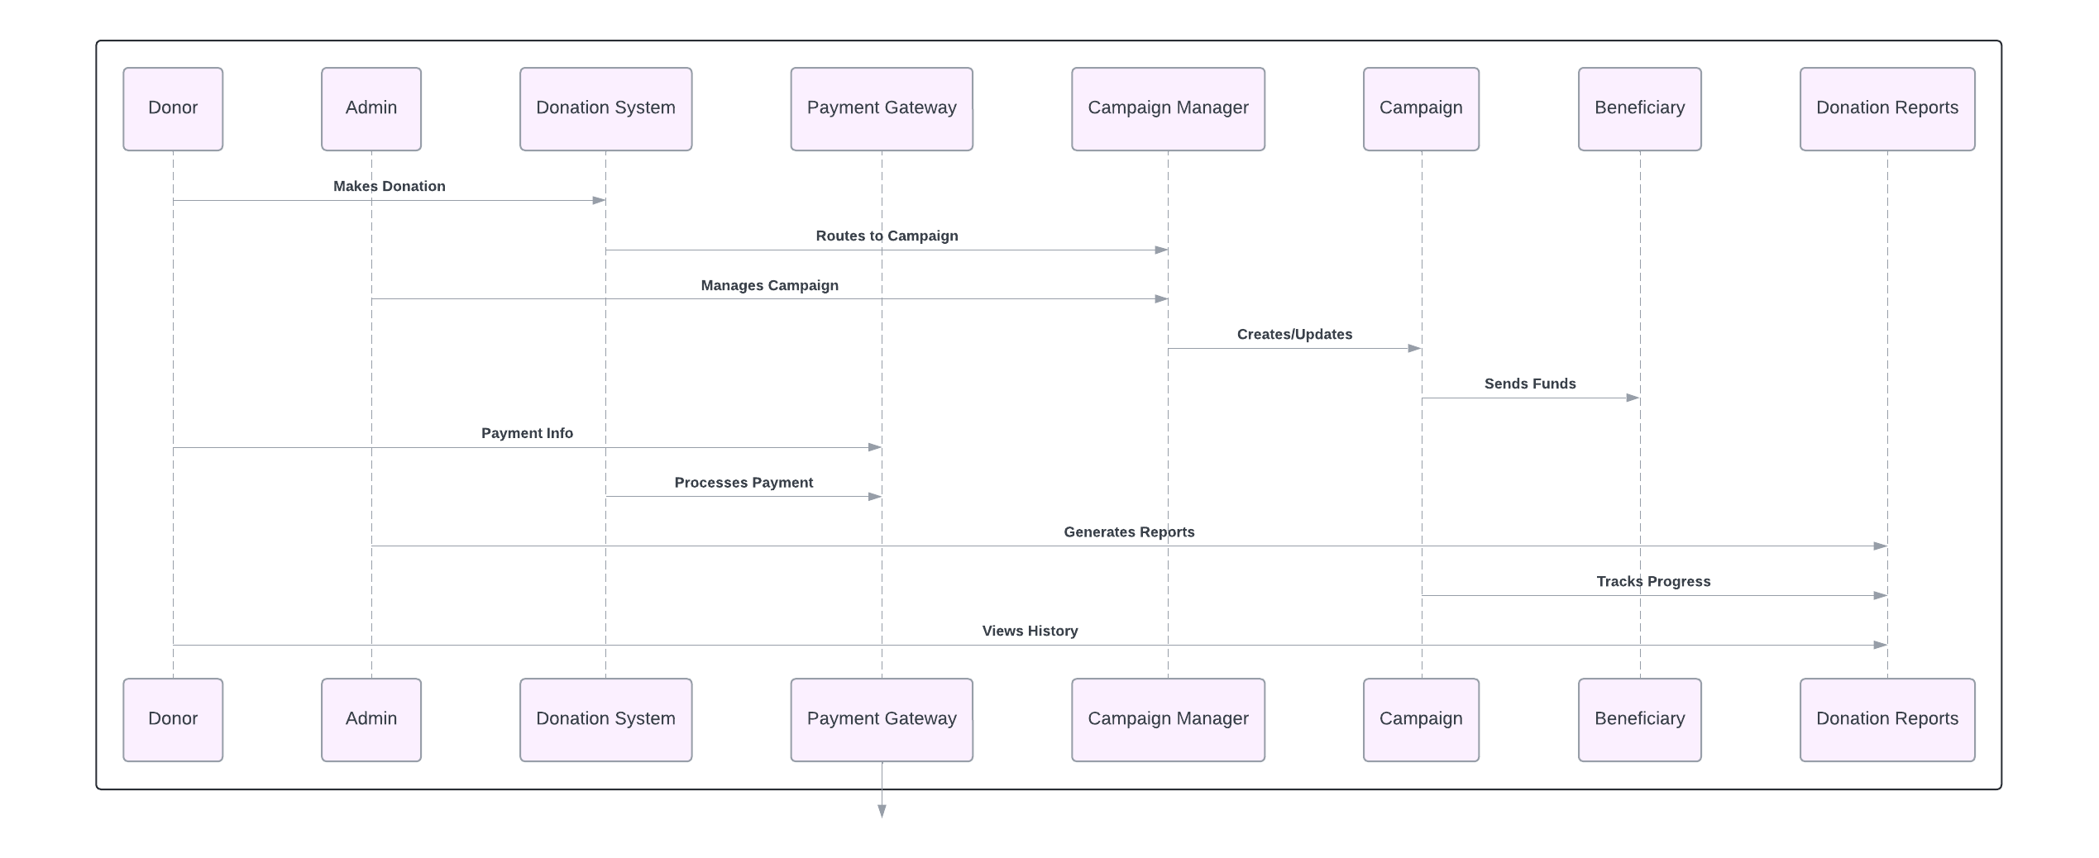

**7.Conclusion:**

The Online Donation System is designed to streamline the process of charitable giving by providing a secure, transparent, and user-friendly platform for donors, campaign managers, and beneficiaries. Through its modular architecture and well-defined components, the system ensures scalability, maintainability, and ease of integration with third-party services like payment gateways.