Rusted PackFile Manager

By *Ismael Gutiérrez González*, A.K.A “***Frodo45127”***

Version 1.0, available here: <https://github.com/Frodo45127/rpfm>

# Introduction

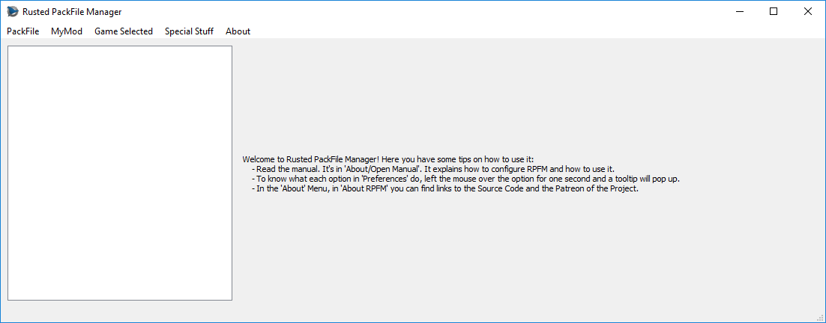

This is ***Rusted PackFile Manager***, or ***RPFM***, a modding tool for modern Total War Games. If you've used PFM before, you can see it has a similar UI. It's done that way to make it easier to use for modders coming from PFM. We are going to do the initial configuration first, and then we are going to take a look at the different features RPFM has to offer.

Remember that, since version 1.0, this manual should always be in RPFM’s folder, or accessible from “***About/Open Manual***” in RPFM’s Menu Bar, in case you want to check it later.

# Initial Configuration

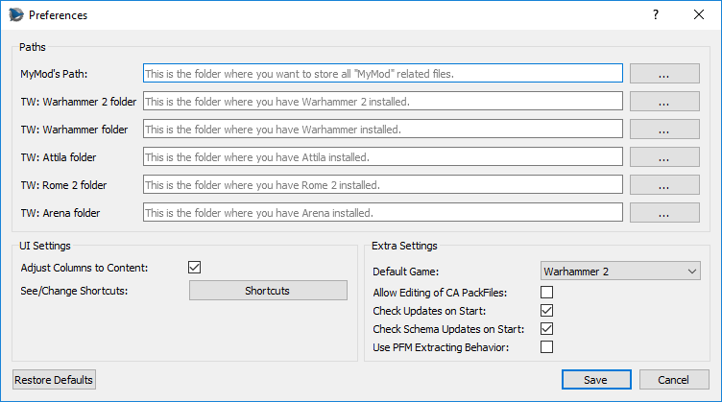

After the first start, we need to go to ***“PackFile/Preferences”***, and configure the stuff we want. First, the ***“MyMod”*** Path. This is the path where ***"MyMods"*** and their data will be stored. We'll see later in the tutorial what this *"MyMods"* thing is. For this tutorial, we'll pick an empty folder. Then, the games paths. These are the folders where each game is installed. We'll fill the ones for the games we have installed.

In the end, it should look something like this: 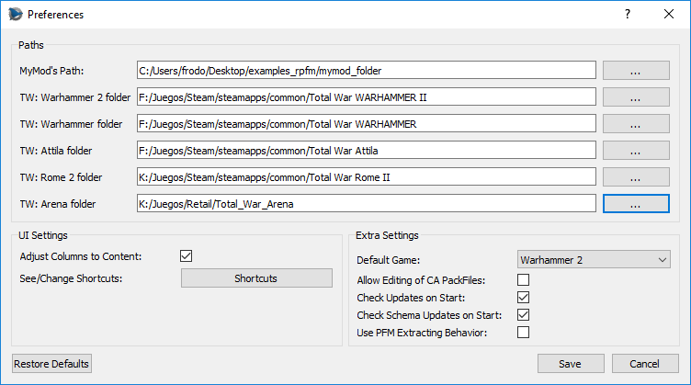

Now we choose our “***Default Game***”. RPFM uses a ***"Game Selected"*** setting to configure certain parts of the program to work with a game or another. For example, it changes the way the mods are saved, the default folder to save them, the schema used for the tables,.... Here you can set the game that'll be selected by default when you open the program. We'll leave it in ***“Warhammer 2”*** for this tutorial.

Next, all these checkboxes. You can get an explanation about what they do just by hovering them with the mouse, like this.

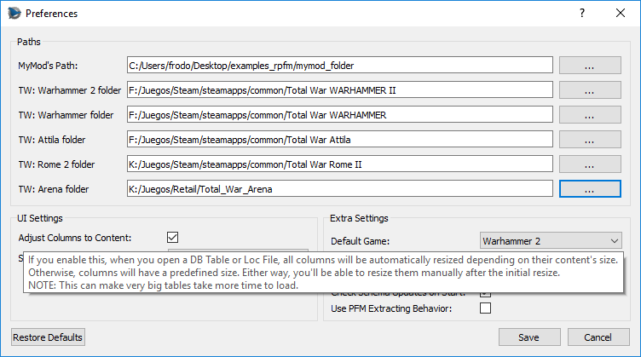

And finally, the “***Shortcuts***” button. Hitting it will open the “***Shortcuts***” window, were you can see and edit all the shortcuts currently used by RPFM.

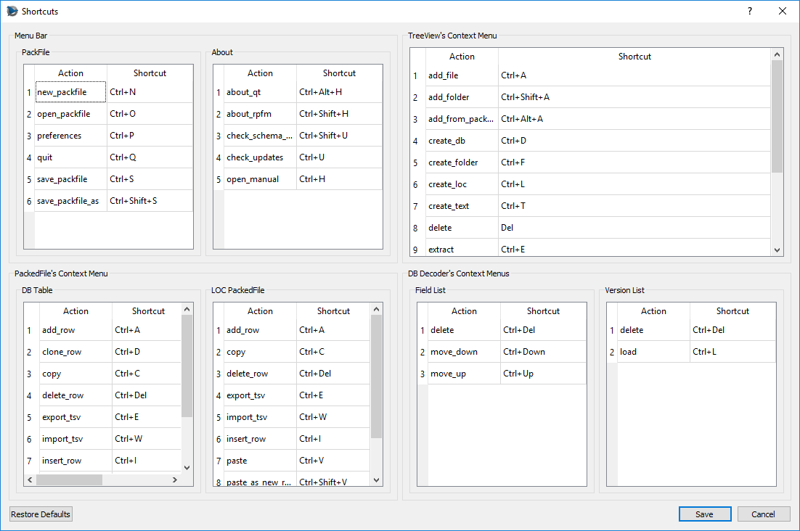

Just keep in mind that some of **the shortcuts are applied when the program starts**, so you’ll have to close and re-open RPFM for the changes to take effect.

When you're done with the settings, just hit "***Save***". You can restore them to the defaults with the button of the left (same for the shortcuts with their “***Restore Defaults***” button).

With that, we have completed the initial configuration. Starting on version 1.0, new updates should continue to work with the same settings/shortcuts, updating them automatically in case a new setting/shortcut is introduced, storing the saved configurations in the files “***settings.json***” and “***shortcuts.json***”, in RPFM’s folder.

So now that we’re done configuring RPFM, let's take a look at the features it has to offer.

# Menu Bar Features

Any action in the Menu Bar has a little tip that'll show up in the Status Bar when selecting it, just in case you want to know what them do. So, we are going to explain here the…. Not very common features, menu by menu.

## PackFile Menu

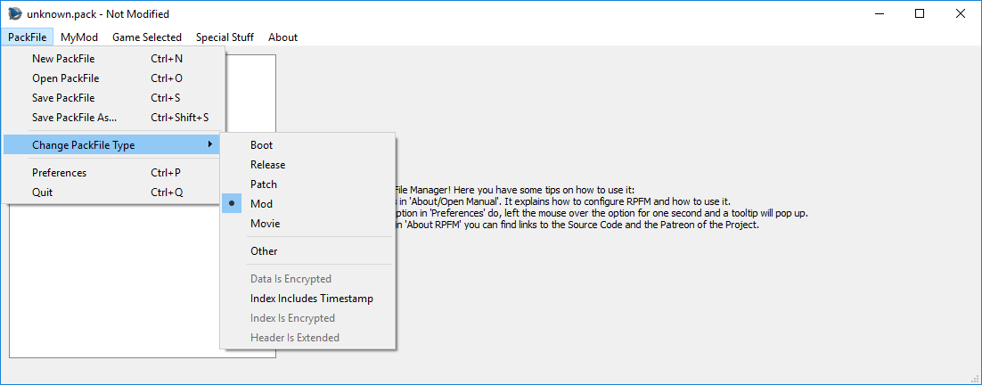

Here, we can find the "Basic" actions: ***New***, ***Open***, ***Save***, ***Save*** ***As***, ***Preferences*** and ***Quit***. Then we have "***Change PackFile Type***", where you can select the type of the currently open PackFile, and see some special configurations some PackFiles have, like if certain parts of the PackFile are encrypted.

For the types, for modding you’ll only want to use the “***Mod***” type, and maybe, in very specific situations, the “***Movie***” type. “***Boot***”, “***Release***”, and “***Patch***” are types used by CA PackFiles, not suitable for modding. “***Other***” is for weird or special PackFiles. Do not use it.

Something to remember is that, by default, RPFM doesn’t let you save a PackFile if it’s “***Boot***”, “***Release***” or “***Patch***”. If you still want to do it, enable the “Allow Editing of CA PackFiles” setting. “***Other***” PackFiles and PackFiles with “***Data Is Encrypted***”, “***Index Is Encrypted***” or “***Header Is Extended***” cannot be saved in any way.

## MyMod’s Menu

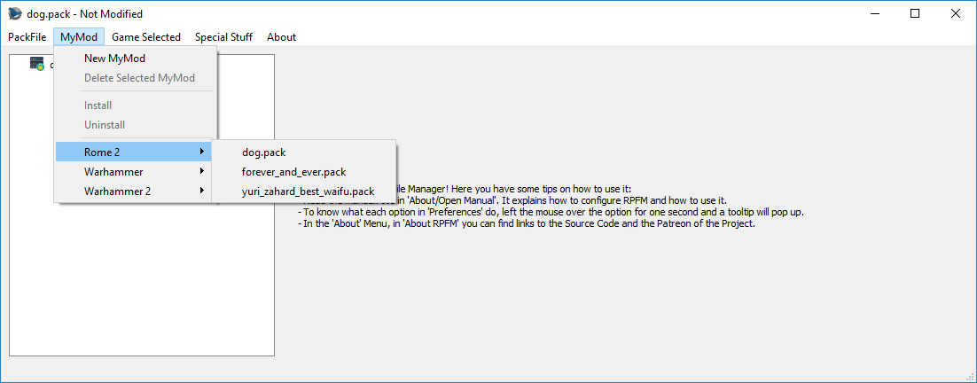

***MyMods*** are a way to keep data organized when creating a mod. The system is almost a 1:1 clone of PFM's MyMods and don’t want to explain it again, so check this link for the original PFM’s explanation: <http://www.twcenter.net/forums/showthread.php?536546-The-PFM-2-1-s-MyMod-Feature&styleid=43>

The only differences are:

* When deleting a MyMod, his files are also deleted.
* It'll enable itself when you open a "***MyMod***" mod, and disable itself when you open another mod.

## Game Selected Menu

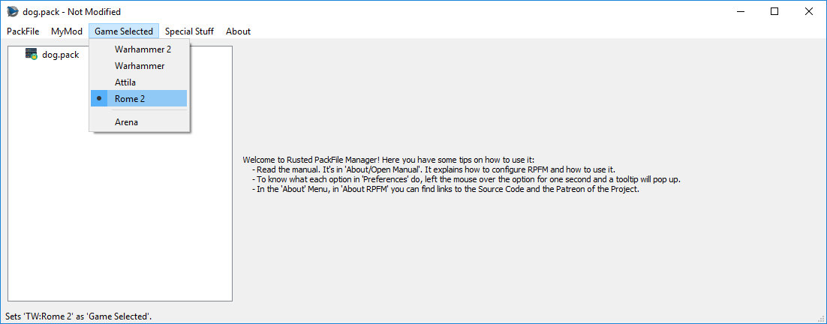

This is where you choose the “***Game Selected***” we talked before. When opening PackFiles, RPFM tries to be smart and auto-select a game, but there are some PackFiles that are the same between games (for example, Attila and Warhammer 1 PackFiles are identical), so... just make sure the right game is selected after opening a PackFile, as that affects how many parts of the program work. Also, ***Arena support is READ-ONLY***. You can’t save Arena PackFiles.

## Special Stuff Menu

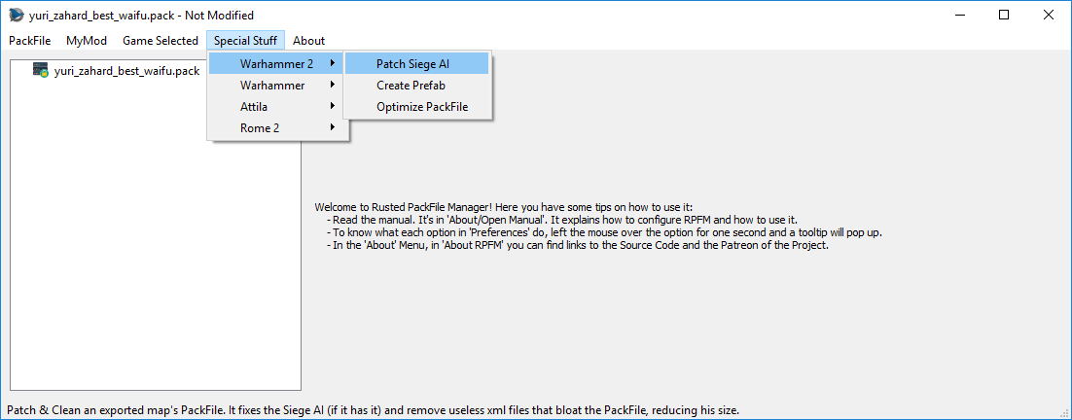This has special features implemented for specific games. Here we have "***Patch SiegeAI***", used in Warhammer 1&2 for creating siege maps that the AI can handle. Then we have “***Create Prefab***”, that you can forget for now, because despite Zoidberg’s best efforts to make me finish it, it doesn't work yet.

And finally, we have “***Optimize PackFile***”, that reduces the size of your PackFile by “*cleaning*” your tables from data that’s the same as the one present in the game. For example, if you have a table where all rows but one are exactly the same as the ones in vanilla tables and another table that’s a 1:1 copy of a vanilla table without changes, RPFM remove all the rows but the one you changed from the first table, and it’ll remove the second table. This is meant to ***improve compatibility with other mods***, and to reduce the size of the PackFile.

This optimization is going to be expanded in the future to Loc PackedFiles and other “useless” files, but for now it only affects DB Tables.

## About Menu

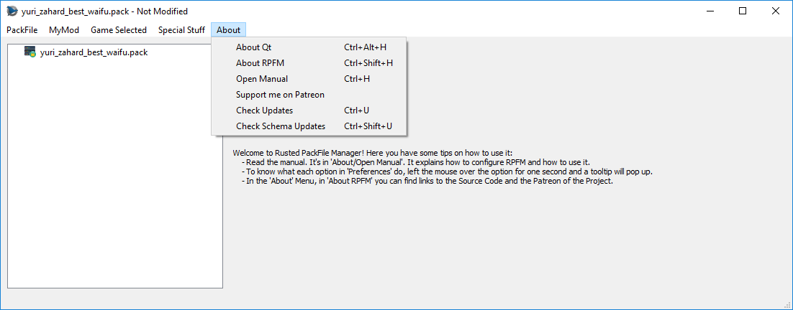

Here you can find info “***About*** ***Qt***” (the UI toolkit use to make RPFM), “***About*** ***RPFM***”, a button to open this manual in an PDF Reader, a link to RPFM's Patreon that I'm using for important releases, and as a kind of dev blog, and the updaters. The “***Check Updates***” checks if there is any update available for RPFM, and it gives you a link to download it if it finds one. And “***Check Schema Updates***” checks for schema updates and downloads and applies them if you wish. The “***Schema***” is what tells RPFM how to decode the tables of the game. It's very common that after an update a few tables change his structure and are no longer decodables. To get them to work again, the schema has to be updated.

And that's all for the Menu Bar. Now we'll take a look at the TreeView. The TreeView is where all the files inside the PackFile will show up.

# PackFile’s TreeView

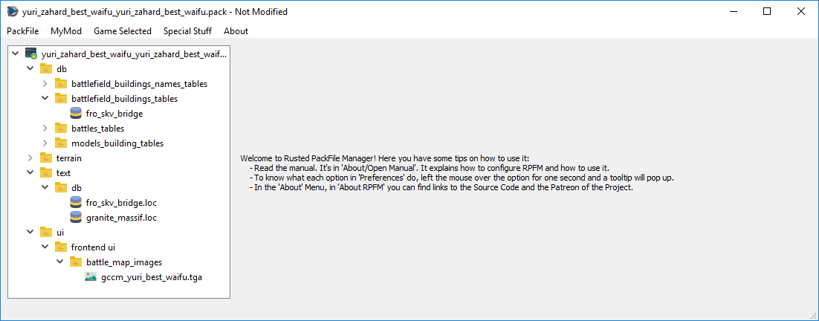

That thing on the left with folders and stuff is the “***TreeView***”. When you Right-Click on any of that stuff, it shows this context menu:

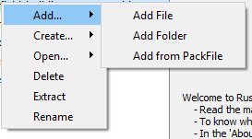

These are the actions we can use to alter the PackFile. Each one of them has a hotkey, in case you’re a lazy bastard. These are all the actions in the menu:

* ***Add…/Add File:*** Allows you to add one or more files to the PackFile.
* ***Add…/Add Folder:*** Allows you to add a folder to the PackFile.
* ***Add…/Add from PackFile:*** Allows you to add files or folders from another PackFile. Just, select whatever you want to add, double click it and it’ll be added to your PackFile, keeping his path.
* ***Create…/Create Folder:*** Allows you to create an empty folder. Due to how PackFiles work empty folders are not saved so, if you want to keep the folder, add a file to it.
* ***Create …/Create Loc:*** Allows you to create an empty Loc PackedFile.
* ***Create …/Create DB:*** Allows you to create an empty DB Table.
* ***Create …/Create Text:*** Allows you to create an empty text file.
* ***Create …/Mass-Import TSV:*** Allows you to import a bunch of TSV files at once. The system is able to distinguish between DB and Loc TSV files, so you can import all of them at the same time, and RPFM will create all the files needed, in their correct place.
* ***Create …/Mass-Export TSV:*** Allows you to export as TSV every DB Table and Loc PackedFiles inside your PackFile at once.
* ***Open …/Open with Decoder:*** Allows you to open a table in the DB Decoder. Only used to decode new tables, so…. You shouldn’t touch this.
* ***Delete:*** Allows you to delete whatever is selected. If the PackFile is selected, it removes every file from it.
* ***Extract:*** Allows you to extract whatever is selected out of the PackFile.
* ***Rename:*** Allows you to rename whatever is selected, except the PackFile.

Keep in mind that the availability of these actions depends on what is selected, and on the currently loaded schemas and Dependency PackFile. For example, you can’t add anything if you have selected a PackedFile. Also, keep in mind that if there is a “*MyMod*” loaded, some of these actions may work different.

Also, when you add/modify a file, it changes in the TreeView with the following colour code:

* ***Green***: added file.
* ***Yellow***: modified file.
* ***Magenta***: added AND modified file.

This colour code is applied to the parents too, up to the PackFile, so you easily know what you changed since the last time you saved the PackFile.

# PackedFile’s Views

Now, time to see the views of each PackedFile’s Type RPFM can open.

## DB PackedFiles

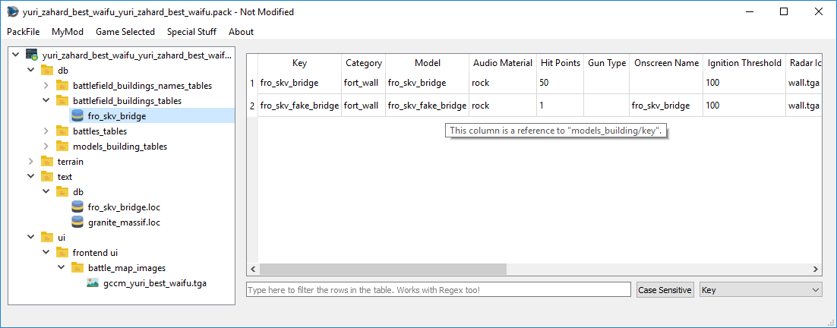

These are encoded tables with most of the “*data*” of the games. This is how a DB Table shows up in RPFM. First, if you hover over any column that references another table, or has a “*description*” in the schema, you can see in the tooltip to what that column references.

In the bottom of the window you have a ***real-time filter***. Select the column you want to use to filter, if you want it to filter as “*Case Sensitive*”, and just write and see how the table gets filtered as you type. It works with Regex too. For example, the following will only show up the rows that contain in their “*Key*” column “***v_b***” or “***fake***”:



Here you have a “Regex Cheatsheet” in case you want to use more complex filters: <https://www.cheatography.com/davechild/cheat-sheets/regular-expressions/>

Now, with the Right-Click Menu:

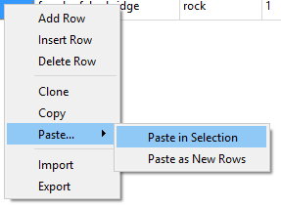

These are all the actions available for tables:

* ***Add Row:*** Appends an empty row at the end of the table.
* ***Insert Row:*** Insert an empty row after every row with a selected cell.
* ***Delete Row:*** Uses the computational power of your GPU to mine cryptocurrencies. Joking, it deletes any row with a selected cell.
* ***Clone:*** Creates a duplicate of every row with a selected cell and inserts the duplicate just below the original row.
* ***Copy:*** It copies whatever is selected to the Clipboard, in a format compatible with Excel, LibreOffice Calc and others.
* ***Paste…/Paste in Selection:*** It tries to paste whatever is in the Clipboard to the selected cells. It does nothing if there are no selected cells, or the clipboard’s contents cannot be pasted into the selected cells without errors. This works by pasting until it ran out of selected cells, or contents to paste.
* ***Paste…/Paste as New Rows:*** It tries to paste whatever is in the Clipboard as new rows, appended at the end of the table. It doesn’t do anything if the contents of the Clipboard cannot be pasted without errors. In case the contents could be pasted as a “Partial” row, it creates an empty row, and paste what it can paste, leaving the rest of the row empty.
* ***Import:*** Allows you to import TSV files to the table, overwriting whatever the table currently has. ***IT’S NOT COMPATIBLE WITH PFM TSV FILES***.
* ***Export:*** Allows you to export the table as a TSV File, compatible with Excel, Calc….

Tables uses the same colour code for cells and rows as the TreeView. And that’s more or less what you can do with a DB Table.

Apart of these, the “***Del***” key in DB Tables and PackedFiles acts as an “***Smart Delete***” key. This means depending on what you have selected when you press “Delete” it’ll delete:

* **If you have selected random** cells, it’ll delete their contents.
* **If you have selected a full row**, it’ll remove the row from the table.
* **If you have a combination of both**, it’ll delete rows where all cells are selected, and it’ll delete the contents of the cells where not all cells in a row are selected. Fancy.

## LOC PackedFiles

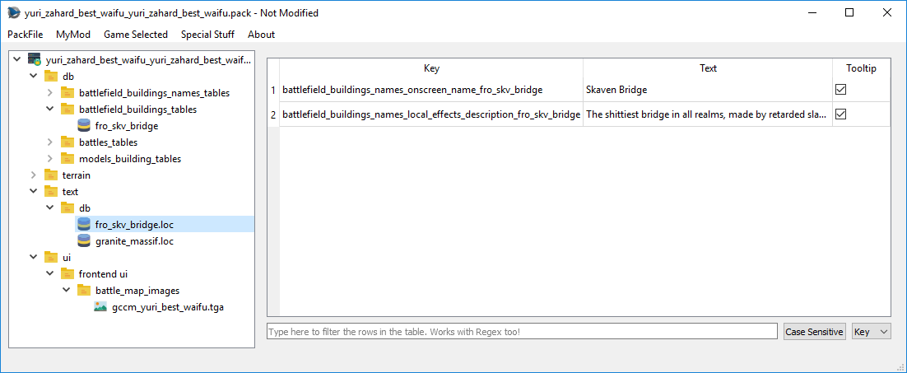

Loc PackedFiles are files that end in ***“.loc”,*** and contain most of the texts you see ingame. When you open them, you can see they work like a… minimal DB Table. The only real differences with tables is that it doesn’t have a “***Clone***” action. Other than that, it’s just a little table. Loc PackedFiles uses the same colour code for cells and rows as the TreeView.

## Text PackedFiles

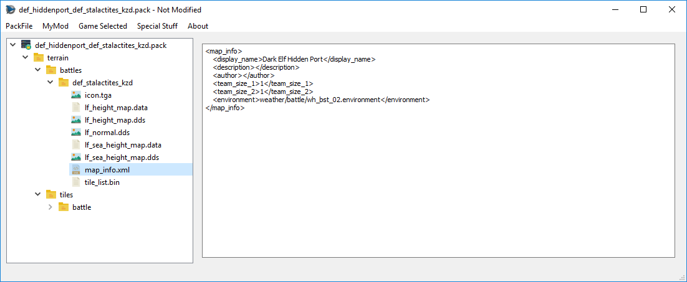

RPFM can open and edit a wide variety of Text PackedFiles, such as ***XML, HTML, LUA, TXT,….*** It has native ***Undo/Redo support, Copy/Paste support…*** the normal things for a basic text editor.

## Rigid Model PackedFiles

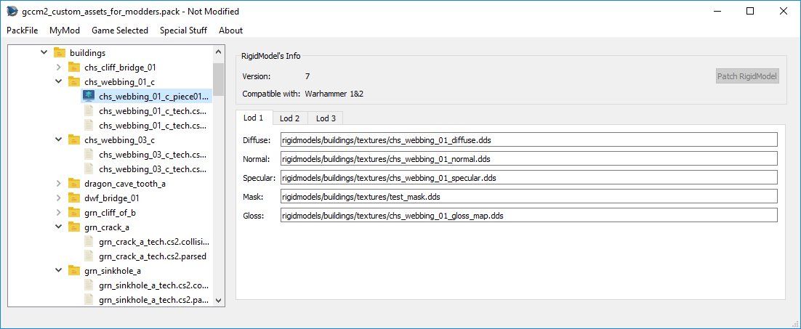

RPFM allows some limited editing of RigidModels (3D models). It allows you to change any of the textures each model uses and to patch Attila’s RigidModels for being loadable in Warhammer games (just the model, it doesn’t patch collisions or logic). It doesn’t work with all the RigidModels.

## Image PackedFiles

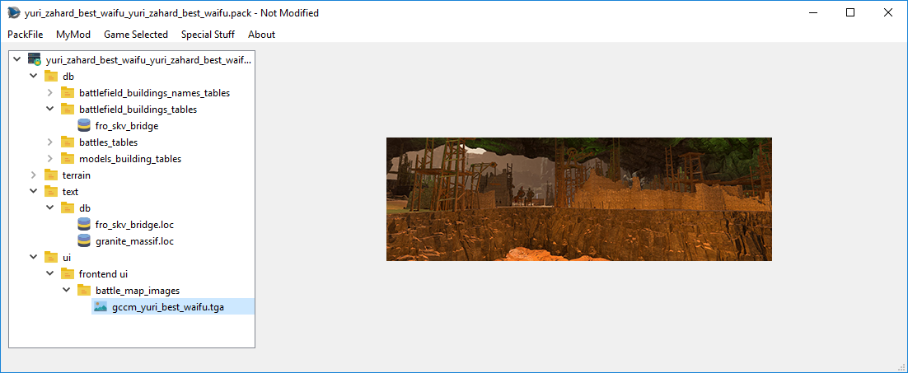

RPFM can open a variety of image formats, such as ***PNG, JPG, TGA, DDS (most of them)…*** Just select the image you want to see, and it’ll open in the right side of the window.

# DB Decoder

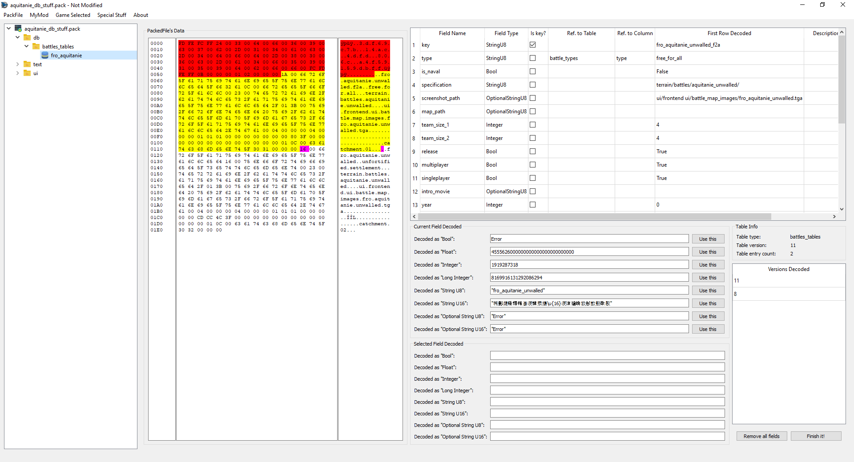

RPFM has an integrated database decoder, to speed up a lot the decoding process of the “***structure***” (or “***Definition***”) of a table. It can be opened by right-clicking on a table and selecting “***Open/Open with Decoder***”. Only works on tables.

Starting by the left we have this:

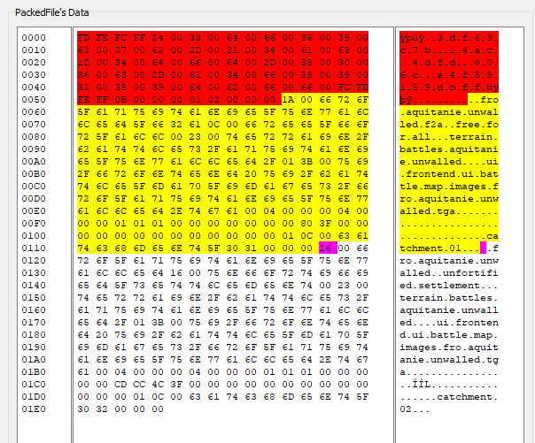

This is the “***PackedFile’s Data***” view. It’s similar to a hexadecimal editor, but far less powerful, and it’s not editable. In the middle you have “*Raw Hexadecimal Data*”, and in the right, you have a “*Decoded*” version of that data. To make it easier to work with it, both scrolling and selection are synchronised between both TextViews. So you can select a byte in the middle view, and it’ll get selected in the right one too. The colour code here means:

* ***Red***: header of the table. It contains certain info about what’s in the table.
* ***Yellow***: the part of the table already decoded following the structure from the fields table.
* ***Magenta***: the byte where the next field after all the fields from the fields table starts.

For performance reasons, this view is limited to 60 lines, which should be more than enough the decode the first row of almost every table.

Next, to the right, we have this:

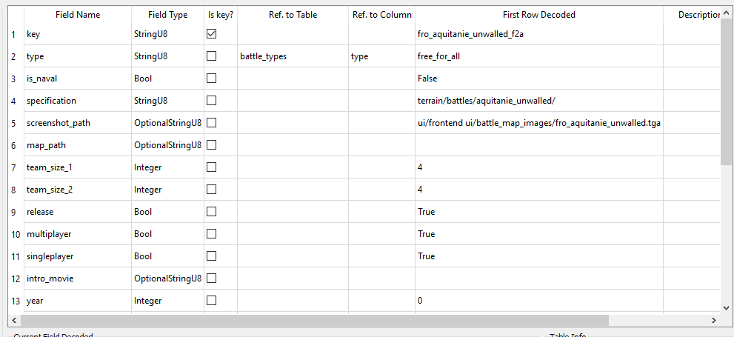

This is the “***Fields List***”. Here are all the columns this table has, including their title, type, if they are a “*key*” column, their relation with other tables/columns, the decoded data on each field of the first row of the table, and a “Description” field, to add commentaries that’ll show up when hovering a cell of that column with the mouse.

If we right-click in any field of the table, we have these three self-explanatory options to help us with the decoding:

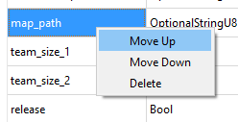

And finally, under the table, we have this:

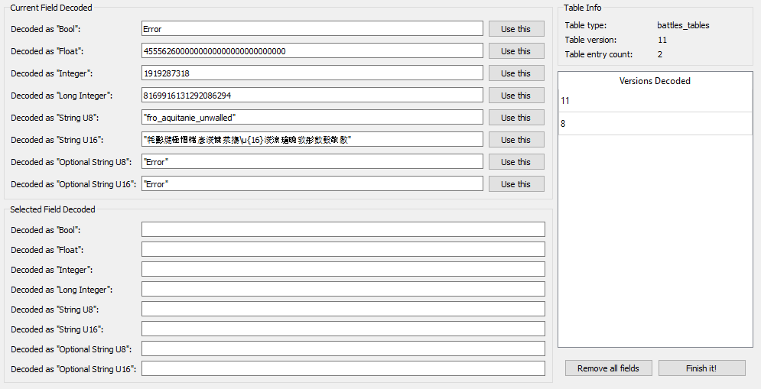

The “***Current Field Decoded***” will show up the field that starts in the magenta byte of the “*PackedFile’s Data*” View, decoded in the different types the tables use. His use is simple: check what type makes more sense (for example, in the screenshot, it’s evidently a “*StringU8*”), and click the “***Use this***” button in his row. Doing that will add a field of that type to the “Fields List”, and it’ll update the “*PackedFile’s Data*” View to show where the next field starts. Keep doing that until you think you’ve decoded the complete first row of the table, hit “***Finish It!***” at the right bottom corner, and select the table again. If the decoding is correct, the table will open. And that’s how I ~~met your moth~~er you decode a table.

Under “***Current Field Decoded***” we have “***Selected Field Decoded***”. It does the same that “*Current Field Decoded*”, but from the byte you selected in the “*PackedFile’s Data*” View. Just select a byte and it’ll try to decode any possible field starting from it. It’s for helping decoding complex tables.

To the right, we have a list of data about the table, and the list of versions of that table we have a definition for. If we right-click in one of them, we can load that version (useful to have something to start when a table gets “*updated*” in a patch) or delete it (in case we make a totally disaster and don’t want it to be in the schema).

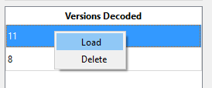

And at the bottom, we have the “***Remove all fields***” and “*Finish It!*” buttons. The first one clears the “*Fields List*” and reset the decoding process. The second one saves the current “*Fields List*” into the game’s schema and reloads the schema, so the changes can be used immediately.