Why:
In cases where the devices themselves support the IP stack, these gateways only have to forward packets to the Internet. Non-IP protocols such as LoRaWAN require some form of routing and processing before messages can be delivered to an application.
Network Server is positioned between the gateways and the applications and takes care of these routing and processing.

Vision : decentralized（区中心即分散的） and distributed（分布式）

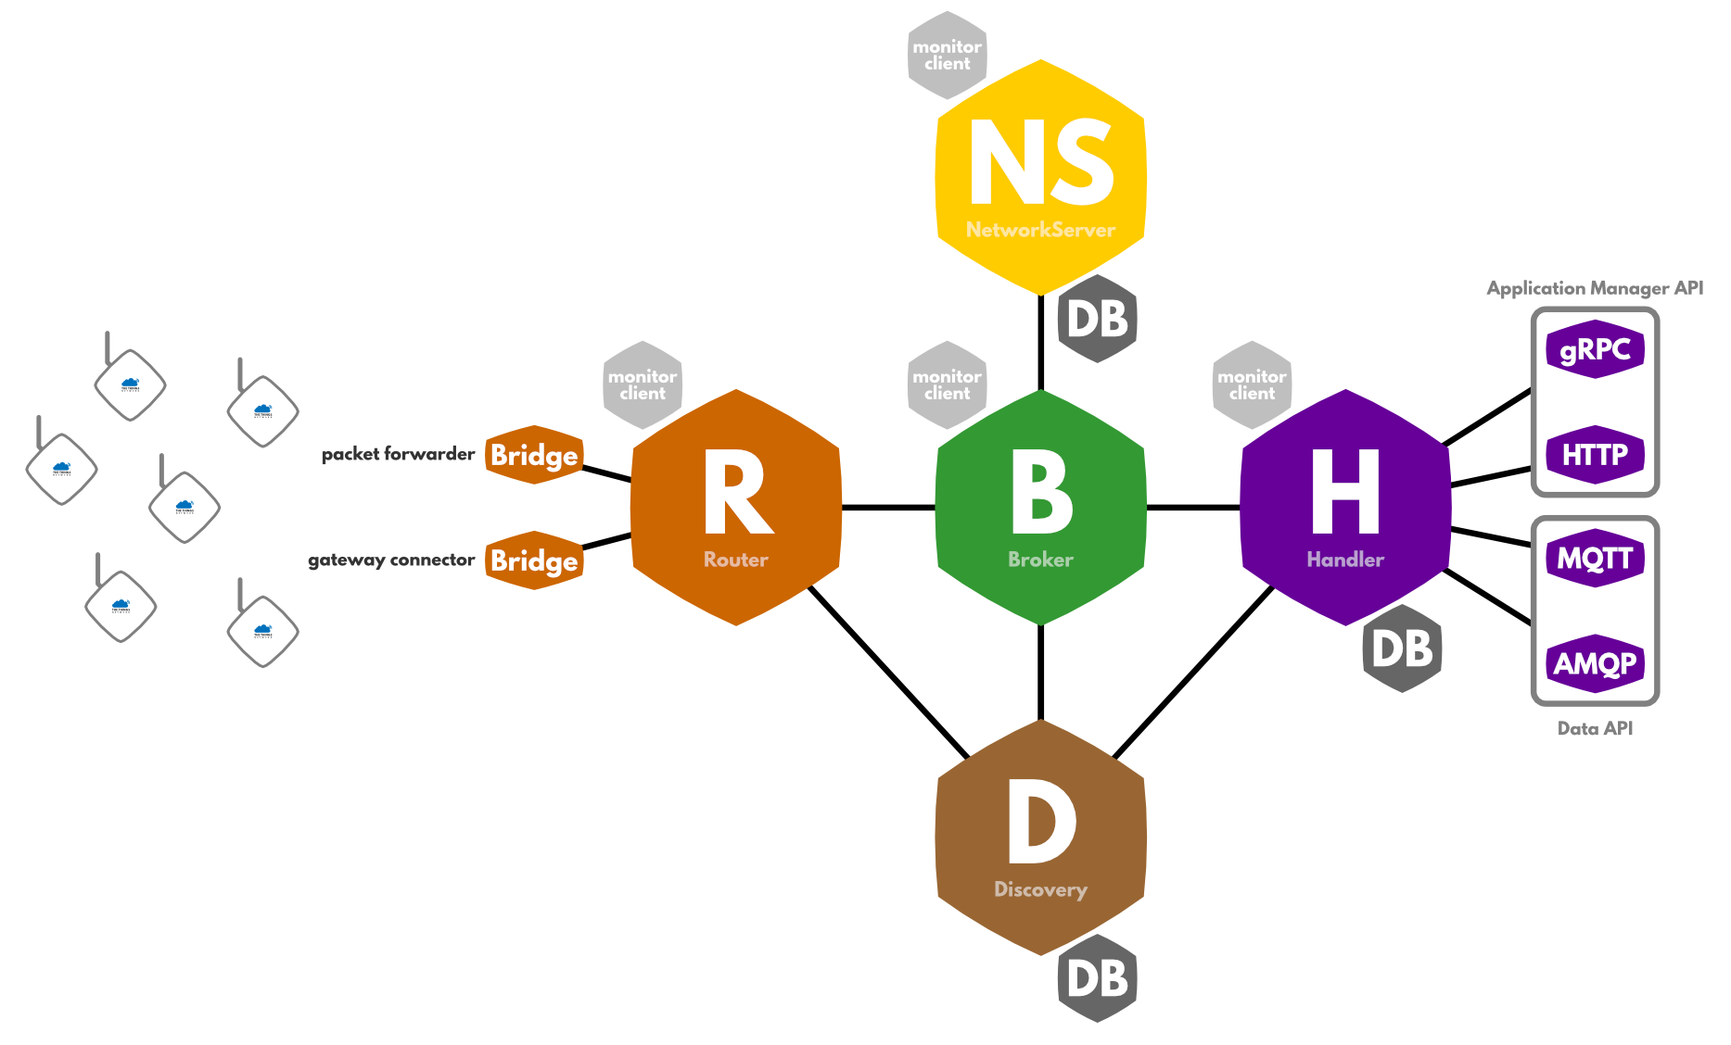
Gateway:
The Gateway is a piece of hardware that forwards radio transmissions to the backend（后端）. It is connected to one Router.a gateway can only do one transmission at the same time.

Router:
connected with gateways,responsible for managing the gateway’s status and for scheduling transmissions.Each Router is connected to one or more Brokers.
Broker:
Brokers are the central part of The Things Network. Their responsibility is to map a device to an application, to forward uplink messages to the correct application and to forward downlink messages to the correct Router (which forwards them to a Gateway).
Network Servers:
is responsible for functionality that is specific for LoRaWAN.
- there are Gateway-related functions such as scheduling and managing the utilization（利用率） of the gateways.
- we need device-related functions that manage the state of devices in the network.the network has to keep track of which addresses are used by which devices .And Other things the network must keep track of are the security keys and frame counters.
- as The Things Network is a distributed network, there has to be functionality that supports this distribution. Service discovery functionality helps components to determine where traffic should be routed to.
Handler:
is responsible for handling the data of one or more Applications. To do so, it connects to a Broker where it registers applications and devices. The Handler is also the point where data is encrypted (加密)or decrypted.（解密）

LoRaWAN：
LoRaWAN is a “network-intensive”（网络密集型） protocol, intensive in the sense that due to the simple and minimalistic（简约的） approach for devices, the backend systems (also called Network Servers) are responsible for most of the logic.

///////////////////////////////////////////////////////////////////////////////////////////////////////////////////

Separation of Concerns
In order to make the different backend components as decoupled as possible, we make a clear separation of the responsibilities of each component. The general idea is that the Router is responsible for all gateway-related functionality and region-specific details. A Broker handles a range of device addresses and is responsible for finding the right Handler to forward each message to. The Network Server is responsible for keeping the state of all individual devices. The Handler is responsible for encryption, decryption and conversion (转发)of messages and for forwarding messages to applications.

Processing Flow of Uplink Messages
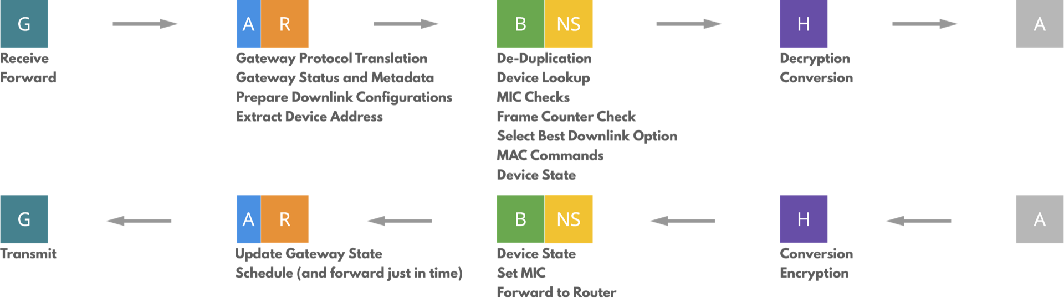
Gateway Protocol Translation（Router）：
When one or more messages are received, their binary payload is forwarded to the backend, together with metadata such as signal strength (RSSI) and signal-to-noise ratio (SNR). Periodically the gateway also sends some status information about the gateway itself, such as GPS coordinates, the number of packets received and transmitted and other metrics.

Gateway Status and Metadata (Router)
The GPS coordinates of a gateway can especially be relevant（closely connected or appropriate to what is being done or considered.） to the application. Therefore the backend stores the latest status message sent by the gateway and injects the GPS information into the metadata of each uplink message.

Downlink Configuration (Router)
After each uplink message, there two receive windows, one at exactly 1 second after the uplink, the other after 2 seconds. Therefore, for each gateway that received the uplink message, a Router builds two downlink configurations.

Device Address Extraction（the action of taking out something, especially using effort or force.） (Router)
The first step in routing a packet is based on the device address. This DevAddr is a non-unique 32-bit address of which 25 bits can be assigned by the network operator. The Things Network has chosen to distribute the traffic based on device address prefix（前缀）. Each Broker announces a number of device address prefixes with a discovery service. Messages are forwarded to all Brokers that announce a prefix matching the device address of the message.

De-Duplication(去除重复) (Broker)
Because LoRaWAN is a long-range radio protocol,so messages are more likely received more than one gateway.This means that the backend has to perform some kind of de-duplication in order to deliver a message only once to the application.
type Deduplicator interface {
// Deduplicate a value based on a given key Deduplicate(key string, value interface{}) []interface{}}
The current implementation（实现） of the backend locally de-duplicates uplink messages based on the md5 sum of the payload.and the chance that during the de-duplication period (usually a couple of seconds) a different message with the same hash arrives, is extremely low. In order to collect the metadata added to the message by each gateway, the Broker has to buffer duplicates for some appropriate amount of time. （1 second）

Device and Application lookup (Broker/Network Server)
Because device addresses are non-unique it is necessary to determine the exact device that sent the message, and the application it belongs to.To do this, the backend has to perform a series of cryptographic message integrity code (MIC) checks, one for each device that uses the same device address. To do so, the Broker requests a list of devices with the given device address from the Network Server and checks if the MIC can be validated（验证） using network session key. If no match is found, the message is dropped.

Frame Counter Check (Broker)
As frame counters can only increase, a message with a frame counter that is lower than the last known frame counter should be dropped.Additionally, the Broker has to verify that the gap between the last known frame counter and the counter in the message is not too big. According to the LoRaWAN specification, the maximum gap is 16384.the backend has to keep track of the full 32-bit frame counter and use this

Metadata Collection (Broker)
When all checks have succeeded, the Broker can continue processing the message.重复性的基础属性只发送一次，For example, the frequency, modulation and data rate will be the same for all gateways, so it only needs to be forwarded once.On the other hand, the signal strength, reception time and GPS coordinates of each gateway should all be included when forwarding the message。区分自身的特定的数据和要发送的信息。

//Selecting Best Downlink Option (Broker)

Device State and MAC Commands (Network Server)
Before forwarding the uplink message to the Handler, it is first sent to the Network Server so that the device’s state can be updated.. The Network Server also adds a downlink template （a shaped piece of metal）
to the message. This template can be used by the Handler to send a downlink message back to the device. It contains all necessary values (such as the frame counter, message type and option flags) so that the Handler only has to add the application payload to the message. Additionally, this gives the Network Server a chance to add MAC commands to the message.（ instruct the device）

//Message Decryption (Handler)

Payload Conversion (Handler)
The Handler is able to decode and convert the payload into a format that is easily accessible by the application. The implementation of the default Handler therefore includes so-called payload functions.The optional validator can be used to check the validity of the data and drop outliers.

MQTT (Handler)
The default Handler implementation simply publishes a JSON representation of uplink messages to a topic <app_id>/devices/<dev_id>/up on an MQTT broker. This allows applications to simply subscribe to the same MQTT topic and process the data in any way.

//Downlink (Handler)

Device State (Network Server)
After the Broker receives a downlink message from a Handler, it sends the message to the Network Server, which will update the device’s state (specifically, the frame counters) in the database and generate the MIC（信息完整码） of the message. After this, the Broker forwards the downlink message to the router that is responsible for the gateway that has to transmit the the downlink message.

Downlink Scheduling (Router)
As mentioned in the beginning of this chapter, the Router is responsible for managing the schedule of the Gateway. As most gateways only have a buffer of 1 downlink message, the Router has to buffer scheduled messages until the last moment, and then send each message just in time to the gateway.

