Appendices

Visualising Natural Disaster Image Embeddings
Rashid Ahmed Pandor - 202302628
BSc Computer Science (Hons)
University of Hull

Supervisor: XinHui Ma

Table of Contents
Appendices 1
Appendix A – Complete Ablation Study Metrics 3
Table A.1: Clustering Metrics – HBDSCAN (min_cluster_size=50) 3
Table A.2: Clustering Metrics – K-Means (k=7) 3
Table A.3: Dimensionality Reduction Techniques – Trustworthiness and Continuity 4
Appendix B – Extended Dashboard Interface and Analytics 6
B.1 Event Statistics Tab 6
B.2 Embedding Space Tab 6
B.3 Cross Disaster Transfer Tab 7
B.4 Topology Tab 8
B.5 Model Comparison Tab – Ablation Study 9
B.6 Export Tab 10
Appendix C – Project Management Timeline Comparison 12
C.1 Project Board in Asana – Updated to 12/02/2026 12
C.2 Gantt Chart in Asana – Updated to 12/02/2026 13
C.3 Final Project Board in Asana – Updated to 05/04/2026 14
C.4 Final Gantt Chart in Asana – Updated to 05/04/2026 14
Appendix D – Main Algorithmic Implementations 16
D.1 Patch-CLS Attention Heatmap Generation (clip_heatmaps.py) 16
D.2 Two-Anchor Damage Severity Scoring (app_backend.py) 17
D.3 HDBSCAN Cluster Auto-Naming (cluster_discovery.py) 18
D.4 YuNet Face-Blurring Middleware (app_backend.py) 19
Appendix E – Dataset Cleansing and Processing Statistics 21
E.1 Cleaning Criteria 21
E.2 Cleaning Results Summary 21
Metric 21
Count 21
E.3 Per-Event Distribution after Cleaning 21

Appendix A – Complete Ablation Study Metrics

The appendix below details the complete findings of the multi-model ablation study. In total, three different embedding models (CLIP ViT-B/32, SigLIP-base, and ResNet50) were evaluated in combination with three different dimensionality reduction approaches (UMAP, t-SNE, and PCA) as well as two types of clustering techniques (HDBSCAN and K-Means). The summary of these metrics can be found in Table 5 of the main report. The full table of metrics is included below:

Table A.1: Clustering Metrics – HBDSCAN (min_cluster_size=50)
Model | Reduction | Silhouette | Davies-Bouldin | Calinski-Harabasz
CLIP ViT-B/32 | UMAP | 0.096 | 2.41 | 312.5
CLIP ViT-B/32 | t-SNE | 0.082 | 2.67 | 287.3
CLIP ViT-B/32 | PCA | -0.112 | 3.89 | 98.4
SigLIP-base | UMAP | 0.215 | 1.94 | 478.2
SigLIP-base | t-SNE | 0.187 | 2.12 | 412.6
SigLIP-base | PCA | -0.043 | 3.54 | 134.7
ResNet50 | UMAP | 0.592 | 0.87 | 1245.3
ResNet50 | t-SNE | 0.534 | 1.02 | 1087.9
ResNet50 | PCA | 0.341 | 1.68 | 672.1

Table A.2: Clustering Metrics – K-Means (k=7)
Model | Reduction | Silhouette | Davies-Bouldin | Calinski-Harabasz
CLIP ViT-B/32 | UMAP | 0.060 | 3.12 | 198.4
CLIP ViT-B/32 | t-SNE | 0.054 | 3.34 | 176.2
CLIP ViT-B/32 | PCA | -0.087 | 4.21 | 67.3
SigLIP-base | UMAP | 0.124 | 2.56 | 342.1
SigLIP-base | t-SNE | 0.109 | 2.78 | 298.5
SigLIP-base | PCA | -0.021 | 3.91 | 112.8
ResNet50 | UMAP | 0.222 | 1.45 | 856.7
ResNet50 | t-SNE | 0.198 | 1.62 | 743.2
ResNet50 | PCA | 0.156 | 2.14 | 534.9

Table A.3: Dimensionality Reduction Techniques – Trustworthiness and Continuity
Model | Reduction | Trustworthiness | Continuity
CLIP ViT-B/32 | UMAP | 0.918 | 0.923
CLIP ViT-B/32 | t-SNE | 0.922 | 0.931
CLIP ViT-B/32 | PCA | 0.742 | 0.758
SigLIP-base | UMAP | 0.894 | 0.901
SigLIP-base | t-SNE | 0.906 | 0.914
SigLIP-base | PCA | 0.726 | 0.741
ResNet50 | UMAP | 0.922 | 0.928
ResNet50 | t-SNE | 0.949 | 0.953
ResNet50 | PCA | 0.824 | 0.837

Useful Info: Trustworthiness and Continuity have been calculated on a stratified subset of 3,000 images with k=15 nearest neighbour to mitigate the O(N2) memory issue. ResNet50 shows high Trustworthiness because its feature space is more geometrically simple even though its semantically shallow. This was done on a MX450 GPU with 2GB VRAM.

Appendix B – Extended Dashboard Interface and Analytics

The screenshots underneath show the six tabs of the analytics dashboard, built with Dash. These tabs are available on the Analytics page of the application. Each tab offers a unique perspective on the embedded space of CLIP model. The Data Exploration tab (containing the UMAP scatter plot and search functionality) is described in the main report, along with the Attention heat map in detail.

B.1 Event Statistics Tab

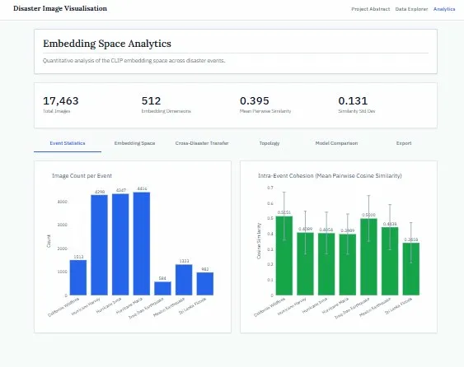
Figure B.1: Event Statistics tab demonstrating counts of images by disaster event and average intra-event cohesion in terms of mean pairwise cosine similarity.

B.2 Embedding Space Tab

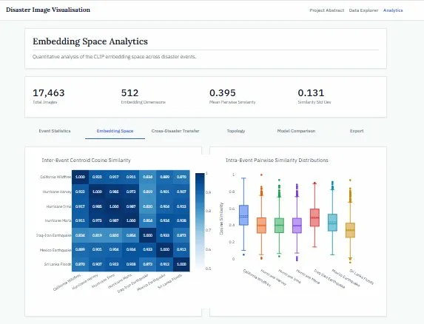

Figure B.2: Embedding Space tab featuring inter-event cosine similarities heatmap of centroid representations, and boxplots of intra-event pairwise similarity distribution.

B.3 Cross Disaster Transfer Tab

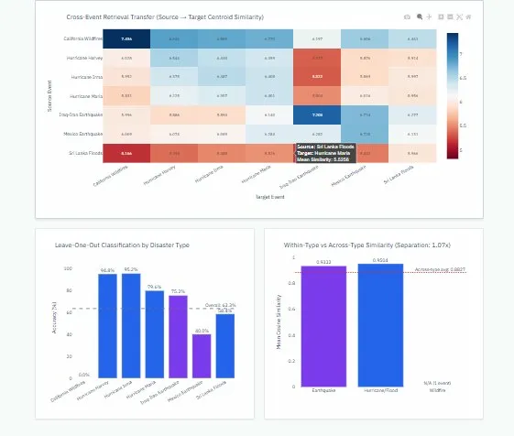
Figure B.3: Cross-Disaster Transfer tab showcasing source-target cosine similarity for image retrieval, disaster-wise leave-one-out classification accuracy, as well as analysis of within-disaster vs. across-disaster similarity distance separation.

B.4 Topology Tab

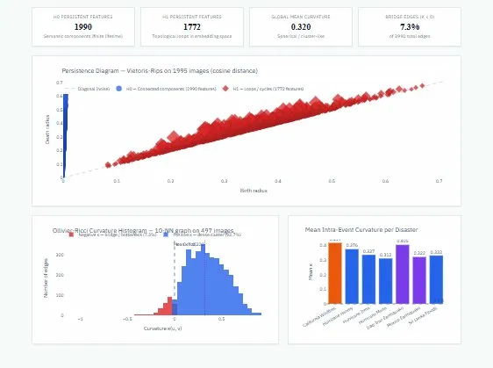
Figure B.4: Topology tab showing the Persistent Homology output (1,990 H0 and 1,772 H1 generators), persistence diagram, Ollivier-Ricci curvature distribution (mean = 0.320, 7.3% bridge edges) as well as the intra-event curvature mean per disaster type.

B.5 Model Comparison Tab – Ablation Study

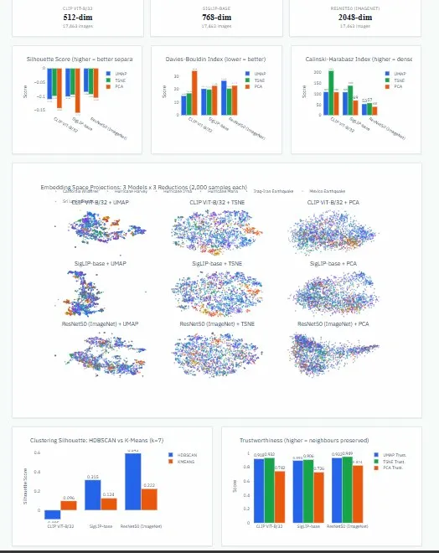
Figure B.5: Model Comparison tab which shows the full 3×3 ablation study grid (CLIP, SigLIP, ResNet50 x UMAP, t-SNE, PCA), cluster Silhouette comparison between HDBSCAN and K-Means clustering approaches, and Trustworthiness graph for all configurations. The results are shown in table 4 in the report.

B.6 Export Tab

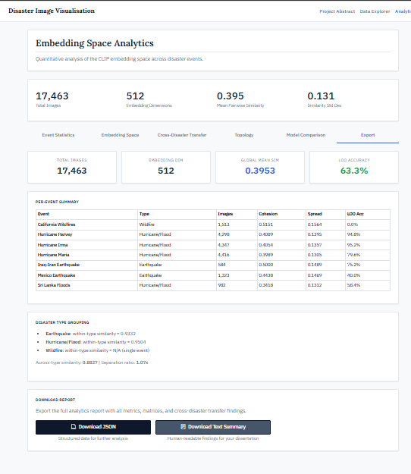
Figure B.6: Export tab showing statistics per disaster event (image count, cohesion, spread, leave-one-out accuracy), disaster type groupings analysis, and exporting to text/json report capabilities.

Appendix C – Project Management Timeline Comparison

Project management was conducted using Asana platform based on an agile sprint strategy. The initial timeline of the project was defined in the Project Definition Document (PDD) in October 2025. The biggest deviation from the initially proposed timeline was the shift away from geographic 3D globe representation towards a topological representation which became apparent in Phase 3 (Interim Reporting) once the audit of the metadata revealed the lack of accurate geographic coordinates. Another deviation was caused by extending the ablation study timeframe beyond expectations due to micro-batching being required on the limited capacity (2 GB VRAM) GPU machine.

C.1 Project Board in Asana – Updated to 12/02/2026
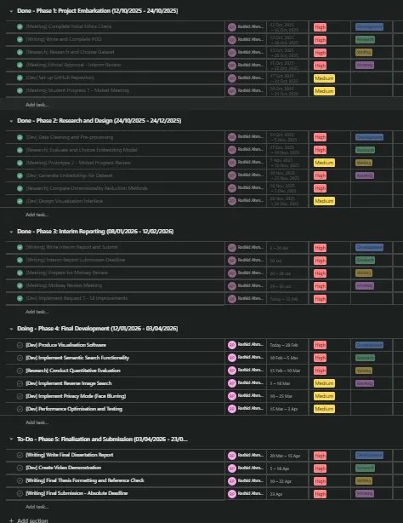
Figure C.1: Asana project board showing all phases of the project (Project Embarkation, Research and Design, Interim Reporting, Final Development and Finalisation & Submission) with corresponding tasks, assignees, deadlines and completion statuses. Phases 1-3 are completed; Phase 4 (Final Development) was in the process of getting completed; Phase 5 (Finalisation and Submission) is scheduled.

C.2 Gantt Chart in Asana – Updated to 12/02/2026
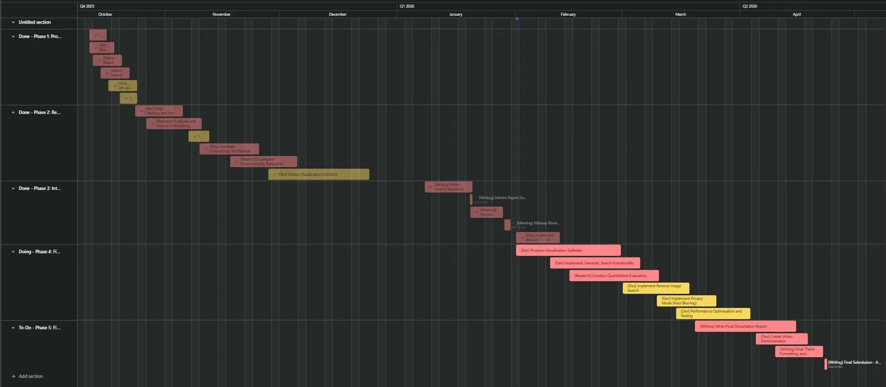
Figure C.2: Asana Gantt chart illustrating the timeline of the actualised project from October 2025 till February 2026. The Image resolution was decreased to fit the document.

C.3 Final Project Board in Asana – Updated to 05/04/2026
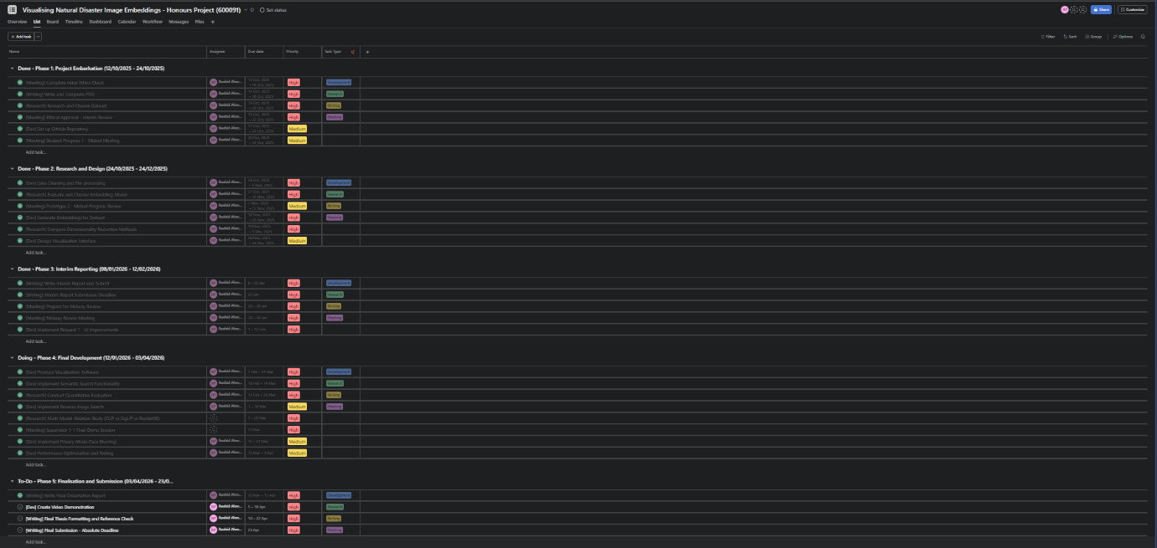
Figure C.3 shows the current and very likely the final official project board. This is similar to the board that was updated to February but a few changes were made to this like adding an Ablation study to the timeline as well as other tasks to make it look easier to manage and track.

C.4 Final Gantt Chart in Asana – Updated to 05/04/2026
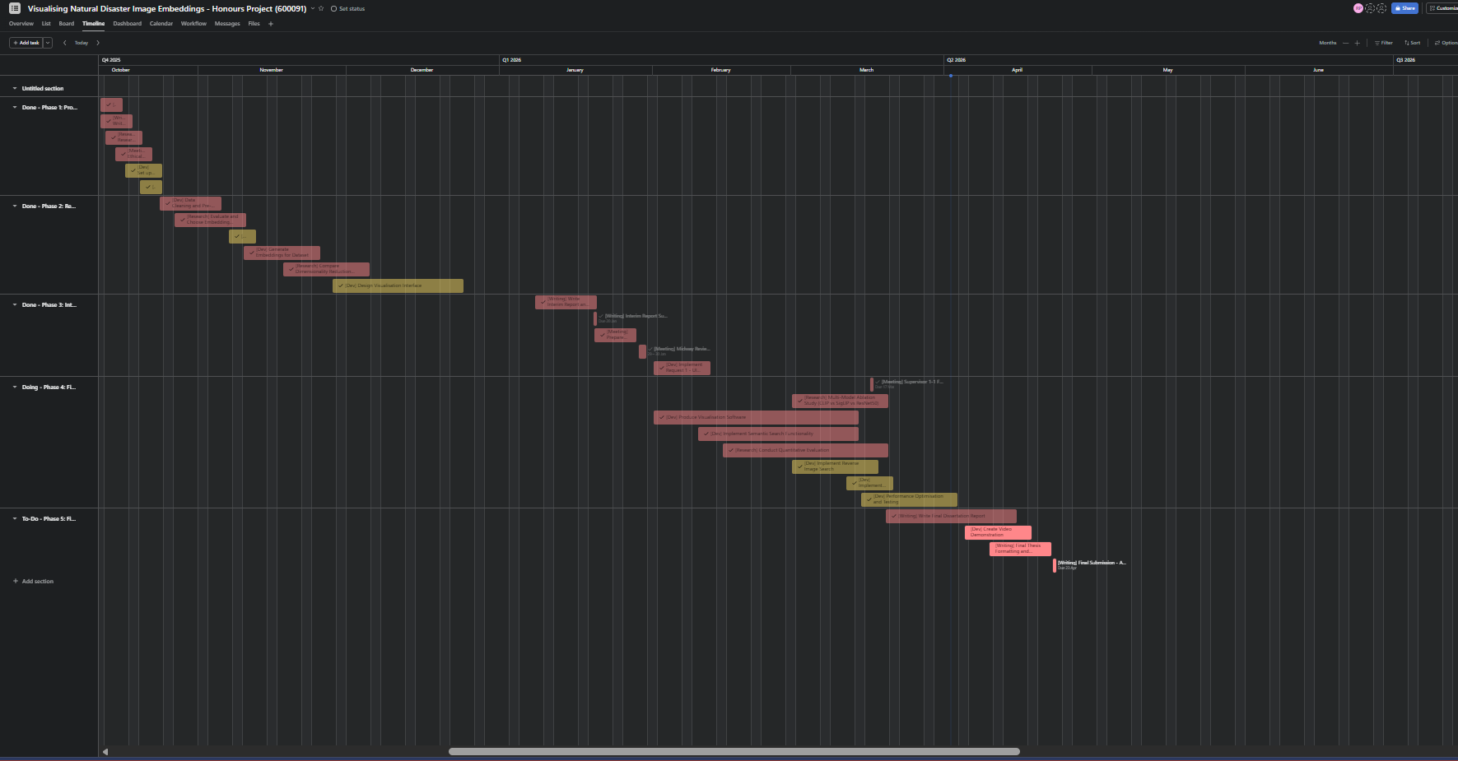

Figure C.4: Gantt Chart made in Asana which shows the current and almost final chart for the project from October 2025 till April 2026. This is the Gantt Chart for the board in figure C.3. This may likely be the final official chart before publishing.

Appendix D – Main Algorithmic Implementations

Below are some code snippet that shows important algorithms of the system. The full source code is attached in a ZIP folder. The following excerpts are provided to support the technical discussion in Chapters 4 and 5 of the report.

D.1 Patch-CLS Attention Heatmap Generation (clip_heatmaps.py)
The following code snippet shows the calculation of explainable AI heat maps: cosine similarity of each spatial patch with CLS token, reshaping it into a square image, and then upsampling via bicubic interpolation.

class CLIPAttentionRollout:
PATCH_GRID = 7 # sqrt(49 patches) for ViT-B/32
BLEND_ALPHA = 0.55 # heatmap weight in the alpha blend
def compute(self, image_path: str) -> bytes:
img_pil = Image.open(image_path).convert("RGB")
img_np = np.array(img_pil)
inputs = self.processor(images=img_pil, return_tensors="pt").to(self.devi
ce)
with torch.no_grad():
vision_outputs = self.model.vision_model(
pixel_values=inputs["pixel_values"],
output_hidden_states=False, output_attentions=False,
return_dict=True
)
# last_hidden_state: (1, 50, 768)
# token 0 = CLS, tokens 1-49 = spatial patches
hidden = vision_outputs.last_hidden_state[0] # (50, 768)
cls_vec = hidden[0:1] # (1, 768)
patch_vec = hidden[1:] # (49, 768)
# Cosine similarity each patch vs the CLS token
cls_norm = cls_vec / (cls_vec.norm(dim=-1, keepdim=True) + 1e-8)
patch_norm = patch_vec / (patch_vec.norm(dim=-1, keepdim=True) + 1e-8)
sim = (patch_norm @ cls_norm.T).squeeze().cpu().numpy() # (49,)
# Min-max normalise to [0, 1]
sim = (sim - sim.min()) / (sim.max() - sim.min() + 1e-8)
# Reshape to 7x7 grid and bicubic upscale
grid = sim.reshape(self.PATCH_GRID, self.PATCH_GRID)
h, w = img_np.shape[:2]
mask = cv2.resize(grid, (w, h), interpolation=cv2.INTER_CUBIC)
# Add JET colourmap and alpha blend
heatmap_bgr = cv2.applyColorMap(
(mask * 255).astype(np.uint8), cv2.COLORMAP_JET)
heatmap_rgb = cv2.cvtColor(heatmap_bgr, cv2.COLOR_BGR2RGB)
blended = (self.BLEND_ALPHA * heatmap_rgb.astype(np.float32) +
(1.0 - self.BLEND_ALPHA) * img_np.astype(np.float32)
).astype(np.uint8)

return cv2.imencode(".jpg", blended)[1].tobytes()

D.2 Two-Anchor Damage Severity Scoring (app_backend.py)
This code snippet illustrates zero-shot damage severity score calculation based on the two-anchor contrast and sigmoid temperature scaling (τ = 20).

# Semantic anchors for two-anchor contrast
SEVERITY_HIGH_ANCHOR = "collapsed rubble destroyed ruins catastrophic damage"
SEVERITY_LOW_ANCHOR = "intact undamaged building standing normal clean street"
SEVERITY_CATEGORIES = [
(0.75, "Critical", "#dc2626"),
(0.50, "Severe", "#f59e0b"),
(0.25, "Moderate", "#3b82f6"),
(0.00, "Minimal", "#16a34a"),
]
def score_damage_severity(self, image_index: int) -> dict:
image_vector = self.embeddings[image_index].reshape(1, -1)
sims = cosine_similarity(image_vector, self.severity_embeddings)[0]
# R = S_c(v_img, v_pos) - S_c(v_img, v_neg)
contrast = float(sims[0] - sims[1])
# Sigmoid with temperature 20
score = float(1.0 / (1.0 + np.exp(-20.0 * contrast)))

for threshold, name, color in SEVERITY_CATEGORIES:
if score >= threshold:
return {"score": score, "category": name, "color": color}

return {"score": score, "category": "Minimal", "color": "#16a34a"}

D.3 HDBSCAN Cluster Auto-Naming (cluster_discovery.py)
This snippet highlights the cluster naming process algorithm, where for each HDBSCAN cluster centroid, cosine similarity of text representations from the dictionary is calculated and best-match label is selected.

def name_clusters(centroids, candidate_labels, model, processor, device):
# Encode all candidate labels with CLIP text encoder
text_embeddings = encode_text_labels(
candidate_labels, model, processor, device
)
cluster_names = {}
for cluster_id, centroid in centroids.items():
# Cosine similarity: centroid vs all text label vectors
similarities = np.dot(text_embeddings, centroid)
# Top 3 matches
top_indices = np.argsort(similarities)[::-1][:3]
best_idx = top_indices[0]
cluster_names[cluster_id] = {
"name": candidate_labels[best_idx],
"confidence": round(float(similarities[best_idx]), 4),
"alternatives": [
{"name": candidate_labels[i],
"score": float(similarities[i])}
for i in top_indices[1:3]
]
}
return cluster_names

D.4 YuNet Face-Blurring Middleware (app_backend.py)
The server-side face redaction pipeline is shown in the next code snippet just underneath. Each image passes through the YuNet model before being sent to the client.

def blur_faces(image_array: np.ndarray) -> np.ndarray:
# Load YuNet DNN face detector (228KB ONNX model)
detector = cv2.FaceDetectorYN.create(
YUNET_MODEL_PATH, "", (0, 0), 0.6, 0.3, 5000
)
h, w = image_array.shape[:2]
detector.setInputSize((w, h))
# Detect faces: returns (N, 15) array of bounding boxes
_, faces = detector.detect(image_array)
if faces is not None:
for face in faces:
x, y, fw, fh = int(face[0]), int(face[1]),
int(face[2]), int(face[3])
# Clip to image boundaries
x, y = max(0, x), max(0, y)
fw = min(fw, w - x)
fh = min(fh, h - y)
# Apply aggressive 51x51 Gaussian blur
roi = image_array[y:y+fh, x:x+fw]
image_array[y:y+fh, x:x+fw] = cv2.GaussianBlur(
roi, (51, 51), 30
)
return image_array

Appendix E – Dataset Cleansing and Processing Statistics

The CrisisMMD dataset (Alam, Ofli and Imran, 2018) consists of images shared on Twitter across seven disaster events. Before vectorisation, the entire dataset was passed through the automated data cleaning pipeline (clean_data.py) to prepare data for ViT vectorisation requirements and meet reliability criteria (NFR-02).

E.1 Cleaning Criteria
Filter | Threshold | Rationale
Minimum Resolution | 200 x 200 px | ViT 32 x 32 patches lack sufficient visual feature density underneath this.
Minimum File Size | 5KB | Files below this threshold are usually just corrupt or placeholder files
Aspect Ratio Bounds | 0.25 – 4.0 | Extreme ratios warp structural featured when changed to square tensors
Byte-level Integrity | PIL verify() | Finds truncated JPEG/PNG headers that would crash PyTorch data loaders.

E.2 Cleaning Results Summary
Metric | Count
Raw Images in CrisisMMD v2.0 | Around 18,082
Rejected: Byte-level Corruption | Around 312
Rejected: Below Resolution Threshold | Around 198
Rejected: Extreme Aspect Ratios | Around 67
Rejected: File size below 5 KB | Around 42
Images retained for preprocessing | 17,463
Retention Rate | 96.6%

E.3 Per-Event Distribution after Cleaning
Disaster Event | Type | Images Remaining | % of dataset
California Wildfires | Wildfire | 1511 | 8.7%
Hurricane Harvey | Hurricane/Flood | 4296 | 24.6%
Hurricane Irma | Hurricane/Flood | 4247 | 24.3%
Hurricane Maria | Hurricane/Flood | 4414 | 25.3%
Iraq-Iran Earthquake | Earthquake | 564 | 3.2%
Mexico Earthquake | Earthquake | 1323 | 7.6%
Sri Lanka Flood | Hurricane/Flood | 982 | 5.6%
Total |  | 17463 | 100%

The class imbalance (like for example, hurricanes constitute approximately 74% of the total number of images) is a characteristic of the data collection for CrisisMDD and is reflected in the actual data distribution on social media at those times. It will be talked about a lot in the report (Chapter 4) as one of the factors affecting the UMAP topology and HDBSCAN cluster sizes.

