500083 Lab Book
Week 2 – Lab 2: Thread Hierarchy & Global Indexing
10 Feb 2026

Exercise 1: Thread Index Identification in CUDA
Question:
For the vector addition kernel, list the values of threadIdx.x and blockIdx.x for each of the following thread configurations.
Solution:
1) addKernel<<<1, 5>>> — 1 block, 5 threads
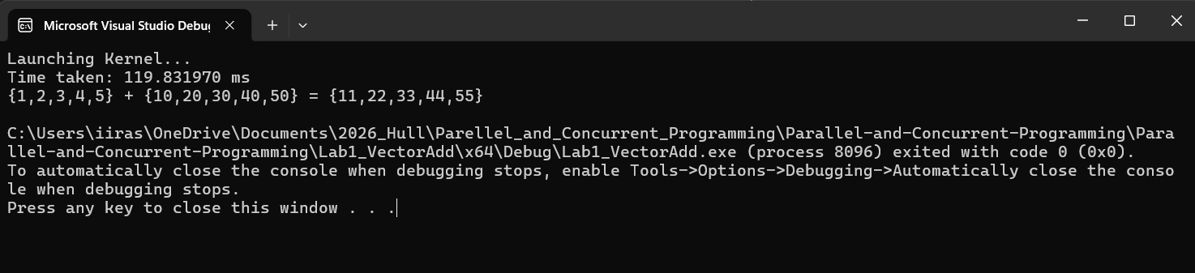
2) addKernel<<<2, 3>>> — 2 blocks, 3 threads each
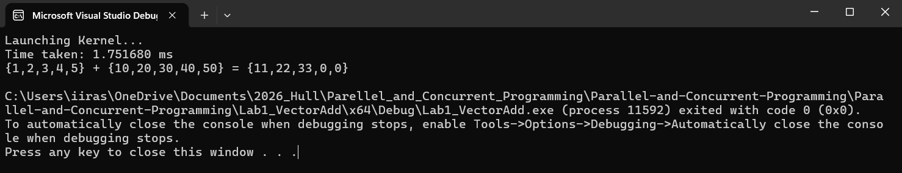
3) addKernel<<<3, 2>>> — 3 blocks, 2 threads each
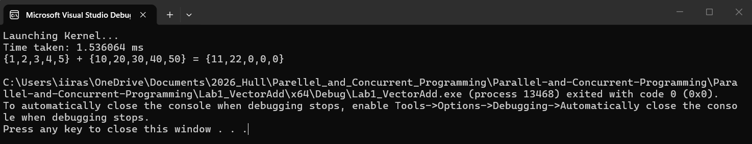
4) addKernel<<<6, 1>>> — 6 blocks, 1 thread each
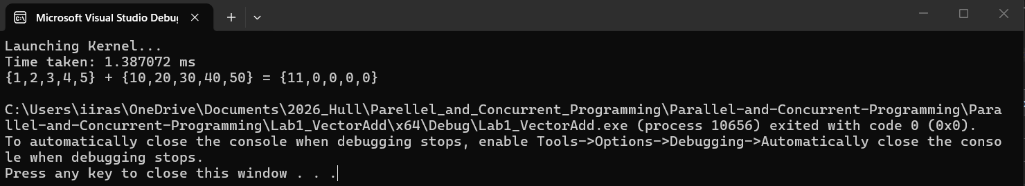

Reflection:
With a single block, threadIdx.x is unique and can serve directly as the array index. With multiple blocks, threadIdx.x resets to 0 in each block, producing duplicate indices. A global index formula is therefore needed to assign every thread a unique ID.

Exercise 2: Global Thread Index for Multiple 1D Blocks
Question:
Determine the output when the kernel is launched with addKernel<<<3, 2>>> and modify the kernel to use the correct global thread index.
Solution:
The original kernel used int i = threadIdx.x; which only produces values 0 and 1 in every block, leaving indices 2–4 uncomputed. The fix:
int i = blockIdx.x * blockDim.x + threadIdx.x;
This gives each of the 6 threads a unique index (0–5), so all 5 array elements are correctly computed.
Sample output (before fix):
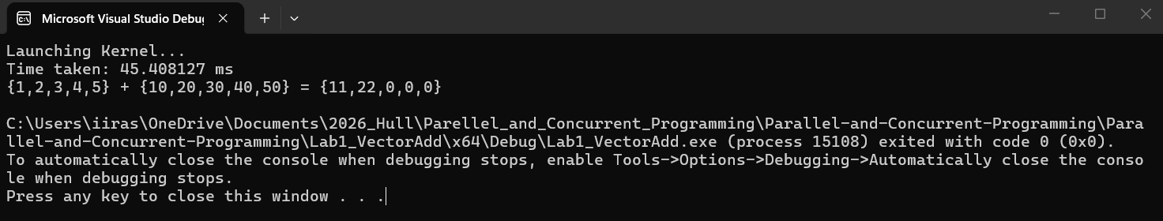
Sample output (after fix):
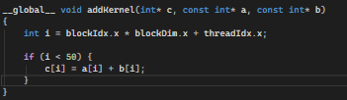
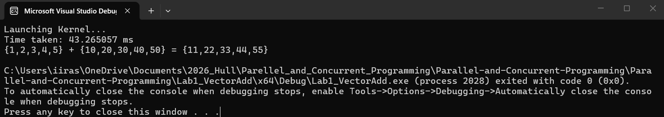
Reflection:
The formula blockIdx.x * blockDim.x + threadIdx.x offsets each block’s threads by the block size. Block 0 gets indices 0–1, Block 1 gets 2–3, and Block 2 gets 4–5, ensuring every thread maps to a unique element.

Exercise 3: 2D Thread Blocks
Question:
For each of the following thread configurations, list all possible values of threadIdx.x and threadIdx.y.
Solution:
1) addKernel<<<1, dim3(2, 3)>>> — 1 block, 2×3 = 6 threads
2) addKernel<<<1, dim3(3, 3)>>> — 1 block, 3×3 = 9 threads
With dim3, threads are arranged in a 2D grid within each block. threadIdx.x spans the columns and threadIdx.y spans the rows.
Sample output:
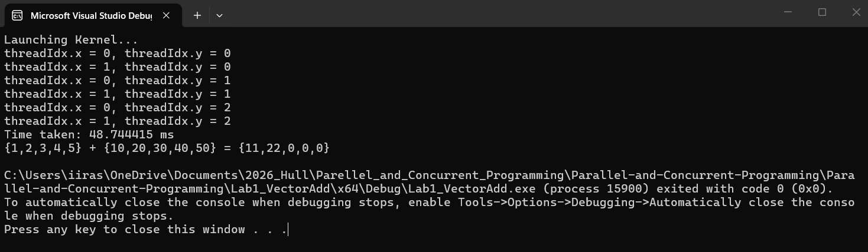
Reflection:
Using dim3 organises threads in 2D, which is useful for matrix and image operations. Each thread identifies its position via threadIdx.x and threadIdx.y.

Exercise 4: Global Thread Index for 2D Thread Blocks
Question:
Determine the output when the kernel is launched with addKernel<<<1, dim3(3, 2)>>> and modify the index calculation for the correct global thread index.
Solution:
With a 2D block of 3 columns and 2 rows, the 2D thread position must be flattened into a 1D index:
int i = threadIdx.y * blockDim.x + threadIdx.x;
Row 0 maps to indices 0–2 and row 1 maps to indices 3–5.
Sample output:
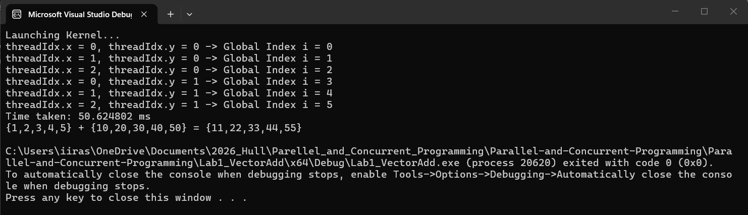
Reflection:
With 2D blocks, threadIdx.x alone is insufficient. The formula threadIdx.y * blockDim.x + threadIdx.x flattens the 2D position into a unique 1D index, mirroring how 2D arrays are stored row-by-row in memory.

Exercise 5: Global Thread Index for Multiple 2D Thread Blocks
Question:
Determine the output when the kernel is launched with addKernel<<<dim3(2, 3), dim3(2, 2)>>> and modify the index calculation for the correct global thread index.
Solution:
This uses a 2D grid (2×3 = 6 blocks) with 2D blocks (2×2 = 4 threads each), giving 24 threads total. The global index is calculated as:
int blockId = blockIdx.y * gridDim.x + blockIdx.x;
int threadId = threadIdx.y * blockDim.x + threadIdx.x;
int i = blockId * (blockDim.x * blockDim.y) + threadId;
blockId linearises the block position (0–5), threadId linearises the thread position within a block (0–3), and the global index offsets each block’s threads accordingly. A bounds check (if i < 50) ensures only threads 0–4 perform the addition.
Sample output:
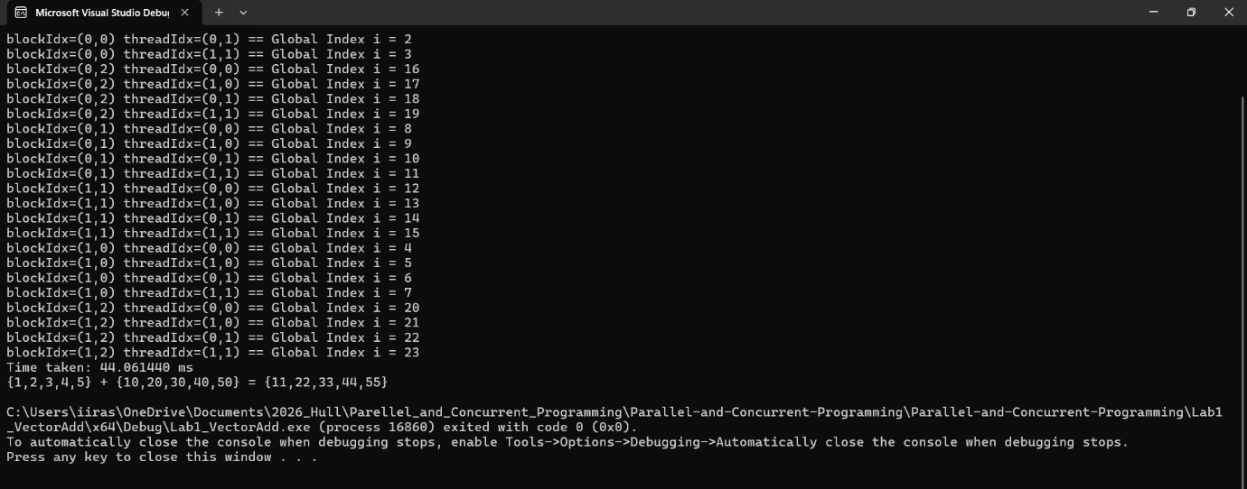
Reflection:
This exercise combined all prior concepts. When both the grid and blocks are 2D, both dimensions must be linearised separately and then combined. This general formula is the standard approach in real CUDA programs.

