500083 Lab Book
Week 3 – Lab 3: Memory Management & Dot Product
17 Feb 2026

Exercise 1: Dot Product – CPU Baseline and CPU+GPU Solution

Exercise 1.1: CPU-Only Dot Product
Question:
Write a CPU-only C++ program to compute the dot product of vectors A and B as a baseline for verifying GPU results. Formula: result = A[0]*B[0] + A[1]*B[1] + … + A[n-1]*B[n-1]
Solution:
Created as a standard C++ console application (no CUDA required).
const int N = 5;
int a[N] = { 1, 2, 3, 4, 5 };
int b[N] = { 10, 20, 30, 40, 50 };

int result = 0;
for (int i = 0; i < N; i++)
result += a[i] * b[i];
Test data:
A = {1, 2, 3, 4, 5}, B = {10, 20, 30, 40, 50}
Expected: (1×10) + (2×20) + (3×30) + (4×40) + (5×50) = 550
Sample output:
CPU Dot Product = 550
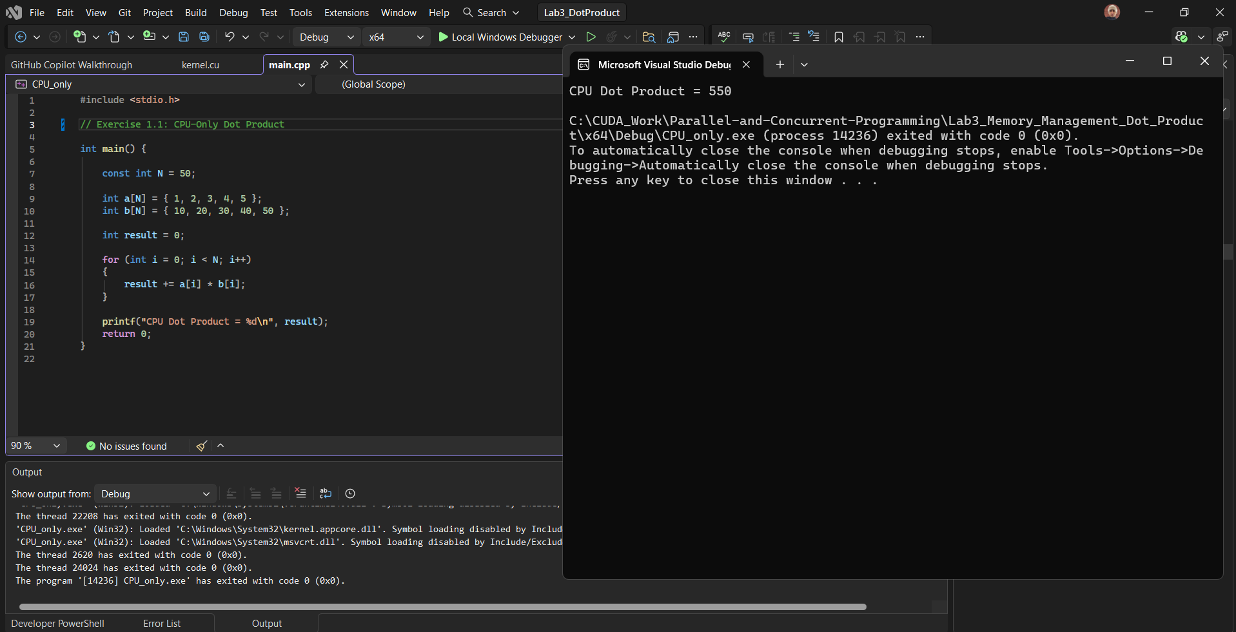

Exercise 1.2: CPU+GPU Dot Product
Question:
Accelerate the dot product using CUDA: the GPU computes C[i] = A[i] * B[i] in parallel, then the CPU sums C to get the final result.
Solution:
__global__ void multiplyKernel(int* c, const int* a, const int* b) {
int i = threadIdx.x;
c[i] = a[i] * b[i];
}
Launched with multiplyKernel<<<1, N>>>(dev_c, dev_a, dev_b); then the CPU sums C after copying it back.
Test data:
C after GPU multiply = {10, 40, 90, 160, 250}. Dot product (CPU sum) = 550
Sample output:
GPU+CPU Dot Product = 550
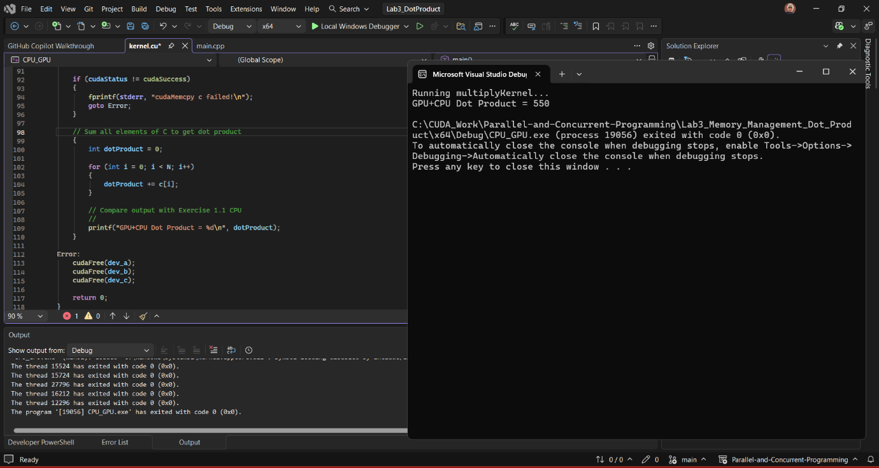
Reflection:
The CPU-only version provided a trusted baseline of 550. For Exercise 1.2, the GPU handled the element-wise multiplications in parallel whilst the CPU summed the results after a cudaMemcpy. Both approaches matched, confirming the GPU path was correct.

Exercise 2: Dot Product using Unified Memory

Exercise 2.1: Dynamic Managed Memory
Question:
Replace explicit memory management with Unified Memory (cudaMallocManaged()), removing the need for any cudaMemcpy calls.
Solution:
int* a, * b, * c;
cudaMallocManaged(&a, arraySize * sizeof(int));
cudaMallocManaged(&b, arraySize * sizeof(int));
cudaMallocManaged(&c, arraySize * sizeof(int));

// Initialise arrays, launch kernel, then synchronise
PerElement_AtimesB<<<1, arraySize>>>(c, a, b);
cudaDeviceSynchronize();

int dotProduct = 0;
for (int i = 0; i < arraySize; i++)
dotProduct += c[i];

cudaFree(a); cudaFree(b); cudaFree(c);
Sample output:
Dot Product (Dynamic Unified Memory) = 550
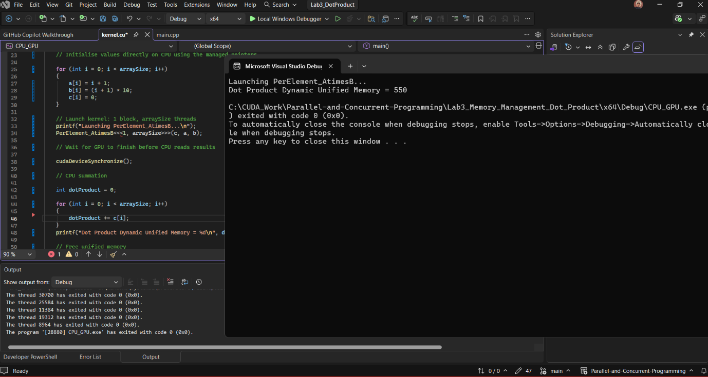

Exercise 2.2: Static Managed Memory
Question:
Compute the dot product using __device__ __managed__ global arrays, removing cudaMalloc, cudaMemcpy, and cudaFree entirely.
Solution:
__device__ __managed__ int a[5];
__device__ __managed__ int b[5];
__device__ __managed__ int c[5];

__global__ void PerElement_AtimesB(int* c, int* a, int* b) {
int i = threadIdx.x;
c[i] = a[i] * b[i];
}

// main: initialise arrays on CPU, launch kernel,
// cudaDeviceSynchronize(), then sum on CPU
Sample output:
Dot Product Static Managed Memory = 550
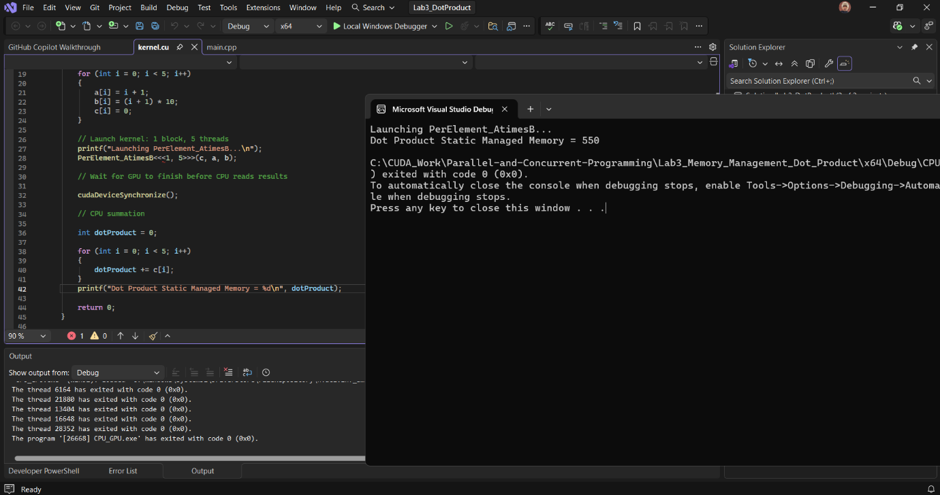
Reflection:
Exercise 2.1 replaced cudaMalloc with cudaMallocManaged, giving a single pointer usable on both CPU and GPU without cudaMemcpy. Exercise 2.2 went further with __device__ __managed__ globals, eliminating cudaMalloc and cudaFree as well. Both produced 550, and the code made clear how much of Exercise 1 was purely memory-transfer boilerplate.

Exercise 3: Dot Product using Shared Memory
Question:
Use shared memory to compute per-block subtotals on the GPU rather than copying every multiplication result back individually. Thread 0 of each block reduces the products into a single subtotal, and the CPU sums only the subtotals. Three configurations tested on 8 elements: <<<1, 8>>>, <<<2, 4>>>, and <<<4, 2>>>.
Solution:
__global__ void dotProductShared(int* c, int* a, int* b) {
__shared__ int dataPerBlock[8];
int i = blockIdx.x * blockDim.x + threadIdx.x;

dataPerBlock[threadIdx.x] = a[i] * b[i];
__syncthreads();

if (threadIdx.x == 0) {
int subtotal = 0;
for (int k = 0; k < blockDim.x; k++)
subtotal += dataPerBlock[k];
c[blockIdx.x] = subtotal;
}
}
The CPU then sums c[0..numBlocks-1] after cudaDeviceSynchronize().
Test data:
A = {1–8}, B = {10–80}. A×B = {10, 40, 90, 160, 250, 360, 490, 640}. Dot product = 2040
<<<2, 4>>> breakdown: Block 0 subtotal = 300, Block 1 subtotal = 1740. CPU sum = 2040
Sample output:
<<<1, 8>>> -> 1 subtotal(s), Dot Product = 2040
<<<2, 4>>> -> 2 subtotal(s), Dot Product = 2040
<<<4, 2>>> -> 4 subtotal(s), Dot Product = 2040
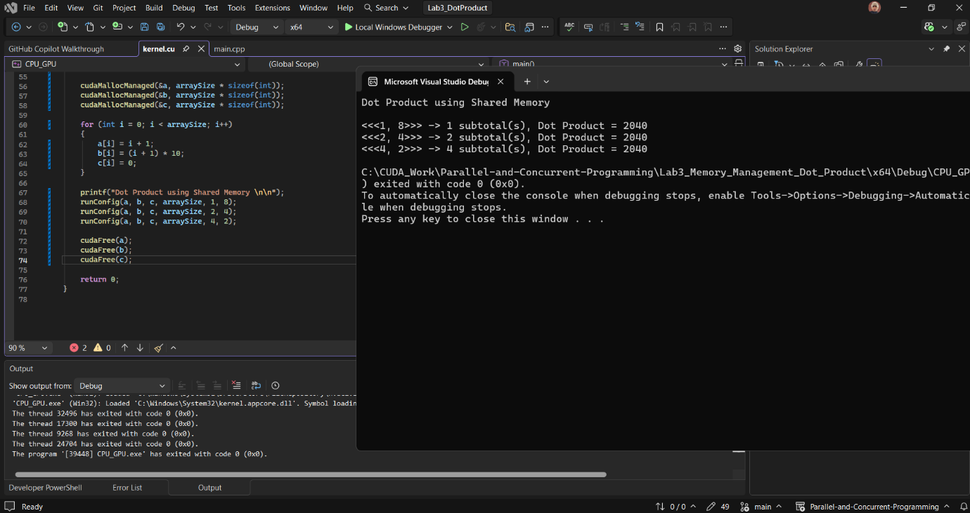
Reflection:
Each thread writes its product into shared memory (dataPerBlock), then __syncthreads() ensures all writes complete before Thread 0 reduces them into a subtotal stored in c[blockIdx.x]. This means the CPU only sums one value per block rather than one per element. All three configurations returned 2040, confirming the approach is correct regardless of how the work is divided across blocks.

