**IOT BASED AIR QUALITY MONITORING SYSTEM**

**TEAM MEMBER**

**710621106005: K.HARI HARAN**

**Phase-1 Document Submission**

**PROJECT: IOT based air quality monitoring system**

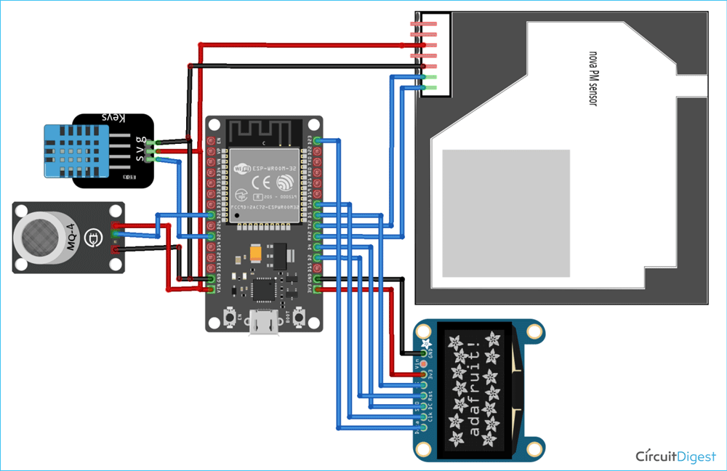

**PROJECT OBJECTIVE**

An IOT-based air pollution monitoring system is a revolutionary solution that can provide accurate and real-time data about the air quality in a particular area. It can help identify the sources of pollution and take necessary measures to reduce it, protecting the environment and human health.

**Phase-1**

So in this project, we are going to build an **ESP32 Air Quality Monitoring** System using Nova PM SDS011 sensor, MQ-7 sensor, and DHT11 sensor. We will also be using an OLED Display module to display Air Quality Values. The **Air Quality Index** (AQI) in India is based on eight pollutants, PM10, PM2.5, SO2 and NO2, CO, Ozone, NH3, and Pb. However, it is not necessary to measure all of the pollutants. So we are going to measure the concentration of PM2.5, PM10, and Carbon Monoxide to calculate the Air Quality Index. The AQI values will be published on Adafruit IO so that we can monitor it from anywhere

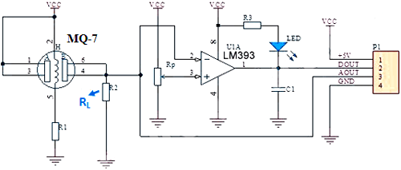

### ****COMPONENTS REQUIRED****

* ESP32
* Nova PM Sensor SDS011
* 0.96’ SPI OLED Display Module
* DHT11 Sensor
* MQ-7 Sensor
* Jumper Wires

**METHODOLOGY**

An IoT-based air and sound pollution monitoring system is implemented using a network of sensors, connectivity technologies, and data analytics platforms. Air quality sensors are deployed in strategic locations to measure pollutant levels such as particulate matter, gases, and volatile organic compounds (VOCs).

**PROBLEM**

Air pollution is one of environmental issues that cannot be ignored. Inhaling pollutants for a long time causes damages in human health. Traditional air quality monitoring methods, such as building air quality monitoring stations, are typically expensive. This project is suitable for air quality monitoring in real time. Design a tool which will sense quality of air and display it in the form of percentage, Sense how much carbon mono-oxide(CO) is present in air and display in the form of percentage, Sense the temperature and display it in degree celcius.

**FUTURE SCOPE**

The future scope for an IoT-based air quality monitoring system is promising and continues to evolve as technology advances and environmental concerns grow. Here are some potential future developments and opportunities in this field

Improved Sensor Technology: IoT-based air quality monitoring systems will benefit from advancements in sensor technology, leading to smaller, more cost-effective, and more accurate sensors. These sensors will be capable of measuring a wider range of air pollutants with higher precision.

Real-time Data Analysis: Enhanced data analytics and machine learning algorithms will enable real-time analysis of air quality data. This will allow for quicker response to pollution events and the development of predictive models for pollution forecasting.

Integration with Smart Cities: Smart city initiatives will integrate air quality monitoring systems into their infrastructure. This will enable better urban planning and management of resources to combat pollution and improve the overall quality of life for city residents.

Healthcare Applications: IoT-based air quality monitoring can have significant applications in healthcare. Continuous monitoring of air quality can help individuals manage respiratory conditions, and healthcare providers can use the data to track and address public health issues related to air pollution.

Environmental Policy and Regulation: Governments and regulatory bodies will increasingly rely on IoT-based air quality monitoring data to formulate and enforce environmental policies and regulations. This will drive the adoption of such systems on a larger scale**.**

**CONCLUSION**

IoT-based air quality monitoring systems hold great promise for the future, driven by technological advancements and the growing importance of environmental sustainability. These systems are poised to play a critical role in improving air quality and public health, as well as informing policy and decision-making. Key takeaways for the future of IoT-based air quality monitoring include:

Sensor Advancements: Expect smaller, more accurate, and cost-effective sensors that can measure a wider range of air pollutants.

Real-time Analysis: Enhanced data analytics and machine learning will enable real-time analysis and predictive modeling for pollution forecasting.

Smart Cities Integration: These systems will be integrated into smart city initiatives, aiding in urban planning and resource management.

Healthcare Applications: IoT-based monitoring will have applications in healthcare for managing respiratory conditions and public health tracking.

Policy and Regulation: Governments will rely on IoT data for environmental policy and regulation, driving adoption.