**Tours & Travels Agency**

**Dr. Babasaheb Ambedkar Marathwada University,**

**Chatrapati Sambhajinagar.**

**S.B.E.S.College of Science, Aurangabad.**

**Department of Computer Science**



**Project Report On**

**“Tours and Travels Agency”**

**Presented By**

**Mr****. Sanmati Gosavi**

**Mr. Darshan Sangwai**

**Project Guided By**

**Mrs. S. M. Choudhari.**

**Year 2022-2023**

**Tours and Travels Agency**

**Dr. Babasaheb Ambedkar Marathwada University,**

**Chatrapati Sambhajinagar.**

**S.B.E.S.College of Science, Aurangabad.**

**Department Of Computer Science 2022-2023**

**Department Of Computer Science & Information Technology**

**2022-2023**



CERTIFICATE

**This is to certify that**

**Mr. Sanmati Gosavi**

**Mr. Darshan Sangwai**

Has Successfully Completed The Project On Tours and travels agency Under The Subject Computer Science Towards The Partial FulfilmentOf The **Bachelor ‘S Degree In Science.BCS.** Course during the Academic Year **2022-2023**

**Project Guided By B.CS Incharge**

**Mrs. S. M. Choudhari. Mr. R.P. Raibole**

**Acknowledgement**

We Wish To Express Our Deep Sense Of Gratitude To Our Guide **Mrs. S.M.Choudhari** for His Valuable Guidance &Kind Co-Operation Through The Period Of Work Hard Undertaken Which Has Been Instrumental In The Success To This Project. We Cordially Thanks To All Those Who Have Contribute His Sincere Co-Operation Directly And Indirectly And Material Help For The Preparation Of This Project. Last But Least We Also Extend Thanks To Our **B.CS. Incharge R.P Raibole** Whose Timely Help Made Our Project A Great Success. We Are Also Thankful To All Our Friends And To All Of Those Who Have Contributed Intellectually And Materially For The Preparation Of Our Project.

**Mr. Sanmati Gosavi Class-B.C.S. 2rd year**

**Roll no:21033**

**Mr. Darshan Sangwai**

**Class-B.C.S. 2rd year**

**Roll no:21091**

**INDEX**

|  |  |
| --- | --- |
| **S.R** | **TITLE** |
| **1.** | **Abstract** |
| **2.** | **Introduction to project** |
| **3.** | **User interview** |
| **4.** | **System requirements ->technical physibility** |
| **5.** | **E-R diagram** |
| **6.** | **Data flow diagram** |
| **7.** | **Conclusion** |

**1.Abstract**

Tours and Travels agency Provides Technical Features For Customers. This Project Has Many Features Which Are Generally Not Available In Stores. Like, Facilities Of Our Website, Blogs, 360 Degree Photos, And Models With Detailed Information.

All The Features Is Available On Our Website With Complete Information. We Provide A Different Sections For Available Tourspackage, For Contacting With Our Team.

We Provides You Different Kinds Of Photos Regarding To tours package Choice With Best Information And The Best Tour Package in our agency.You Will Like Our Interface , And Our Engagement With Our Customers .

**2.Introduction to project**

**Introduction To Project:-**

The project development is not an easy job. Every aspect of the ‘software design’ project should be well analyzed and data should be in a very structured manner. Duplicity of the data should be avoided, to the point and descriptive fields should be taken. I have put my best efforts to computerize the process of Academic System and other relevant details for ready reference to the best of my information about this. It is a very comprehensive and complicated job, which involves many persons; whatever I have analyzed is detailed portion of record entries. The main outcome is shown through the help of different reports.

Various reports that are made in the project are:-

* List of tours package
* List of destination spot

**3.User Interview**

**Interviewer: -** What Is The Primary Reason You Would Visit This Webpage?

**Customer: -** The User Interface, Key Features Of This

Webpage and Most Important Specifications.

**Interviewer: -** What Information Are You Hoping To Find A Webpage?

**Customer**: - I Need Multiple tours package And The Best facilitys provide from agency. I Need To Know The Customer Service.

**Interviewer**: - How Easy Was It To Navigate This Webpage?

Customer: - The Interface Is Good, Using Experience Is Better Than Other Competitive Websites.

**Interviewer**: - What Did You Dislike About This Webpage?

**Customer**: - Nothing Is There Which Is Unlikeable But We Hope It Will Get More Better In Future Updates.

**Interviewer**: - What Do You Like In This?

**Customer**: - Everything Is Good But I Like The Navigation And Designing In This.

**Interviewer**: - How Important Is The Design Of The Webpage To You?

**Customer**: - Designing Always Attracts The New Customers. If Someone Is Providing A Really Good Design The People Will Always Run There.

**Interviewer**: - What Would Make You Come Back To This Webpage Again?

**Customer**: - Especially The Service Which Is Provided By Your Team. The Using Expensive Is Good And It Is Trustworthy To The Every Single Customer. The Multiple Options Of Cars In Different Segment Like SUV, Sedan, and Sport Everything Is Good.

**Interviewer**: - Thank You.

**4.System Requirement Specifications**

System Requirements Specifications Will Always Depend On The Specific Features That Will Provide In Our Websites.

* **Hardware** **requirements:-**

Our Website Is Created With A High Speed And Easy Interface Structure. Gets Executed In Any Condition.

* **Software requirements:-**

This Website Comes With Beautiful Interface And Many Features. This Website Is Created With **HTML** and Designed By **CSS**.

* **Non – functional requirements:-**

This Websites Performs As Per Requirements. This Is Very Easy To Use And Navigate. With A Very User-Friendly Interface. The Webpages Gets Load Very Easily. We Provide You High Security.

**Physibility study -> technical physibility**

This websites is very open for developers. Whenever customers need any changes in our software it’s easy to change. Easy to implement new features. This website is created with interesting and new technology. Easy interface and attracting themes always inspires the developers.

Instead of creating crucial interface and background we provide simple things.

Performance is fast including fast webpage load time.

This website is created with html completely and designed by CSS. Everyone can easily understand programming of this website.

**5.E-R DIAGRAM**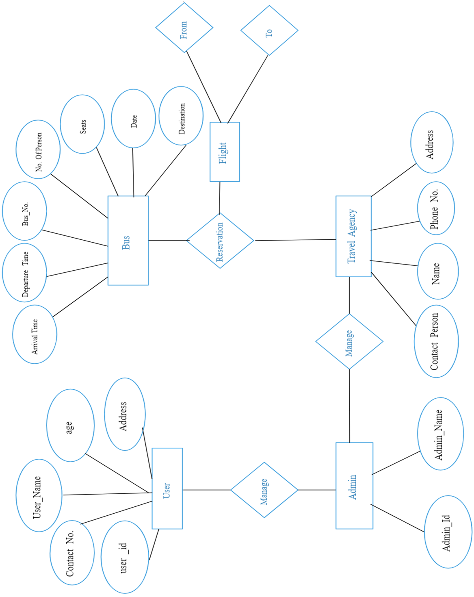

**6.Data flow diagram**

Detailed information

Learn more

Information about creator

All models provided by us

All featured photos

Information about Tours package

Contact

B.M.W

Photo

Blog

Website interface with

Multiple options

Opening the website

**7.Conclusion**

In Conclude The Description About The Project. The Project Developed Using by HTML And CSS and Microsoft .Net Server. Based On The Requirement Of Customer And User. This Website Is Created In HTML and Designed In CSS. This Project Is Always Ready To Future Enhancement.

Car Showroom Website Is Useful For Buyers, Specifically Same Choose Buyers. This Website Is Always Wants Options And Good Secure. For The Past Few Years Car Market Is Expanding So Fast.

If You Want Survive Then You Have To Do Global Steps. Online Market Helps To The User And Customer To Create A Strong Bond And A Good Relation. Online Is Best Option In This Running Business.