用Aui-core+CSS3实现3D骰子JS特效
此js特效是用一个JS框架Aui-core+css3实现的，滚动鼠标滚轮时可以放大，骰子会慢慢的变形一直到可以看骰子里的世界，效果非常棒，因为用css3的缘故，所以网友们在浏览的时间请不要用IE浏览器来运行，为了让网友们看到最终效果请使用谷歌、火狐等浏览打开运行。

CSS3样式代码如下：
#shadow { height:300px; width:600px; position:absolute; top:400px; left:0; z-index:0; background:-webkit-radial-gradient(center center , 150px 50px, #cfcfcf, #efefef ); background:-moz-radial-gradient(center center , 150px 50px, #cfcfcf, #efefef ); background:-ms-radial-gradient(center center , 150px 50px, #cfcfcf, #efefef ); background:-o-radial-gradient(center center , 150px 50px, #cfcfcf, #efefef ); background:radial-gradient(center center , 150px 50px, #cfcfcf, #efefef ); -webkit-transform:perspective(100px) rotateX(60deg) rotateY(0deg); -moz-transform:perspective(100px) rotateX(60deg) rotateY(0deg); -ms-transform:perspective(100px) rotateX(60deg) rotateY(0deg); -o-transform:perspective(100px) rotateX(60deg) rotateY(0deg); transform:perspective(100px) rotateX(60deg) rotateY(0deg); opacity:0;
}
#container {
/*background:black;*/ height:240px; width:240px; position:absolute; top:180px; z-index:1; -webkit-transform-style:preserve-3d; -moz-transform-style:preserve-3d; -ms-transform-style:preserve-3d; -o-transform-style:preserve-3d; transform-style:preserve-3d; -webkit-transform:perspective(2000px) rotateX(-10deg) rotateY(45deg) ; -moz-transform:perspective(2000px) rotateX(-10deg) rotateY(45deg) ; -ms-transform:perspective(2000px) rotateX(-10deg) rotateY(45deg) ; -o-transform:perspective(2000px) rotateX(-10deg) rotateY(45deg) ; transform:perspective(2000px) rotateX(-10deg) rotateY(45deg) ;
}#container p { position:absolute; top:40%; left:35%; padding:5px; word-spacing:0.2em; line-height:20px; background:black; color:#fff; text-align:center;
}#container div {
height:240px; width:240px; position:absolute; left:0; top:0; color:#fff; line-height:240px; text-align:center; font-weight:bold; font-size:80px; cursor:pointer;
background:rgba( 239,239,239, 1 ); -webkit-transition:500ms all ease; -moz-transition:500ms all ease; -ms-transition:500ms all ease; -o-transition:500ms all ease; transition:500ms all ease;
}#container div div { border:1px solid #fff; /* rgba( 255,255,255, 1 ) */ box-shadow:1px 0 3px #fff,1px 0px 10px #efefef; border-radius:8px; background:-webkit-radial-gradient(center, #d81002, #b20c00 ); background:-moz-radial-gradient(center, #d81002, #b20c00 ); background:-ms-radial-gradient(center, #d81002, #b20c00 ); background:-o-radial-gradient(center, #d81002, #b20c00 ); background:radial-gradient(center, #d81002, #b20c00 );
}#container div div:hover { background:-webkit-radial-gradient(center, #f00, #b20c00 ); background:-moz-radial-gradient(center, #f00, #b20c00 ); background:-ms-radial-gradient(center, #f00, #b20c00 ); background:-o-radial-gradient(center, #f00, #b20c00 ); background:radial-gradient(center, #f00, #b20c00 );
}#container div ul { list-style:none; margin:30px;
}#container div li { width: 60px; height:60px; float:left; overflow:hidden; -webkit-transition:500ms all ease; -moz-transition:500ms all ease; -ms-transition:500ms all ease; -o-transition:500ms all ease; transition:500ms all ease;
}
#container div li span {
width:50px; height:50px; margin:5px auto; display:block; background:-webkit-linear-gradient(top, #eee, #fff ); background:-moz-linear-gradient(top, #eee, #fff ); background:-ms-linear-gradient(top, #eee, #fff ); background:-o-linear-gradient(top, #eee, #fff ); background:linear-gradient(top, #eee, #fff ); border-radius:25px; box-shadow:-1px -1px 2px #000;
}

效果如下：
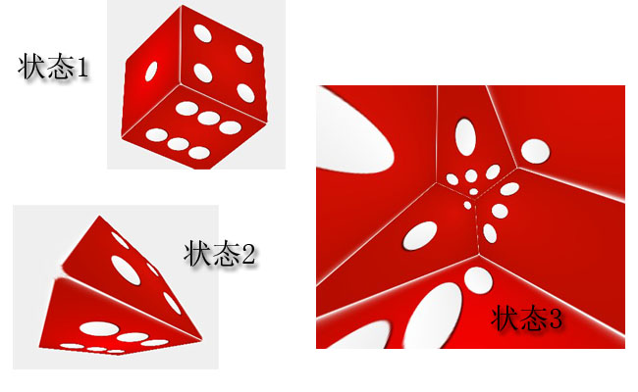

演示地址
分类: CSS3, javascript
标签: 图片3D旋转, css3, 3D特效, Aui-core, js特效

