Hibernate is a Java framework that simplifies the development of Java application to interact with the database. It is an open source, lightweight, ORM (Object Relational Mapping) tool. Hibernate implements the specifications of JPA (Java Persistence API) for data persistence.

The ORM tool internally uses the JDBC API to interact with the database.

## Advantages of Hibernate Framework

Following are the advantages of hibernate framework:

### 1) Open Source and Lightweight

Hibernate framework is open source under the LGPL license and lightweight.

### 2) Fast Performance

The performance of hibernate framework is fast because cache is internally used in hibernate framework. There are two types of cache in hibernate framework first level cache and second level cache. First level cache is enabled by default.

### 3) Database Independent Query

HQL (Hibernate Query Language) is the object-oriented version of SQL. It generates the database independent queries. So you don't need to write database specific queries. Before Hibernate, if database is changed for the project, we need to change the SQL query as well that leads to the maintenance problem.

### 4) Automatic Table Creation

Hibernate framework provides the facility to create the tables of the database automatically. So there is no need to create tables in the database manually.

### 5) Simplifies Complex Join

Fetching data from multiple tables is easy in hibernate framework.

# Hibernate Architecture

The Hibernate architecture includes many objects such as persistent object, session factory, transaction factory, connection factory, session, transaction etc.

The Hibernate architecture is categorized in four layers.

* Java application layer
* Hibernate framework layer
* Backhand api layer
* Database layer

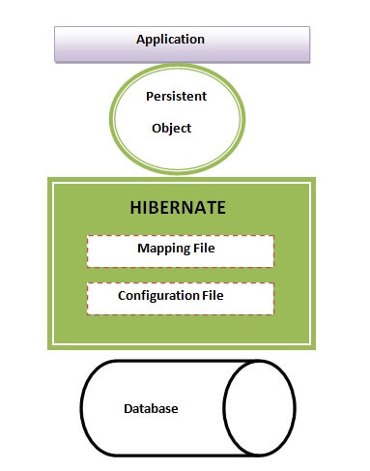€

This is the high level architecture of Hibernate with mapping file and configuration file.

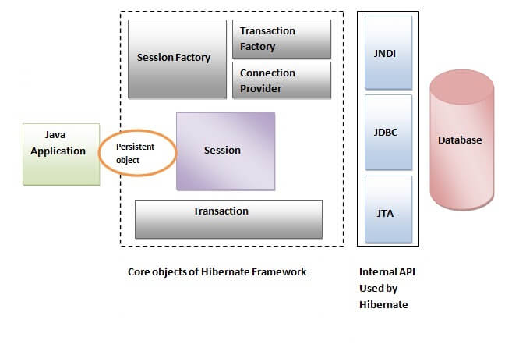

Hibernate framework uses many objects such as session factory, session, transaction etc. alongwith existing Java API such as JDBC (Java Database Connectivity), JTA (Java Transaction API) and JNDI (Java Naming Directory Interface).