# Introduction

This document is a guide for those who are interested in creating an AI Headstamp Sorter machine. This document references resources found in the GitHub Repository at [link to github repo].

Also available is the video build series at: [link to youtube playlist]

## Requirements

Central to this project is the Windows based software which handles the picture classification and builds the machine learning models used for classification. Here is the list of requirements to run the software:

* Windows 10 (x64) or greater
* 64bit processor architecture
* Processor must support AVX instructions (AVX, AVX2, etc). Most processors made after 2015 support it. Most Celeron and Atom processors do not support AVX instructions.
* C++ VS Redistributable
* (2) USB 3.0 or type A ports. (a USB hub can be used if the machine has other USB port types)

## Overview

The AI Headstamp Sorter machine has 3 major components:

* Classifier – The part of the machine which takes a picture of the brass and classifies it. Then it is dropped into the sorter. The camera assembly is included as part of the classifier.
* Sorter – The bottom half of the machine which has a rotary arm with tubes to sort the brass into bins.
* Electronics & Enclosure – The electronics are housed in an enclosure which is powered by an external power supply and connects to the computer using USB.

# Classifier Assembly

## Printing the Classifier Models – General Settings

It is highly recommended that you use Black PLA+ for all components in this project. I have used the JAYO brand of PLA+ with great success. For all models, these are the general print settings that I have used:

* **Nozzle Temp:** 222C
* **Bed Temp:** 60C
* **Layer Height:** .20mm
* **Support overhang angle:** 88 degrees.
* **Support type**: tree
* **Infill**: 30%
* **Infill Pattern**: Lines or Grid

These should be the assumed print settings for all models unless specific changes/overrides are indicated below.

The models account for shrinkage already and though a calibrated printer will give you better dimensional results, if you print all the parts with the same print settings, everything should fit together with minimal post-print modification.

### Classifier

#### Classifier Parts Listing Diagram

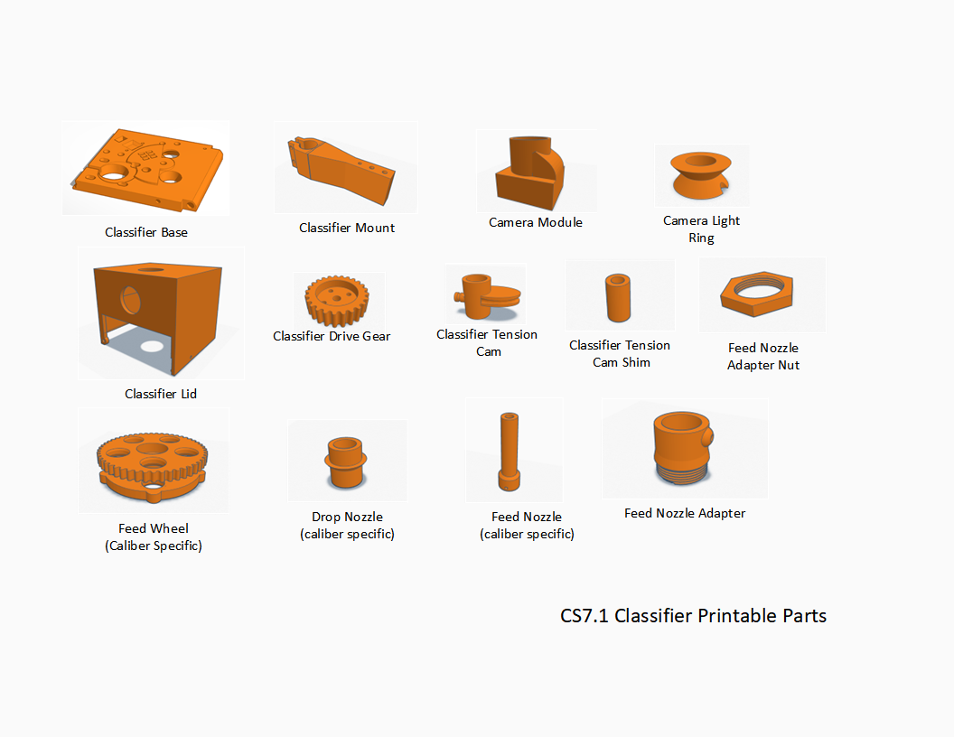

#### Classifier – Base Plate

[Link to Model]

Recommend using black PLA+ but if you decide to use a different color, you will need to “black-out” the bottom of the camera hole and surrounding side surfaces to keep the picture dark. Flat black paint or a sharpy will usually work as these parts do not have any wear.

#### Classifier – Camera Module

**Layer Height:** 1.6mm (or smaller).

The camera module has some very small screw holes to facilitate the m2.5 screws needed to bolt on the blower fan. The more precision you can get out of your printer, the better. Recommended to use Black PLA or PLA+ as any other color will result in less-than-optimal image processing results.

It may also help to slow down your print speed on the first 10 layers of this print to get better screw hole definition.

#### Classifier – Camera Light Ring

**Color Material:** Non-Opaque White PLA.

The purpose of this part is to diffuse the light from the led light strip. The more translucent the material, the better. Generally cheap white PLA works great here.

#### Classifier – Wheel (Caliber Specific)

This wheel can be printed in either orientation however, it is recommended to print the wheel with the bottom (non-geared side) down. If you are printing to a smooth glass bed, this may result in a very shiny bottom on the part and you will need to “scuff” it with some light sandpaper 300-400 grid to avoid reflections from the camera backlight. Using print base with a matte texture is recommended. [see link to magnetic printer surface]

#### Classifier – Drive Gear

This part can be printed in any color you choose. Recommend PLA+ for greater durability but no problems have been reported with just standard PLA.

#### Classifier – Top Lid

This lid was designed for two functions:

1. To support the feed tube mechanism.
2. To block overhead ambient light from leaking into the camera.

It is for this second function that it is recommended that this part also be printed in black.

#### Classifier – Feed Nozzle (Caliber Specific)

Any desired color can be used for this part.

#### Classifier – Tension Cam

* **Layer Height:** .16
* **Infill**: 100%

#### Classifier – Tension Cam Shim

This part should thread snugly onto an M6 bolt or threaded rod. It should also fit loosely in the tension cam. Print the part as is and if there is a fit issue, scale the part up or down by 1% until you get the desired fit. The cam should move freely and easily when installed over this part.

This part should be printed in Black.

#### Classifier – Drop Nozzle (Caliber Specific)

The drop nozzle is designed cancel the rotational effect on the falling brass and allow the brass to drop straight down into the sort tube which as the effect of a smoother/faster sort drop (vs the brass rattling around in the tube and not making it into the desired sort bucket in time. Standard print settings apply but the part should be a press fit into the drop hole. If it is too tight/loose, use scaling in your slicer to upscale/downscale by 1%.

This part is not required but may improve performance. It can be printed in the color of your choosing.

## Assembling the Classifier

[TBD]

# Sorter Assembly

[TBD]

# Electronics and Enclosure Assembly

## Printing the Enclosure Models – General Settings

The electronics enclosures can be printed in any material and color of your choosing. This is entirely personal preference and I make no recommendations here.

#### Enclosure – Box

This box houses the electronics. As long as it is printed to spec, it should match up to existing Arduino uno holes. It is recommended that you should use a support angle of 88 degrees. The only support area needed is the USB hole.

#### Enclosure – Lid

Recommend to print along with the box with the same material so after accounting for shrinkage, everything works.

## Electronics Assembly

Refer to the Parts List section below for the list parts and resources to acquire the needed components to complete this project

**QUICK STEPS**

1. Install 40mm Fan
2. Install PWM Dimmer with 4.7K resistor.
3. Install 12v Jack
4. Install Power switch
5. Install Arduino Uno
6. Install Motor Shield
7. Connect all 12v power lines and ground
   1. Arduino Shield
   2. Dimmer
   3. Fan
   4. Drop Sensor
   5. Wires for Camera Fan
8. Attach motor cables to shield
9. Add Motor controller to shield (TCM2209)
10. Adjust Vref on motors
11. Load Arduino code onto arduino

## Parts List

|  |  |
| --- | --- |
| Electronics and Enclosure Parts |  |
| 12v Jack | * <https://www.amazon.com/gp/product/B091PS6XQ4> * <https://www.amazon.com/gp/product/B07Y8KKSR1/> |
| 12mm Push button switch | * <https://www.amazon.com/gp/product/B06XF6PT9L> * <https://www.amazon.com/Cylewet-Self-Locking-Latching-Button-CYT1091/dp/B075VBV4QH> |
| 12v motor dimmer PWM (led dimmer) | * <https://www.amazon.com/gp/product/B07GP72BWV> |
| Arduino Uno R3 (Genuine Arduino recommended) | * <https://www.amazon.com/ELEGOO-Board-ATmega328P-ATMEGA16U2-Compliant/dp/B01EWOE0UU> * <https://www.amazon.com/Arduino-A000066-ARDUINO-UNO-R3/dp/B008GRTSV6> * <https://www.amazon.com/SunFounder-Board-Arduino-ATMEGA328P-ATMEGA16U2/dp/B08353DL5P> |
| CNC Expansion Shield | * <https://www.amazon.com/WWZMDiB-CNC-Shield-V3-Engraving/dp/B0BQDW1H8Z> * <https://www.amazon.com/Ximimark-Engraver-Printer-Expansion-Arduino/dp/B07L74X18N> * <https://www.amazon.com/Printer-A4988-Expansion-Arduino-Engraver/dp/B09YR2HZP6> |
| (7) 2-pin jumpers | * <https://www.amazon.com/gp/product/B077957RN7> |
| 40mm 12v Fan | * <https://www.amazon.com/gp/product/B07CH6YC32> |
| 12v 5amp Power supply | * <https://www.amazon.com/gp/product/B01GEA8PQA> * <https://www.amazon.com/gp/product/B0711Q5B49> |
| 4.7K Ohm Resistor | * <https://www.amazon.com/California-JOS-4-7K-Tolerance-Resistance/dp/B0B4FXTWWY> |
| Classifier Parts |  |
|  |  |
|  |  |
|  |  |
|  |  |
|  |  |