**s54 – Kadena**

**Milestone 1D - Marketplace Back End**

For the exercise we will buy and sell in fiat and kda at [https://estrellas.54.wtf/](https://estrellas.54.wtf/asset-76212-kda-mainnet-test), demonstrating the capabilities of the backend and indicating the code segments with line numbers where segments start on GitHub available at  
<https://github.com/73kn1k/s54_kadena/blob/main/payment.php>

* We start by login as the user that whants to buy an asset to sell it later;  
  we go to <https://estrellas.54.wtf/asset-76212-kda-mainnet-test>,

pressing on “Get One” and at the pop-up “Pay with Card”

will trigger a backend call code @ payment.php [#50](https://github.com/73kn1k/s54_kadena/blob/bd29cdf545d8f290e11a3b4de9cfc7fceac0c965/payment.php#L50)  
or “Use Chainweaver” triggers call @ payment.php [#156](https://github.com/73kn1k/s54_kadena/blob/bd29cdf545d8f290e11a3b4de9cfc7fceac0c965/payment.php#L156)  
  
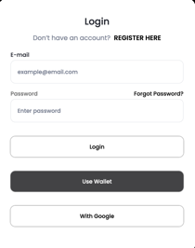 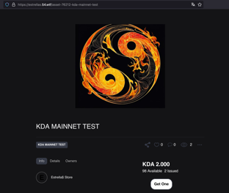 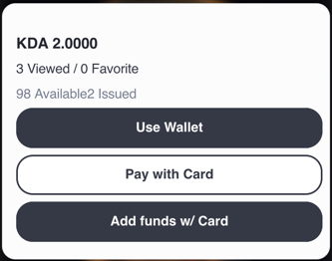 or 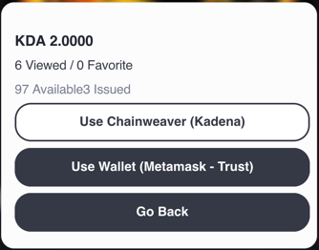

* To carry out the exercise for the secondary market we will put the newly purchased asset up for sale and with another user we will buy it paying with fiat or kda.  
  By paying with card will trigger call @ payment.php [#90](https://github.com/73kn1k/s54_kadena/blob/bd29cdf545d8f290e11a3b4de9cfc7fceac0c965/payment.php#L90)  
  or using chainweaver @ payment.php [#185](https://github.com/73kn1k/s54_kadena/blob/bd29cdf545d8f290e11a3b4de9cfc7fceac0c965/payment.php#L185)  
    
   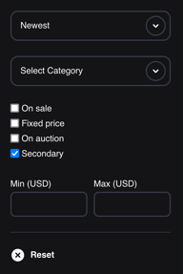 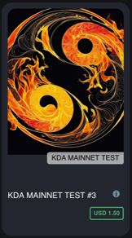 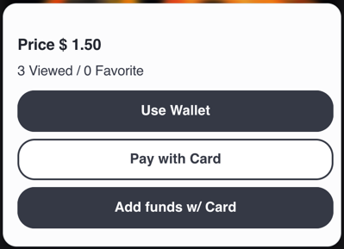 or 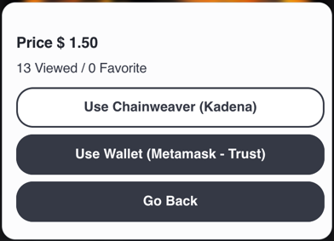
* To perform an asset transfer between wallets we will click “Transfer” at the desired asset and at the pop-up introducing the receivers wallet triggering so a call @ payment.php [#235](https://github.com/73kn1k/s54_kadena/blob/bd29cdf545d8f290e11a3b4de9cfc7fceac0c965/payment.php#L235)  
    
  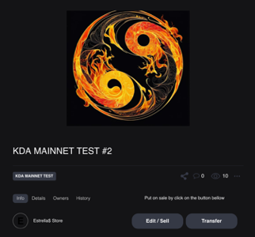 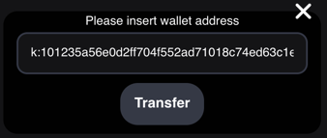
* To make a withdrawal of the profits from sales or resales. We access our profile and press “Withdraw” witch triggers a call @ payment.php [#251](https://github.com/73kn1k/s54_kadena/blob/bd29cdf545d8f290e11a3b4de9cfc7fceac0c965/payment.php#L251)

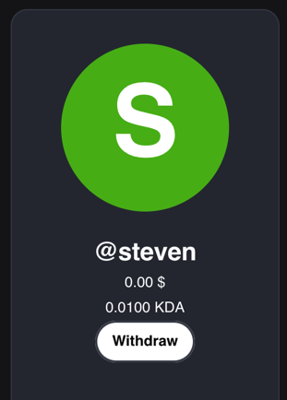 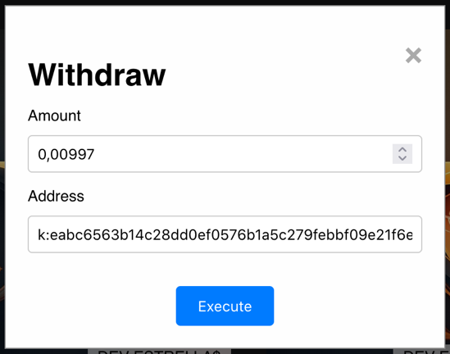

* Addressing “indexing” we have two methods, our own and a third party.

They can be found at the desired asset by clicking on Details or Owners  
  
own indexing third party indexing( clicking on collection ID )  
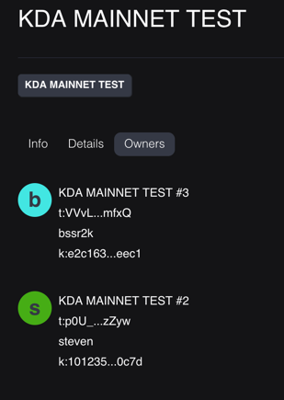 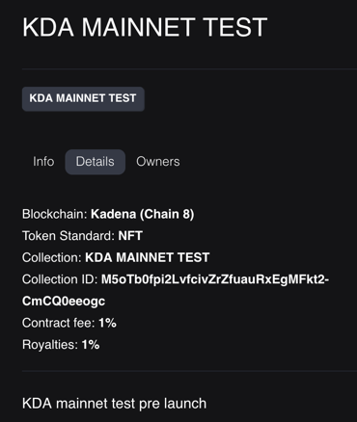 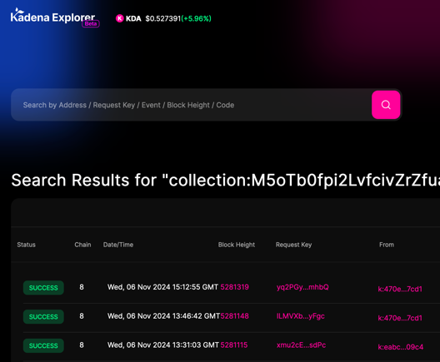

* The policy used for on-chain royalties distribution can be found at:  
  <https://explorer.chainweb.com/mainnet/txdetail/fGaf2zqXgkabAmAUPiS38nfFEKcYUQcdoJswxnZpVA8>

or at the module explorer on mainnet chain 8:  
“n_bc7a2c08104706e8d02a01db35bfda1e5cb297f2. nft-policy-v1”