Assignment 4

Becoming an Independent Data Scientist

1 Region and Domain

State the region and the domain category that your data sets are about.

. States of India

. Pandemic: C0VID-19

2. Research Question

You must state a question about the domain category and region that you identified as being

interesting.

Q.) What is the correlation between the all the states of India and these topics:

(COVID-19 cases, Number of Beds available, State wise Testing Details in India,

State wise Population of India) to according to "Population_India_Census2011"

over all states of India?

3. Links

# You must provide at least two links to publicly accessible datasets. These could be links

# To files such as CSV or Excel files, or links to websites which might have data in tabular

# form, such as Wikipedia pages.

# 1. COVID_19_India: - (https://www.kaggle.com/sudalairajkumar/covid19-in-india?select=covid_19_india.csv)

# 2. Hospital Beds India: - (https://www.kaggle.com/sudalairajkumar/covid19-in-india?select=HospitalBedsIndia.csv)

# 3. ICMR testing Labs: - (https://www.kaggle.com/sudalairajkumar/covid19-in-india?select=ICMRTestingLabs.csv)

# 4. State wise testing: - (https://www.kaggle.com/sudalairajkumar/covid19-in-india?select=StatewiseTestingDetails.csv)

# 5. Population India: - (https://www.kaggle.com/sudalairajkumar/covid19-in-india?select=population_india_census2011.csv)

# 4. Image

# You must upload an image which addresses the research question you stated. In

# addition to addressing the question, this visual should follow Cairo’s principles of truthfulness, functionality, beauty, and insightfulness.

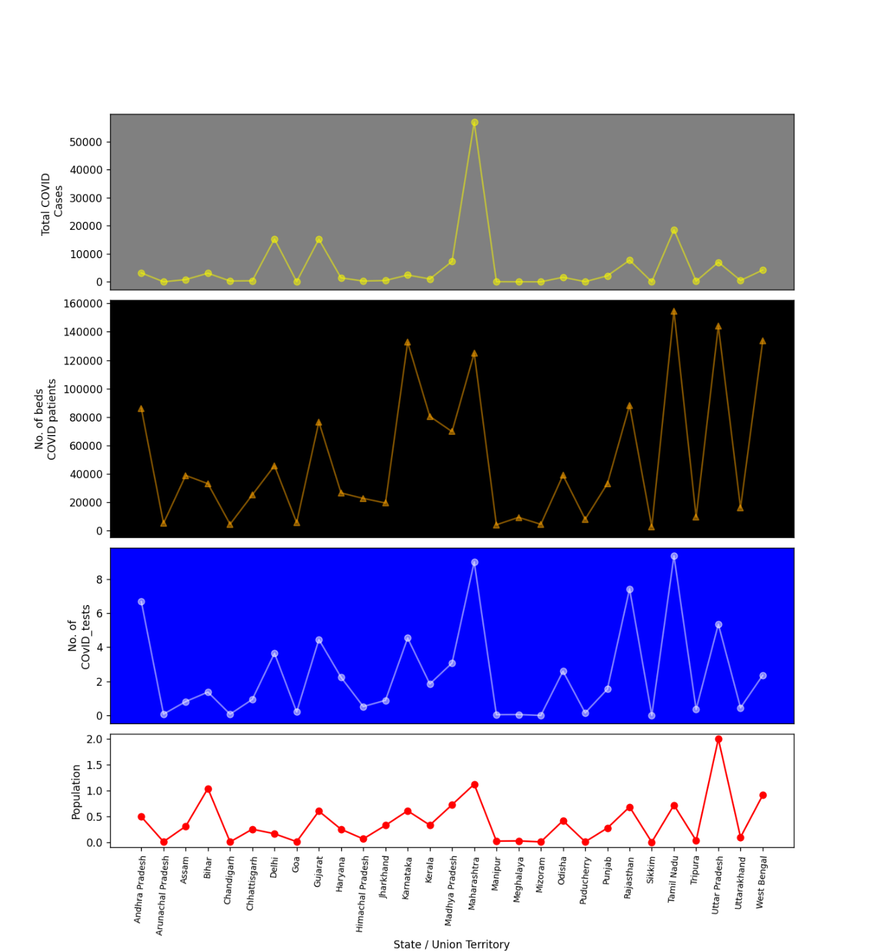

5 Discussion

You must contribute a short (1-2 paragraph) written justification of how your visualization addresses your stated research question.

This visualization was concerned with answering the question that comparison between the Statistics of all states of India and (COVID-19 cases, Number of Beds available, State-wise Testing Details in India, State-wise Population of India). Each plot indicates the statistics of the matter of fact that plays an important role in this phase of Pandemic. The reason behind choosing this topic is the whole world is suffering from COVID-19 and the vaccine is not yet come in the picture. The Mentioned subplot is directly relatable with controlling the effect of COVID-19. Each subplot has its level of importance.

**Do’s**: - Standard recommendations to prevent infection spread include regular hand washing, covering mouth and nose when coughing and sneezing, thoroughly cooking meat and eggs. Avoid close contact with anyone showing symptoms of respiratory illness such as coughing and sneezing.

(This is the out of the topic)

This visualization gives the depth report of this pandemic condition in India.