Tran Tuan Anh

CT0286273

FT-DipIT-45

Introduction to Multimedia and the Internet

Malarkodi

Assessment 2: Individual Assignment

Travel destinations – Ninh Kieu Quay

Assignment 2 - CT0286273

NINH KIEU QUAY

1. Introduction:

Ben Ninh Kieu – Ninh Kieu Quay, it is one of famous place in Can Tho City, when you take the boat trip to visit Cai Rang Floating market, you will know Ben Ninh Kieu where and how is it. For local people Ben Ninh Kieu is one of the featured culture and character of Can Tho People.

Ninh Kieu Quay in Vietnamese call “Bến Ninh Kiều”, it is one of famous place in Can Tho City, this is a part of Can Tho city with renowned proverbs, It is said that:

*“Can Tho has Ninh Kieu quay*

*Has also a beautiful river*

*And many pretty women”*

Ninh Kieu quay which is located on the bank of Can Tho river, now has Ben Ninh Kieu become a 7000m2 park which serves multi-functional purposes of locals and visitors. The statue of Uncle Ho, made from bronze, 7.2 m in height, 13 tons in weight, is put in the middle of the park with a holly meaning, so this is the place locals celebrate meetings to memorize him. By mid-december of lunar calendar annually, a special flower market has been organized at Ninh Kieu quay. Besides, Ninh Kieu quay also includes many other constructions such as Can Tho ancient market, Can Tho floating restaurant (yacht), ect.

* **Objectives:**

The website aim is introducing widely to the domestic and foreign tourists more interesting information about Ninh Kieu and a part of Can Tho culture as well.

Website is designed as simple, as most memorable images and attracting people. Create more interactions than the traditional webs, simple layout reducing unnecessary icons. Giving viewers a glimpse over the web interface.

Making a website to introduce about Ninh Kieu harbor, focus on Ninh Kieu harbor – one of the most famous places in Can Tho city.

The website aim is introducing widely to the domestic and foreign tourists more interesting information about Ninh Kieu and a part of Can Tho culture as well.

2. Story board:

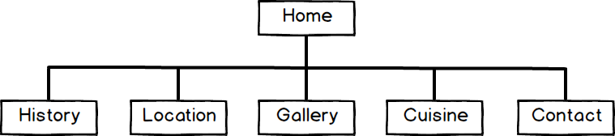* **Structure Chart**

**\* Outline design - Home page:** in this page you can see the main interface for online-users, with background music and menu taskbar which place you can choose which page you want to see.

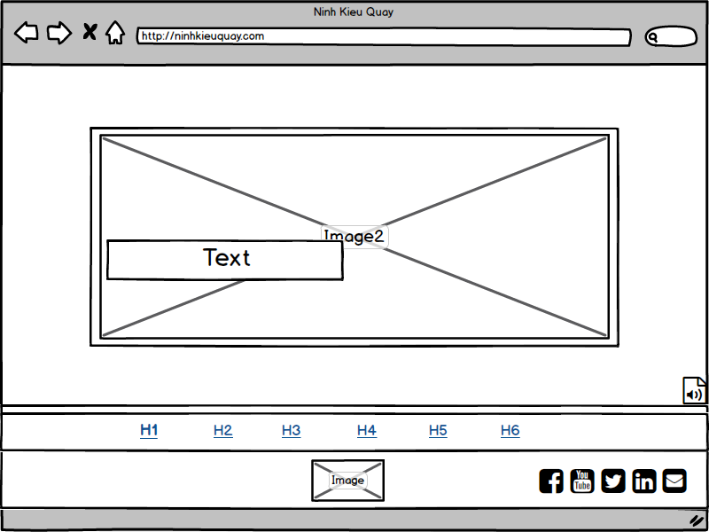

|  |  |  |
| --- | --- | --- |
| **Field** | **Description** | **Data type** |
| Image2 | Showing the image slider of Ninh Kieu Quay | Image |
| Text | Showing the text following image | Text |
| Audio | Website’s soundtrack | Audio |
| H1 | Hyperlink to Home | Hyperlink |
| H2 | Hyperlink to History | Hyperlink |
| H3 | Hyperlink to Location | Hyperlink |
| H4 | Hyperlink to Gallery | Hyperlink |
| H5 | Hyperlink to Cuisine | Hyperlink |
| H6 | Hyperlink to Contact | Hyperlink |
| Image | Logo of website | Image |

**Output design - Home page** :

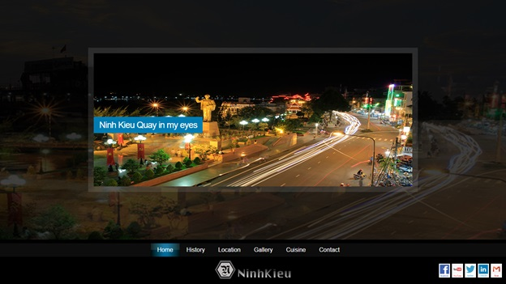

* **Outline design - History page:** history page is the page I want introduce everything about history of Ninh Kieu Quay, from the beginning until now and short introduce about the meaning when create this website.

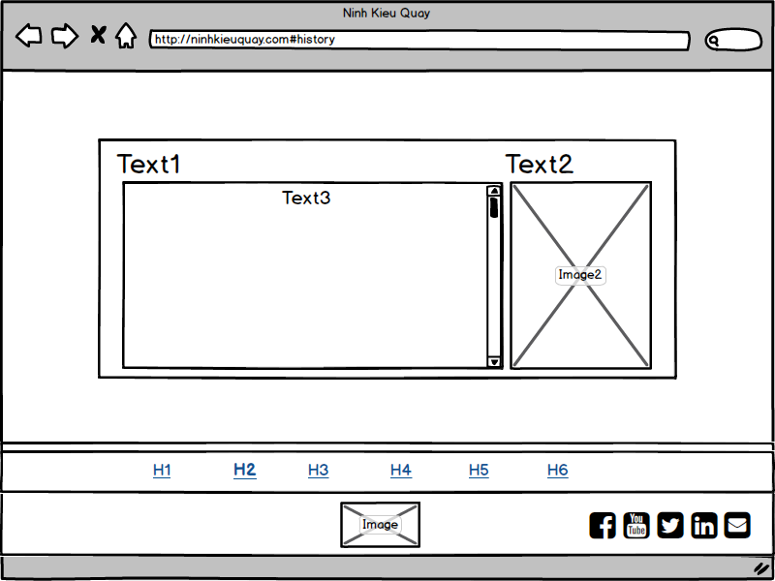

|  |  |  |
| --- | --- | --- |
| **Field** | **Description** | **Data type** |
| Text1 | Title of Text3 | Text |
| Text2 | Title of Image2 | Text |
| Text3 | Short introduce about history of Ninh Kieu Quay | Text |
| Image2 | Showing the image of Ninh Kieu Quay | Image |
| H1 | Hyperlink to Home | Hyperlink |
| H2 | Hyperlink to History | Hyperlink |
| H3 | Hyperlink to Location | Hyperlink |
| H4 | Hyperlink to Gallery | Hyperlink |
| H5 | Hyperlink to Cuisine | Hyperlink |
| H6 | Hyperlink to Contact | Hyperlink |
| Image | Logo of website | Image |

**Output design - History page:**

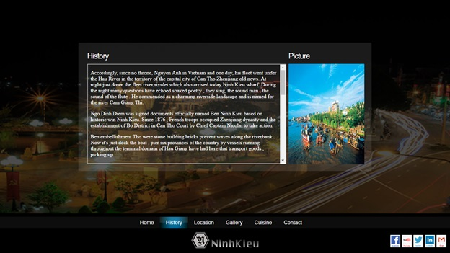

* **Outline design - Location page:** location page is the page let you know where is Ninh Kieu Quay through google map, including two videos of that place.

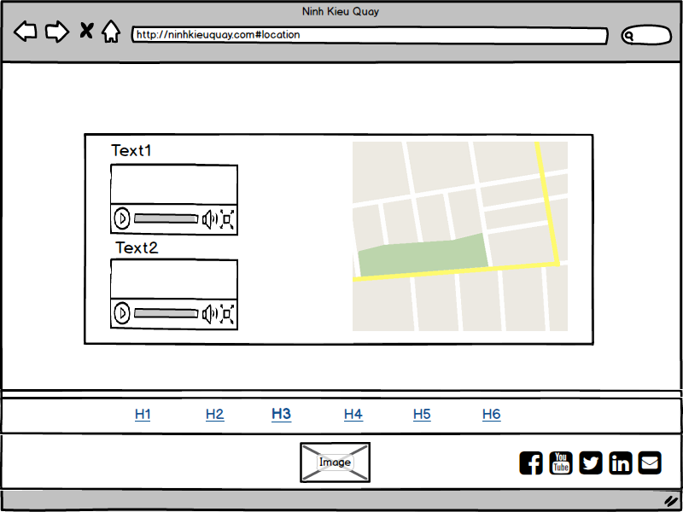

|  |  |  |
| --- | --- | --- |
| **Field** | **Description** | **Data type** |
| Text1 | Title of Image2 | Text |
| Video1 | Showing the video of Ninh Kieu Quay | Video |
| Text2 | Title of Image3 | Text |
| Video2 | Showing the video of Ninh Kieu Quay | Video |
| Map | Showing the locate of Ninh Kieu Quay | Map |
| H1 | Hyperlink to Home | Hyperlink |
| H2 | Hyperlink to History | Hyperlink |
| H3 | Hyperlink to Location | Hyperlink |
| H4 | Hyperlink to Gallery | Hyperlink |
| H5 | Hyperlink to Cuisine | Hyperlink |
| H6 | Hyperlink to Contact | Hyperlink |
| Image | Logo of website | Image |

**Outline design - Location page:**

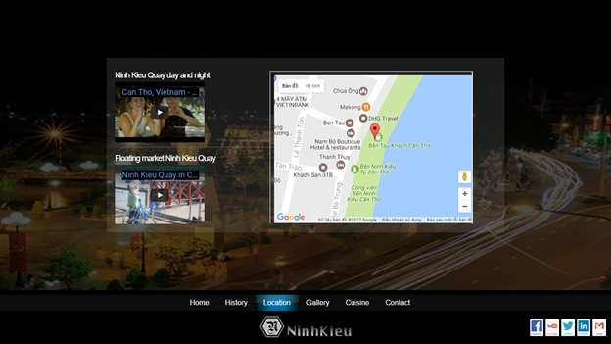

* **Outline design - Gallery page:** gallery page is the page where introduce some gallery about Ninh Kieu Quay. It’s also show the image slider when user click on any image.

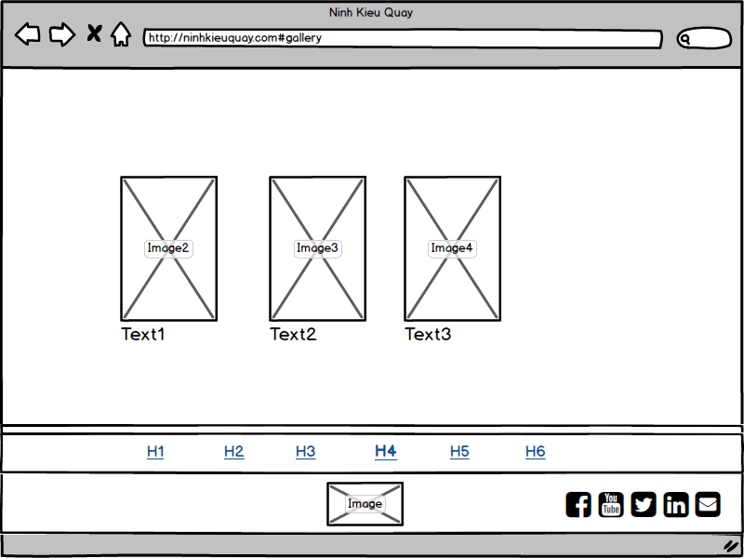

|  |  |  |
| --- | --- | --- |
| **Field** | **Description** | **Data type** |
| Image2 | Showing the image of Ninh Kieu Quay | Image |
| Text1 | Title of Image2 | Text |
| Image3 | Showing the image of Ninh Kieu Quay | Image |
| Text2 | Title of Image3 | Text |
| Image4 | Showing the image of Ninh Kieu Quay | Image |
| Text3 | Title of Image4 | Text |
| H1 | Hyperlink to Home | Hyperlink |
| H2 | Hyperlink to History | Hyperlink |
| H3 | Hyperlink to Location | Hyperlink |
| H4 | Hyperlink to Gallery | Hyperlink |
| H5 | Hyperlink to Cuisine | Hyperlink |
| H6 | Hyperlink to Contact | Hyperlink |
| Image | Logo of website | Image |

**Output design - Gallery page:**

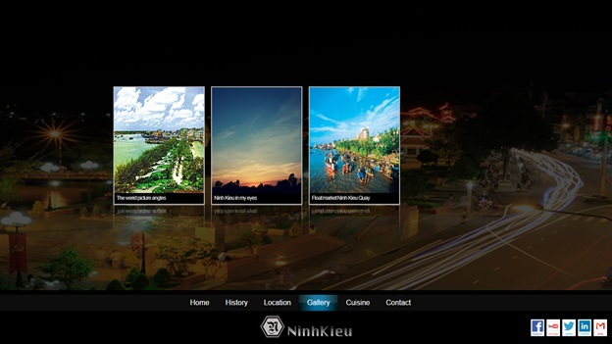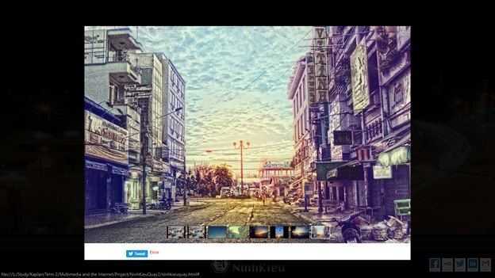

* **Outline design - Cuisine page:** cuisine page is where will show some special cuisine likes street foods having at Ninh Kieu Quay.

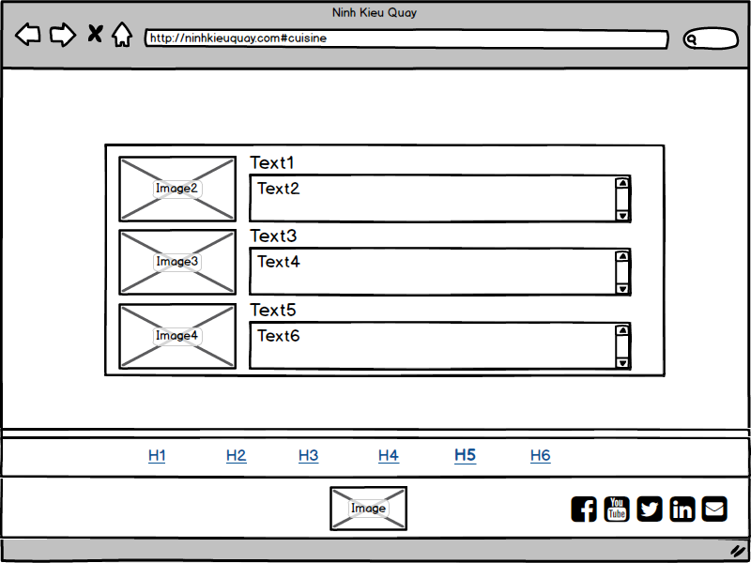

|  |  |  |
| --- | --- | --- |
| **Field** | **Description** | **Data type** |
| Image2 | Showing the image of cuisine | Image |
| Text1 | Title of Image2 | Text |
| Text2 | Short information of Image2 | Text |
| Image3 | Showing the image of cuisine | Image |
| Text3 | Title of Image3 | Text |
| Text4 | Short information of Image3 | Text |
| Image4 | Showing the image of cuisine | Image |
| Text5 | Title of Image4 | Text |
| Text6 | Short information of Image4 | Text |
| H1 | Hyperlink to Home | Hyperlink |
| H2 | Hyperlink to History | Hyperlink |
| H3 | Hyperlink to Location | Hyperlink |
| H4 | Hyperlink to Gallery | Hyperlink |
| H5 | Hyperlink to Cuisine | Hyperlink |
| H6 | Hyperlink to Contact | Hyperlink |
| Image | Logo of website | Image |

**Output design - Cuisine page:**

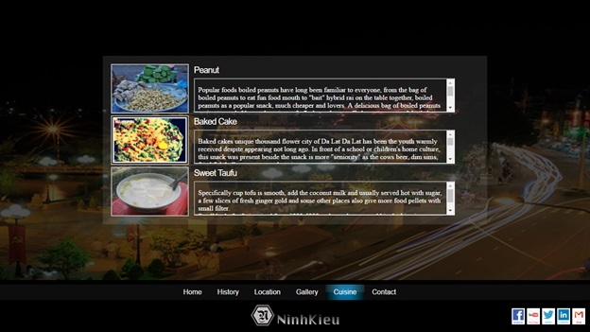

* **Outline design - Contact page:** in this page you can send feedback, comment, ask any question or any idea about our website.

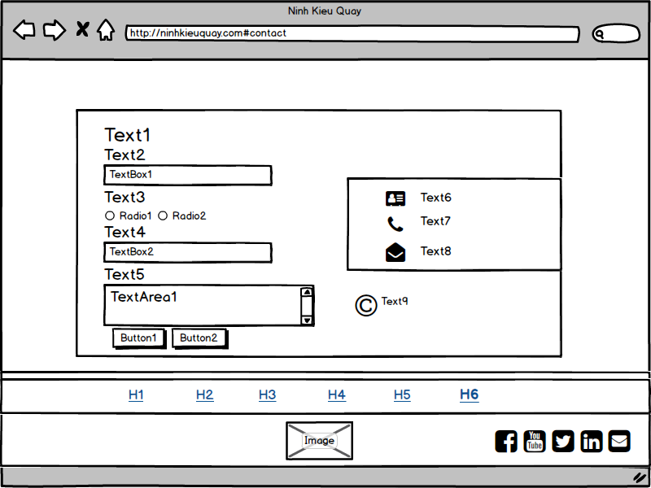

|  |  |  |
| --- | --- | --- |
| **Field** | **Description** | **Data type** |
| Text1 | Title of Page | Text |
| Text2 | Title of TextBox1 | Text |
| TextBox1 | To accept name from user | Text Box |
| Text3 | Title of Radio1, 2 | Text |
| Radio1 | Gender-Male | Radio |
| Radio2 | Gender-Female | Radio |
| Text4 | Title of TextBox2 | Text |
| TextBox2 | To accept email from user | Text Box |
| Text5 | Short information of TextArea1 | Text |
| TextArea1 | To accept feedback from user | Text Area |
| Button1 | Send all data of textboxs to server | Button |
| Button2 | Clear all textboxs | Button |
| Text6 | Web creator’s information | Text |
| Text7 | Web creator’s phone number | Text |
| Text8 | Web creator’s email address | Text |
| Text9 | Web copyright | Text |
| H1 | Hyperlink to Home | Hyperlink |
| H2 | Hyperlink to History | Hyperlink |
| H3 | Hyperlink to Location | Hyperlink |
| H4 | Hyperlink to Gallery | Hyperlink |
| H5 | Hyperlink to Cuisine | Hyperlink |
| H6 | Hyperlink to Contact | Hyperlink |
| Image | Logo of website | Image |

**Outline design - Contact page:**

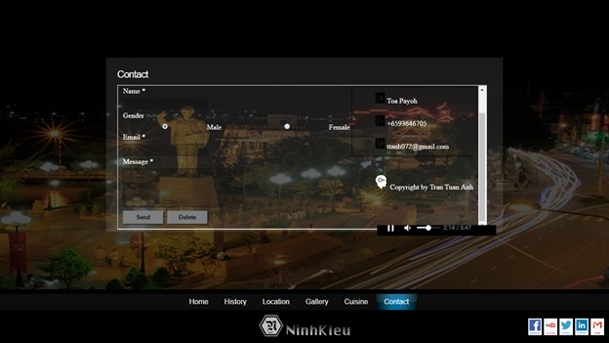

*Reference List:

Diploma Programme – Introduction to Multimedia and the Internet

https://www.w3schools.com/

Music & video:

Can Tho, Vietnam - Floating market and more... - www.saapro.com.vn

Ninh Kieu Quay in Can Tho - Maze Vietnam

Mien Tay que toi - Duong Dinh Tri

Icon & image:

http://www.flaticon.com/free-icons/

jQuery & CSS:

Background Stretcher jQuery Plugin © 2011 ajaxBlender.com

jQuery Nivo Slider © 2011, Gilbert Pellegrom

Pascal Theme © Gilbert Pellegrom & Pascal Gartner

jScrollPane © 2010 Kelvin Luck

jCarousel © 2006 Jan Sorgalla

jQuery Easing © 2008 George McGinley Smith

jquery bgpos © Alexander Farkas

Background Stretcher jQuery Plugin © 2011 ajaxBlender.com

Fullscreen Slideshow jQuery Plugin © Sam Dunn / One Mighty Roar (www.onemightyroar.com)

jQuery v1.7.2 © jquery.org/license

QueryLoader © 2011 - Gaya Kessler

prettyPhoto © Stephane Caron

google map and youtube API