INSTALL GUIDE
….̴…..
Guide Installing the necesssary software
INSTALL IIS( Internet Information Service )

Configuration requirements

IIS in Windows is the option be activated in “Windowns Feature”.To Install IIS press attention Windowns + R or Start -> Run , Next Enter Keyword “appwiz.cpl” and press Enter
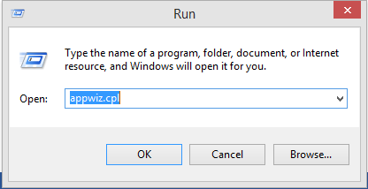

Picture Step 1

This will help you open the Control Pannel’s Program and Features , click the link “ Turn Windows features on or off ”

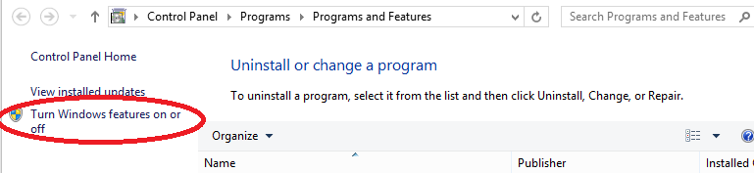
Picture step 2
Dialog “ Program and features ” appears after you click on “ Turn Windows features on or off ” , then you click “ Internet Information Service ”
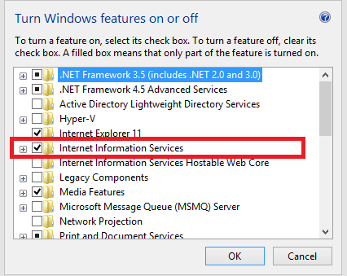
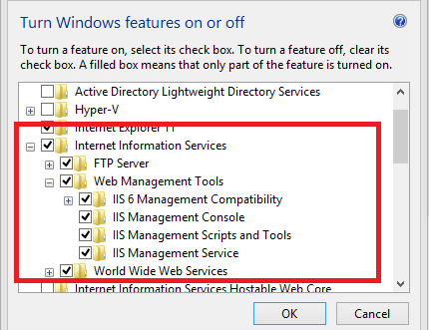
Picture step 3
Then click to OK to start the installation process ,after completion of open web browser and type the address http://localhost/ you see display like

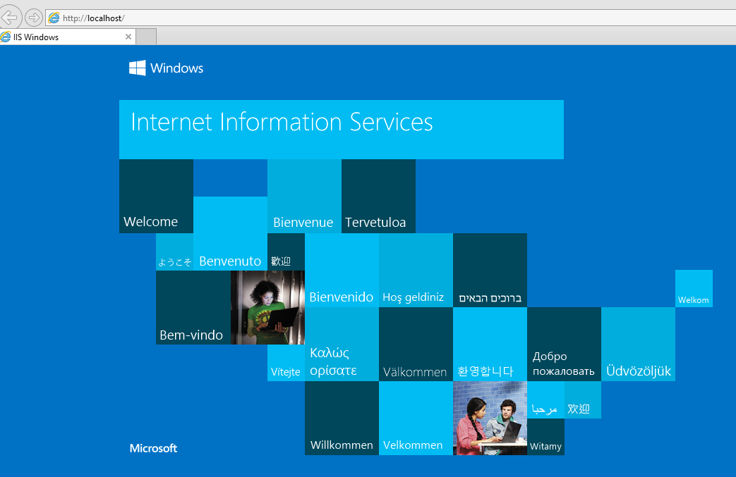
Picture

PUBLISH ASP.NET WEBSITE IN IIS ON LOCALHOST
Step 1 : Run IIS by typing the command in inetmgr in Windows command prompt as shown in the picture belows:
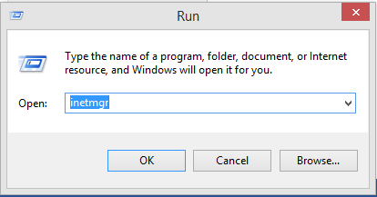
Picture step 1
Step 2 : In IIS right click on Site Node and then Add Web Site as shown in the diagram below:
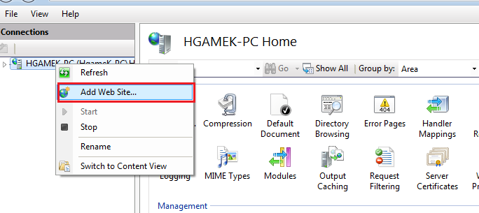
Picture step 2

Step 3 : Inside Add Website Windows type the name of website under Site name and in Physical path select the location of the website on the local system as shown in the picture below:
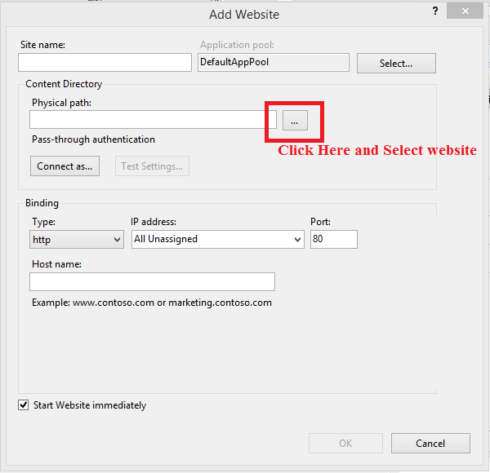
Picture step 3

Step 4: Select the path to the folder containing websitewith name StarSecurityService
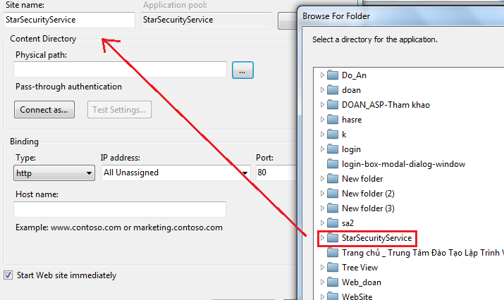
Picture step 4
Step 5: Under Binding change the port Number from 80 as it is the default port and assigned to Default website in IIS. You can set it according to your choice as shown in the picture below and then click on OK button:
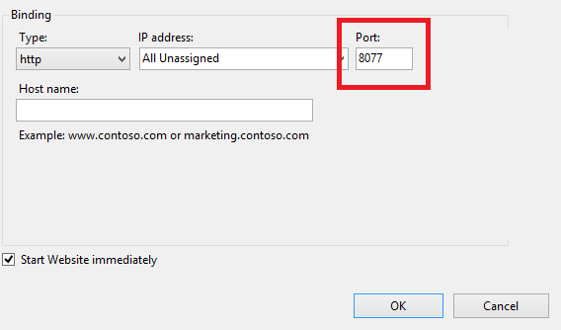
Picture step 5
Step 6: Next select the Application Pools in the left side in IIS then Right click on the Name of website added in the previous step and then select Advanced Settings as shown in the picture below:
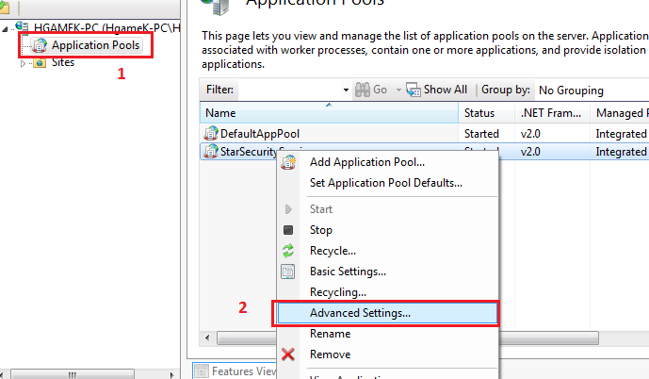
Picture step 6
Step 7: In the Advanced Settings select the .Net Framework Version 4.0 and then click on OK button as shown in the picture below:
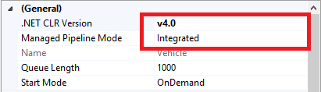
Picture step 7
Step 8: Select the website and then Double Click on Directory Browsing and Enable it as shown below:
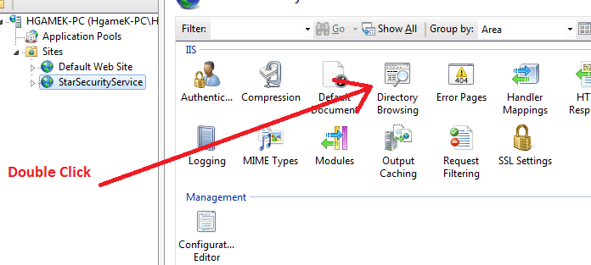
Picture step 8
Step 9: Now the whole procedure of adding website is done now to check the site in browser Right click on the website you added in IIS then go to Manage Web Site and then click on Browse as shown in the diagram:
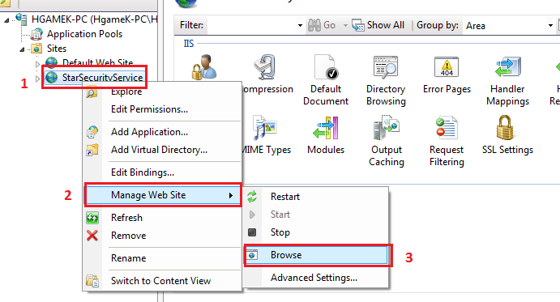
Picture step 9

ATTACH DATABASE
Step 1 : Connect Database : Start > SQL Server Managements Studio as shown in the picture below.
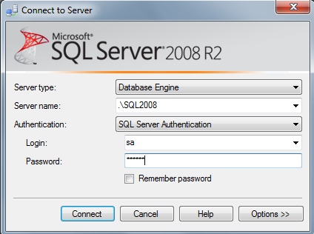
Picture step 1
Step 2 : click Connect button .In Database Right click Attach as shown in the picture below
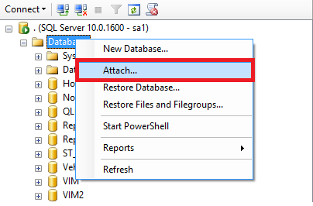
Picture step 2

Step 3 : Click Add button as shown in the picture below
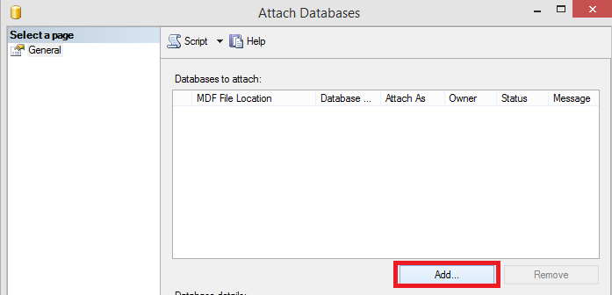
Picture step 3
Step 4 : Select the path to the folder containing StarSecurityDB.mdf click OK button as shown in the picture below
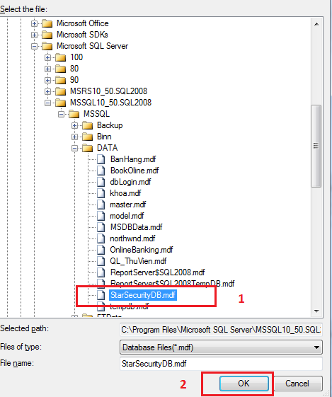

Picture step 4
Step 5 : check Database StarSecurityDB appear . If not appear right click Refresh as shown in the picture below
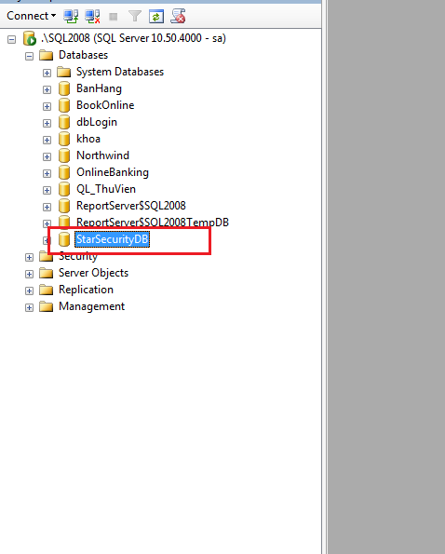
Picture step final
Login
Open website
Click login button to login:


Then you can enter User name: Star1
Password: 12345
To login as administrator of website
*Note:
1. We use jquery library and AjaxControlToolkit.dll for this project
2. Enable JavaScript in the Web browser
3. We create database in SQL2005 then you just attach with the version higher
4. We create website in Microsoft Visual Studio 2008
5. You must have .NetFramework 3.5 or the version higher to run this project

