《数据库系统》SQL实习

用SQL进行数据定义与数据操纵--实验报告

学号：161250049 姓名：金鑫 联系方式：15996065160

实验环境

[如果自己选择DBMS，请简明扼要地介绍你使用的操作系统、软件版本]

Window10

Mysql

实验过程

[实验的详细过程，必须包含所有SQL语句和要求的实验截图]

1. **使用SQL语句创建sys数据库中的四张基本表：Customers, Agents, Products, Orders**

CREATE TABLE `sys`.`customers` (

`cid` CHAR(4) NOT NULL,

`cname` VARCHAR(13) NULL,

`city` VARCHAR(20) NULL,

`discnt` REAL,

PRIMARY KEY (`cid`));

CREATE TABLE `sys`.`agents` (

`aid` CHAR(4) NOT NULL,

`aname` VARCHAR(13) NULL,

`city` VARCHAR(20) NULL,

`percent` DECIMAL(5,1) NULL,

PRIMARY KEY (`aid`));

CREATE TABLE `sys`.`products` (

`pid` CHAR(4) NOT NULL,

`pname` VARCHAR(13) NULL,

`city` VARCHAR(20) NULL,

`quantity` INT NULL,

`price` REAL NULL,

PRIMARY KEY (`pid`));

CREATE TABLE `sys`.`orders` (

`ordno` CHAR(5) NOT NULL,

`month` VARCHAR(5) NULL,

`cid` CHAR(4) NULL,

`aid` CHAR(4) NULL,

`pid` CHAR(4) NULL,

`qty` INT NULL,

`dollars` REAL NULL,

PRIMARY KEY (`ordno`));

2.1向Customers表插入下列数据：

INSERT INTO `sys`.`customers` (`cid`, `cname`, `city`, `discnt`) VALUES ('c001', 'Tiptop', 'Duluth', '10.00');

INSERT INTO `sys`.`customers` (`cid`, `cname`, `city`, `discnt`) VALUES ('c002', 'Basics', 'Dallas', '12.00');

INSERT INTO `sys`.`customers` (`cid`, `cname`, `city`, `discnt`) VALUES ('c003', 'Allied', 'Dallas', '8.00');

INSERT INTO `sys`.`customers` (`cid`, `cname`, `city`, `discnt`) VALUES ('c004', 'ACME', 'Duluth', '8.00');

INSERT INTO `sys`.`customers` (`cid`, `cname`, `city`, `discnt`) VALUES ('c006', 'ACME', 'Kyoto', '0.00');

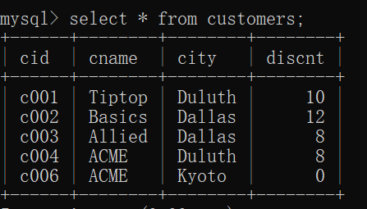

2.2向Agents表插入下列数据：

INSERT INTO `sys`.`agents` (`aid`, `aname`, `city`, `percent`) VALUES ('a01', 'Smith', 'New York', '6');

INSERT INTO `sys`.`agents` (`aid`, `aname`, `city`, `percent`) VALUES ('a02', 'Jones', 'Newark', '6');

INSERT INTO `sys`.`agents` (`aid`, `aname`, `city`, `percent`) VALUES ('a03', 'Brown', 'Tokyo', '7');

INSERT INTO `sys`.`agents` (`aid`, `aname`, `city`, `percent`) VALUES ('a04', 'Gray', 'New York', '6');

INSERT INTO `sys`.`agents` (`aid`, `aname`, `city`, `percent`) VALUES ('a05', 'Otasi', 'Duluth', '5');

INSERT INTO `sys`.`agents` (`aid`, `aname`, `city`, `percent`) VALUES ('a06', 'Smith', 'Dallas', '5');

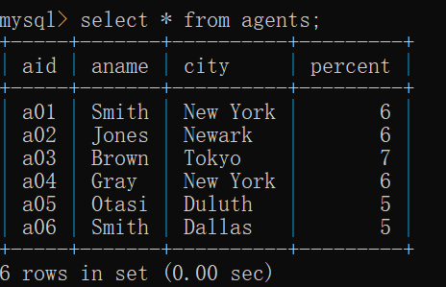

2.3向Products表插入下列数据：

INSERT INTO `sys`.`products` (`pid`, `pname`, `city`, `quantity`, `price`) VALUES ('p01', 'comb', 'Dallas', '111400', '0.50');

INSERT INTO `sys`.`products` (`pid`, `pname`, `city`, `quantity`, `price`) VALUES ('p02', 'brush', 'Newark', '203000', '0.50');

INSERT INTO `sys`.`products` (`pid`, `pname`, `city`, `quantity`, `price`) VALUES ('p03', 'razor', 'Duluth', '150600', '1.00');

INSERT INTO `sys`.`products` (`pid`, `pname`, `city`, `quantity`, `price`) VALUES ('p04', 'pen', 'Duluth', '125300', '1.00');

INSERT INTO `sys`.`products` (`pid`, `pname`, `city`, `quantity`, `price`) VALUES ('p05', 'pencil', 'Dallas', '221400', '1.00');

INSERT INTO `sys`.`products` (`pid`, `pname`, `city`, `quantity`, `price`) VALUES ('p06', 'folder', 'Dallas', '123100', '2.00');

INSERT INTO `sys`.`products` (`pid`, `pname`, `city`, `quantity`, `price`) VALUES ('p07', 'case', 'Newark', '100500', '1.00');

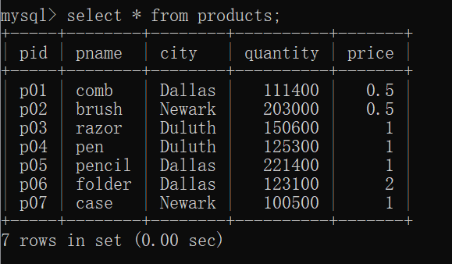

2.4向Orders表插入下列数据：

INSERT INTO `sys`.`orders` (`ordno`, `month`, `cid`, `aid`, `pid`, `qty`, `dollars`) VALUES ('1011', 'jan', 'c001', 'a01', 'p01', '1000', '450.00');

INSERT INTO `sys`.`orders` (`ordno`, `month`, `cid`, `aid`, `pid`, `qty`, `dollars`) VALUES ('1012', 'jan', 'c001', 'a01', 'p01', '1000', '450.00');

INSERT INTO `sys`.`orders` (`ordno`, `month`, `cid`, `aid`, `pid`, `qty`, `dollars`) VALUES ('1019', 'feb', 'c001', 'a02', 'p02', '400', '180.00');

INSERT INTO `sys`.`orders` (`ordno`, `month`, `cid`, `aid`, `pid`, `qty`, `dollars`) VALUES ('1017', 'feb', 'c001', 'a06', 'p03', '600', '540.00');

INSERT INTO `sys`.`orders` (`ordno`, `month`, `cid`, `aid`, `pid`, `qty`, `dollars`) VALUES ('1018', 'feb', 'c001', 'a03', 'p04', '600', '540.00');

INSERT INTO `sys`.`orders` (`ordno`, `month`, `cid`, `aid`, `pid`, `qty`, `dollars`) VALUES ('1023', 'mar', 'c001', 'a04', 'p05', '500', '450.00');

INSERT INTO `sys`.`orders` (`ordno`, `month`, `cid`, `aid`, `pid`, `qty`, `dollars`) VALUES ('1022', 'mar', 'c001', 'a05', 'p06', '400', '720.00');

INSERT INTO `sys`.`orders` (`ordno`, `month`, `cid`, `aid`, `pid`, `qty`, `dollars`) VALUES ('1025', 'apr', 'c001', 'a05', 'p07', '800', '720.00');

INSERT INTO `sys`.`orders` (`ordno`, `month`, `cid`, `aid`, `pid`, `qty`, `dollars`) VALUES ('1013', 'jan', 'c002', 'a03', 'p03', '1000', '880.00');

INSERT INTO `sys`.`orders` (`ordno`, `month`, `cid`, `aid`, `pid`, `qty`, `dollars`) VALUES ('1026', 'may', 'c002', 'a05', 'p03', '800', '704.00');

INSERT INTO `sys`.`orders` (`ordno`, `month`, `cid`, `aid`, `pid`, `qty`, `dollars`) VALUES ('1015', 'jan', 'c003', 'a03', 'p05', '1200', '1104.00');

INSERT INTO `sys`.`orders` (`ordno`, `month`, `cid`, `aid`, `pid`, `qty`, `dollars`) VALUES ('1014', 'jan', 'c003', 'a03', 'p05', '1200', '1104.00');

INSERT INTO `sys`.`orders` (`ordno`, `month`, `cid`, `aid`, `pid`, `qty`, `dollars`) VALUES ('1021', 'feb', 'c004', 'a06', 'p01', '1000', '460.00');

INSERT INTO `sys`.`orders` (`ordno`, `month`, `cid`, `aid`, `pid`, `qty`, `dollars`) VALUES ('1016', 'jan', 'c006', 'a01', 'p01', '1000', '500.00');

INSERT INTO `sys`.`orders` (`ordno`, `month`, `cid`, `aid`, `pid`, `qty`, `dollars`) VALUES ('1020', 'feb', 'c006', 'a03', 'p07', '600', '600.00');

INSERT INTO `sys`.`orders` (`ordno`, `month`, `cid`, `aid`, `pid`, `qty`, `dollars`) VALUES ('1024', 'mar', 'c006', 'a06', 'p01', '800', '400.00');

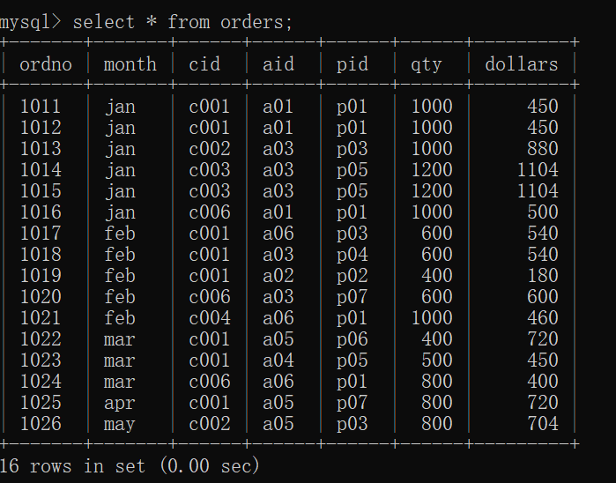

**3. 数据查询：请用SQL语句执行下述查询**

1. **检索每个经销商销售每一种产品的总数量.**

**Select aid,pid,sum(qty) as TOTAL from orders group by aid,pid;**

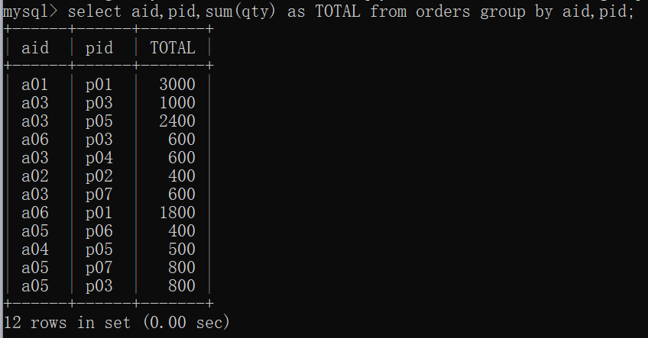

1. **检索符合下述要求的客户的编号：在该客户订购过的所有商品中，每一种商品的平均每笔订单的订购数量均达到或超过300**

**select t.cid from (select cid,pid,avg(qty) as q_avg from orders group by cid,pid) t group by t.cid having min(t.q_avg)>=300;**

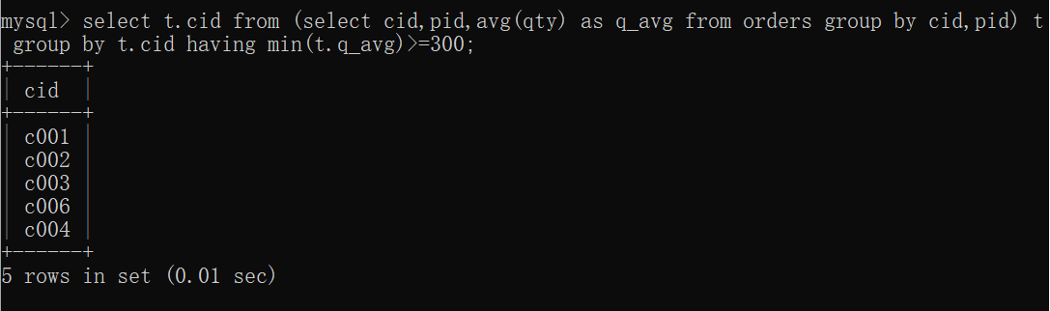

1. **检索没有为居住在Duluth的任何客户订购过任何商品的经销商的编号.**

**select aid from agents where not exists(select * from orders join customers where orders.cid = customers.cid and city = "Duluth");**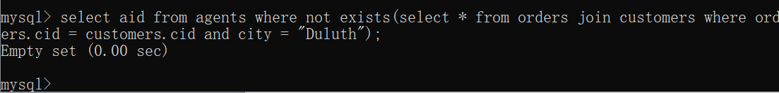

1. **检索为居住在Duluth和Kyoto的所有客户订购过同一种商品的经销商的编号.**

**select o1.aid from orders o1,customers c1 where o1.cid = c1.cid and not exists (select * from customers c2 where c2.city = "Duluth" or c2.city = "Kyoto" and c2.cid not in (select o2.cid from orders o2 where o2.aid = o1.aid and o2.pid = o1.pid));**

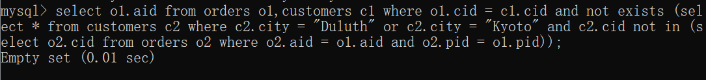

1. **检索仅通过a03和a05两个经销商订购过商品的客户编号.**

**select o1.cid from orders o1 where o1.cid not in (select o2.cid from orders o2 where o2.aid <> "a03" and o2.aid <> "a05");**

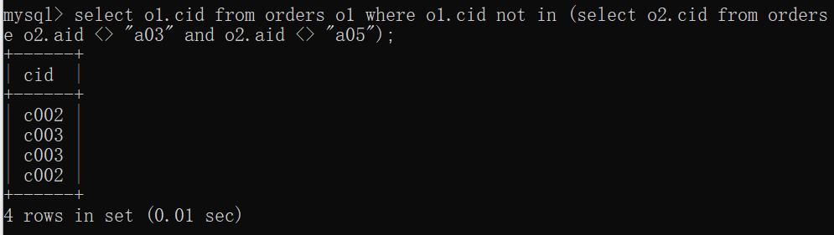

1. **检索居住在Dallas的所有客户都订购过的商品编号.**

**select pid from products p where not exists (select * from customers c where c.city = "Dallas" and c.cid not in (select o.cid from orders o where o.pid=p.pid));**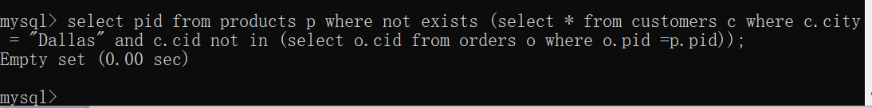

1. **检索享有最高佣金比率的经销商.**

**select aid from agents where percent in (select max(a.percent) from agents a);**

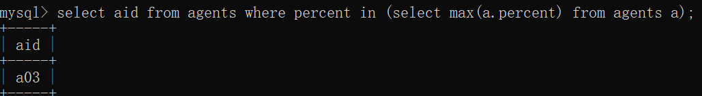

1. **检索仅仅通过a04号经销商订购过商品的客户编号，并给出每个客户的订购总金额.**

**select o1.cid,sum(o1.dollars) from orders o1 where o1.cid not in (select o2.cid from orders o2 where o2.aid <> "a04") group by o1.cid;**

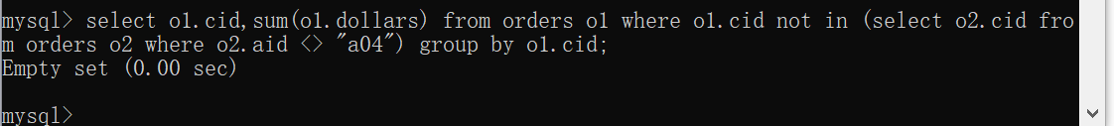

1. **检索为居住在Duluth的所有客户订购过商品的经销商的编号及其佣金百分比，并按照佣金百分比的降序输出查询结果**

**select aid,percent from agents a where not exists (select * from customers c where c.city = "Duluth" and c.cid not in (select o.cid from orders o where o.aid = a.aid)) order by percent desc;**

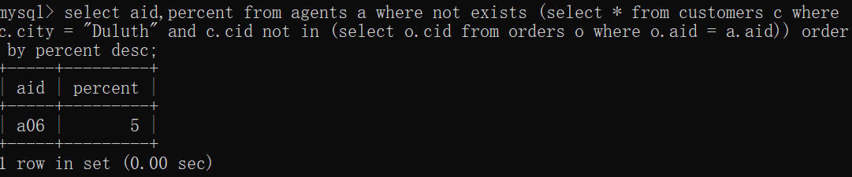

1. **检索符合下述条件的商品的编号：至少有一个客户通过与该客户位于同一个城市的经销商订购过该商品.**

**select o.pid from orders o,customers c,agents a where o.cid = c.cid and o.aid = a.aid and c.city = a.city;**

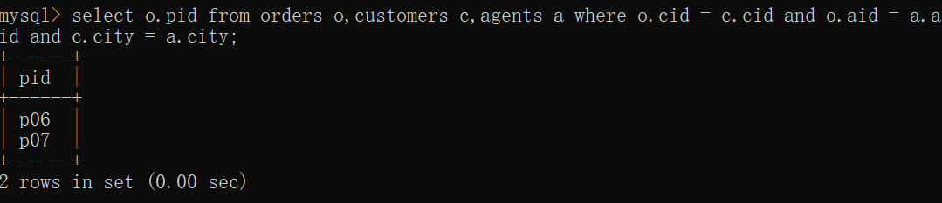

**4. 数据更新：请用SQL语句完成下列的数据增、删、改操作**

1. **在Agents表中插入一条percent的取值为空的元组，然后再用IS NULL谓词查出该新插入的元组，最后用COMMIT命令提交本次插入操作的执行结果。**

**Begin;**

**INSERT INTO agents (aid, aname, city, percent) VALUES ('a07', 'JinXin', 'Nanjing',null);**

**select * from agents where percent is NULL;**

**Commit;**

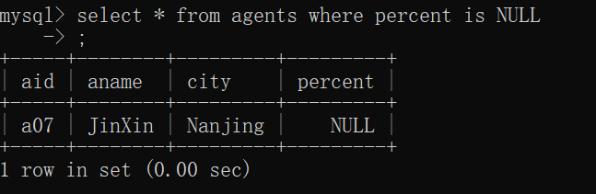

1. **在agents表中删除名字为Gray的供应商元组，然后再用ROLLBACK命令恢复被删除的Gray元组。**

**Begin;**

**delete from agents where aname = "Gray";**

**rollback;**

**select * from agents;**

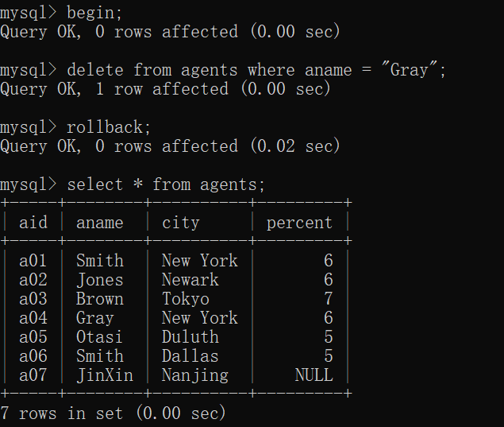

1. **在agents表中，将所有供应商的percent值提升10%，然后再查出所有供应商的信息。**

**update agents set percent = 1.1 * percent;**

**select * from agents;**

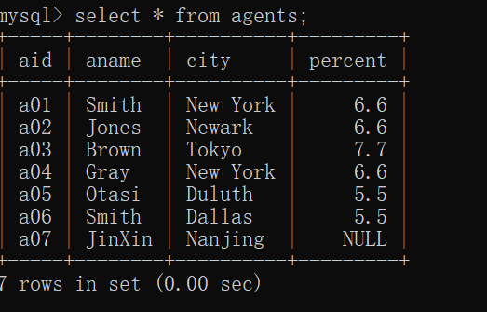

1. **删除基本表：用DROP TABLE命令删除这四张表。**

**Drop table agents;**

**Drop table customers;**

**Drop table orders;**

**Drop table products;**

实验中遇到的困难及解决办法

[详细说明你认为本次实验中比较困难的地方，也可以对实验设计提出建议]

参考文献及致谢

[如果你参考了任何书籍、网页，或与他人进行了讨论，请在此注明]

做题时参考课本例题，老师的ppt，安装MySQL时参考了他人博客