Assignment 12
1.
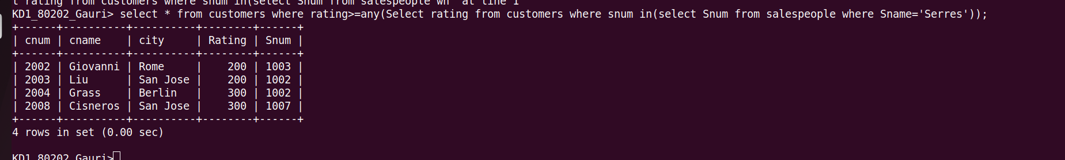

Q2.

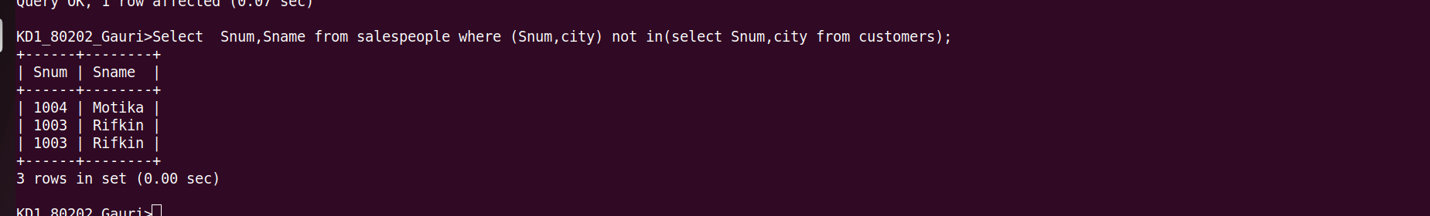

Q3.
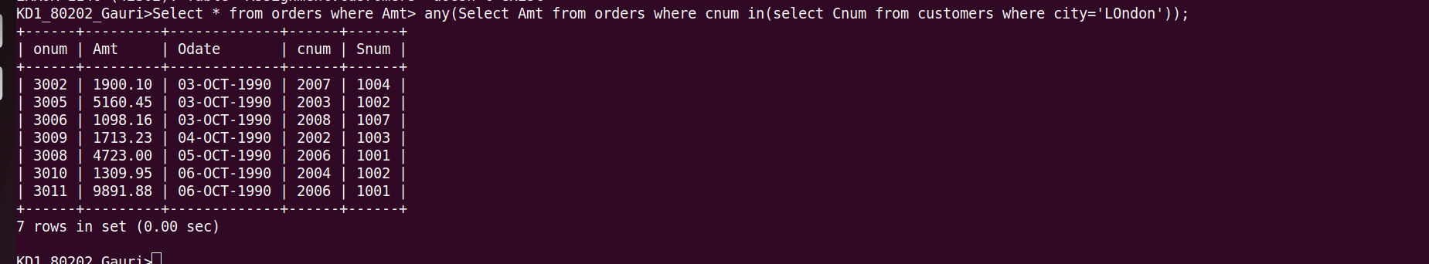

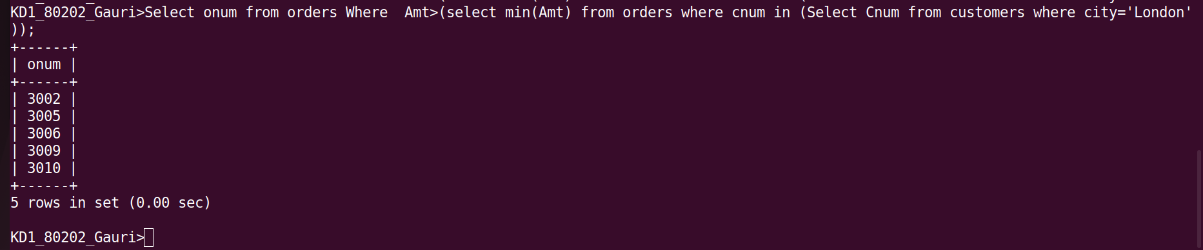
Q4.

