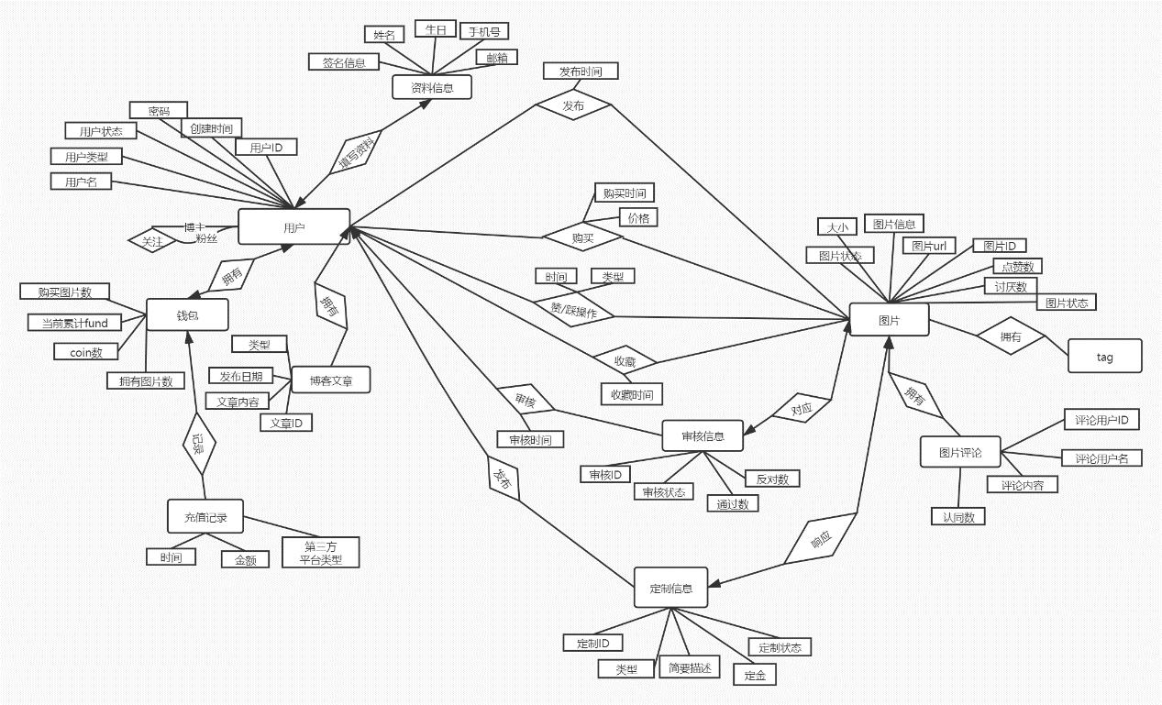

关系模式

用户user(***u_id* string**, password **varchar(10)** u_name **string**. u_type **varchar**, u_status **varchar**

, creat_time **date**);

**所有id都是varchar(8)**

关注 follow (fans_id , follow_id);

用户资料信息userInfo(***u_id*,** name, birthday **date**,phone_number,mail **varcahr**,message **varchar(50)**);

U_id参照用户中的u_id.

钱包 wallet( u_id, fund, coin, publish_num, buy_num);

充值记录 payment (u_id , time, money, source_type);

拥有博客 ownBlog(u_id, b_id);

博客 blog (***b_id***, date, b_type, publish_time);

发布图片publishPicture(u_id ,p_id,time);

收藏图片 favoritePicture(u_id,p_id,time);

赞/踩操作 likesPicture(u_id,p_id,time,type);

审核 check(u_id ,c_id,c_time)

审核信息 checkInfo***(c_id***,p_id,c_status,pass_num,fail_num);p_id依赖图片中的P_id

图片 picture(***p_id***,p_size,p_info,p_url**(varchar(100))**,p_status,likes,dislikes);

拥有Tag ownTag(p_id,tag_name);

Tag标签 tag(tag_name);

认同评论 commentLike(u_id, comm_id,p_id);

图片评论 picComment(u_id,p_id,p_name,comment,likes);

发布定制 order(u_id, o_id);

定制信息 orderInfo(***o_id***, o_type, o_status, description **varchar(50)**,reward);

图片响应 orderPic(o_id,p_id);

全局信息管理 totalInfo(user_num,blog_num,pic_num,check_num,order_num);

对应id bool数组、没有记为null.