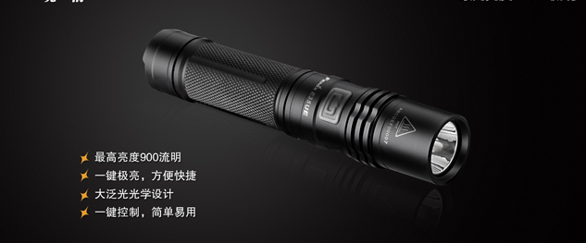

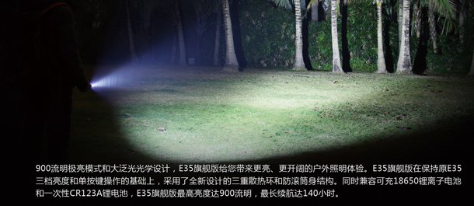
Accessories for LED Flashlight
HS CODE | Product Name | Price
8513901000 | LED flashlight accessories | $1.3/pcs
Total |  | 1.3 x 20 = $26

To:
Moklis Ali
Tel: +44 17632713

From:
Company: HangZhou WoRong Technology Co. Ltd
Tel: 86-15967129903
Manager: Vincent Chen

