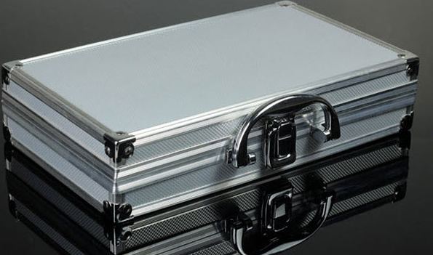
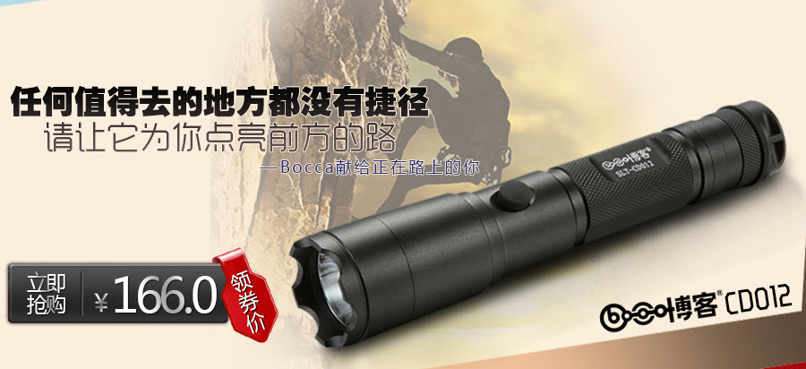

Empty Aluminium box , gift box

HS CODE | Product Name | Price
7616999000 | Aluminium Box | $2/pcs
Total |  | 20 x 2 = $40

To:
Moklis Ali
Tel: +44 17632713

From:
Company: HangZhou WoRong Technology Co. Ltd
Tel: 86-15967129903
Manager: Vincent Chen

