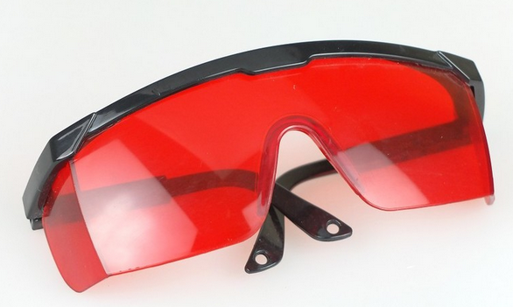
Goggle glasses

HS CODE | Product Name | Price
9020000000 | Goggle glasses | $0.5/pcs
Total |  | 20 x 0.5= $10

To:
Moklis Ali
Tel: +44 17632713

From:
Company: HangZhou WoRong Technology Co. Ltd
Tel: 86-15967129903
Manager: Vincent Chen

