http://jingyan.baidu.com/article/d3b74d64a511651f77e609eb.html
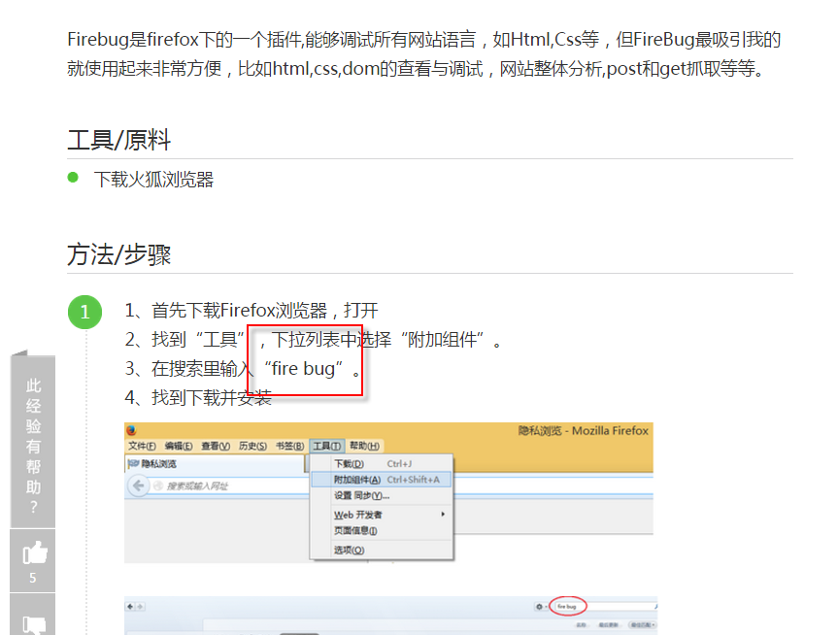
- 下载不了

→ http://www.webkaka.com/blog/archives/how-to-use-firefox-to-analyze-webpage.html
