- Battery installation method.
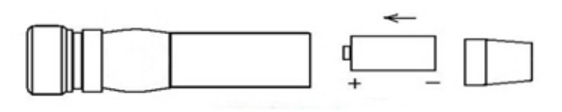  The negative pole point to the lid. | 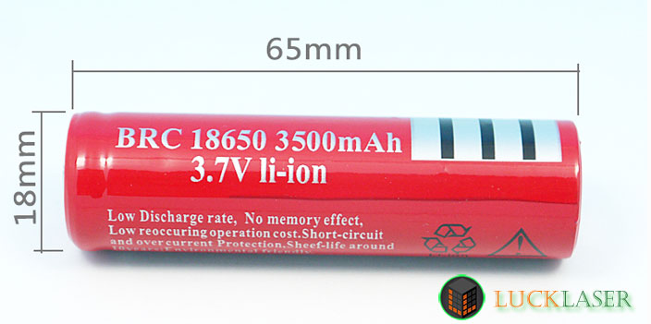
18650 battery (Not Include)
- WARNING
1. Never look directly into the laser beam.
2. Never point a laser beam at a person.
3. Do not aim the laser at reflective surfaces.
4. Do not allow children to use laser pointers unless under the supervision of an adult.

- Battery installation method.
The negative pole point to the lid.
18650 battery (Not Include)
- WARNING
1. Never look directly into the laser beam.
2. Never point a laser beam at a person.
3. Do not aim the laser at reflective surfaces.
4. Do not allow children to use laser pointers unless under the supervision of an adult.

- Battery installation method.
The negative pole point to the lid.
18650 battery (Not Include)
- WARNING
1. Never look directly into the laser beam.
2. Never point a laser beam at a person.
3. Do not aim the laser at reflective surfaces.
4. Do not allow children to use laser pointers unless under the supervision of an adult.

