LASER SIGHT (R.G) USER MANUAL
Item code | Length | Wavelength | Height | Wattage | Weight | Reaching distance | Battery | Voltage
CHENGXIN | 120MM | 532NM | 36MM | 20MW | 144G | 800M | 16340 | 3.6V

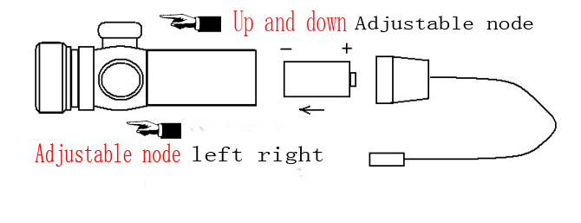
OPERATION
- Fix the laser sight on a weapon
- Make the elevation and wind age adjustment by twisting the 2 small screws in the head part with smaller allen wrench, turning it until the main laser spot overlap with the scattered points.
- To change the batteries .unscrew and open the back cover of body, then install the batteries with positives with positive pole. Finally, replace
- To operate the laser ,press the switch.

SAFETY CAUTIONS
- Never look directly into the laser.
- Never point a laser beam at a person.
- Do not aim the laser at reflective surfaces.
- Never view a laser pointer using optical instrument, such as binocular or microscope.
- Do not allow children to use laser pointers unless under the supervision of an adult.

