调制模组使用说明

1. 使用时，把红线和黄线短接，模组会亮，处于连续工作模式；
.2、 要调制时，信号线负极接黑线，正极接黄线，红线悬空，模组处于调制工作状态,

3. 信号输入的调制频率需在500KHZ范围内,

4. 调制工作时输入高电平为3V,持续工作输入电压也是3V

Modulation module instructions
- When in use, connect the red and yellow line, the module will be bright, and in continuous work mode;
- When you want modulation, connect the negative of signal line to black line, and positive to yellow line, keep the red line suspended, then the module in modulation mode;
- Signal input should be in the range of 500KHZ;
- The input voltage of modulation work is 3.3V, continuous work input voltage is 3.3V.

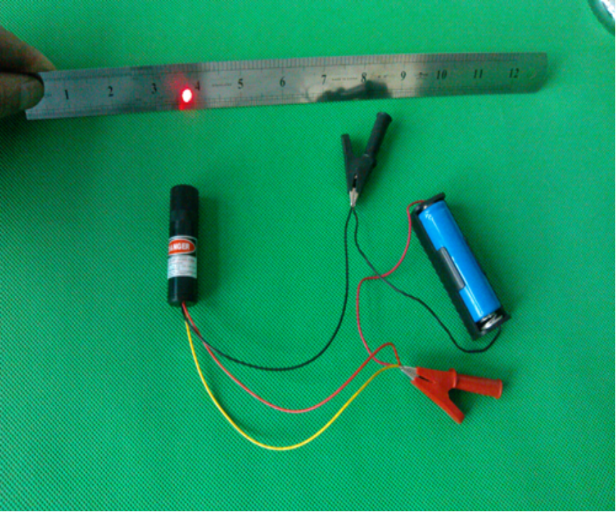

TTL 带电源线使用说明：
带DC插头的调制模组使用说明：
带DC插头的调制模组，除了DC插头的正负极外，还有另外三根线，一红，一黄，一黑，其中红为正极，黑为负极，黄为信号线正极，信号线负极为黑；
使用时，插上DC插头，模组不亮，必须要把红线和黄线短接，模组会亮，处于连续工作模式；
要调制时，信号线负极接黑线，正极接黄线，红线空着，不用接，模组处于调制工作状态。
信号输入的调制频率需在1000KHZ范围内,调制高电平为3V

TTL Modulation module instructions
TTL laser Module with DC interface
Besides the DC interface, this module includes three wires.
Red line: positive pole
Black line: negative pole
Yellow line: Positive of the signal modulation line

- Continuous work model
step1: connect the DC interface.
Stpe2: Let the red line and yellow line shorted
- Modulation model
Step1: The negative pole of the signal line connects black line;
Stpe2: The positive pole of the signal line connects yellow line;
Step3: Red line is empty.
(The modulation frequency of the input signal need 1000KHZ range, the modulated high level is 3V)

