模板 <http://www.58pic.com/yuanchuang/17208694.html>

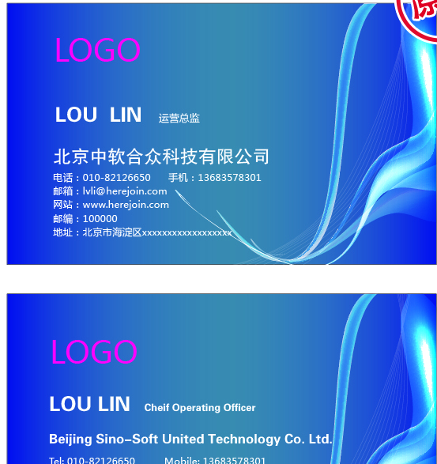

中文内容

+++++++++++++++++++++++++++++++++++++++++++++++++++++++++++++++++++



杭州纳酷科技有限公司

陈水军 总经理

地址: 浙江省杭州市滨江区西铺路滨科大厦

手机: 15967129903

电话: 0571-56072699

Email: [nakukeji@163.com](mailto:nakukeji@163.com)

<Http://nakukeji.com>

英文内容

+++++++++++++++++++++++++++++++++++++++++++++++++++++++++++++++++++



HangZhou NaKu Technology Co. Ltd

Vincent Chen General Manager

Add: Binjiang PuYan Xipu Road 1503# Binke Building,Hangzhou,Zhejiang,China

Mobile: +86(571) 15967129903

Email: [nakukeji@163.com](mailto:nakukeji@163.com)

<Http://nakukeji.com>